Date: 14/02/2022
From: Irish Wheelchair Association
Contact Details: Jean Coleman National Housing Programme Manager

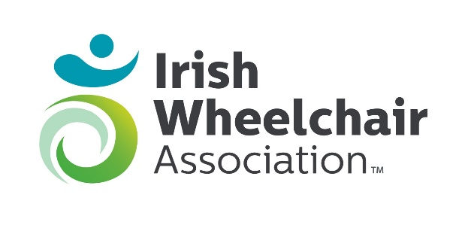

Irish Wheelchair Association
Submission to Dublin City Development Plan 2022-2028
Background
Irish Wheelchair Association (IWA) has a vision of an Ireland where people with disabilities enjoy equal rights, choices and opportunities in how they live their lives, and where our country is a model worldwide for a truly inclusive society. We work with, and on behalf of, people with physical disabilities to drive positive change in Ireland through the influencing of public policy, the provision of quality services and enabling accessibility to all aspects of society.

Irish Wheelchair Association is Ireland’s leading representative organisation and service providers for people with physical disabilities. We advocate for the needs of people with physical disabilities and provide services and support to over 20,000 members in their homes and communities throughout Ireland every year.
Everything we do is driven by IWA’s vision of an Ireland where people with disabilities can enjoy equal rights, choices and opportunities and live their lives independently.

IWA believes in a fair and inclusive society. We work actively to ensure that every person with a physical disability in Ireland can achieve their right to an independent life, with equal access to opportunities, services and supports within their communities.

Irish Wheelchair Association welcomes the opportunity to participate in the Public Consultation Process, please see forthwith our observations under the following themes:

Quality Housing and Sustainable Neighbourhoods

Article 28 of the United Nations Convention on the Rights of People with Disabilities (UNCRPD) on providing an Adequate Standard of Living and Social Protection states that, “governments must ensure access by persons with disabilities to public housing programmes.”
The experience of IWA members, who are wheelchair users, in accessing social housing has not been positive. People who are wheelchair users typically spend long waiting periods on social housing lists with no timeframe within which to expect an offer of housing. We believe that the current social housing waiting lists are an under representation of the real need because wheelchair users are not applying because they know there are no wheelchair liveable houses available, either through the City Council or HAP. For example, IWA tenants living in Clontarf have been in transitional housing in an Office Campus for years because of the unavailability of wheelchair liveable housing in an area of their choice in a community setting. While we welcome the new National Housing Strategy for Disabled People 2022 - 2027, there is still no strategically planned annual supply of fully wheelchair liveable properties.

The inclusion of Universal Design in the new National Housing Strategy for Disabled People 2022 – 2027 is a big step in the right direction, however the basic level of Universal Design is not always Wheelchair liveable, its needs to be Universal Design + and Universal Design ++.
The Department of Housing, Local Government and Heritage launched the Design Manual for Quality Housing, and although we acknowledge the recommendation of 10% – 16% of additional floor area meets the need for age friendly and those with reduced mobility, this additional floor space would not accommodate people using power wheelchairs. More and more people are now using power wheelchairs to support their independence and these chairs are larger than the standard manual wheelchair.
IWA would recommend 20% additional floor space to ensure that people using power chairs are not excluded. IWA recommend that 7% of all new housing developments, both in the private and public sector to be fully wheelchair liveable, meeting at a minimum the Universal Design + standard.
Again, the basic level of Universal Design is not wheelchair liveable.
Where a person using a larger powerchair or requires assistance with their activities of daily living and/or personal care, the design of the house/home should be designed and constructed to the Universal Design ++ standard.
It’s important that all disabled people can access all areas of their homes, to enable them to live, work and play in their homes.
Think Ahead Think Housing
IWA is currently working on designing wheelchair liveable homes with Mayo County Council. After consultation with the HSE they identified 22 people with disabilities with a housing requirement in Castlebar, but on investigation only one person had registered with the local authority for social housing. We urge DCC to promote Think Ahead Think Housing Campaign which will be relaunched in May of 2022 and their by ensuring that the true housing needs of people with disabilities are reflected on the social housing waiting lists, and in so doing empower the local Authority to respond appropriately to those needs by including sufficient UD+ homes in their planning.

Recommendations:

- IWA recommends that Dublin City Development Plan includes promotion of IWA’s Think Ahead, Think Housing campaign. Think Ahead, Think Housing encourages people with disabilities to apply to their local authority to secure their future housing needs.
This campaign is of paramount importance to ensure that the real need of disabled people is reflected in the approved social housing waiting lists.

- IWA recommends that Dublin City Development Plan includes IWA’s Think Housing Build Accessible campaign. Think Housing Build Accessible is a campaign led by IWA with the support of eleven coalition partners from across the disability sectors, calling for 7% of all new developments, both in the private and public sector to be fully wheelchair Accessible, meeting at a minimum, the UD+ standard of Universal Design.
Where a person using a larger powerchair, or requiring assistance with their activities of daily living and/or personal care, the design of the house/home should be designed and constructed to the UD++ standard of Universal Design.

The remaining 93% of houses should be designed and constructed t the UD/ lifetime adaptable homes standards.
The campaign is calling for a review of PART M OF THE BUILDING REGULATIONS 2010 (SECTION 3 - ACCESS AND USE OF DWELLINGS) ensuring that the minimum accessibility standard for new builds in Ireland would be much higher.

- IWA recommends Dublin City Development Plan commits that that all social housing projects supported by capital funding from the Department of Housing, Planning and Local Government deliver 7% of integrated UD+ designed, fully wheelchair accessible social housing units within choice locations that are accessible to community amenities and transport links. Furthermore, the inclusion of fully wheelchair accessible UD+ design should be incorporated into each social housing project planning at stage 1 of the Capital Appraisal Process.
- IWA recommends that Dublin City Development Plan promote innovative housing design models e.g. those that incorporate the provision of an interlinking overnight room for personal assistants as well as the option of people with disabilities to share a tenancy with one or two other people on the social housing list.
- IWA recommends mixed tenure developments or integrated housing which will ensure sustainability of all future housing in terms of a mix of people; their ages and backgrounds, ensuring that persons of different ages and persons with and without disabilities from all walks of life are part of all future housing developments.
Appendix:
The following graphs demonstrate a couple of examples of how Universal Design guidance varies.
It clearly demonstrates that UD designed houses are not wheelchair Liveable houses.
Example 1 Door Width in Universal Design guidance documents

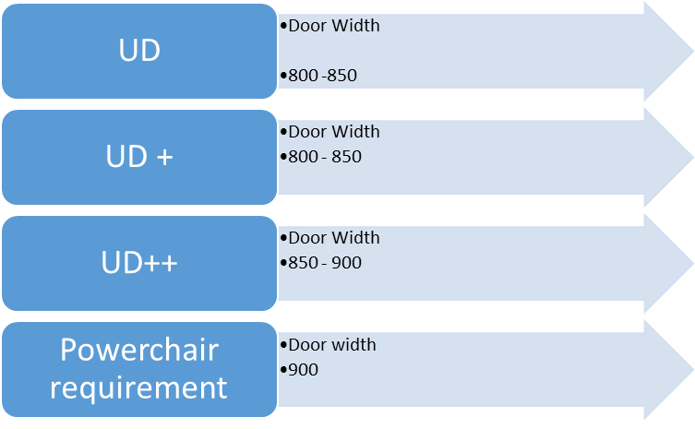
Example 2 Turning circle (space needed to turn a wheelchair) guidance in Universal Design GD

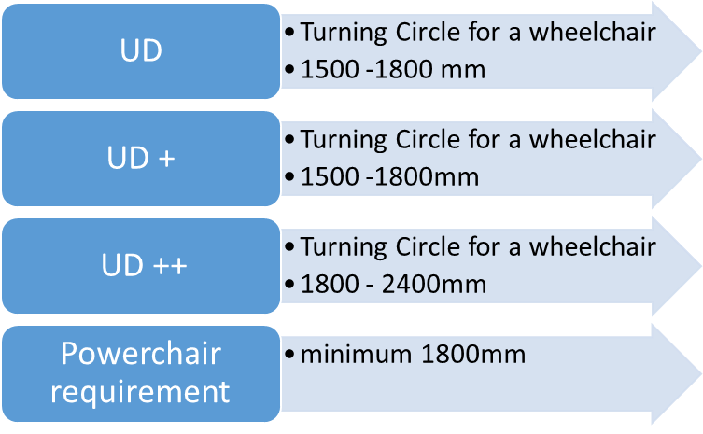

Services IWA provide:
- Irish Wheelchair Association is also an approved housing body specialising in wheelchair accessible housing which it provides directly to its members in Clontarf Dublin, Carlow, Tipperary, Kilkenny, Galway, Mayo and Roscommon.
- Every year our 1,600 personal assistants provide over two million hours of support to help those with physical disabilities and other mobility impairments in their journeys towards independent living.
- We provide community centres, training facilities, social activities and holiday homes.
- The largest of our services is the Assisted Living Service which provides Personal Assistants to people in their own homes and communities.
- People are central to everything we do with a focus on improving quality of life.

This submission should be seen only as one stage of the consultation phase so that concerns raised by people with disabilities are dealt with as they are planned and not when they have been implemented. The need for ongoing meaningful consultation on a phase by phase basis is compulsory, understanding that a city that is accessible to a person with a disability is a city that is accessible to everyone.

The ratification of the United Nations Convention on the Rights of Persons with Disabilities (UNCRPD) brought with it a legal basis for people with disabilities to have the right to live independently. This independence will only come when it is truly realised that people with disabilities have the same rights as everyone else such as transport, housing, education employment etc.

