Strategic Flood Risk Assessment

For

  - PROPOSED VARIATION No. 33

Of

  - DUBLIN CITY COUNCIL DEVELOPMENT PLAN 2016-2022

  - Changes to the Land Use Zoning of lands at Jamestown Road, St Margaret’s Road and McKee Avenue, Finglas, Dublin 11, from Land Use Zoning Objective Z6 to Land Use Zoning Objective Z14, the designation of a new Strategic Development and Regeneration Area (SDRA), and associated text changes and new figure to Section 15.1.1 of the Dublin City Development Plan 2016-2022.

Contents
1.0 Introduction + Context 2
1.1 Proposed Variation 2
1.2 Purpose of the Proposed Variation 4
1.2.1 Policy Context 4
1.2.2 Background 4
2.0 Study Area 7
2.1 Context for Variation Lands 7
2.2 Watercourses 8
2.2.1 River Tolka 8
2.2.2 Tributaries of the River Tolka 8
2.3 Existing Surface Water Infrastructure 9
2.4 Topography 10
2.5 Water Attenuation 11
2.6 Groundwater Vulnerability 12
3.0 The Planning System and Flood Risk Management 13
3.1 Identification of Flood Risk 13
3.2 Likelihood of Flooding 14
3.3 Consequences of Flooding 14
3.4 Definition of Flood Zones 14
3.5 Sequential Approach & Justification Test 15
4.0 Data Collection 17
4.1 Overview 17
4.2 National PFRA Study 17
4.3 Eastern CFRAM Study 17
4.4 Dublin City Development Plan 2016 – 2022: Strategic Flood Risk Assessment Volume 7 17
4.5 Sources of Flooding 18
4.5.1 Surface Water / Pluvial Flood Risk 18
4.5.2 Fluvial or river flooding 19
4.6 Climate Change 20
5.0 Flood Risk Management 21
5.1 Overview 21
5.2 Recommendations for Managing Flood Risk 21
5.2.1 Recommended Objectives 21
5.3 Recommendations for Managing Surface Water 22
5.3.1 Recommended Objectives 22

1.0 Introduction + Context
This report has been prepared in accordance with ‘The Planning System and Flood Risk Management Guidelines for Planning Authorities’ (2009), published by the Department of Environment, Heritage and Local Government (DoHLG).

Proposed Variation
It is proposed to make a Variation to the Dublin City Development Plan 2016 – 2022 by changing the Land Use Zoning Objective of a c. 43.11-hectare land bank situated between Jamestown Road and St Margaret's Road / McKee Avenue, Finglas, Dublin 11,
from Land Use Zoning Objective Z6 (Employment / Enterprise) “To provide for the creation and protection of enterprise and facilitate opportunities for employment creation”
to Land Use Zoning Objective Z14 (Strategic Development and Regeneration Areas): “‘To seek the social, economic and physical development and/or rejuvenation of an area with mixed-use, of which residential and ‘Z6’ would be the predominant uses”.
It is also proposed to designate the lands a Strategic Development and Regeneration Area (SDRA).
The proposed changes to the Dublin City Development Plan 2016-2022 are as follows:
- Land Use Zoning Map Change (Map A) to Z14 (Strategic Development and Regeneration Areas) to replace the existing Z6 (Employment / Enterprise) zoning.
- Amend Map K, to include the new Strategic Development and Regeneration Area (SDRA).
- Amend Chapter 15, to insert new Strategic Development and Regeneration Area (SDRA) Guiding Principles for the subject lands.
- Amend Chapter 2, to include the SDRA lands into the Core Strategy.
It is proposed to include additional text to Section 15.1.1 of the City Development Plan and a new figure in respect of proposed SDRA 19 Jamestown Road, St Margaret’s Road and McKee Avenue, Finglas, to include the following:
Guiding Principles for the SDRA
A number of guiding principles have been established which will inform the future development of the SDRA lands. These principles include requirements for the following:
- Urban Structure.
- Land Use & Activity.
- Height.
- Design.
- Green Infrastructure.
- Climate Change.

Requirement for Masterplan
To ensure that the development of the subject lands occurs in a sustainable and coherent manner, a masterplan shall be prepared for the entire SDRA by all major landowners, which complies with the guiding principles above, to be agreed with the Planning Authority, before the lodgment of any planning application. All planning applications in the SDRA will be required to comply with the Masterplan and the Principles outlined above. Minor deviations will only be considered where the change supports the implementation of the Principles and provides an improved solution.
This Masterplan shall respond to the SDRA guiding principles and will not be limited to, but shall include details on the following:
- Public realm and street design and interface with existing streets.
- Housing Needs Demand Analysis (HNDA).
- Range of housing typologies.
- Green Infrastructure Strategy.
- Integrated Surface Water Management Strategy.
- Mobility Management Strategy.
- Encourage exploration of options for district heating.
- Statement submitted with any planning permission demonstrating how proposals accord with SDRA and Masterplan.
- Development shall occur sequentially and contiguous to existing residential development.
- Phasing plan.
- Delivery of new community facilities.

It is proposed to amend Chapter 2 by amending table C (page 22) to include the hectage as one of the “other zonings containing residential use”; thus increasing the size from 2043 to 2086 and the associated total from 6509 to 6552.
It is also proposed to add Finglas SDRA to Table E (page 25) and amend the total so that is reads:
SDRA 19 | Finglas | 2,200
 | Total | 54,500- 54,800.

1.2 Purpose of the Proposed Variation
The purpose of this proposed variation is to change the land use zoning objective of a c. 43.11-hectare land bank situated between Jamestown Road and St Margaret's Road / McKee Avenue in Finglas, from Land Use Zoning Objective Z6 (Employment/Enterprise) to Z14 (Strategic Development and Regeneration Areas), to fulfil National and Regional planning objectives on responding to climate change, delivering compact development and sustainable urban growth.

1.2.1 Policy Context
The National Planning Framework (NPF) (Project Ireland 2040) states that at least 50% of all new homes for Dublin City and suburbs are required to be delivered within and adjoining its existing built-up footprint. To achieve this, the NPF identifies the reusing of large and small ‘brownfield’ land/infill sites, and underutilised lands at locations well served by existing and planned public transport. The NPF particularly highlights the need to focus on underutilised lands within the canals and the M50 ring. The proposed variation supports this policy position.
The Regional Spatial and Economic Strategy (RSES) for the Eastern and Midlands Region seeks the consolidation and re-intensification of infill, brownfield, and underutilised lands within Dublin City and its suburbs. 50% of all new homes within Dublin City and its suburbs are to be located in the existing built-up area. The RSES identifies a population target increase for Dublin City (DCC’s administrative area) of circa 100,000 people by 2031. To facilitate this growth the RSES also includes a Metropolitan Area Strategic Plan (MASP) for Dublin. The MASP directs future growth to identified Strategic Development Areas located on existing and planned strategic transport corridors and anticipates future growth will also be accommodated on brownfield/infill development lands in the city. The proposed variation supports this policy position.
The National Transport Authority’s Transport Strategy for the Greater Dublin Area 2016-2035 provides a framework for developing a sustainable transport network. Three key public transportation projects for Dublin City include:
- Finglas Luas– the extension of the green line Luas from Broombridge to Charlestown, to the northwest of the Jamestown Z6 land bank.
- Bus Connects – enhancement of Dublin's bus network along with several identified Core Bus Corridors, including Finglas.
- Metrolink – proposed rail link from the City Centre to Dublin Airport / Swords. Both the Finglas Luas and Finglas Core Bus Corridor are being designed to integrate and interchange with Metrolink as part of a wider strategic transport network for Dublin.
The Proposed Variation supports and establishes a plan-led approach to maximising the development of the lands in line with significant State investment in the public transport infrastructure of the area.

1.2.2 Background
Following a review of the City’s employment / industrial lands in 2018/19, the Planning Department identified 82 land parcels with the potential to accommodate future housing and more intense land uses, within the existing built fabric of the City. Of these, 20 small to medium land banks were initially proposed for re-zoning by way of a Variation to the Dublin City Development Plan 2016-2022 (Proposed Variations No.’s 8 - 27). At the Dublin City Council monthly meeting held on 2nd March 2020 and continued 10th March 2020 a number of these Proposed Variations were adopted.
The potential of the Jamestown Z6 land bank was identified in the 2018/19 study, having regard to the lands strategic location inside the M50 and adjacent to the proposed Luas extension to Finglas (Finglas Luas). The study recognised that this area represents well-connected but underutilized employment (Z6) zoned brownfield lands within the built-up area of the City with the potential to allow for more varied and intense mixed uses.
Since March 2020, Dublin City Council has been in consultation with Transport Infrastructure Ireland (TII) and there is now greater certainty around the timeline and process for the delivery of the Finglas Luas. Furthermore, there has been ongoing engagement between Dublin City Council and the National Transport Authority (NTA) concerning the Finglas Core Bus Corridor as part of the Bus Connects project which is providing greater clarity in terms of the delivery of this public transport project. Also, there has been increased landowner interest in advancing the development of the lands.
As a result of this change in circumstances and having regard to the significance of the lands in achieving the National and Regional policy objectives set out in the NDF and RSES / MASP, it was considered appropriate to bring forward these lands for re-zoning from Z6 to Z14 subject to the requirement for a Masterplan based on guiding principles established for the SDRA and shown in the Framework Plan (Figure 38A)
Land Use Zoning Objective Z14 of the Dublin City Development Plan endeavours “To seek the social, economic and physical development and/or rejuvenation of an area with mixed-use, of which residential and 'Z6' would be the predominant uses”. Chapter 15 of the Dublin City Development Plan identifies several SDRAs and sets out the guiding principles for their development. SDRAs are capable of delivering significant quanta of homes and employment for the City, with many situated within the existing built environment on underutilised or brownfield sites. Finglas is currently designated a Key District Centre (KDC) in the Dublin City Development Plan. KDCs represent the top-tier of urban centres outside the City Centre and a number of these form part of the larger SDRAs. KDCs act as strong spatial hubs for development in the suburbs.
Therefore, the rationale for this Variation is as follows:
- To provide for more varied and intense mixed uses of these existing low-density mono use brownfield urban lands within the Dublin Metropolitan Area. This Variation supports the National and Regional planning objectives set out in the NPF and RSES / MASP by supporting the area regeneration to deliver a compact and sustainable urban form at this location, to achieve the sustainable use of scarce urban land, and to respond to climate change.
- To maximise the potential of a well-connected but underutilised brownfield low-intensity employment land, situated within the existing built fabric of the City and adjacent to the proposed Luas green line extension to Finglas, and proposed Finglas Core Bus Corridor, as set out in the National and Regional planning objectives in the NPF and RSES / MASP.
- To support the economic revitalisation of Finglas village through the creation of a cohesive urban framework and guiding principles, by way of a new SDRA designation for the proposed Z14 lands, to ensure that the future development of the lands occurs in a coordinated and sustainable manner that can act as a catalyst to regenerate the village.
The lands proposed for re-zoning comprise a total of c. 43.11 hectares. Assuming a target density of 100 units per hectare and assuming that 50% of the land would be in residential use, this land bank has the potential to deliver an indicative c. 2,220 residential units. It is anticipated that the remaining land would be comprised of 30% employment/commercial, 10% public open space, and 10% social/community/education.
In preparing for the proposed change of zoning to allow for such a significant area of potential new residential units, the impact of this variation has been examined in relation to the Core Strategy. Whilst the volume of land proposed provides for approximately 2,200 units, it is not expected that any significant portion of this will be delivered during the lifetime of the current City Development Plan; though it is possible that a number of permission applications will be made within this time.
In analysing the delivery of the sub-areas for residential development (Table E), it is clear that a number of these have yet to reach their full capacity and some are not yet progressed nor likely to be by the end of the life of the current Development Plan. It is therefore considered that the additional zoning provided will remain consistent with the Core Strategy and it’s defining principle of achieving a compact sustainable mixed use growth with the existing envelope of the city, supported by high quality public transport and connectivity.
Delivery of SDRA housing within a brownfield, infill or regeneration context is complex due to its context, and delivery of housing often extends across a series of Development Plans. This variation and other SDRAs are designated within that long term horizon. The capacity provided by these lands will aid the Council in meeting it’s future housing targets in tandem with the other SDRA lands and it will be particularly relevant to the brownfield targets of the NPF.
It is proposed to amend table C (page 22) to include the hectage as one of the “other zonings containing residential use”; thus increasing the size from 2043 to 2086 and the associated total from 6509 to 6552.
It is also proposed to add Finglas SDRA to Table E (page 25) and amend the total so that is reads:
SDRA 19 | Finglas | 2,200
 | Total | 54,500- 54,800.

2.0 Study Area

2.1 Context for Variation Lands
The c. 43.11-hectare land bank is situated to the immediate north of Finglas village and is bound by Jamestown Road to the east, McKee Avenue, and St Margaret’s Road to the west and interfaces with the administrative boundary of Fingal County Council to the north, where the lands are currently characterised by employment/industrial uses. The lands border existing residential dwellings to the south/southwest. Existing residential dwellings are located along Jamestown Road and McKee Avenue, with a mix of commercial and residential uses along St Margaret’s Road. Charlestown Shopping Centre is located to the northwest of the lands and the emerging preferred route option for the proposed Luas extension to Finglas will border the lands, along St Margaret’s Road, terminating at Charlestown. The proposed Core Bus Corridor from Finglas to the City Centre as part of the Bus Connects project will also serve the lands, from the Finglas Road to the west.
The lands contain a number of existing industrial estates and a business park that is characterised by buildings/structures with large footprints with low-intensity employment uses. The area also contains a number of vacant sites and has a poor relationship with the adjoining street network. There is poor permeability through these lands, with private/controlled access to individual premises and across the lands.

Location Map
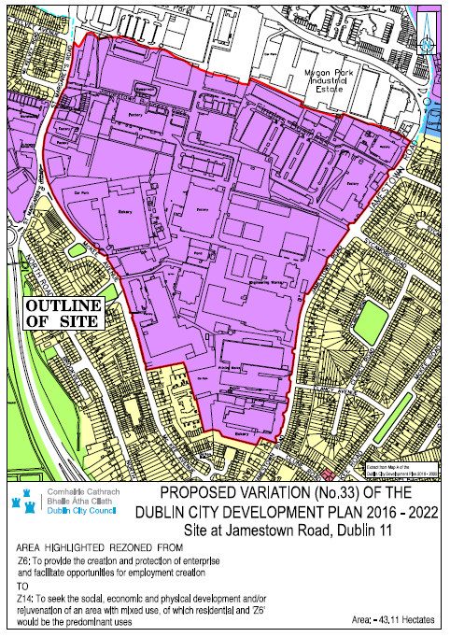

2.2 Watercourses

2.2.1 River Tolka
The River Tolka rises near Culmullin Cross Road in County Meath flows through, Dunboyne, Clonee, and Blanchardstown, and then enters the Finglas area at Tolka Valley Park, flowing through Finglas and then Glasnevin. It continues in a southeasterly direction discharging to Dublin Bay east of the Dart line at Fairview Park on the north side of Dublin City.

Except for lands within the Tolka Valley Park, the Finglas area lies within Flood zone C, where the probability of flooding from rivers and the sea is low.

Several tributaries flow into the Tolka River, which will be outlined below.

2.2.2 Tributaries of the River Tolka
As noted above there are several tributaries of the River Tolka which run through the Finglas area.

Tributaries of the River Tolka

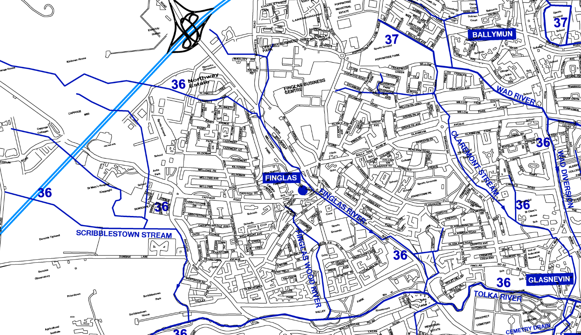Source: Extract from The Rivers of Dublin by Claire Sweeney, as revised by Gerard O’Connell & Michael Curtis (2017)
The Finglas River
The Finglas River or “Fionnglas”, meaning the clear stream is believed to have given Finglas its name. Rising the far side of the M50, it enters the Finglas area along Cappagh Avenue and makes its way south-east via a culvert towards the roundabout where St. Margaret’s Road meets the North Road. Here it is joined by a branch stream flowing south from the Charlestown area (which runs through the lands subject to this proposed variation) and the merged river continues south now in an open channel to the east of the N2 within a heavily wooded strip of land to the west of Brookville/ North Road. Piped surface water outfalls from housing areas join it here and elsewhere along its course. The river re-enters a piped culvert, under the N2 and continues south along the western edge of the Finglas Road. On approaching Prospect Hill it crosses back to the east side of the Finglas Road and enters an open channel for c. 230metres. Here it is joined by two small tributaries flowing from Griffith Road and Glasnevin Downs. It then crosses back to the west side of Finglas Road at the Old Finglas Road junction, where it enters the Tolka River.

Finglaswood Stream
This is a small stream named after Finglaswood House, an ancient structure dating to Anglo-Norman times. The stream is culverted along its entire length from Cappagh Road south and into Tolka Valley Park where it discharges into the Tolka River, upstream of Finglas Wood Bridge.

Scribblestown Stream
This stream has several branches all rising on the far side of the M50. One of the branches crosses under the M50 to the west of the North Park Business Park.

Claremont Stream
This stream rises to the east of Jamestown Road, east of the lands subject to this variation, and travels east via a culvert across the Sycamore, Oakwood, Cedarwood area, towards Willow Park Road, where it turns south parallel to Ballygall Road East, and into the grounds of St. Clare’s Hospital where it enters into an open channel. South of these grounds it re-enters a channel and continues south until it discharges into the Tolka at Glasnevin Bridge.

2.3 Existing Surface Water Infrastructure
Along with the culverted tributaries identified above, there is a stormwater piped network that crosses the area, draining to the River Tolka. There are very few open channel watercourses remaining in the study area, with most having been culverted progressively over time as development spread. However, there are open channels at Kildonan, along the Finglas Road, and at St. Clare’s Nursing Home (outside the area) that should be preserved and extended where possible.
The existing primary surface water infrastructure within the area is indicated below. Most of the land within Finglas is serviced with a separate foul and surface water system, apart from the Z6 lands subject to this variation.
The sub-catchment of Finglaswood Stream drains the steep-sided Tolka Valley Park via the Finglaswood Stream along with smaller piped systems to the lower reaches. The head of the stream/main surface water infrastructure drains eastwards via road drainage, joining the original stream at Wellmount Avenue/Dunsink Avenue junction in a 600mm dia culvert. The culvert discharges to a 1050mm dia culvert in Tolka Valley Park. The stream outfalls from a box culvert to a small wetland at the base of the Tolka Valley Park, adjacent to the Tolka River, which provides attenuation and a water quality function. Runoff collected in this wetland overflows via a sewer to the Tolka River.

Surface Water Infrastructure Network
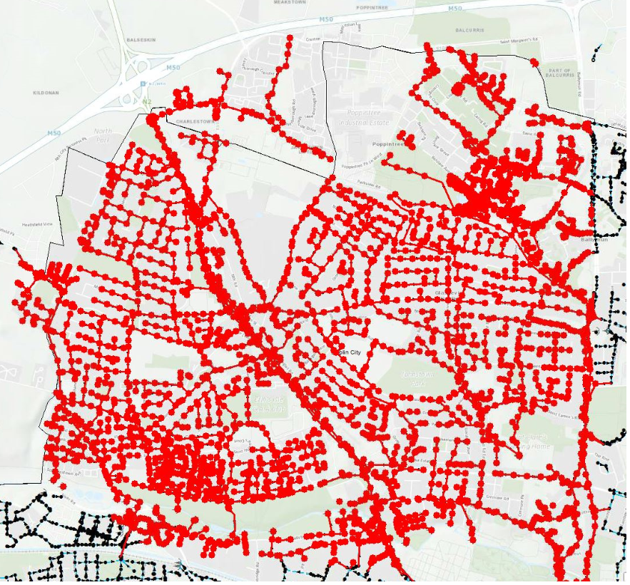
The sub-catchment between the Wad River and Finglas River is drained via the culverted Claremont Stream. This sub-catchment comprises well-established urban areas with a good proportion of institutional lands and sports fields in the middle and lower reaches of the Claremont Stream.
The culverted stream drains southwards in a 600mm-900mm dia culvert from Hillcrest Park to Ballygall Road East before discharging into an open channel at St. Clare’s Nursing Home. The stream continues southeast and under Griffith Avenue via several sized culverts. The stream finally outfalls to the Tolka at St Mobhi Drive. The surrounding areas of the catchment drain a network of surface water sewers, with outfalls of 300mm dia -450mm dia directly to the Tolka.
A network of surface water sewers feeds into the main strategic infrastructure. This network is well developed, however, there is a lack of existing surface water infrastructure in the Jamestown Industrial Estate lands.

2.4 Topography
Finglas is a relatively high lying area in relation to the City, with the land falling gradually towards the Tolka Valley and on to Dublin Bay, see Figure 6.1 below. Towards the northern parts of Finglas, the land lies c. 200 feet above sea level, dropping to c. 100 feet at the edge of Tolka Valley Park, and c. 70ft along the Tolka River’s edge.

Topography of Finglas
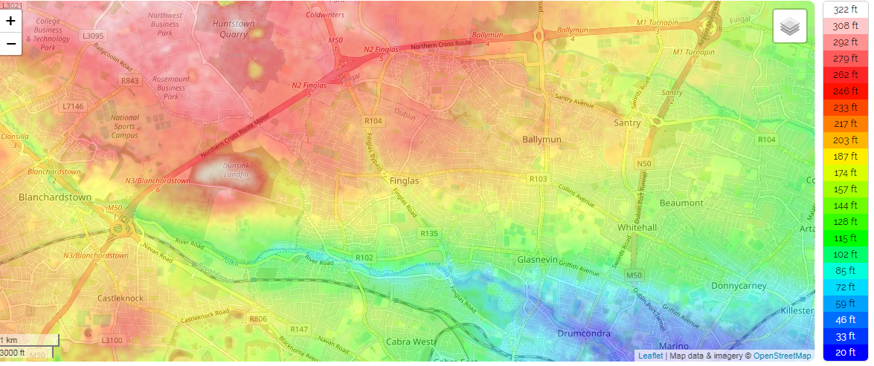
Source: https://en-ie.topographic-map.com/maps/qb/Dublin/

2.5 Water Attenuation
Linked to topography and also ground conditions is the rate at which water is retained within an area. As can be seen in Figure 6.2 below, Finglas has in general a low water retention value, with limited opportunities for water to be held locally, before it reaches the Tolka Valley. Retaining water locally can greatly help to reduce flood and water pollution issues downstream. The darker colours shown on the map represent areas that temporarily store water, slowing down the overland flow and therefore contribute to flood control. The lighter colours indicate areas where water is moving quickly through the environment contributing to flooding risk at the downstream parts of the catchment. All new developments within the City are required to demonstrate how they can reduce the water run-off from each site, preferably through the use of natural water retention measures.

Water Retention

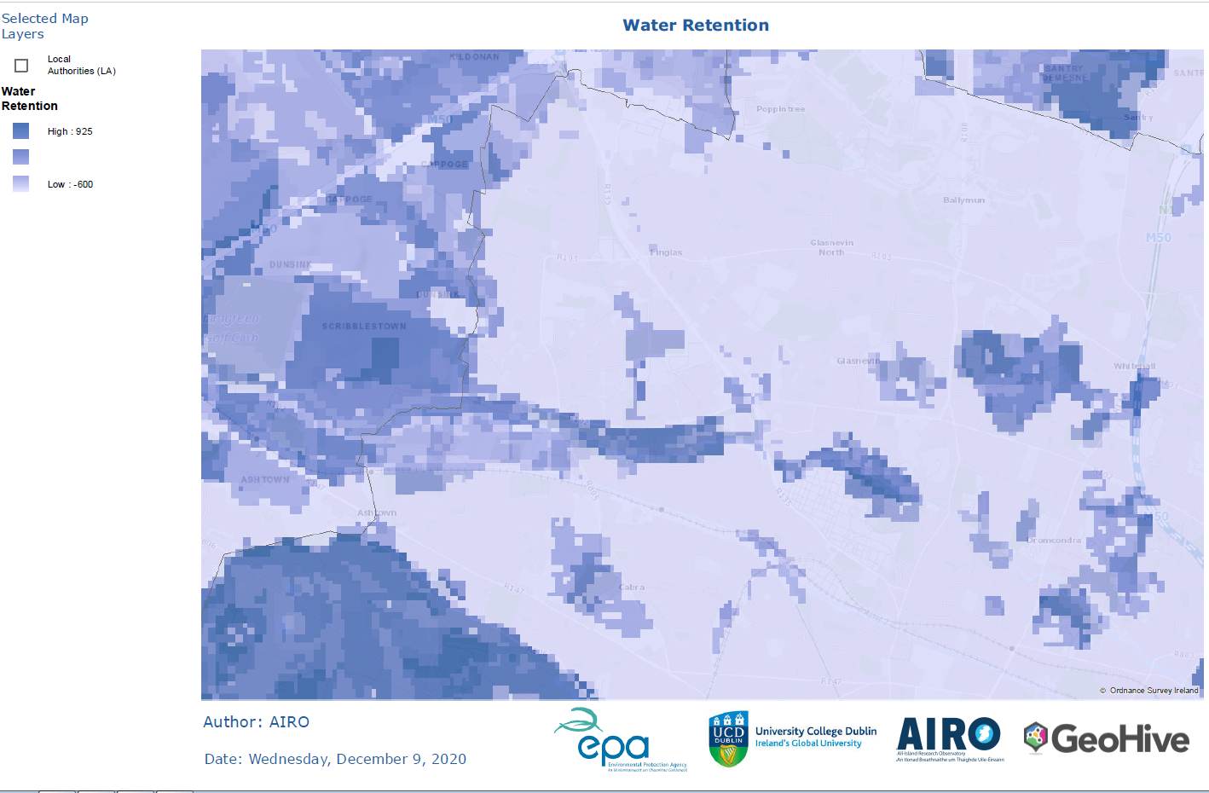

Source: National Parks and Wildlife Service (2016), GeoHive Directory.

2.6 Groundwater Vulnerability
Groundwater Vulnerability is a term used to represent the natural ground characteristics that determine the ease with which groundwater may be contaminated by human activities. It is based on the concept of whether water and contaminants can move within the subsurface materials (soil and subsoil) and get down to groundwater easily. The vulnerability category assigned to an area is thus based on the relative ease with which infiltrating water and potential contaminants may reach groundwater in a vertical or sub-vertical direction. As all groundwater is hydrologically connected to the land surface, it is the effectiveness of this connection that determines the relative vulnerability to contamination. Groundwater that readily and quickly receives water (and contaminants) from the land surface is considered to be more vulnerable than groundwater that receives water (and contaminants) more slowly, and consequently in lower quantities. Also, the slower the movement and the longer the pathway, the greater is the potential for attenuation of many contaminants.
In areas where water moves quickly or at times of flooding, then higher quantities of contaminants will have access to groundwater. Since water tends to move quickly in Finglas there is a high risk of groundwater contamination. The groundwater vulnerability map published by the Geological Survey of Ireland (GSI) and as shown below in Figure 6.3, shows that most of Finglas has a high to extreme groundwater vulnerability, and as such any development in this area will require a surface water management strategy. The eastern edge of the study area is shown to have low groundwater vulnerability.
Ground Water Vulnerability
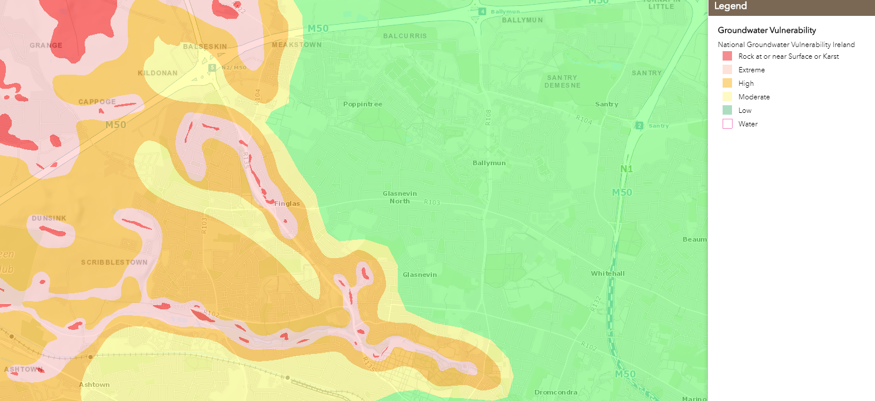
Source: Geological Survey Ireland

3.0 The Planning System and Flood Risk Management
The Planning System and Flood Risk Management: Guidelines for Planning Authorities (the Guidelines), published in 2009, provides a framework for assessing flood risk in the planning process. This Section will outline the definition of risk in terms of its likelihood and consequences and will define the Flood Zones. It will then set out the justification test that is used as a planning tool when considering sites for development.

3.1 Identification of Flood Risk
Flood risk is a combination of the likelihood of a flood event occurring and the potential consequences arising from that flood event. Flood risk can be expressed by the following relationship:

Flood Risk = Probability of Flooding x Consequences of Flooding

To fully assess flood risk an understanding of where the water comes from (i.e. the source), how and where it flows (i.e. the pathways), and the people and assets affected by it (i.e. the receptors) is required. The source-pathway-receptor model below illustrates this.

Source-Pathway-Receptor Model

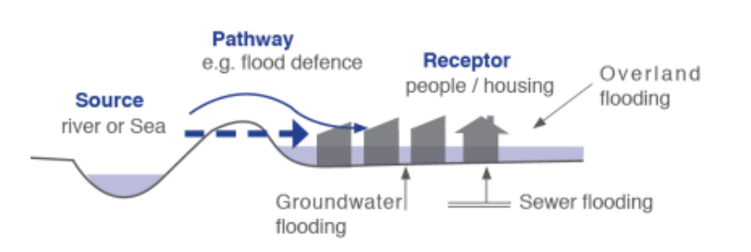

Source: The Planning System and Flood Risk Management: Guidelines for Planning Authorities (2009)

The principal sources of flooding generally are rainfall or higher than normal sea levels. The principal pathways are rivers, drains, sewers, overland flow, and river and coastal floodplains. The receptors can include people, their property, and the environment. All three elements as well as the vulnerability and exposure of receptors must be examined to determine the potential consequences.

The Guidelines set out a staged approach to the assessment of flood risk with each stage carried out only as needed. The stages are listed below:

Stage I Flood Risk Identification – to identify whether there may be any flooding or surface water management issues.

Stage II Initial Flood Risk Assessment – to confirm sources of flooding that may affect an area or proposed development, to appraise the adequacy of existing information, and to scope the extent of the risk of flooding which may involve preparing indicative flood zone maps.

Stage III Detailed Flood Risk Assessment – to assess flood risk issues in sufficient detail and to provide a quantitative appraisal of potential flood risk to a proposed or existing development or land to be zoned, of its potential impact on flood risk elsewhere and the effectiveness of any proposed mitigation measures.

3.2 Likelihood of Flooding
The Guidelines define the likelihood of flooding as the percentage probability of a flood of a given magnitude or severity occurring or being exceeded in any given year. It is generally expressed as a return period or annual exceedance probability (AEP). A 1% AEP flood indicates a flood event that will be equalled or exceeded on average once every hundred years and has a return period of 1 in 100 years. Annual Exceedance probability is the inverse of the return period as shown below.
Probability of Flooding
Return Period (Years) | Annual Exceedance Probability (%)
2 | 50
100 | 1
200 | 0.5
1000 | 0.1

3.3 Consequences of Flooding
The consequences of flooding depend on the hazards caused by flooding (depth of water, speed of flow, rate of onset, duration, water quality) and the vulnerability of receptors (the type of development, nature, presence, and reliability of mitigation measures, etc.).
The Guidelines provide three vulnerability categories, based on the type of development, which are detailed in Table 3.1 of the Guidelines, and are summarised as follows:
- Highly vulnerable: including residential properties, essential infrastructure, and emergency service facilities.
- Less vulnerable: such as retail and commercial and local transport infrastructure.
- Water compatible: including open space, outdoor recreation, and associated essential infrastructure, such as changing rooms.

3.4 Definition of Flood Zones
The Guidelines use flood zones to indicate the likelihood of a flood event occurring. The zones indicate a high, moderate, or low risk of flooding occurring.

It is important to note that the definition of flood zones is based on an undefended scenario and does not consider flood protection measures.

Flood zones only indicate flooding from fluvial and tidal sources and do not consider other sources such as groundwater or pluvial sources.

Zone | Description
Zone A  High Probability of Flooding | This zone defines areas with the highest risk of flooding from rivers (i.e. more than 1% probability or more than 1 in 100) and the coast (i.e. more than 0.5% probability or more than 1 in 200).
Zone B  Moderate Probability of Flooding | This zone defines areas with a moderate risk of flooding from rivers (i.e. 0.1% to 1% probability or between 1 in 100 and 1 in 1000) and the coast (i.e. 0.1% to 0.5% probability or between 1 in 200 and 1 in 1000).
Zone C  Low Probability of Flooding | This zone defines areas with a low risk of flooding from rivers and the coast (i.e. less than 0.1% probability or less than 1 in 1000).

3.5 Sequential Approach & Justification Test
The Guidelines outline a sequential approach to managing flood risk in the planning process. The principles of the sequential approach are illustrated by the following diagram.
Sequential Approach Principles in Flood Risk Management
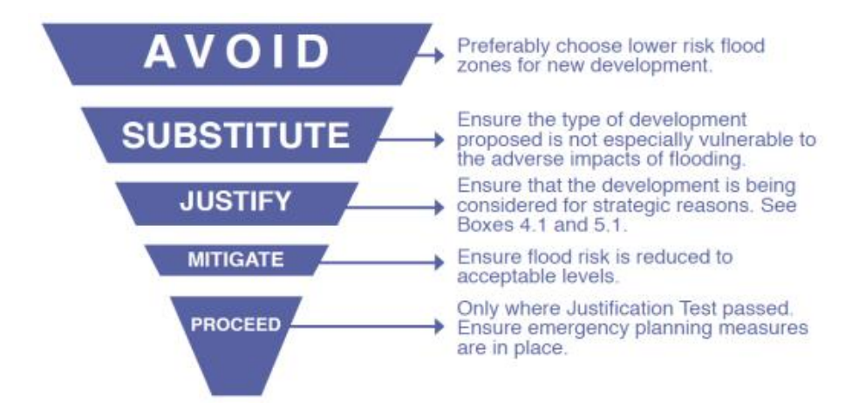
Source: The Planning System and Flood Risk Management: Guidelines for Planning Authorities (2009)

The Justification Test has been designed to rigorously assess the appropriateness, or otherwise, of developments that are being considered in areas of moderate or high flood risk. The test comprises the following two processes.

- The first is the Plan-making Justification Test and is used at the plan preparation and adoption stage where it is intended to zone or otherwise designate land which is at moderate or high risk of flooding.

- The second is the Development Management Justification Test and is used at the planning application stage where it is intended to develop land at moderate or high risk of flooding for uses or development vulnerable to flooding that would generally be inappropriate for that land.
The following table illustrates the matrix of vulnerability as per the Guidelines. The SFRA aims to guide development zonings to those which are 'appropriate' and thereby avoid the need to apply the Justification Test.

Flood Zone Matrix of Vulnerability
 | Flood Zone A | Flood Zone B | Flood Zone C
Highly Vulnerable Development | Justification Test | Justification Test | Appropriate
Less Vulnerable Development | Justification Test | Appropriate | Appropriate
Water-Compatible Development | Appropriate | Appropriate | Appropriate

Source: The Planning System and Flood Risk Management: Guidelines for Planning Authorities (2009)

The lands subject to this proposed variation are situated within Flood Zone C. Having regard to the above and the SFRA that was prepared for the Dublin City Development Plan 2016-2022 (the Development Plan), the proposed re-zoning from Z6 to Z14 is considered appropriate and therefore a justification test is not required.

4.0 Data Collection

4.1 Overview
There are several sources of flood data available for the study area.

4.2 National PFRA Study
The Preliminary Flood Risk Assessment (PFRA) is a national screening exercise that was undertaken by the OPW to identify areas at potential flood risk. The PFRA was a requirement of the EU Floods Directive and this work informed the more detailed Catchment Flood Risk Assessment and Management (CFRAM) studies. As part of the PFRA study, maps of the country were produced showing the indicative fluvial, coastal, and pluvial, and groundwater flood extents.

The PFRA fluvial maps have been superseded by the detailed Eastern CFRAM (Catchment Flood Risk Assessment and Management).

4.3 Eastern CFRAM Study
The National CFRAM study is a more detailed FRA for the key flood risk areas (AFA’s) identified in the PFRA. The subject site is covered by the Eastern CFRAM study area. The CFRAM Studies generated several outputs including:

- Flood maps indicating modelled flood extents and flood zones for a range of flood events of annual exceedance probability (AEP).

- Flood Risk Management Plans (FRMPs) to manage flood risk within the relevant river catchment.

4.4 Dublin City Development Plan 2016 – 2022: Strategic Flood Risk Assessment Volume 7
A Strategic Flood Risk Assessment (SFRA) was prepared as part of the Development Plan. The SFRA informed the strategic land use planning decisions by providing an assessment of all flood risks within Dublin City. The SFRA contains inter-alia, a Composite Flood Map, flood management policies and objectives, and justification Tests. The SFRA was based on historical information such as floodmaps.ie and predictive flood maps sourced from the CFRAM and FloodReslienCity pluvial programmes.

According to the Composite Flood Map for Dublin City, the subject Z6 zoned lands proposed for re-zoning are within Flood Zone C.

4.5 Sources of Flooding
A review of the historical event data and predictive flood information has highlighted several sources of potential flood risk to the area.

4.5.1 Surface Water / Pluvial Flood Risk
Pluvial Flooding results when heavy, often sudden rainfall, causes flooding before it can infiltrate the ground, or enter a natural or man-made drainage system or a watercourse or a conveyance system (e.g. canal) because the system is already full to capacity. Pluvial flooding is associated with storm (surface) water flooding, which is a combination of true pluvial flooding, sewer flooding (due to heavy rainfall), groundwater flooding, and flooding from urban watercourses.
Extracts from the Development Plan Strategic Flood Risk Assessment for pluvial flooding in the study area are illustrated below, showing the main flood risk areas in the vicinity of the local river systems and to the south of the Village. The majority of the Z6 lands subject to proposed variation indicate a low pluvial flood hazard, with smaller areas showing a moderate risk concentrated to the north of the site. It is important to note that this could change if these sites are developed.
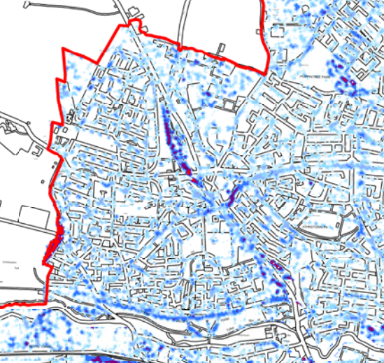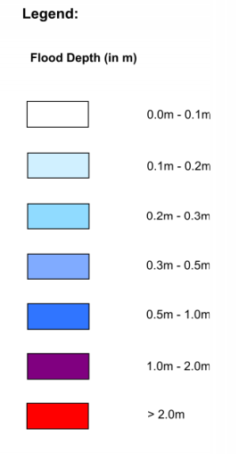
Type 1 Pluvial Flood Depth Map (1% AEP Event – 3 Hr Duration Model, DCDP 2016

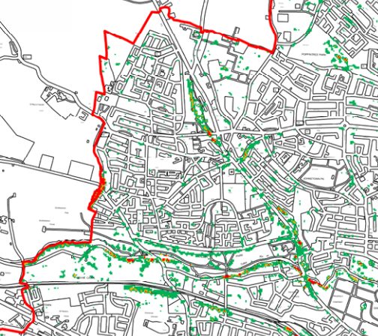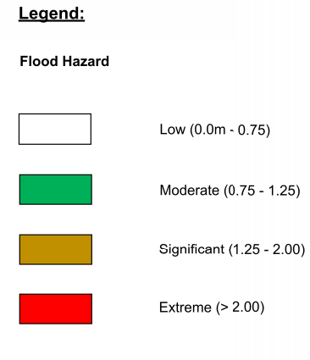
Type 1 Pluvial Flood Hazard Map (1% AEP Event – 3 Hr Duration Model, DCDP 2016

4.5.2 Fluvial or river flooding
Due to the topography and the fast nature at which water flows through the area, the majority of flood events in this area happen within the immediate vicinity of the Tolka River, see information from the OPW Flood maps below. The one exception is a flood event dating from 2011 within Ballygall Crescent and Fairways Green, which predates the installation of the new flood retention measures at Glasanaon Road. No historical events are shown affecting the subject site.
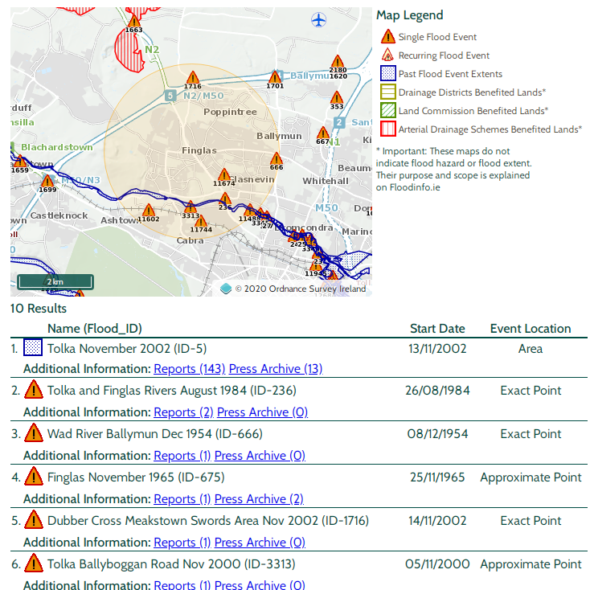
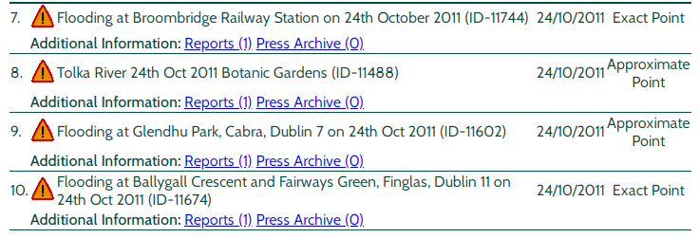
Flood Events. Source: OPW website

4.6 Climate Change

The Planning System and Flood Risk Management guidelines recommend that a precautionary approach to climate change is adopted due to the level of uncertainty involved in the potential effects. Specific advice on the expected impacts of climate change and the allowances to be provided for future flood risk management in Ireland is given in the OPW guidance. This guidance considers two climate change scenarios. These include the Mid-Range Future Scenario (MRFS) and the High-End Future Scenario (HEFS). The MRFS is intended to represent a "likely" future scenario based on the wide range of future predictions available. While the HEFS represents a more "extreme" future scenario at the upper boundaries of future projections.

The OPW recommends the following allowances for climate change, as illustrated below.

Allowances for Future Scenarios
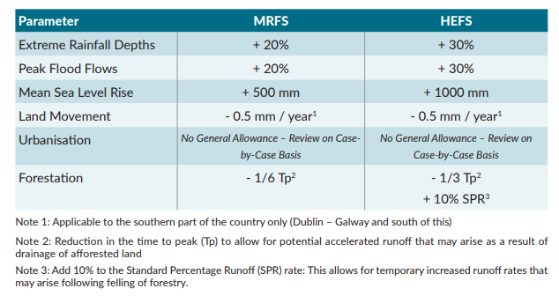
Source: OPW (September 2019) Flood Risk Management Climate Change Sectoral Adaptation Plan

5.0 Flood Risk Management

5.1 Overview
Based on a high-level assessment of the information outlined in the preceding sections, several constraints have been highlighted and can be summarised as follows:
- The existing surface water drainage infrastructure within Finglas would be susceptible to increased pluvial flooding unless the management of new development is carefully managed sustainably through the use of SuDS.
- The Jamestown Industrial estate lands that are proposed for re-zoning and redevelopment will require new surface water sewer infrastructure separating surface water runoff from the combined sewer system. Most of the current drainage network is at or near capacity. An opportunity exists to incorporate green infrastructure and surface water management into the development at an early stage.
- Any future development must take cognisance of the impact on downstream receiving watercourses and groundwater, requiring the implementation of an appropriate SuDS treatment measures.
- Climate change which is estimated to add between 20% and 30% to design rainfall flood events had to be taken into account in the surface water management of all future proposed developments.

5.2 Recommendations for Managing Flood Risk
The Guidelines recommend a sequential approach to spatial planning, promoting avoidance rather than justification and subsequent mitigation of risk. As identified, the lands subject to this proposed variation are situated within flood zone C, and thus have a low risk associated with fluvial flooding and therefore, the justification test is not required. Having regard to the aim to transform this underutilised land bank into a sustainable, mixed-use community, there is an opportunity to manage surface water, through green infrastructure, having regard to the impact any future development may have on watercourses downstream.

Recommended Objectives

No. | Objectives
1 | Ensure that the future development of the lands is in accordance with the key principles of the Planning System and Flood Risk Management Guidelines.
2 | An Integrated Surface Water Management Strategy for the entire development lands shall be prepared to inform the Masterplan to ensure necessary public surface water infrastructure is in place to service new development and shall include a modelling exercise to determine the extent of existing flood zones.
3 | Future developments on the subject lands shall allow for the control of outflow to the River Tolka, with surface water discharges limited to 0-2l/s/ha for the 1 in 100-year storm event, including an additional 20-30% to allow for climate change.
4 | A site-specific Flood Risk Assessment shall accompany all proposed developments at the planning application stage.
5 | Existing open watercourses shall be retained with an appropriate riparian zone to be provided.

Recommendations for Managing Surface Water
The management of surface water within the subject lands should be such that there is no increased risk of flooding downstream, due to increased surface water generated by any proposed development. Additionally, the management of surface water would have to adhere to the requirements of the Greater Dublin Strategic Drainage Study (GDSDS). As such a Surface Water Management Strategy should be prepared for the subject site, to ensure that any future development is sustainable and introduces best practice in terms of SuDS and Green Infrastructure.

5.3.1 Recommended Objectives

No. | Objectives
1 | An Integrated Surface Water Management Strategy for the entire development lands shall be prepared to inform the Masterplan to ensure necessary public surface water infrastructure is in place to service new development.
2 | All surface water on the subject lands shall be managed utilising the SuDS Treatment Train.
3 | A Green Infrastructure Strategy for the entire development lands shall be prepared to inform the Masterplan.
4 | SuDS features shall be incorporated into the public realm and street network and within public open spaces.
5 | Explore opportunities to de-culvert the Finglas River (branch stream) as it runs through the subject lands and to provide an appropriate riparian zone.

Including but not exclusively SDRA 17 (650-700), SDRA 12 (over half of 800-1,000), SDRA 4 (LAP had reduced this area, less than half likely of 2,000) to be implemented during the Plan lifetime. Also taken into account are Variations 8-22 which added just under 35 ha of residential and mixed use lands across a range of smaller infill sites.

