APPROPRIATE ASSESSMENT SCREENING IN ACCORDANCE WITH THE REQUIREMENTS OF ARTICLE 6(3) OF THE EU HABITATS DIRECTIVE FOR THE PROPOSED VARIATION OF THE DUBLIN CITY DEVELOPMENT PLAN 2016-2022 – NORTH GREAT GEORGE’S STREET & ENVIRONS, DUBLIN 1 - ARCHITECTURAL CONSERVATION AREA.

INTRODUCTION:
This is an Appropriate Assessment screening of a proposed variation of the Dublin City Development Plan 2016-2022 in accordance with the requirements of Article 6(3) of the EU Habitats Directive (92/43/EEC) in relation to the designation of North Great George’s Street & Environs, Dublin 1 (as shown on the attached map) as an Architectural Conservation Area. This report has been prepared by the Planning and Development Department of Dublin City Council.

ASSESSMENT METHODOLOGY:
The methodology for the screening assessment process follows Appropriate Assessment for Plans and Projects in Ireland: Guidance for Planning Authorities, which was issued by the Department of the Environment, Heritage and Local Government in 2009 (revised 10/02/10). This methodology also applies elements of good practice as set down by the following documents:

- Department of the Environment Heritage and Local Government (DoEHLG) Circular letter SEA 1/08 and NPWS 1/08.

- Managing Natura 2000 Sites. The provisions of Article 6, of the ‘Habitats’ Directive 92/43/EEC. (2000) European Commission.

- Assessment of plans and projects significantly affecting Natura 2000 sites Methodological guidance on the provision of Article 6(3) and (4) of the Habitats Directive 92/43/EEC. (2002) European Commission.

- Department of the Environment Heritage and Local Government (DoEHLG) Circular letter NPWS 1/10 and PSSP 2/10.

The screening methodology applied in the case of the proposed variation of the Dublin City Development Plan 2016-2022 has followed the approach advised within the EC and DoEHLG guidance. The structure of the screening process is as follows:

- Describing the nature of the proposed variation.

- Identifying the relevant Natura 2000 sites that could be affected by the proposed variation.

- Predicting any likely effects – direct, indirect and cumulative – undertaken on the basis of available information as a desk study.

- Conclusion on the likelihood of significant environmental effects.

SCREENING MATRIX:

BRIEF DESCRIPTION OF PROJECT OR PLAN
The proposal is a statutory variation of the Dublin City Development Plan 2016-2022 in relation to the designation of North Great George’s Street & Environs, Dublin 1 (as shown on the attached map) as an Architectural Conservation Area.
The area sited within the solid red line will be designated an Architectural Conservation Area:
An Architectural Conservation Area seeks to preserve the character of a place, area, group of structures or townscape that is of special architectural, historical, archaeological, artistic, cultural, scientific, social or technical interest or value or contributes to the appreciation of protected structures.

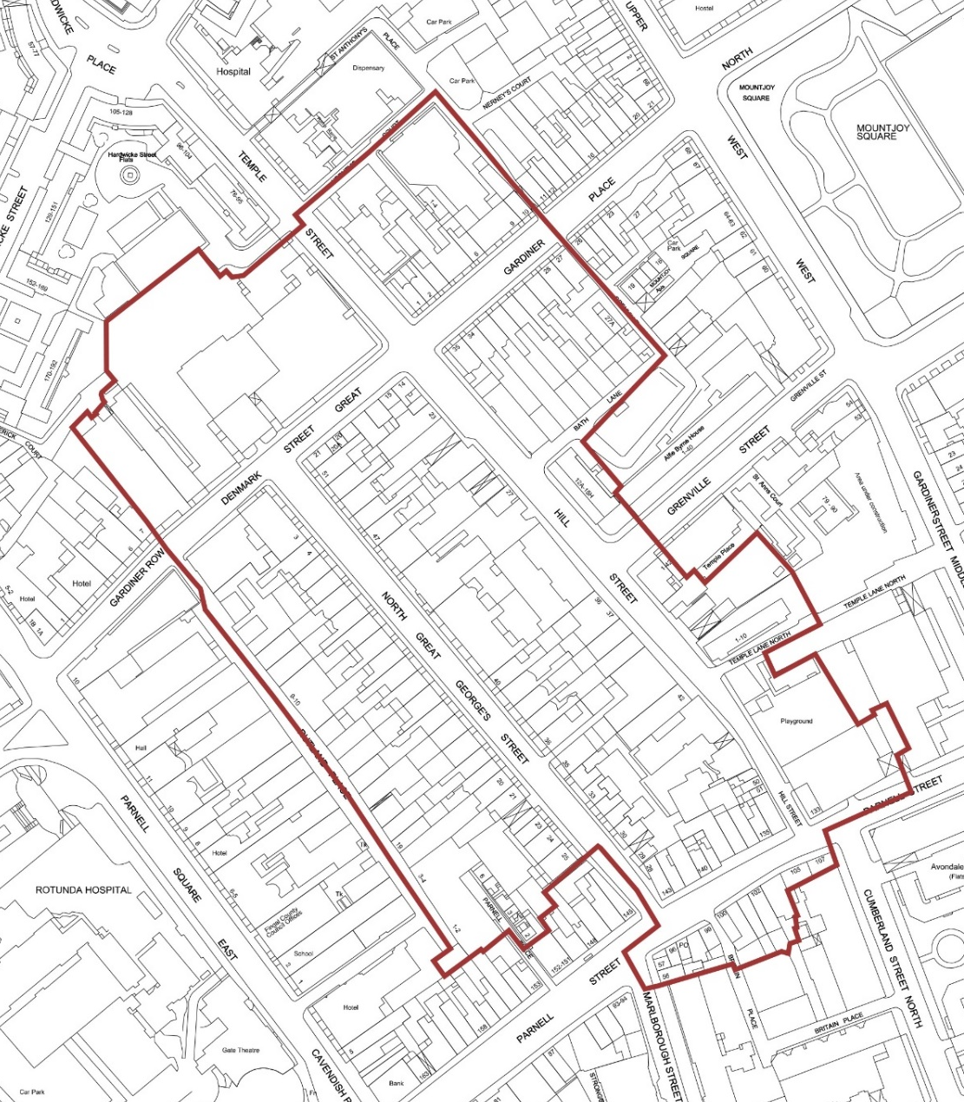

BRIEF DESCRIPTION OF THE NATURA 2000 SITES
The principle trigger for undertaking an ‘Appropriate Assessment’ or screening for Appropriate Assessment would be if the variation was likely to have significant effects on a Natura 2000 site. For the purposes of Article 6 Assessments, Natura 2000 sites are those identified as Sites of Community Importance under the Habitats Directive, or classified as Special Protection Areas under the Birds Directive (79/409/EEC). There are no Natura 2000 sites in the variation area. The closest Natura 2000 sites are North Dublin Bay cSAC approximately 10km’s to the east and Sandymount Strand/Tolka Estuary SPA approximately 10 km’s to the south east. The Natura 2000 sites within the wider vicinity of the variation area are as follows:

candidate Special Areas of Conservation

South Dublin Bay cSAC (000210):
c.11km from variation area.
Do any potential source-pathway-receptor links exist between the proposed variation area and the Natura 2000 sites?
No significant linkage.

North Dublin Bay cSAC (000206):
c.10km from variation area.
Do any potential source-pathway-receptor links exist between the proposed variation area and the Natura 2000 sites?
No significant linkage.

Irelands Eye cSAC (02193):
c.14km from variation area.
Do any potential source-pathway-receptor links exist between the proposed variation area and the Natura 2000 sites?
No significant linkage.

Baldoyle Bay cSAC (01999):
c.12km from variation area.
Do any potential source-pathway-receptor links exist between the proposed variation area and the Natura 2000 sites?
No significant linkage.

Rye Water Valley / Carton cSAC (001398):
c.23km from variation area.
Do any potential source-pathway-receptor links exist between the proposed variation area and the Natura 2000 sites?
No significant linkage.

Glenasmole Valley cSAC (1209):
c.17km from variation area.
Do any potential source-pathway-receptor links exist between the proposed variation area and the Natura 2000 sites?
No significant linkage.

Wicklow Mountains cSAC (2122):
c.14km from variation area.
Do any potential source-pathway-receptor links exist between the proposed variation area and the Natura 2000 sites?
No significant linkage.

Special Protection Areas

Sandymount Strand/Tolka Estuary SPA (004024):
c.10 km from variation area.
Do any potential source-pathway-receptor links exist between the proposed variation area and the Natura 2000 sites?
No significant linkage.

North Bull Island SPA (004006):
c.10 km from variation area.
Do any potential source-pathway-receptor links exist between the proposed variation area and the Natura 2000 sites?
No significant linkage.

Malahide Estuary SPA (004025)
c.18km from variation area.
Do any potential source-pathway-receptor links exist between the proposed variation area and the Natura 2000 sites?
No significant linkage.

Dalkey Island SPA (004122):
c.17km from variation area.
Do any potential source-pathway-receptor links exist between the proposed variation area and the Natura 2000 sites?
No significant linkage.

Wicklow Mountains SPA (002122):
c.20 km from variation area.
Do any potential source-pathway-receptor links exist between the proposed variation area and the Natura 2000 sites?
No significant linkage.

Baldoye Bay SPA (004016):
c.14km from variation area.
Do any potential source-pathway-receptor links exist between the proposed variation area and the Natura 2000 sites?
No significant linkage.

All other designated sites have been excluded from the lists above due to distance, but sites within the wider area are illustrated in the map below.

Proposed Variation Designation of North Great George’s Street & Environs as an Architectural Conservation Area

ASSESSMENT CRITERIA
Describe any likely direct, indirect or secondary impacts of the project (either alone or in combination with other plans or projects) on the Natura 2000 site by virtue of:

There is no Natura 2000 site located in the proposed variation area. There are no likely cumulative, direct or indirect impacts on any Natura 2000 sites as a result of the proposed variation given the nature of the designation and the separation distances involved. In ecological and environmental impact assessment, for an impact to occur there must be a risk enabled by having a ‘source’ (e.g. construction works at a proposed development site), a ‘receptor’ (e.g. a SAC or other ecologically sensitive feature), and a pathway between the source and the receptor (i.e. a watercourse which connects the proposed variation area to the SAC). Where a pathway exists, but the magnitude of the potential impact generated at the source is sufficiently small, the pathway can be ruled out.

An Appropriate Assessment was carried out at all stages of the Development Plan in order to ensure that its policies and objectives do not result in significant adverse impacts on the integrity of any of the identified Natura 2000 sites.

Size and scale;
The proposed variation consists of circa 7.29 ha of zoned land in an established historic urban area. New development will be integrated into the established urban pattern and is not predicted to have any likely impact on the conservation function of any Natura 2000 site in respect to size or scale.

Land-take;
Not applicable

Distance from Natura 2000 site or key features of the site;
The nearest Natura 2000 site is in the order of approximately 8km distant from the proposed variation area. The proposed variation is not predicted to have any likely impact on the key features or the conservation function of any Natura 2000 sites.

Resource requirements (water abstraction etc);
Resource supply, including potable water, will be provided from existing municipal infrastructure. Any potential indirect or secondary impact on the conservation function of any Natura 2000 site as a result of increased population equivalent (P.E.) demand for potable water supply will be subject to a separate higher level Appropriate Assessment/Strategic Environmental Assessment (SEA) at regional level.

Emission (disposal to land, water or air);
No predicted likely direct impact on the conservation function of any Natura 2000 site is predicted as a result of the implementation of the proposed variation. The most likely potential indirect or secondary impact on a Natura 2000 site is by way of effluent discharge from the Ringsend waste water treatment plant which serves the entire Dublin region to Dublin Bay. Any future planning permission will be subject to conditions to ensure disposal to land, water and air has no impact on any Natura 2000 site. In addition, there is a commitment under the Dublin City Development Plan 2016–2022 to “To support and facilitate Irish Water to ensure the upgrading of wastewater infrastructure, in particular the upgrading of the Ringsend Wastewater Treatment Plant” (Policy SI2). It is also an objective of the Eastern River Basin District Management Plan to achieve good water status in the Liffey Estuary by 2027.

Excavation requirements;
Not applicable

Transportation requirements;
Not applicable

Duration of construction, operation, decommissioning, etc;
Not applicable

Other
None

DESCRIBE ANY LIKELY CHANGES TO THE SITE ARISING AS A RESULT OF:

Reduction of habitat area:
Not applicable

Disturbance to key species:
Not applicable

Habitat or species fragmentation:
Not applicable

Reduction in species density:
Not applicable

Changes in key indicators of conservation value:
Not applicable

Climate change:
Not applicable

DESCRIBE ANY LIKELY IMPACTS ON THE NATURA 2000 SITE AS A WHOLE IN TERMS OF:

Interference with the key relationships that define the structure of the site;
No predicted likely impact on the conservation function of any Natura 2000 sites.

Interference with key relationships that define the function of the site;
No predicted likely impact on the conservation function of any Natura 2000 sites.

PROVIDE INDICATORS OF SIGNIFICANCE AS A RESULT OF THE IDENTIFICATION OF EFFECTS SET OUT ABOVE IN TERMS OF:
Loss;
Not applicable

Fragmentation;
Not applicable.

Disruption;
Not applicable

Disturbance;
Not applicable
Change to key elements of the site (e.g. water quality etc);
Not applicable

DESCRIBE FROM THE ABOVE THOSE ELEMENTS OF THE PROJECT OR PLAN, OR COMBINATION OF ELEMENTS, WHERE THE ABOVE IMPACTS ARE LIKELY TO BE SIGNIFICANT OR WHERE THE SCALE OR MAGNITUDE OF IMPACTS ARE NOT KNOWN.
No predicted likely impact on the conservation function of any Natura 2000 sites.

FINDING OF NO SIGNIFICANT EFFECTS MATRIX
NAME OF PROJECT OR PLAN:
Proposed Variation of Dublin City Development Plan 2016-2022 – Designation of North Great George’s Street & Environs as an Architectural Conservation Area.

NAME AND LOCATION OF NATURA 2000 SITES
No Natura 2000 sites are located in the proposed variation area. Natura 2000 sites in the wider vicinity of the proposed variation area are provided above.

DESCRIPTION OF THE PROJECT OR PLAN
As provided in the screening matrix above.

IS THE PROJECT OR PLAN DIRECTLY CONNECTED WITH OR NECESSARY TO THE MANAGEMENT OF THE SITE (PROVIDE DETAILS)?
No

ARE THERE OTHER PROJECTS OR PLANS THAT TOGETHER WITH THE PROJECT OR PLAN BEING ASSESSED COULD AFFECT THE SITE (PROVIDE DETAILS)?
The draft variation provides for the sustainable development of developed and brownfield urban land in accordance with the Dublin City Development Plan 2016-2022 and the principles of proper planning and development. There are no interactions identified with other plans or projects that together with the proposed variation could affect the sites.

THE ASSESSMENT OF SIGNIFICANCE OF EFFECTS

Describe how the project or plan (alone or in combination) is likely to affect the Natura 2000 sites:
No significant effects identified.

Explain why these effects are not considered significant:
No effects have been identified.

List of Agencies Consulted:

The Manager, Development Applications Unit, Department of Housing, Planning and Local Government, Dun Sceine, Harcourt Lane, Dublin 2. Telephone: 01 833 3190

Co-Ordination Unit, Department of Environment, Climate and Communications, Leeson Lane, Dublin 2 Telephone: 01 678 3051, CorporateSupport.Unit@DCCAE.gov.ie

Mr. Tadhg O’Mahony, Senior Scientific Officer, SEA Section Office of Environmental Assessment, Environmental Protection Agency, Inniscarra, County Cork. Telephone: 021 4860818

________________________________________________________________________________
Response to Consultation:
A response to the consultation was received from the EPA on 27th October 2020. The EPA raised the following observation:
• Ensure that the Variation complies with the requirements of the Habitats Directive where relevant. Where Appropriate Assessment is required, the key findings and recommendations should be incorporated into the SEA and the Variation.
• Refers to the EPA’s AA GeoTool which allows users to a select a location, specify a search area and gather available information for each European Site within the area.
This observation was taken on board by Dublin City Council in the finalisation of this AA screening report.

DATA COLLECTED TO CARRY OUT THE ASSESSMENT
Who carried out the Assessment?
Planning and Economic Development Department
Dublin City Council

Sources of Data
As part of the Appropriate Assessment screening process for the proposed variation, particular reference has been made to the following documents:
- Managing Natura 2000 sites. The provisions of Article 6, of the ‘Habitats’ Directive 92/43/CEE.
- Department of the Environment Heritage and Local Government (DoEHLG) circular letter SEA 1/08 and NPWS 1/08.

- Department of the Environment Heritage and Local Government (DoEHLG) Circular letter NPWS 1/10 and PSSP 2/10.
- Department of Environment, Heritage and Local Government (DoEHLG). Appropriate Assessment of Plans and Projects in Ireland, Guidance for Planning Authorities.
- Directive 2000/60/EC of the European Parliament and of the Council establishing a framework for the Community action in the field of water policy.
- Natura Impact Report of the Dublin City Development Plan 2016-2022.
- Eastern River Basin Management Plan.
- Greater Dublin Strategic Drainage Study.
- The Planning System and Flood Risk Management Guidelines for Planning Authorities.
- Existing NPWS Data.
- Assessment of plans and projects significantly affecting Natura 2000 sites Methodological guidance on the provision of Article 6(3) and (4) of the Habitats Directive 92/43/EEC. (2002) European Commission.

Level of Assessment Completed
Desktop Study

Where can the full results of the assessment be accessed and viewed?
This document contains the full results of the Appropriate Assessment Screening exercise and will be placed on display with the proposed variation.

Overall Conclusion
Stage 1 screening indicates that the proposed variation will not have any significant cumulative, direct or indirect impacts upon any of the Natura 2000 sites. Therefore it is not considered necessary to undertake any further stages of the Appropriate Assessment process.

Proposed Draft Variation of the
Dublin City Development Plan 2016-2022

It is proposed to initiate the procedures for the variation of the
Dublin City Development Plan 2016-2022 by Designating North Great George’s Street & Environs as an Architectural Conservation Area.

Proposed ACA shown as solid black line.

