To the Lord Mayor and Report No. 171/2023
Members of Dublin City Council Report of the Chief Executive

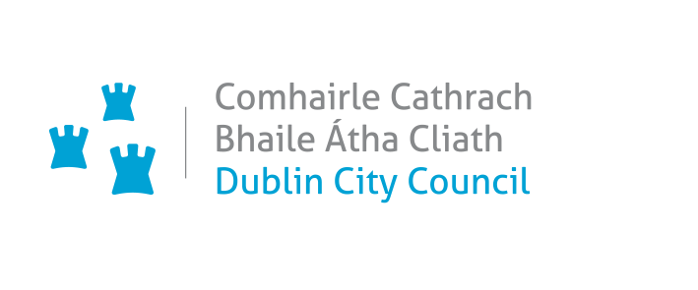_________________________________________________________________________
Proposed Variation (No. 1) Of The Dublin City Development Plan 2022 – 2028

Proposed Variation of the Dublin City Development Plan 2022-2028: Site at Basin View, Dublin 8
_________________________________________________________________________

Executive Summary

The Variation
The variation seeks to vary the Dublin City Development Plan 2022-2028 to reorder the land use zoning of the lands at Basin View, Dublin 8 from Z1 (Sustainable Residential Neighbourhoods) and Z9 (Amenity/Open Space Lands/Green Network) to Z9 (Amenity/Open Space Lands/Green Network) and Z1 (Sustainable Residential Neighbourhoods).

The Purpose of the Variation
The area encompassing the two variation sites will be the subject of a significant scale regeneration project, providing high quality new housing and a new public park. The purpose of the variation is to allow a new design and footprint for the housing, and a re-positioning of Oisín Kelly Park so that it serves better the residents of the regenerated housing and the wider public within the community. This re-positioning will also allow for a less disruptive approach to the regeneration of the site, by facilitating construction in a phased manner. The size of both plots are almost identical; and this proposed change will not result in the loss of any Z9 lands to this area. It will however, ensure that the open space provided in this street block is significantly upgraded and will provide a high quality amenity space for the community.

Submissions
In total 13 submissions were received, mostly from public bodies and local residents including the Office of the Planning Regulator, the Environmental Protection Agency (EPA), the Eastern and Midland Regional Assembly and Basin Street Residents Regeneration Committee.

Issues Raised
The majority of submissions welcome the proposed variation and acknowledge that it will facilitate the successful delivery of a social housing regeneration project. A number of submissions were received from local residents and community groups welcoming the regeneration project, some submissions object to the proposed variation on the basis that wider public consultation is needed regarding the design and use of the proposed open space area and a submission objects to the proposed phasing of the regeneration project due to lack of community consultation and decanting of the existing blocks.

Response
Allowing the reordering the zoning on this site will facilitate the successful delivery of the overall development, comprising of a new mixed tenure housing development, improved permeability east to west and north to south, a new Oisín Kelly Park in line with the Dublin City Council Parks Strategy 2019 and overall enrichments to the public realm. The lands form part of Strategic Development and Regeneration Area 15 (Liberties and Newmarket Square) (SDRA 15), which is an area identified as having considerable regeneration potential in the Dublin City Development Plan 2022-2028. Any residential development of the site the subject of the proposed variation will be subject to a separate planning application process at which stage issues including the detailed design and use of the open space will be fully addressed. In terms of phasing of the project, this will be carried out according to construction management requirements and decanting of the existing blocks will be carried out in consultation with the residents.

Proposal

It is proposed to vary the Dublin City Development Plan 2022-2028 to reorder the land use zoning of the subject lands at Basin View, Dublin 8;
From:
Zoning Objective Z1 - To protect, provide and improve residential amenities
and
Zoning Objective Z9 - To preserve, provide and improve recreational amenity, open space and ecosystem services

To:
Zoning Objective Z9 - To preserve, provide and improve recreational amenity, open space and ecosystem services
and
Zoning Objective Z1 - To protect, provide and improve residential amenities,

The proposed draft variation areas are delineated on the attached map.

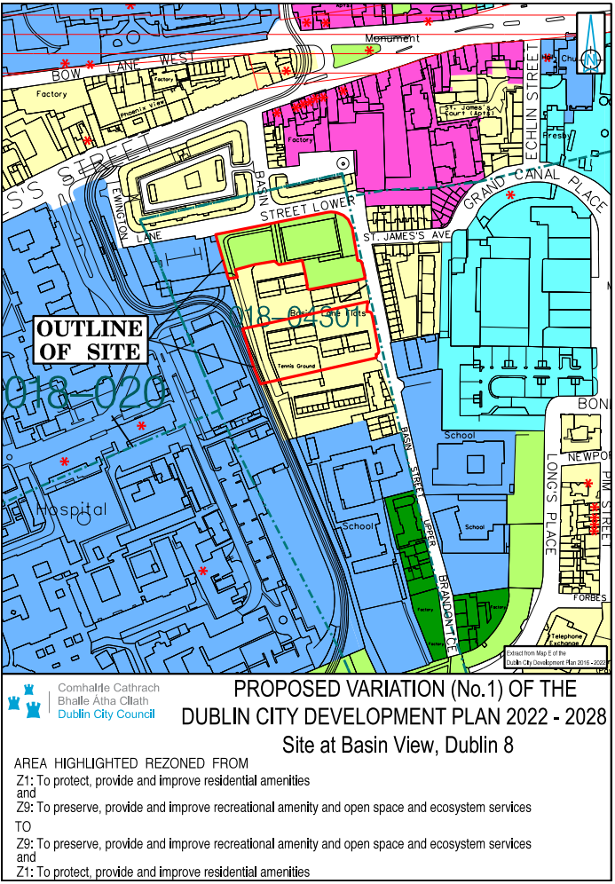

The Variation
The variation seeks to vary the Dublin City Development Plan 2022-2028 to reorder the land use zoning of the lands at Basin View, Dublin 8 from Z1 (Sustainable Residential Neighbourhoods) and Z9 (Amenity/Open Space Lands/Green Network) to Z9 (Amenity/Open Space Lands/Green Network) and Z1 (Sustainable Residential Neighbourhoods).

Procedure Followed
Public Notice and Public Display
Members of the public were invited to make submissions regarding the Proposed Draft
Variation. In accordance with the procedures set out in the Planning and Development Acts
2000 as amended, the proposed variation was placed on public display from Thursday 15th June to Friday 14th July 2023 inclusive and a public notice was inserted into a national newspaper.

Copies of the Proposed Draft Variation, together with the SEA and AA screening reports and Strategic Flood Risk Assessment, were made available for inspection at the Civic Offices, Wood Quay, Dublin 8 and at the South Central Area Office, Eblana House, Marrowbone Lane, Dublin 8, within the above listed dates. Details were also available on the City Council’s website at www.dublincity.ie.

Strategic Environmental Appraisal
The Planning Authority determined, using the screening criteria set out in Schedule 2A Planning and Development Regulations 2001 as amended, that the proposed Variation (No. 1) would not be likely to have significant effects on the environment, taking account of relevant criteria set out in Schedule 2A of the Planning and Development Regulations, 2001, as amended.

Appropriate Assessment Screening
An Appropriate Assessment (AA) screening determination has been made by Dublin City Council (in compliance with Section 177U of the Planning and Development Act 2000 as amended) regarding the proposed Variation. The Stage 1 Screening determines that Appropriate Assessment of the Proposed Variation is not required as the proposal, individually or in combination with other plans or projects will not have a significant effect on a European site.

The prescribed bodies were notified of the above determinations in relation to SEA and AA and no objections to the conclusions were received within the appropriate period.

Purpose of the Proposed Variation
The Planning Authority considers that it is appropriate to reorganise the land use zoning of the lands at Basin View, Dublin 8 from Z1 (Sustainable Residential Neighbourhoods) and Z9 (Amenity/Open Space Lands/Green Network) to Z9 (Amenity/Open Space Lands/Green Network) and Z1 (Sustainable Residential Neighbourhoods) on foot of a request from the Housing Department of the Council. The purpose and rationale of this proposed variation is set out below.

The Basin Street Flats site was selected for inclusion in the Social Housing Public Private Partnership (PPP) Programme, which is a partnership between the Department of Housing, Local Government and Heritage (DoHLGH), local authorities, the National Development Finance Agency and a specially formed Project Company to deliver new social housing units. The DoHLGH have approved in principle the site at Basin View, which is the first site to be regenerated under this programme and where 100-170 units are to be constructed.

The area encompassing the two variation sites will be the subject of a significant scale regeneration project, providing high quality new housing and a new public park. The purpose of the variation is to allow a new design and footprint for the housing, and a re-positioning of Oisín Kelly Park so that it serves better the residents of the regenerated housing and the wider public within the community. This re-positioning will also allow for a less disruptive approach to the regeneration of the site, by facilitating construction in a phased manner. The size of both plots are almost identical; and this proposed change will not result in the loss of any Z9 lands to this area. It will however, ensure that the open space provided in this street block is significantly upgraded and will provide a high quality amenity space for the community.

Allowing the reordering the zoning on this site will facilitate the successful delivery of the overall development, comprising of a new mixed tenure housing development; improved permeability east to west and north to south; a new Oisín Kelly Park in line with the Dublin City Council Parks Strategy 2019 and overall enrichments to the public realm.

The lands are located within the St. James Harbour Character Area of SDRA 15 Liberties and Newmarket Square, an area which has considerable regeneration potential with both private and public land holdings of considerable scale. Connectivity and green infrastructure initiatives are identified in the SDRA, including improved public open space at Oisín Kelly Park and new east-west permeability interventions between the St. James’ Hospital grounds and Basin View, which are required in order to improve the amenity for existing and future residents and to better integrate the area with its adjoining institutions and neighbourhoods.

A brief planning profile of the proposed variation site is as follows:
There are;
- no Natura 2000 sites on or beside the variation site
- no NHA (Natural Heritage Area) or a proposed NHA on or beside the variation site and,
- no significant flooding issues as identified in the accompanying SFRA statement to this variation documentation, which classifies the site as Flood Zone C (with a low probability of flooding) suitable for a vulnerable use such as housing without the need for a justification test, all as per the Section 28 Guidelines on Flooding 2009, as amended.
The site is located within a zone of archaeological interest associated with St. James’s Walk Watercourse (DU018-04301).

It is therefore considered appropriate to seek to reorder the land use zoning of the subject lands at Basin View, Dublin 8 to Z1 (Sustainable Residential Neighbourhoods) and Z9 (Amenity/Open Space Lands/Green Network) for the following reasons:
- Oisín Kelly Public Park is currently underutilised by the general public with anti-social behaviour along the access streets Basin Street Lower and Basin View;
- Improved permeability along the public park to facilitate desirable connections with the surrounding area and provide clear, safe public streets;
- The area of park will open up a north-south connection alongside the Luas line and Basin Street Lower to cater for pedestrians;
- Improved permeability also opens up an east-west connection that allows St. James’s hospital usage of the public park and connection through the new Basin View development to Grand Canal Harbour and Bond Street;
- Clearly defines the flow and separation of the spaces between public; semi-public and private areas.
- Provides housing within enclosed urban blocks, making defensible amenity courtyard spaces thus enabling passive supervision of public open spaces and prevention of anti-social behaviour.
- Use of the redevelopment as an opportunity to improve public realm and surrounding streets to better integrate the scheme with its neighbourhood and support the Council’s wider regeneration strategies.
- The reordering of the zoning will provide a simpler phasing strategy, lower overall development costs and provides a feasible scheme that will regenerate this area of the city.
- Extension of amenity/recreational spaces in association with the linear park along St James Hospital.
- Existing area of Z9 land zoning (0.422 ha) is equal to the proposed Z9 land zoning (0.422 ha).

It is noted that there also have been significant improvements made and planned in the delivery of new public open space and upgraded open space in the wider area in the recent past, including Weaver Park, Bridgefoot Street, St Luke’s, St. Audeon’s Park, St Teresa’s Gardens and St. James's Linear Park.

Report on Submissions and observations

3.1 List of Submissions Received
The following persons or bodies made submissions or observations in relation to the proposed variation of the Development Plan.
- Environmental Protection Agency (EPA)
- Uisce Éireann / Irish Water
- Gary Mackin
- TII
- Department of Transport
- Office of Public Works
- Office of the Planning Regulator
- Eastern and Midland Regional Assembly
- Sporting Liberties
- Damien Farrell
- Mary Darcy Fox
- Christopher Kavanagh
- Basin Street Residents Regeneration Committee

3.2 Submission by the Office of the Planning Regulator (OPR)

Summary of Submission
The OPR acknowledges at the outset that the proposed Variation will facilitate the successful delivery of a social housing regeneration project, and that reordering the zoning is necessary to: provide a simpler phasing strategy; lower overall development costs; and provide a feasible regeneration scheme. The OPR also acknowledges that the proposed Variation will facilitate the delivery of an improved public park and improved east to west and north to south permeability in the area. The OPR notes that the subject land forms part of Strategic Development and Regeneration Area 15 (Liberties and Newmarket Square) (SDRA 15), which is an area identified as having considerable regeneration potential in the Dublin City Development Plan 2022-2028 (the Development Plan) and the RSES for the EMRA area. The OPR state that the proposed Variation will facilitate the delivery of 100-170 housing units in an area targeted for regeneration consistent with the core strategy of the Development Plan and objective CSO7. The OPR considers that the proposed Variation is generally consistent with the guiding principles relating to Key Opportunity Site 7 in Chapter 13 of the Development Plan. The OPR’s evaluation and assessment of the proposed Variation concludes that no recommendations or observations are warranted.

Chief Executive’s Response
The OPR’s evaluation and assessment of the proposed Variation is noted.

Recommendation
Submission is noted; no change recommended.

3.3 Submission by the Eastern and Midland Regional Assembly

Summary of Submission
The Eastern and Midland Regional Assembly (EMRA) considers that the proposed Variation is consistent with the Regional Spatial and Economic Strategy (RSES) 2019-2031 and acknowledges in principle the proposed Variation to the Dublin City Development Plan 2022-2028, which aligns planning policy at county and local levels with Regional and National Policy.

Chief Executive’s Response
EMRA’s acknowledgement of the proposed Variation is noted.

Recommendation
Submission is noted; no change recommended.

3.4 Submission by the Office of the Environmental Protection Agency (EPA)

Summary of Submission
The Environmental Protection Agency (EPA) advocate consistency with higher level plans/ programmes, infrastructure-led development and alignment with national commitments on climate change mitigation and adaption. The agency highlights the environmental and climate change policy context of the proposed Variation and provides guidance on the procedures for carrying out an SEA Screening determination.

Chief Executive’s Response
The Chief Executive notes the submission by the EPA and the policy context and guidance that the agency has provided.

Recommendation
Submission is noted; no change recommended.

3.5 Submission by the Department of Transport

Summary of Submission
The Department of Transport notes the proposed Variation, welcomes the planned permeability measures aimed at improving access to and for pedestrians in the area and states that it should be noted that the provision of infrastructure for Active Travel, both walking and cycling, should be one of the main considerations of any development, particularly in urban areas.

Chief Executive’s Response
The content of the submission is noted.

Recommendation
Submission is noted; no change recommended.

3.6 Submission by Uisce Éireann / Irish Water

Summary of Submission
Uisce Éireann state that they have no objection to the proposed Variation and make a number of comments in relation to the general regeneration of the area which may impact on below ground infrastructure including that where planned development may impact on Uisce Éireann assets, early engagement is requested to ensure public water services are protected and access is maintained.

Chief Executive’s Response
The content of the submission is noted.

Recommendation
Submission is noted; no change recommended.

3.7 Submission by Transport Infrastructure Ireland

Summary of Submission
Transport Infrastructure Ireland (TII) state that they have no observations to make on the proposed Variation.

Chief Executive’s Response
The content of the submission is noted

Recommendation
Submission is noted; no change recommended.

3.8 Submission by the Office of Public Works Flood Risk Management

Summary of Submission
The Office of Public Works (OPW) Flood Risk Management notes and welcomes the preparation of a Strategic Flood Risk Assessment, and the acknowledgement of and the continued commitment to adhere to the appropriate application of the Planning System and Flood Risk Management Guidelines (2009) and Circular PL02/2014.

Chief Executive’s Response
The content of the submission is noted.

Recommendation
Submission is noted; no change recommended.

3.9 Submission from Dublin Airport Authority (DAA)

Summary of Submission
The DAA state that they have no comment to make in respect of the proposed Variation.

Chief Executive’s Response
The content of the submission is noted.

Recommendation
Submission is noted; no change recommended.

3.10 Submissions from Local Residents and Community Groups

Summary of Submissions

A number of submissions were received from local residents and community groups welcoming the regeneration project.

Some submissions object to the proposed variation on the basis (i) that wider public consultation is needed regarding the design and use of the proposed open space area and (ii) one submission objects to the proposed phasing of the regeneration project due to lack of community consultation and decanting of the existing blocks.

Basin Street Residents Regeneration Committee object to the progression of the proposed variation on the basis that (i) issues regarding proposals for the future use of the new public greenspace should be subject to a wider public consultation process and (ii) object to the phasing of the project due to lack of community consultation and that that decanting of all blocks of Basin Street Flats should be completed prior to the commencement of construction works.

Sporting Liberties welcome the regeneration project and the opportunity to improve public recreation amenities in the community and state that the best way to utilise this opportunity is to initiate a public consultation process to determine the design and use of the future land with input from local clubs and community groups.

Chief Executive’s Response
The Chief Executive notes all these submissions and their welcome of the overall regeneration project for the Basin Street Flats site.

The variation process only addresses the zoning of the lands and as such, cannot address the detail of the future design of the project as raised in the submissions.

Any future residential development of the site will be subject to a separate planning application process. Such an application will address directly the issues and concerns raised by the submissions; including (i) phasing of the project; and (ii) the detailed design and use of the open space.

This critical stage will also involve public consultation and will provide the opportunity for the local community to comment directly on the detailed plans and particulars of the future development, at both statutory and non-statutory consultation opportunities.

The Council is committed direct community engagement and consultation as this project moves forward to the next key stage.

Recommendation
Submissions are noted; no change recommended.

Recommendation to City Council
Having regard to the submissions received and to the Chief Executive’s Response to the issues raised therein, it is recommended that the City Council adopt the Proposed Draft Variation (No. 1) of the Dublin City Development Plan 2022-2028 to reorder the land use zoning of the lands at Basin View, Dublin 8 from Z1 (Sustainable Residential Neighbourhoods) and Z9 (Amenity/Open Space Lands/Green Network) to Z9 (Amenity/Open Space Lands/Green Network) and Z1 (Sustainable Residential Neighbourhoods).

Resolution on Adopting Variation 1
I recommend that the Elected Members adopt the following resolution:

‘The Members of the authority having considered the proposed variation and the Chief Executive’s Report No. 171/2023, and the issues raised, the proper planning and sustainable development of the City, the statutory obligations of the local authority and the relevant policies or objectives of the Government or of any Minister of the Government; the City Council resolves that Variation No. 1 of the Dublin City Development Plan 2022-2028 is hereby made and that the necessary notices of the making of Variation No. 1 of the Dublin City Development Plan 2022-2028 be published’.

Dated this day the 8th August 2023.

Owen P. Keegan
Chief Executive

