**Strategic Flood Risk Assessment**

**for**

**Proposed Variation**

**(No. 32)**

**of the**

**Dublin City Development Plan  
2016-2022**

**1.0 Introduction**

Dublin City Council has commenced the preparation of proposed variation no. 32 for lands located at the site of **Ballsbridge Hotel (Formerly Jury’s), Pembroke Road, Ballsbridge, Dublin 4** that will facilitate the expansion of the American Embassy for Ireland located in Dublin city. The area of the site is approximately 1.7 ha and delineated in red, identified in Figure 1 below.

The OPW is the lead agency for flood risk management in Ireland. The coordination and implementation of Government policy on the management of flood risk in Ireland is part of its responsibility. The European Communities (Assessment and Management of Flood Risks) Regulations 2010 (S.I. No. 122) identifies the Commissioners of Public Works as the ‘competent authority’ with overall responsibility for implementation of the Floods Directive 2007/60/EC. The Office of Public Works is the principal agency involved in the preparation of Flood Risk Assessment and Management studies (FRAMs).

As a variation to the Dublin City Development Plan 2016 – 2022, the preparation of the proposed variation no. 32 documentation, apart from the principal variation report, includes a Strategic Environmental Assessment (SEA) Screening, an Appropriate Assessment (AA) Screening and this document, which represents the Strategic Flood Risk Assessment (SFRA) of the variation.

The SFRA, prepared as part of the Dublin City Development Plan (CDP) 2016 – 2022 and which informed the preparation of the CDP, had regard to the DEHLG Guidelines for Planning Authorities (DEHLG & OPW, 2009) on ‘*The Planning System and Flood Risk Management’* as amended by Circular Pl2/2014 together with Technical Appendices. These Guidelines (the 2009 Guidelines) were issued under Section 28 of the Planning and Development Act 2000 as amended, and require Planning Authorities to introduce flood risk assessment as an integral and leading element of Spatial Planning. This requirement is also sought for variations to any development plan.

The Strategic Flood Risk Assessment (SFRA) for the administrative area of Dublin City Council is captured under Volume 7 to the City Development Plan (CDP), with Chapter 9 (Sustainable Environmental Infrastructure) of Volume 1, the Written Statement, of the CDP citing policies and objectives relating to Flood Management. Any future planning application arising from this proposed variation no. 32 will be required to comply with the flood risk management provisions of the Dublin City Development Plan 2016 – 2022.

**1.1 The Proposed Variation**

It is proposed to vary the Dublin City Development Plan (CDP) 2016-2022, by changing the land use zoning of the subject lands at Ballsbridge Hotel (Formerly Jury’s), Pembroke Road, Ballsbridge, Dublin 4

**From: Zoning Objective Z1 – To protect, provide and improve residential amenities.**

**To: Zoning Objective Z6 – To provide for the creation and protection of enterprise and facilitate opportunities for employment creation.**

This proposed draft variation is delineated on the attached map, Figure 1, an extract from Map E, Volume 3 of the Dublin City Development Plan 2016 – 2022.

**Note:** This is a zoning map change only and requires no change to the written statement.



**Figure 1 Location of proposed Variation No.32**

**1.2 Purpose Of The Proposed Draft Variation**

The Planning Authority is proposing to change the zoning of the subject lands from Z1 (residential) to Z6 (employment and enterprise) in response to a request from the State Department of the United States to consider such a change.

The needs of the existing American Embassy has outgrown its current location, located close by, necessitating a larger site to accommodate the future expansion needs of the State Department. The preferred location for this future expansion is to remain in the general area in order to continue an established presence in the area, and remain close to its existing landholding. The subject site satisfies the profile of the new site required, both in size and location.

This proposed change of the existing Z1 zoning to a Z6 land use zoning objective will align the zoning policy to facilitate the consideration of a proposed development of a new Embassy of the United States of America on the lands. The proposed new zoning will provide a more suitable zoning context for such a use. The use, ‘embassy office’ is permitted in principle on lands zoned Z6. The land-use definition provided in Appendix 21 to Volume 2 of the CDP states: ‘*Embassy: Office*

*A building or part thereof, or land used by a foreign government for diplomatic purposes, where the use of the building is* ***primarily commercial*** *and where the residential content is minimal, which may include a foreign trade delegation, trade office or public embassy offices.****’ [Author’s emphasis.]***

It is considered that the purpose of the variation is reasonable and the change in the existing land-use zoning objective from Z1, attaching to the lands, to a Z6 land-use zoning is appropriate.

**1.3 Planning Context**

Under the *Dublin City Development Plan 2016-2022*, the subject site is zoned *Zone Z1 – To protect, provide and improve residential amenities.’* The site is located on Map E, Volume 3 to the CDP. In reviewing Map E, there are no specific objectives attaching to the site.

Adjoining lands to the east are zoned Z6 and lands to the west are also zoned Z6 but separated by Lansdowne Road. As the site faces onto Pembroke Road, there two land-banks that have Z6 zoning objectives attaching with a small road island area of land-use zoning Z9 – ‘*to preserve, provide and improve recreational amenity and open space green networks’*.

**2.0 Flood Risk Guidance**

The 2009 Guidelines recommend a staged approach to Flood Risk Assessment (pg 14):

**Stage 1** – identify any flood risks issues

**Stage 2** – where flood risk issues arise, identify the sources and access available mapping with flood risk extents

**Stage 3** – detailed flood risk assessment

The CDP’s SFRA provides a flood extents map for the entire area of the city. This comprises the three flood zone classifications identified in the Guidelines, Flood Zones A, B and C. Flood Zones A and B are described as being of high probability of flooding and moderate probability of flooding respectively and low probability of flooding for Flood Zone C (pg 24). These are coloured coded (dark blue and lighter blue for Flood Zones A and B respectively) and where no colour is equivalent to Flood Zone C.

Land-uses and types of development are accorded a vulnerability class, as set out in Table 3.1 of the Guidelines (pg 25). The intended land use of the proposed variation is, as stated above, for *embassy-office* and the type of development is considered *commercial*, as stated in the above land use definition, as extracted from Appendix 21 to Volume 2 of the CDP. The vulnerability class is therefore described as a ‘*less vulnerable development’*.

A matrix of what vulnerability class is appropriate for each flood zone has been provided in Table 3.2 of the Guidelines (pg 26).

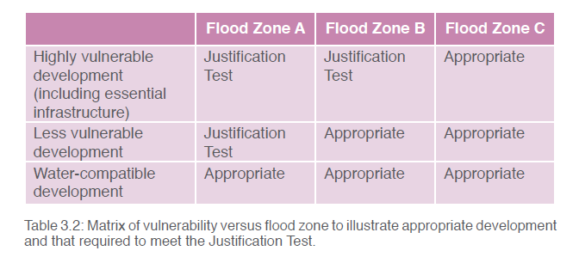

**Extract:** Table 3.2: Matrix of vulnerability versus flood zone to illustrate appropriate development and that required to meet the Justification Test (taken from the 2009 Planning Flood Risk Management Guidelines).

For ‘less vulnerable development’, a plan-making justification test is required for lands in flood Zone A, but not for Flood Zone B or Flood Zone C as these are considered ‘Appropriate’. The justification test is set out in the Guidelines under Box 4.1 (page 37). The location of the proposed variation no. 32 is identified with all three Flood Zones categories, A, B and C and thus captured in the plan – making justification tests of the CPD, see Figure 2 below. The plan – making justification tests of the CDP follow the criteria set out in the above referenced Guidelines under Box 4.1 (pg 37).

The proposed variation forms part of a site that has been studied in closer detail under Appendix 3 Justification Test Tables (page 120, Volume 7of the CDP), as set out below. This site is named ***Site 9. Dodder: Liffey to Ballsbridge.***

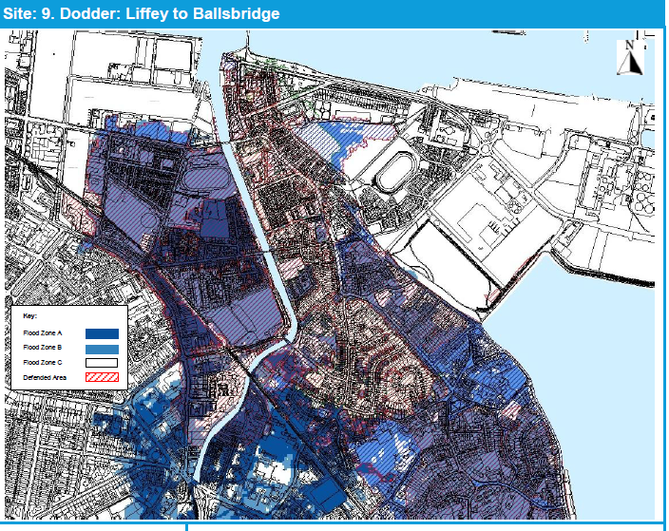

**Figure 2:** Subject site with indicative delineated red line boundary, located to the west of the River Dodder.

**Source:** Extract from DCC CDP, SFRA Volume 7, Appendix 3, Site 9

Under section heading 3 **Specific Flood Risk Assessment,** of the Justification Test for Development Plans, for Dublin City Council, it states:

***‘****On the west side of the Dodder, development proposals should follow the general requirements for FRAs in the SFRA. On the east, potential flood mechanisms are more complex and the FRA should be prepared with consideration of the risks from the Dodder and from the sea.’*

The location for this proposed variation is west of the River Dodder.

It is noted that the most recent grant of permission on the subject site under register reference 3502/19, outlined in the main variation report under heading Planning History, included a flood risk assessment that incorporated correspondence from Dublin City Council’s senior engineer at the Floods Projects and Water Framework Directive Division that updated the status of ‘under construction’ flood protection measures in the general area affecting the subject site, since the making of the City Development Plan.

It identified that Flood defences in Herbert Park installed in 2017 prevent the flood route from the Dodder 100 year flood to the proposed development at Lansdowne Road. The 1000 year flood risk is currently reduced, the extent to which will be reported upon once the works at Donnybrook are completed.

**3.0 Conclusion**

The Flood Risk Assessment for the Proposed Variation no. 32 at the 1.7ha site at **Ballsbridge Hotel (Formerly Jury’s), Pembroke Road, Ballsbridge, Dublin 4** has been undertaken in accordance with the requirements of Section 28 Guidelines for Planning Authorities: ‘*The Planning System and Flood Risk Management’*, 2009.

The subject site, with areas of both Flood zones A and B classification, that forms part of Site 9 of Appendix 3 to the City Development Plan has been assessed under the criteria set out for the plan making justification test required under the Section 28 Flood Risk Management Guidelines, 2009 as amended. This justification states that any proposals west of the Dodder should carry out a site specific flood risk assessment at planning application stage.

Any future planning proposal for development will be required to comply with the Greater Dublin Strategic Drainage Study for surface water management. This is to ensure that there is no increase in flood risk to properties upstream or downstream as a result of future development.

Notwithstanding that the purpose of the proposed variation is to facilitate the expansion of the American Embassy requiring a more appropriate land use zoning objective to enable a compliant planning application be lodged for same, the future stated intended use, embassy: office, classified as a commercial use, is categorised as a less vulnerable use for the purposes of the Flood Risk Management Guidelines and therefore by its nature reduces the potential impacts of flood risk that may be caused by flood events.

More broadly, this proposed variation, to rezone Z1 lands to Z6 lands, will limit the potential impacts of potential flood risk owing to the nature of permissible uses and open for consideration uses under a Z6 land-use zoning objective when compared to the existing Z1 residential land use zoning on the lands that largely feature more vulnerable uses, notwithstanding that such uses under a Z1 zoning can be permitted subject to the above referenced appropriate flood risk assessment (FRA), at planning application stage.

Having reviewed the flood risk assessment in accordance with the above Guidelines the following has been determined:

The proposed variation and any future planning application arising from same that adequately addresses, through detailed design, the flood risk requirement as part of the planning application process, is not likely to change flood risk in the area, upstream or downstream.