Dublin City Development Plan 2016-2022

PROPOSED VARIATION No. 33

  - Zoning Objective Amendment
  - and
  - Strategic Development and Regeneration Area Designation

  - On Lands at Jamestown Road / St Margaret’s Road / McKee Avenue, Finglas, Dublin 11

Planning Report

March 2021

Contents
1.0 Introduction 3
2.0 Context for Variation Lands 4
3.0 Purpose of the Proposed Variation 5
3.1 Policy Context 5
3.2 Background 5
4.0 Content of Proposed Variation No. 33 8
4.1 Land Use Zoning Map Change 8
4.2 Amendment to Map K: ‘Strategic Development and Regeneration Area and Key District Centres’ 10
4.3 Text Amendments 11
5.0 Conclusion 19

1.0 Introduction
The purpose of this report is to set out the planning context and rationale for Proposed Variation No. 33 of the Dublin City Development Plan 2016-2022.
The proposed Variation seeks to re-zone circa 43.11 hectares of lands at Jamestown Road, McKee Avenue, and St Margaret’s Road, Finglas, currently zoned Land Use Zoning Objective Z6, to “provide for the creation and protection of enterprise and facilitate opportunities for employment creation” to Land Use Zoning Objective Z14, with an objective to “seek the social, economic and physical development and/or rejuvenation of an area with mixed-use, of which residential and ‘Z6’ would be the predominant uses”. It is also proposed to designate the lands as a Strategic Development and Regeneration Area (SDRA).
The proposed changes to the Dublin City Development Plan 2016-2022 are :
- Land Use Zoning Map (Map A) to Z14 (Strategic Development and Regeneration Areas) to replace the existing Z6 (Employment / Enterprise) zoning.
- Amend Map K, to include the new Strategic Development and Regeneration Area.
- Amend Chapter 15, to insert new Strategic Development and Regeneration Area (SDRA) Guiding Principles for the subject lands.
- Amend Chapter 2, to include the SDRA lands into the Core Strategy.

2.0 Context for Variation Lands
The c. 43.11-hectare land bank is situated to the immediate north of Finglas village and is bound by Jamestown Road to the east, McKee Avenue, and St Margaret’s Road to the west and interfaces with the administrative boundary of Fingal County Council to the north, where the lands are currently characterised by employment/industrial uses. The lands border existing residential dwellings to the south/southwest. Existing residential dwellings are located along Jamestown Road and McKee Avenue, with a mix of commercial and residential uses along St Margaret’s Road. Charlestown Shopping Centre is located to the northwest of the lands and the emerging preferred route option for the proposed Luas extension to Finglas will border the lands, along St Margaret’s Road, terminating at Charlestown. The proposed Core Bus Corridor from Finglas to the City Centre as part of the Bus Connects project will also serve the lands, from the Finglas Road to the west.
The lands contain an number of existing industrial estates and a business park that is characterised by buildings/structures with large footprints with low-intensity employment uses. The area also contains a number of vacant sites and has a poor relationship with the adjoining street network. There is poor permeability through these lands , with private/controlled access to individual premises and across the lands.
Location of Proposed Variation
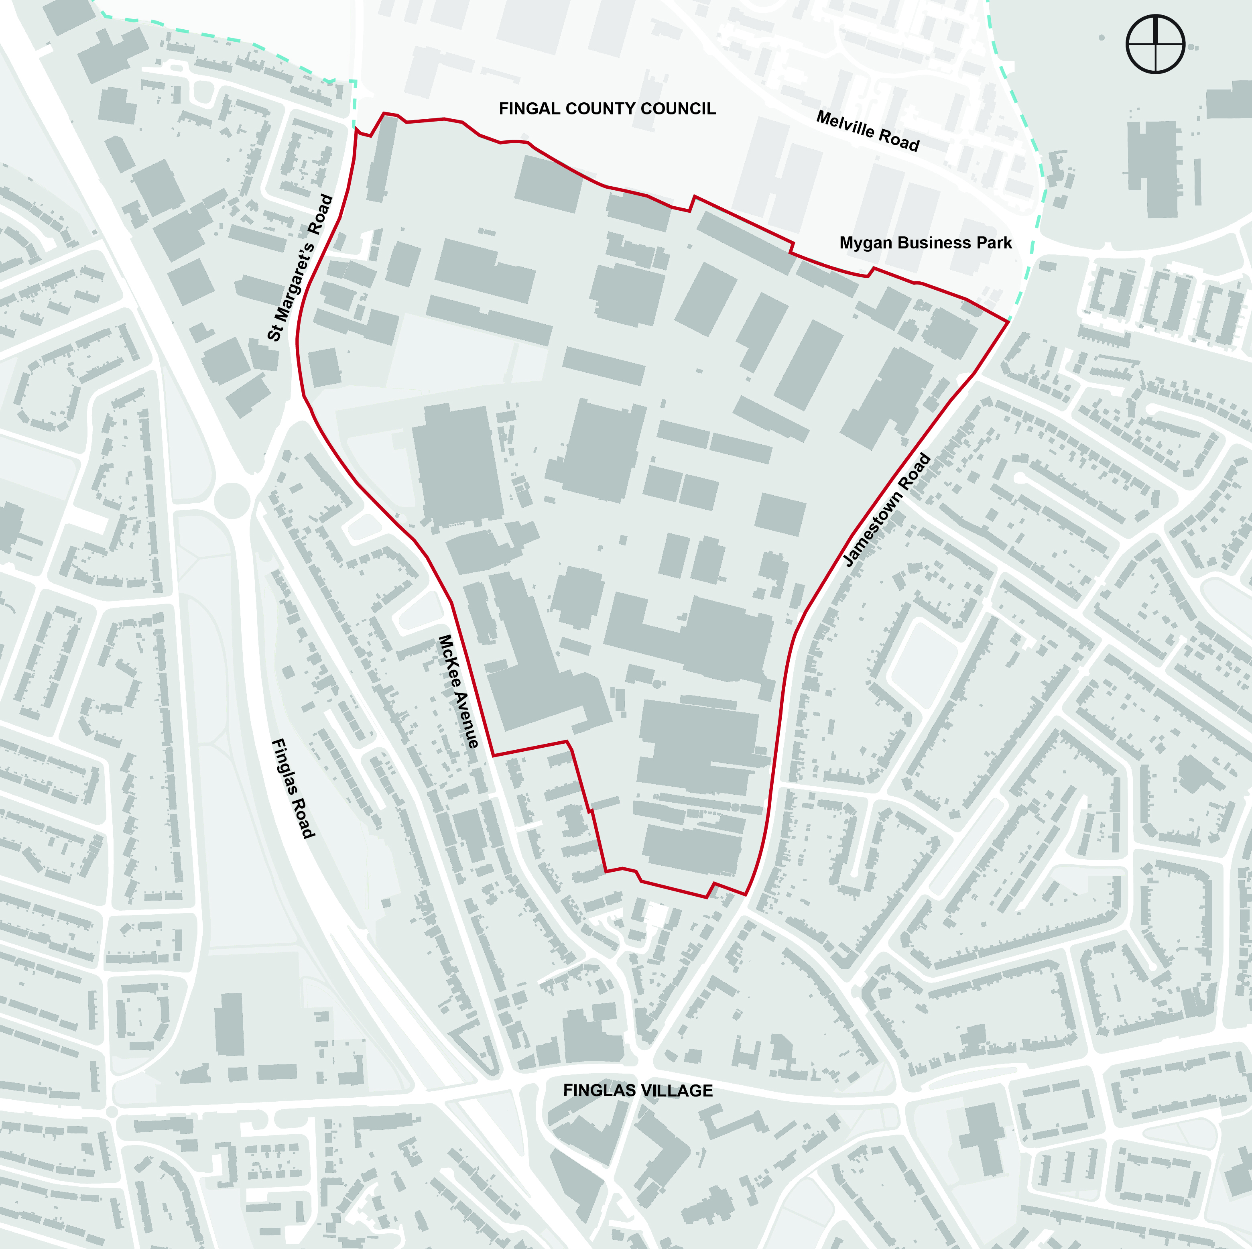

3.0 Purpose of the Proposed Variation
The purpose of this Proposed Variation is to change the land use zoning objective of the subject lands, from Land Use Zoning Objective Z6 (Employment/Enterprise) to Z14 (Strategic Development and Regeneration Areas), to fulfill National and Regional planning objectives on responding to climate change, delivering compact development and sustainable urban growth.

3.1 Policy Context
The National Planning Framework (NPF) (Project Ireland 2040) states that at least 50% of all new homes for Dublin City and suburbs are required to be delivered within and adjoining its existing built-up footprint. To achieve this, the NPF identifies the reusing of large and small ‘brownfield’ land/infill sites, and underutilised lands at locations well served by existing and planned public transport. The NPF particularly highlights the need to focus on underutilised lands within the canals and the M50 ring. The proposed variation supports this policy position.
The Regional Spatial and Economic Strategy (RSES) for the Eastern and Midlands Region seeks the consolidation and re-intensification of infill, brownfield, and underutilised lands within Dublin City and its suburbs. 50% of all new homes within Dublin City and its suburbs are to be located in the existing built-up area. The RSES identifies a population target increase for Dublin City (DCC’s administrative area) of circa 100,000 people by 2031. To facilitate this growth the RSES also includes a Metropolitan Area Strategic Plan (MASP) for Dublin. The MASP directs future growth to identified Strategic Development Areas located on existing and planned strategic transport corridors and anticipates future growth will also be accommodated on brownfield/infill development lands in the city. The proposed variation supports this policy position.
The National Transport Authority’s Transport Strategy for the Greater Dublin Area 2016-2035 provides a framework for developing a sustainable transport network. Three key public transportation projects for Dublin City include:
- Finglas Luas– the extension of the green line Luas from Broombridge to Charlestown, to the northwest of the Jamestown Z6 land bank.
- Bus Connects – enhancement of Dublin's bus network along with several identified Core Bus Corridors, including Finglas.
- Metrolink – proposed rail link from the City Centre to Dublin Airport / Swords. Both the Finglas Luas and Finglas Core Bus Corridor are being designed to integrate and interchange with Metrolink as part of a wider strategic transport network for Dublin.
The Proposed Variation supports and establishes a plan-led approach to maximising the development of the lands in line with significant State investment in the public transport infrastructure of the area.

3.2 Background
Following a review of the City’s employment / industrial lands in 2018/19, the Planning Department identified 82 land parcels with the potential to accommodate future housing and more intense land uses, within the existing built fabric of the City. Of these, 20 small to medium land banks were initially proposed for re-zoning by way of a Variation to the Dublin City Development Plan 2016-2022 (Proposed Variations No.’s 8 - 27). At the Dublin City Council monthly meeting held on 2nd March 2020 and continued 10th March 2020 a number of these Proposed Variations were adopted.
The potential of the Jamestown Z6 land bank was identified in the 2018/19 study, having regard to the lands strategic location inside the M50 and adjacent to the proposed Luas extension to Finglas (Finglas Luas). The study recognised that this area represents well-connected but underutilized employment (Z6) zoned brownfield lands within the built-up area of the City with the potential to allow for more varied and intense mixed uses.
Since March 2020, Dublin City Council has been in consultation with Transport Infrastructure Ireland (TII) and there is now greater certainty around the timeline and process for the delivery of the Finglas Luas. Furthermore, there has been ongoing engagement between Dublin City Council and the National Transport Authority (NTA) concerning the Finglas Core Bus Corridor as part of the Bus Connects project which is providing greater clarity in terms of the delivery of this public transport project. Also, there has been increased landowner interest in advancing the development of the lands.
As a result of this change in circumstances and having regard to the significance of the lands in achieving the National and Regional policy objectives set out in the NDF and RSES / MASP, it was considered appropriate to bring forward these lands for re-zoning from Z6 to Z14 subject to the requirement for a Masterplan based on guiding principles established for the SDRA and shown in the Framework Plan (Figure 38A)
Land Use Zoning Objective Z14 of the Dublin City Development Plan endeavours “To seek the social, economic and physical development and/or rejuvenation of an area with mixed-use, of which residential and 'Z6' would be the predominant uses”. Chapter 15 of the Dublin City Development Plan identifies several SDRAs and sets out the guiding principles for their development. SDRAs are capable of delivering significant quanta of homes and employment for the City, with many situated within the existing built environment on underutilised or brownfield sites. Finglas is currently designated a Key District Centre (KDC) in the Dublin City Development Plan. KDCs represent the top-tier of urban centres outside the City Centre and a number of these form part of the larger SDRAs. KDCs act as strong spatial hubs for development in the suburbs.
Therefore, the rationale for this Variation is as follows:
To provide for more varied and intense mixed uses of these existing low-density mono use brownfield urban lands within the Dublin Metropolitan Area. This Variation supports the National and Regional planning objectives set out in the NPF and RSES / MASP by supporting the area regeneration to deliver a compact and sustainable urban form at this location, to achieve the sustainable use of scarce urban land, and to respond to climate change.
To maximise the potential of a well-connected but underutilised brownfield low-intensity employment land, situated within the existing built fabric of the City and adjacent to the proposed Luas green line extension to Finglas, and proposed Finglas Core Bus Corridor, as set out in the National and Regional planning objectives in the NPF and RSES / MASP.
To support the economic revitalisation of Finglas village through the creation of a cohesive urban framework and guiding principles, by way of a new SDRA designation for the proposed Z14 lands, to ensure that the future development of the lands occurs in a coordinated and sustainable manner that can act as a catalyst to regenerate the village.
The lands proposed for re-zoning comprise a total of c. 43.11 hectares. Assuming a target density of 100 units per hectare and assuming that 50% of the land would be in residential use, this land bank has the potential to deliver an indicative c. 2,220 residential units. It is anticipated that the remaining land would be comprised of 30% employment/commercial, 10% public open space, and 10% social/community/education.
In preparing for the proposed change of zoning to allow for such a significant area of potential new residential units, the impact of this variation has been examined in relation to the Core Strategy. Whilst the volume of land proposed provides for approximately 2,200 units, it is not expected that any significant portion of this will be delivered during the lifetime of the current City Development Plan; though it is possible that a number of permission applicatiosn will be made within this time.
In analysing the delivery of the sub-areas for residential development (Table E), it is clear that a number of these have yet to reach their full capacity and some are not yet progressed nor likely to be by the end of the life of the current Development Plan. It is therefore considered that the additional zoning provided will remain consistent with the Core Strategy and it’s defining principle of achieving a compact sustainable mixed use growth with the existing envelope of the city, supported by high quality public transport and connectivity.
Delivery of SDRA housing within a brownfield, infill or regeneration context is complex due to its context, and delivery of housing often extends across a series of Development Plans. This variation and other SDRAs are designated within that long term horizon. The capacity provided by these lands will aid the Council in meeting it’s future housing targets in tandem with the other SDRA lands and it will be particularly relevant to the brownfield targets of the NPF.
It is proposed to amend table C (page 22) to include the hectage as one of the “other zonings containing residential use”; thus increasing the size from 2043 to 2086 and the associated total from 6509 to 6552.
It is also proposed to add Finglas SDRA to Table E (page 25) and amend the total so that is reads:
SDRA 19 | Finglas | 2,200
 | Total | 54,500- 54,800.

4.0 Content of Proposed Variation No. 33
It is proposed to make a Variation to the Dublin City Development Plan 2016 – 2022 by changing the Land Use Zoning Objective of a c. 43.11-hectare land bank situated between Jamestown Road and St Margaret's Road / McKee Avenue, Finglas, Dublin 11,
from Land Use Zoning Objective Z6 (Employment / Enterprise) “To provide for the creation and protection of enterprise and facilitate opportunities for employment creation”
to Land Use Zoning Objective Z14 (Strategic Development and Regeneration Areas): “‘To seek the social, economic and physical development and/or rejuvenation of an area with mixed-use, of which residential and ‘Z6’ would be the predominant uses”.
It is also proposed to designate the lands a Strategic Development and Regeneration Area (SDRA).
The proposed changes to the Dublin City Development Plan 2016-2022 are as follows:
- Land Use Zoning Map (Map A) to Z14 (Strategic Development and Regeneration Areas) to replace the existing Z6 (Employment / Enterprise) zoning.
- Amend Map K, to include the new Strategic Development and Regeneration Area.
- Amend Chapter 15, to insert new Strategic Development and Regeneration Area (SDRA) Guiding Principles for the subject lands.
- Amend Chapter 2, to include the SDRA lands into the Core Strategy.

4.1 Land Use Zoning Map Change

Existing Land Use Zoning
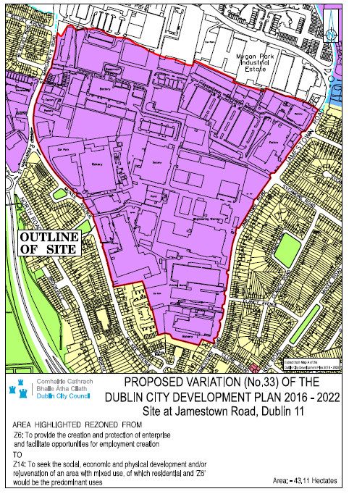
Proposed Land Use Zoning
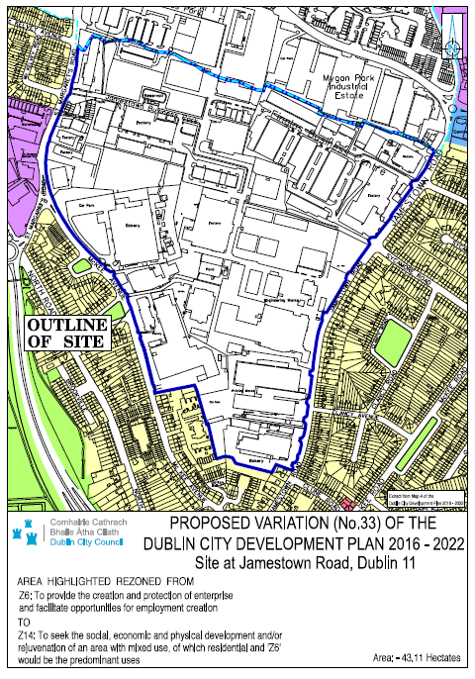

4.2 Amendment to Map K: ‘Strategic Development and Regeneration Area and Key District Centres’

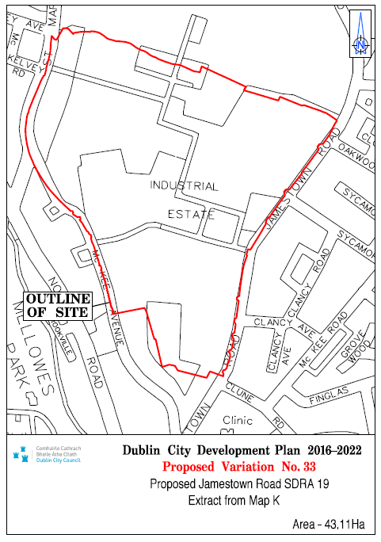

4.3 Text Amendments

Proposed Changes to Chapter 15
It is proposed to amend Chapter 15 of the Dublin City Development Plan 2016-2022 by inserting the below after Section 15.1.1.21.

15.1.1.22 SDRA 19 Jamestown Road, St Margaret’s Road and McKee Avenue, Finglas
These lands immediately north of Finglas Village, at 43.1 hectares are currently used for a range of low density employment and other uses, with a high level of undertilisation and a number of vacant sites. They have been identified as having significant potential for regeneration and providing new brownfield redevelopment within the City, proximate to existing services and planned high quality public transport investment.

The rationale for designating the Jamestown lands as a Strategic Development and Regeneration Area (SDRA) is:
- To provide for more varied and intense mixed uses for these existing low-density mono use brownfield urban lands within the Dublin Metropolitan Area. This supports the National and Regional planning objectives set out in the National Planning Framework (NPF) and Regional Spatial and Economic Strategy (RSES) / Dublin Metropolitan Area Spatial Plan (MASP), by supporting the area regeneration to deliver a compact and sustainable urban form at this location, to achieve the sustainable use of scarce urban land, and to respond to climate change.
- To maximise the potential of a well-connected but underutilised brownfield low-intensity employment land, situated within the existing built fabric of the City and adjacent to the proposed Luas green line extension to Finglas, and proposed Finglas Core Bus Corridor, as set out in the National and Regional planning objectives in the NPF and RSES / MASP.
- To support the economic revitalisation of Finglas village through the creation of a cohesive urban framework and guiding principles, to ensure that the future development of the lands occurs in a coordinated and sustainable manner that can act as a catalyst to regenerate the village.

Guiding Principles for the SDRA
A number of guiding principles have been established which will inform the future development of the SDRA lands. These principlesare listed and subsequently described below:
- Urban Structure.
- Land Use & Activity.
- Height.
- Design.
- Green Infrastructure.
- Climate Change.

Figure 38A: SDRA 19 Framework Plan
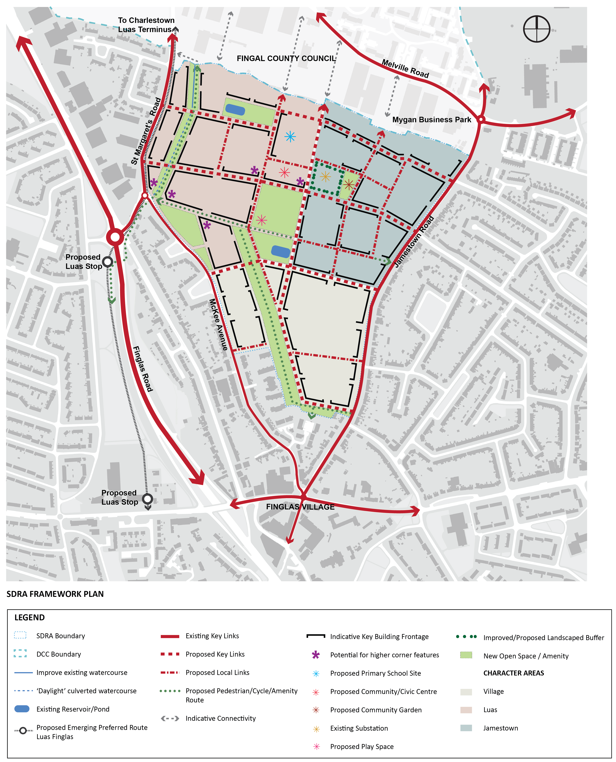
Indicative Map Only

- Urban Structure
- The proposed urban structure provides a strategic blueprint for the future development of the SDRA, identifying key connections, public open spaces, and building frontages that will inform an urban design-led approach to the regeneration of this strategic area.
- The movement framework and street structure, as illustrated in the SDRA Framework Plan (Figure 38A), introduces permeability through the lands, based on proposed key east-west and north-south links and several proposed local access streets. A strategic pedestrian/cycle amenity link crosses the lands, which is aligned with key desire lines to the proposed Luas extension and forms part of the green infrastructure network, providing a key link between proposed open spaces.
- All proposed streets shall comply with the Design Manual for Urban Roads and Streets (DMURS) (2013).
- The movement framework provides a structure for urban blocks and open spaces. The proposed urban block structure provides a coherent framework for future developments that can respond to a range of uses and activities. In accordance with best practice principles, urban blocks shall generally be between 60m-80m in size but shall not be more than 100m in width/length to ensure that an optimal level of permeability is achieved at an appropriate scale.
- The SDRA Framework Plan identifies indicative key building frontages, within the proposed urban block structure. In general, built form shall limit the use of set-backs on the key internal links, are required to provide a tree planted verge and quality footpath, and, where appropriate, privacy strips, to form an edge with the streetscape, provide animation and passive surveillance. Exceptions shall apply, where required to facilitate the Luas and also for the existing boundary roads at Jamestown and McKee Avenue/St Margarets Road, where the set back shall be provided to (i) protect the amenities of the single and two storey houses opposite; (ii) to provide for an enhanced urban realm with tree planting along the full extent of the boundary and (iii) to accommodate an off road cycle track to link to the village and other amentieis and services. Building frontages shall respond to the movement framework and street hierarchy and address all key streets, which will enhance legibility and ensure that a strong sense of enclosure with tree lined streets is achieved throughout the SDRA.

- Land Use & Activity
- The area will primarily support residential and employment-generating uses, complemented by community, education, and public open space, and shall be developed at an approximate ratio (gross) of:
- 50% residential;
- 30% employment/commercial;
- 10% public open space and;
- 10% community/education.
- Assuming a target density of 100 units per hectare this land bank has the potential to deliver an indicative c. 2,220 residential units.
- Having regard to the lands’ proximity to Finglas Village and Charlestown, and the overall aim to support the revitilisation of commercial activity in the village, retail development will be limited throughout the SDRA lands. Retail will only be considered, at an appropriate scale to support local communities, in proximity to the Luas corridor, to the north-west of the lands.
  - A range of housing typologies will be required throughout the SDRA, to serve the existing and future population of the area. All character areas shall avoid the over-proliferation of any single housing typology. Having regard to the size, scale, and location of the subject lands, this is to ensure that the future development of sites are sustainable and contains mixed communities.
  - The SDRA Framework Plan has identified three character areas, based on the above analysis.

The Village
  - The village character area is contiguous to Finglas village and is adjacent to existing residential properties. This character area shall be developed at an approximate ratio of 70% residential (gross) and 30% employment/commercial (gross) to foster the creation of a sustainable community that can support the economic revitilisation of Finglas village.
  - The scaling of development in this area must be sympathetic to the adjoining housing, lower in scale and net density (range of 60-90 units per hectare), and accommodate a range of unit types.

Luas

  - The lands to the north-west are situated within the walking catchment of the proposed Luas green line extension (Luas Finglas) and proposed Bus Connects Core Bus Corridor.
  - These lands shall be developed at an approximate ratio of 70% residential (gross) and 30% employment/commercial (gross), complemented by education, community, and open space, at an appropriate scale and density (with a net density range of 80-120 units per hectare) to support and avail the proposed public transport infrastructure and the development of a sustainable and compact urban form.

Jamestown
- The lands situated to the north-east, along Jamestown Road, shall be developed at an approximate ratio of 70% employment/commercial (gross) and 30% residential (gross), to support the continuation of a sustainable working community in the area. Net densities for residential plots will have a range of 80-100 units per hectare.

Note: deviations in use mix and in relation to density ranges of up to 10% within individual sites and quarters to meet design requirements will be accepted if the change supports overall compliance with the Guiding Principles, and where a joint agreement is proposed between landowners to accommodate certain uses within a particular area, such will be considered where the overall Principles are retained and the use and typology mix is delivered.

- Height
- The SDRA Framework Plan identifies opportunities for additional building height on corners/façades of certain proposed urban blocks, as a tool to enhance urban design and legibility. A masterplan shall be required for the subject lands which will establish and detail an overall height strategy.
- Notwithstanding this, in general, building heights in the range of 4-6 stories will be encouraged in order to provide a coherent street of structure, with an appropriate sense of enclosure.
- Where opportunities for additional height are identified, this shall be limited to corner features and shall not apply to the overall block. This is to avoid the proliferation of monolithic ‘slab’ blocks. Additional height, where appropriate, shall be no more than 1/3 of the overall length/width of the urban block.
- Height shall respond to the existing context and respect existing residential properties along McKee Avenue and Jamestown Road. Having regard to the proposed Luas, in general, there is potential for additional building height towards the north-west of the lands, subject to design and amenity safeguards.
- Opportunities for additional height also exist to frame the proposed centrally located open space, to enhance the legibility of the built environment.

- Design
- High-quality public realm (in compliance with the Street Palette of the Construction Standards for Road and Street Works in Dublin City Council) will be required and shall be applied to the network of streets and public spaces.
- All vehicular streets shall be designed to be taken in charge standards (lighting, pavement, footpaths, tree lined verges) and will be conditioned to be as part of future planning permissions.
- The existing established residential amenity of properties along Jamestown Road, McKee Avenue, and St Margaret’s Road shall be respected. As such the masterplan will be required to demonstrate integration with the surrounding streetscapes. Opportunities exist to upgrade the streetscape along Jamestown Road, McKee Avenue, and St Margaret’s Road, by providing a high-quality public realm and landscaping.
- The masterplan shall also address the interface to the adjoining Fingal County Council employment lands to the north of the lands, in terms of protecting and enhancing visual and residential amenity. Opportunities for additional connections shall be explored.
- High-quality architectural design and quality will be encouraged throughout the SDRA. Architectural design and form shall respond to the identified character areas to enhance legibility and provide visual interest. As such Dublin City Council will strongly encourage architectural variety in terms of design, materials, and finishes. It shall be a requirement of the masterplan that architectural design, materials, and finishes be detailed, and correspond to the identified character areas in the SDRA.

- Green Infrastructure
- The green infrastructure and open space network forms a key structuring element to the SDRA Framework. As such, a Green Infrastructure Strategy must be prepared and agreed with DCC prior to any permission being lodged. This Strategy must provide for the retention of existing open watercourses with an appropriate riparian zone and include the de-culverting of existing watercourses as part of the design
- The Plan must address the integration of sustainable urban drainage (SUDS), utilising an integrated nature based solutions response and not rely on hard infrastructure (storage) as the dominant solution.
- The Plan must set out a play strategy, setting out what active sports and play will be provided for within the larger open space, and how the needs of younger children will be accommodated within each local area.
- All vehicular streets and green links shall be planted with an avenue of trees along their length, and on the landscaped set back for Jamestown and McKee Roads
- Planting and landscaping must be framed on a policy of promoting biodiversity, with a high proportion of native species and those which support this aim, and specific areas of parkland identified for biodiversity purposes

- Climate Change
- To promote sustainable development and encourage the transition to a low carbon future, a range of measures are promoted, including, sustainable urban drainage systems (SUDS), cycling and walking, and the use of only sustainable energy and heating, in accordance with DCCs Climate Change Action Plan.
- All multi-unit buildings utilising a combined heating system and all larger scale commercial buildings (over 1,000 sq.m.) must be district heating enabled.
- All private residential parking must be provided with electrical charging points.

Requirement for Masterplan
To ensure that the development of the subject lands occurs in a sustainable and coherent manner, a masterplan shall be prepared for the entire SDRA by all major landowners, which complies with the guiding principles above, to be agreed with the Planning Authority, before the lodgement of any planning application. All planning applications in the SDRA will be required to comply with the Masterplan and the Principles outlined above. Minor deviations will only be considered where the change supports the implementation of the Principles and provides an improved solution.
This Masterplan shall detail how it will deliver the guiding principles above, and will not be limited to, but shall include the following details:
- Agreed approach to the public realm and street design, including details on how the development will integrate with the existing streetscape along St Margaret's Road / McKee Avenue and Jamestown Road.
- Agreed approach for housing delivery on the lands.
- Prepare a local Housing Needs Demand Assessment (HNDA) for the SDRA which identifies parameters that shall address:
  - Mix.
  - Affordability.
  - Social/affordable housing.
  - Housing for vulnerable groups.
- Demonstrate the incorporation of a range of housing typologies, and avoid the over-proliferation of a single housing tenure in any one character area, to create a sustainable community.
- A Green Infrastructure Strategy that provides for i) retention of existing open watercourses with an appropriate riparian zone ii) explores opportunities to de-culvert existing watercourses and their incorporation into the Masterplan where possible, (iii) provides for extensive tree planting and street avenues; (iv) biodiversity planting; and (v) play.
- An Integrated Surface Water Management Strategy for the entire development lands shall be prepared to ensure necessary public surface water infrastructure and nature based SUDS solutions are in place to service new development and shall include a modelling exercise to determine the extent of existing flood zones.
- A mobility management strategy shall be prepared for the subject lands and inform the preparation of the masterplan.
- The requirement for a Traffic Impact Assessment will be determined on a case by case basis by the Planning Authority, in respect of planning applications lodged for the subject lands.
- All new multiple unit and commercial developments are required to be district heating enabled.
- Each planning application shall submit a statement demonstrating how the proposal accords with the Guiding Principles established in the SDRA and how it complies with the Masterplan.
- It is anticipated that the re-development of the subject lands will occur incrementally and over an extended period. As such all development proposals shall occur sequentially and contiguous to existing residential development.
- The masterplan shall include detailed information on the delivery of the new community faciltiies identified in the SDRA. The community space shall extend over the entire ground floor of the designated block and shall be completed to full fit out standard so it is enabled for immediate use for community purposes. Proposed uses for the space shall be agreed with DCC, informed by a community audit.

Proposed Changes to Chapter 2
It is proposed to amend table C (page 22) to include the hectage as one of the “other zonings containing residential use”; thus increasing the size from 2043 to 2086 and the associated total from 6509 to 6552.
It is also proposed to add Finglas SDRA to Table E (page 25) and amend the total so that is reads:
SDRA 19 | Finglas | 2,200
 | Total | 54,500- 54,800.

5.0 Conclusion
This report has set out the planning context and rationale for Proposed Variation No. 33 of the Dublin City Development Plan 2016-2022.
The rationale for proposing this Variation is to transform the existing low-density mono-use brownfield urban lands within the Dublin Metropolitan Area to provide for more varied and intense mixed uses. This Variation supports the National and Regional planning objectives set out in the NPF and RSES / MASP by supporting the area regeneration to deliver a compact and sustainable urban form at this location, to achieve the sustainable use of scarce urban land, and to respond to climate change.

It is also in response to the proposed Luas green line extension to Finglas, and proposed Finglas Core Bus Corridor, as set out in the National and Regional planning objectives in the NPF and RSES / MASP, encouraging a compact urban form with integrated land use and sustainable transportation.

Finally, the Proposed Variation supports the economic revitalisation of Finglas village through the creation of a cohesive urban framework and guiding principles, by way of a new SDRA designation for the proposed Z14 lands, to ensure that the future development of the Jamestown lands occurs in a coordinated and sustainable manner that can act as a catalyst to regenerate the village.

As such, it is considered that Proposed Variation No. 33 is in accordance with key National and Regional policies, supports the development of a compact and sustainable urban form, with distinct character areas and neighbourhoods focused on key public transportation nodes, and therefore is in accordance with the proper planning and sustainable development of Dublin City.

Including but not exclusively SDRA 17 (650-700), SDRA 12 (over half of 800-1,000), SDRA 4 (LAP had reduced this area, less than half likely of 2,000) to be implemented during the Plan lifetime. Also taken into account are Variations 8-22 which added just under 35 ha of residential and mixed use lands across a range of smaller infill sites.

