Strategic Flood Risk Assessment
(SFRA)

for

Proposed Draft Variation
(No. 3)
of the

Dublin City Development Plan
2022-2028

RE: Lands at Botany Weaving Mill Ltd, Emerald Square, Cork Street, Dublin 8 D08K752

- Introduction
Dublin City Council has commenced the preparation of proposed draft variation no. 3 to change the zoning lands located at Botany Weaving Mill, Emerald Square, Cork Street, Dublin 8 from Z1 (Sustainable Residential Neighbourhoods) to Z4 (Key Urban Villages and Urban Villages). The area of the proposed draft variation rezoning site is approximately 0.4. ha and is delineated in red, identified in Figure 1 below.

The OPW is the lead agency for flood risk management in Ireland, part of the Department of Finance. The coordination and implementation of Government policy on the management of flood risk in Ireland is part of its responsibility. The European Communities (Assessment and Management of Flood Risks) Regulations 2010 (S.I. No. 122) identifies the Commissioners of Public Works as the ‘competent authority’ with overall responsibility for implementation of the Floods Directive 2007/60/EC.

The CFRAM (Catchment Flood Risk Assessment and Management) Programme has been completed and implementation of the outputs from this work is underway. The EU Floods Directive requires Member States to review the PFRA (Preliminary Flood Risk Assessment), the FRMPs (Flood Risk Management Plans) and the flood maps on a six-yearly cycle. As part of the OPW’s commitment to carry out these reviews, the NIFM (National Indicative Fluvial Maps) Programme was completed in 2019. The OPW continues to update predictive flood mapping to provide the best available flood risk information through the map review programme, where the criteria to trigger a review have been met.

As a proposed draft variation to the Dublin City Development Plan 2022 – 2028, the preparation of the documentation, apart from the principal variation report, includes a Strategic Environmental Assessment (SEA) Screening Report, an Appropriate Assessment (AA) Screening Statement and this document, which represents the Strategic Flood Risk Assessment (SFRA) statement of the variation site.

The SFRA, prepared as part of the Dublin City Development Plan (CDP) 2022 – 2028 and which informed the preparation of the CDP, had regard to the DEHLG Guidelines for Planning Authorities (DEHLG & OPW, 2009) on ‘The Planning System and Flood Risk Management’ as amended by Circular Pl2/2014 together with Technical Appendices. These Guidelines (the 2009 Guidelines) were issued under Section 28 of the Planning and Development Act 2000 as amended, and require Planning Authorities to introduce flood risk assessment as an integral and leading element of Spatial Planning. This requirement is also sought for variations to any development plan, hence the preparation of this accompanying document to the proposed variation report.

The Strategic Flood Risk Assessment (SFRA) for the administrative area of Dublin City Council is captured under Volume 7 to the City Development Plan (CDP) 2022 - 2028, with Chapter 9 (Sustainable Environmental Infrastructure and Flood Risk) of Volume 1, the Written Statement, of the CDP citing policies and objectives relating to Flood Management. This relevant documentation can be viewed here at:
https://www.dublincity.ie/residential/planning/strategic-planning/dublin-city-development-plan/development-plan-2022-2028

Any planning application arising from this proposed draft variation no. 3 will be required to comply with the flood risk management and surface water management provisions of the Dublin City Development Plan 2022 – 2028.

1.1 Proposal
It is proposed to vary the Dublin City Development Plan 2022-2028, by changing the land use zoning of lands at Botany Weaving Mill Ltd, Emerald Square, Cork Street, Dublin 8:

From: Zoning Objective Z1: Sustainable Residential Neighbourhoods – ‘To protect, provide and improve residential amenities.’
To: Zoning Objective Z4: Key Urban Villages and Urban Villages–
‘To provide for and improve mixed-services facilities’
The relevant lands are 0.4 ha in area and are delineated on the attached map, an extract from Map E, Volume 3 of the Dublin City Development Plan 2022 – 2028.

1.2 Location and Description of Lands
The subject lands are located in the Liberties in the south west inner city at Emerald Square, Cork Street, Dublin 8. The lands are occupied by Botany Weaving Mills Limited, a long established (since the 1930’s) manufacturing firm (weaving textiles).

The overall commercial premises comprises an irregular shaped plot which abuts Cork Street to the south east, Vauxhall Avenue (a pedestrian walkway) and Morning Star Road / Rosary Road to the east, and Emerald Square to the west.

Botany Weaving Mill is bounded to the east and west by well established residential areas. The southern part of the premises, which is not the subject of this proposed draft variation, fronts onto Cork Street. Cork Street is characterised by commercial and community uses such as the Coombe Hospital which lies near the subject lands.

There are industrial units and associated offices on the lands which range from single storey to three storey in appearance.
Vehicular access to the lands is via Emerald Square and Morning Star Road and there is surface car parking on the lands.

The subject lands are well served by and connected to the surrounding transport and movement corridors. This includes bus routes /cyclepaths with direct access to the city centre and the proposed Bus Connects Tallaght/clondalkin to City Centre route would serve these lands. The Red Luas line at Fatima lies in close proximity to the lands. The Grand Canal with its Greenway lies due south of the subject lands, within walking distance.

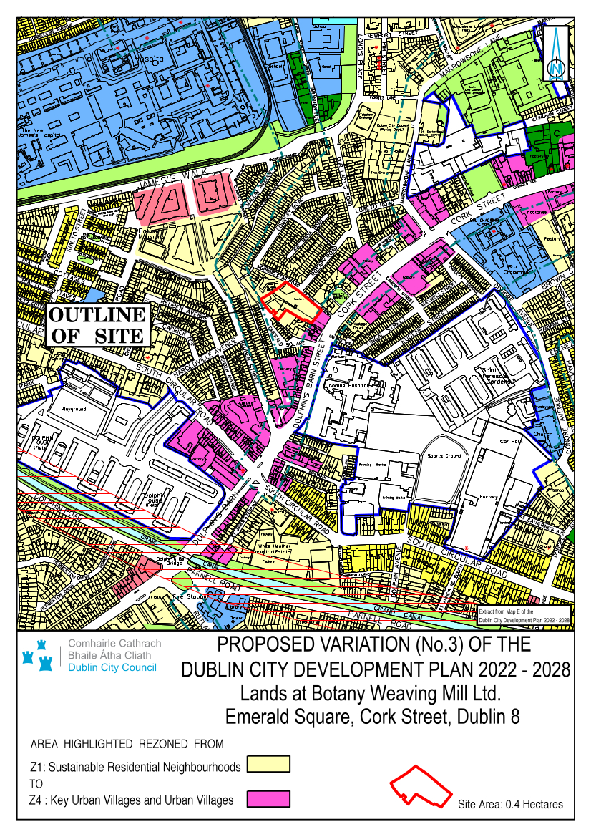

Figure 1: Location of Proposed Draft Variation (No. 3) to the Dublin City Development Plan 2022-2028 located at Botany Weaving Mill, Emerald Square, Cork Street, Dublin 8.
1.3 Development Plan
The subject lands form part of Strategic Development Regeneration Area 15 (Liberties and Newmarket Square) (SDRA 15) which is an area identified in the Dublin City Development Plan 2022-2028 as having considerable regeneration potential. The lands form part of Key Opportunity Site No. 8 Maryland.

1.4 Purpose of the Proposed Draft Variation
The Botany Weaving Mill premises are subject to two zoning objectives under the 2022 – 2028 Dublin City Development Plan. The majority of Botany Weaving Mills lands are zoned Z1 ‘Sustainable Residential Neighbourhoods’ as delineated on the attached Map. The frontage of the premises onto Cork Street is zoned Z4 ‘Key Urban Villages/Urban Villages’, reflecting the urban village / mixed use nature of that road.

The draft variation proposes that the whole Botany Weaving Mill lands will be subject to a Z4 zoning. A Z4 zoning (Key Urban Villages / Urban Villages) pertaining to the whole premises would allow the development of urban village uses / a mixture of uses including residential uses on the lands. The proposed Variation would also support the retention of the existing light industrial use on the lands.

In this regard it is also considered that the urban village zoning, rather than a residential zoning, would more appropriately support the continuation of the existing weaving and textile industry on site which has been in-situ since the 1930’s.

The weaving industry was synonymous with the Liberties area; this is acknowledged at Chapter 12 – Culture - Volume 1, Dublin CDP 2022 – 2028, page 389. Botany Weavers Mill in particular is of local historical interest as the lands are recorded as an ‘industrial heritage site’ (City Woollen Mills) and the existing manufacturing firm is the remaining weaving company in the Liberties.

2.0 Flood Risk Guidance

The 2009 Guidelines recommend a staged approach to Flood Risk Assessment (pg 14):
Stage 1 – identify any flood risks issues
Stage 2 – where flood risk issues arise, identify the sources and access available mapping with flood risk extents
Stage 3 – detailed flood risk assessment

The CDP’s SFRA provides a flood extents map for the entire area of the city. This comprises the three flood zone classifications identified in the Guidelines, Flood Zones A, B and C. Flood Zones A and B are described as being of high probability of flooding and moderate probability of flooding respectively and low probability of flooding for Flood Zone C (pg 24). These are coloured coded (dark blue and lighter blue for Flood Zones A and B respectively) and where no colour is equivalent to Flood Zone C.

Land-uses and types of development are accorded a vulnerability class, as set out in Table 3.1 of the Guidelines (pg 25), see extract below. A matrix of what vulnerability class is appropriate for each flood zone has been provided in Table 3.2 of the Guidelines (pg 26), see extract below.
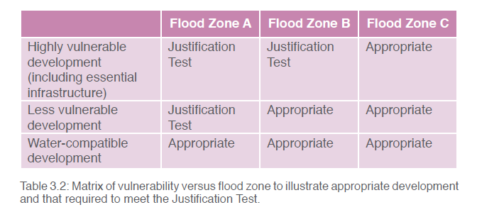
Extract: Table 3.2: Matrix of vulnerability versus flood zone to illustrate appropriate development and that required to meet the Justification Test (taken from the 2009 Planning Flood Risk Management Guidelines).

2.1 Screening / Assessment
It is proposed that the lands will be subject to land use zoning:
Zoning Objective Z4: Key Urban Villages and Urban Villages–
‘To provide for and improve mixed-services facilities’
According to the Strategic Flood Risk Assessment (SFRA) for the Dublin City Development Plan 2022 - 2028, the subject lands are located in flood zone C and B and are adjacent flood zone A.
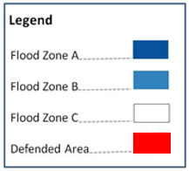
Figure 2: On Left Hand Side - Composite Flood Map, Appendix E of the Dublin City Development Plan 2022 – 2028 Strategic Flood Risk Assessment, Dec 22. This shows the lands in flood zone C and B.

Figure 3: On Right Hand Side – Flood Map for City showing Flooding areas overlaid on the Development Plan Zoning Map.

Development within Flood Zone C is generally appropriate. As Land Use Zoning Objective Z4 can include ‘highly vulnerable development’ such as residential uses, a justification test is required for development in Flood Zones A and B.

The lands are located in Strategic Development Regeneration Area (SDRA) No. 15 (Liberties and Newmarket Square) Key Opportunity Site No. 8 Maryland.

As part of the preparation of the City Development Plan 2022 – 2028, all Strategic Development Regeneration Areas (SDRAs) and their key development sites were reviewed with respect to the Flood Zone(s) they lie in. Where a site was identified in Flood Zone A or B the need for a Justification Test was assessed based on the vulnerability of the Land Use Zoning.

A Justification Test is provided in the city wide SFRA, for Strategic Development Regeneration Area (SDRA) No. 15 (Liberties and Newmarket Square) Key Opportunity Site No. 8 Maryland under Appendix C (C2) of the SFRA for the Dublin City Development Plan 2022 – 2028 and this is reproduced below in Appendix 1.

This sets out that the Poddle Flood Alleviation Scheme proposes to adapt portions of the drainage network to reduce flood risk in the relevant area.

It states that residential development within these sites on Flood Zone A/ B would be premature. Less vulnerable development would require further detailed modelling and assessment to assess the impacts on neighbouring properties having regard to potential displacement effects. After the flood defence works have been completed, a further assessment of risks will be undertaken to determine the appropriate land use and required mitigation measures in these areas.

The referred Justification Test considers, inter-alia - LUZ Objectives Z4, Z1 Z9 in the Maryland area with respect to Flood Zones A, B and C. The Justification Test concludes the:
‘area passes Part 1 and 2 of the Justification Test for Development Plans but Part 3 has found that new development should avoid Flood Zone A and only less vulnerable development is appropriate in previously developed parts of Flood Zone B’.
Development Design Stage
At the development design stage, the line of the Abbey Stream culvert and whether there is any flow in it would need to be established.

In addition there is some pluvial flooding shown on the site in the 100 year flood event which would need to be incorporated into the detailed design of any development proposal on the lands.

3.0 Conclusion
The Initial Flood Risk Assessment (Stage 2) for Proposed Variation no. 3 of the Dublin City Development Plan 2022 – 2028 in respect of lands at Botany Weaving Mill, Emerald Square, Cork Street, Dublin 8 finds that development is appropriate in Flood Zone C where there are no wayleave requirements and only less vulnerable development is appropriate in previously developed parts of Flood Zone B.

________________

Deirdre Scully
City Planning Officer

Date: 11th September 2023

Appendix 1 – Extract from Appendix C.2 of the SFRA, Volume 7 of the Dublin CDO 2022 – 2028 relating to the Justification Test for SDRA 15 – Liberties and Newmarket Square (that includes Site 8, Maryland, within which is located the subject lands of this proposed draft variation no. 3)

SDRA 15: Liberties and Newmarket Square
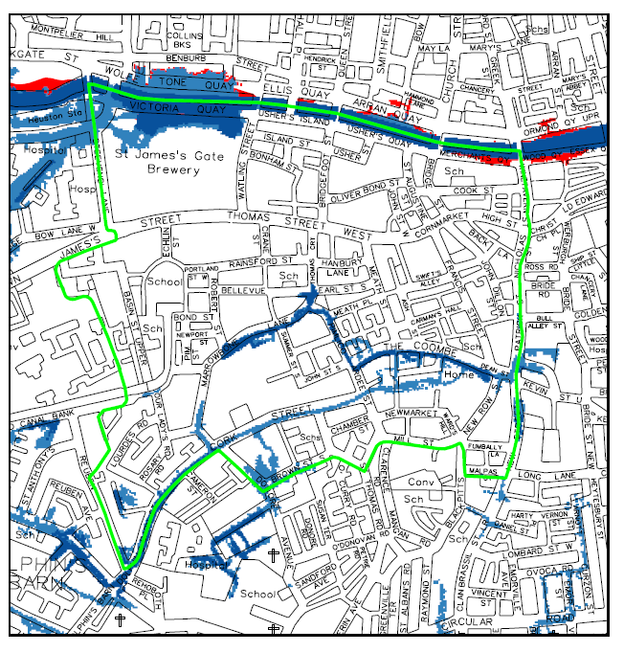
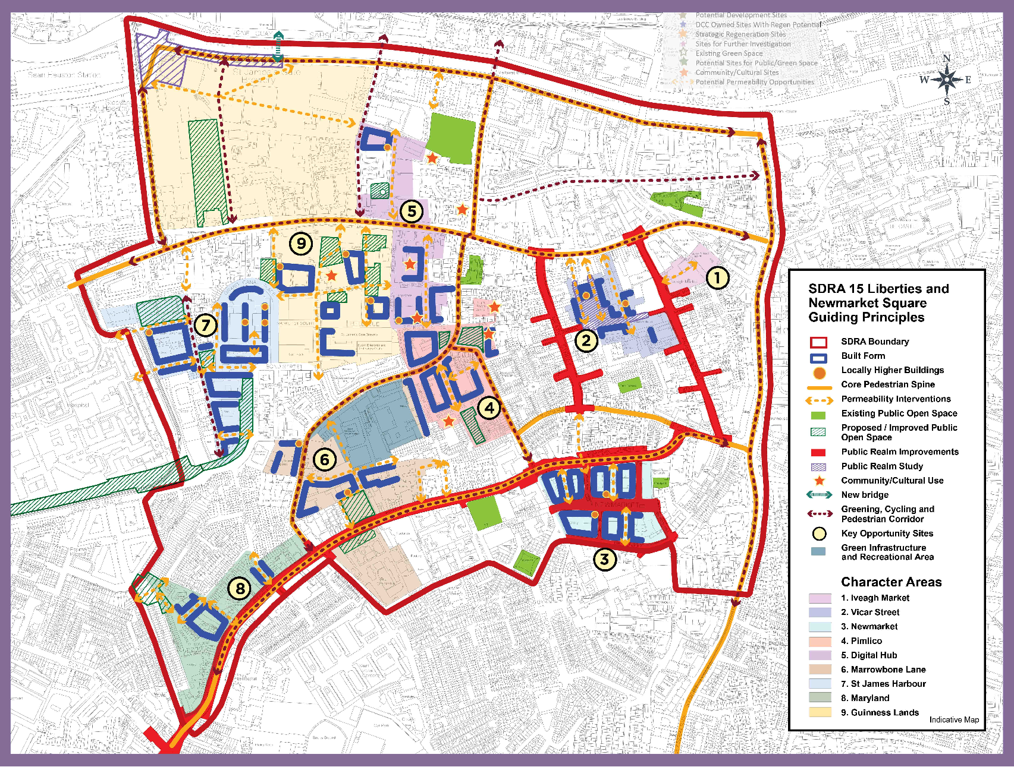
Area Description | The SDRA relates to lands located in the Liberties/ Newmarket area. The area stretches from the Guinness Lands in the north west over to Patrick Street in the east and south to the South Circular Road. The River Liffey is located to the north of the lands and the River Poddle traverses the lands.
Land Use Zoning: | Z1: To protect, provide and improve residential amenities.  Z2: To protect and/or improve the amenities of residential conservation areas.  Z3: To provide for and improve neighbourhood facilities.  Z4: To provide for and improve mixed-services facilities.  Z5: To consolidate and facilitate the development of the central area, and to identify, reinforce, strengthen and protect its civic design character and dignity.  Z7: To provide for the protection and creation of industrial uses, and facilitate opportunities for employment creation including Port Related Activities.  Z9: To preserve, provide and improve recreational amenity, open space and ecosystem services.  Z10: To consolidate and facilitate the development of inner city and inner suburban sites for mixed uses.  Z14: To seek the social, economic and physical development and/or regeneration of an area with mixed use, of which residential would be the predominant use.  Z15: To protect and provide for community uses and social infrastructure.
SDRA 15 Liberties and Newmarket Square: | The Framework Plan above and as set out in Section 13.17 in Chapter 13 of the Written Statement identifies nine development sites and opportunities for the integration of new development into the area addressing issues such as urban structure, land use, infrastructure, design, movement, permeability, building lines, heights and greening opportunities.
Benefitting from Defences (flood relief scheme works)/  Sensitivity to Climate Change/  Residual Risk/  Surface Water/  Historical Flooding | See Area Assessments:  No. 4 Liffey: Sean Heuston Br. - O’Connell Bridge  No. 13 Poddle: Inside Canal
Commentary on Flood Risk:
Following screening, five of the nine Opportunity Sites have been identified as subject to flood risk.
Opportunity Site | Flood Zone
Site 3 Newmarket | B and C
Site 4 Pimlico | A, B and C
Site 6 Marrowbone Lane | A, B and C
Site 8 Maryland | A, B and C
Site 9 Guinness | A, B and C

Justification Test for Development Plans

1. Part 1 of the Justification Test is covered under Section 3.2.1 in the main body of the SFRA report.

2. The zoning or designation of the lands for the particular use or development type is required to achieve the proper planning and sustainable development of the urban settlement and, in particular:

(i) Is essential to facilitate regeneration and/or expansion of the centre of the urban settlement.
Answer: Yes: The lands are located in the Inner City Liberties area of the city. The area is well served by public transport including Luas and local bus services. While the Liberties has seen significant infill/ brownfield development over the last Development Plan period there are a number of opportunity sites in this area, including the Diageo (Guinness) site, which have the potential to contribute of the creation of sustainable compact communities with improved housing choice, access to social and economic opportunities, enhanced services and amenities. According to the Core Strategy, this area has the capacity to deliver some 2,500 residential units. The redevelopment of the lands at increased densities is essential to meet national and regional brownfield development objectives as set out in National and Regional planning policy including the Regional MASP and is considered essential to facilitate the regeneration and expansion of the urban settlement.
(ii) Comprises significant previously developed and/or under-utilised lands
Answer:
Yes: These lands comprise previously developed/ underutilised lands.
(iii) Is within or adjoining the core of an established or designated urban settlement.
Answer: Yes: The lands form part of an established built-up part of the Inner City.
(iv) Will be essential in achieving compact and sustainable urban growth
Answer: Yes: The lands form part of an established built-up part of the Inner City and are essential in achieving compact and sustainable urban growth including through the support such development can provide to existing services – transport, service infrastructure and community infrastructure.
(v) There are no suitable alternative lands for the particular use or development type, in areas at lower risk of flooding within or adjoining the core of the urban settlement.
Answer: There are no suitable alternative lands for the particular uses or development type in areas at lower risk of flooding, within or adjoining the urban settlement.
3. Specific Flood Risk Assessment
The following sites lie partly in Flood Zone A - 4. Pimlico, 6 Marrowbone Lane, and 8 Maryland. The Poddle Flood Alleviation Scheme proposes to adapt portions of the drainage network to reduce flood risk in the relevant area.

Residential development within these sites on Flood Zone A/ B would be premature. Less vulnerable development would require further detailed modelling and assessment to assess the impacts on neighbouring properties having regard to potential displacement effects. After the flood defence works have been completed, a further assessment of risks will be undertaken to determine the appropriate land use and required mitigation measures in these areas.

There is flooding (Zone A and B) (including underground seepage) on the northern side of the Guinness lands from the River Liffey (mainly tidal). As the lands are zoned Z7 there is potential to locate less vulnerable development in Flood Zone B.
Highly vulnerable development could reasonably be accommodated within the extents of Flood Zone C and should not need to extend into Flood Zones A and B.
Conclusion: The subject area passes Part 1 and 2 of the Justification Test for Development Plans but Part 3 has found that new development should avoid Flood Zone A and only less vulnerable development is appropriate in previously developed parts of Flood Zone B.

