To the Lord Mayor and Report of the Chief Executive
Members of Dublin City Council

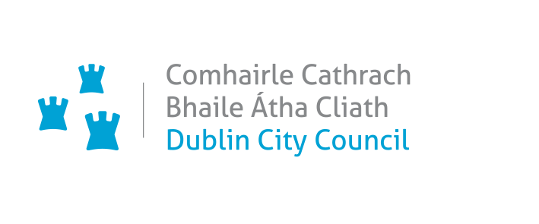_________________________________________________________________________
Proposed Variation (No. 3) Of The Dublin City Development Plan 2022 – 2028

Proposed Variation of the Dublin City Development Plan 2022-2028:
Lands at Botany Weaving Mill Ltd, Emerald Square, Cork Street, Dublin 8 D08K752
_________________________________________________________________________

Executive Summary
The Variation
It is proposed to vary the Dublin City Development Plan 2022-2028, by changing the land use zoning of lands at Botany Weaving Mill Ltd, Emerald Square, Cork Street, Dublin 8 from Zoning Objective Z1 (Sustainable Residential Neighbourhoods) to Zoning Objective Z4 (Key Urban Villages and Urban Villages).

The Purpose of the Variation
The Botany Weaving Mill Ltd premises / lands are subject to two zoning objectives under the 2022 – 2028 Dublin City Development Plan - Z1 ‘Sustainable Residential Neighbourhoods’ and Z4 ‘Key Urban Villages/Urban Villages’. A change to a Z4 zoning (Key Urban Villages / Urban Villages) on the whole premises would allow the development of urban village uses on the lands. The proposed variation would also support the retention of the existing light industrial use on the lands. An urban village zoning, rather than a residential zoning, would more appropriately support the continuation of the existing weaving and textile industry on the lands, in line with Development Plan Policy.

Submissions
In total eight submissions were received, five from public bodies, with two submissions from local representatives, (one Councillor and one TD) and including one from the CEO of Botany Weaving Mill Ltd with signatures of employees. The Public Bodies included the Office of the Planning Regulator (OPR), the Eastern and Midland Regional Assembly (EMRA) the Environmental Protection Agency (EPA), Uisce Eireann (UE), formerly Irish Water, and Transport Infrastructure Ireland (TII).

Issues Raised
There were no issues of concern raised in any of the eight submissions received that included all five public bodies. Three of the submissions specifically welcome the proposed variation acknowledging that it will facilitate the continued successful weaving enterprise at this location.

Response
Dublin City Council acknowledges the submissions received that support the variation as proposed.
Proposal

It is proposed to vary the Dublin City Development Plan 2022-2028, by changing the land use zoning of lands at Botany Weaving Mill Ltd, Emerald Square, Cork Street, Dublin 8:

From: Zoning Objective Z1: Sustainable Residential Neighbourhoods – ‘To protect, provide and improve residential amenities.’
To: Zoning Objective Z4: Key Urban Villages and Urban Villages– ‘To provide for and improve mixed-services facilities’
The relevant lands are 0.4 ha in area and are delineated on the map below, an extract from Map E, Volume 3 of the Dublin City Development Plan 2022 – 2028.

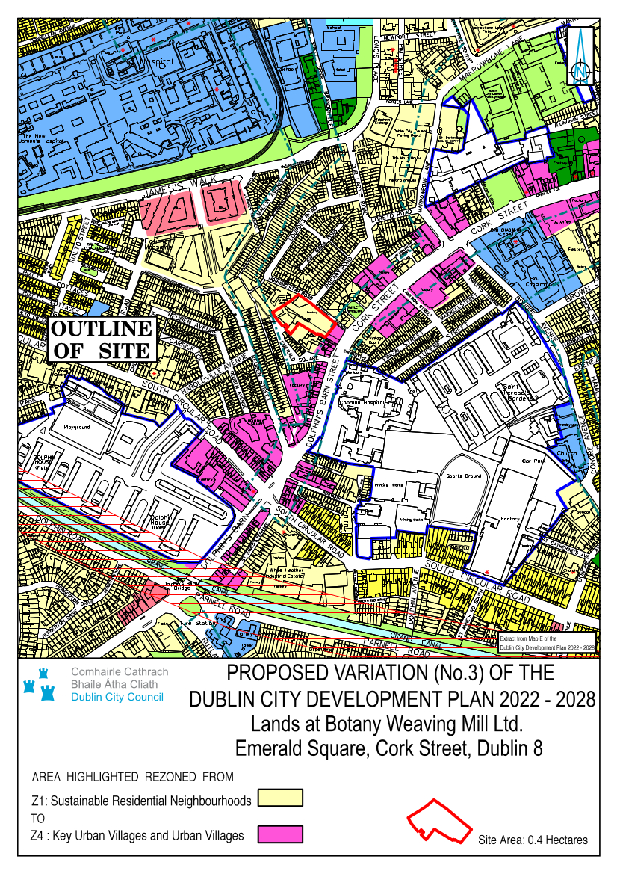

The Variation
The variation seeks to vary the Dublin City Development Plan 2022-2028, by changing the land use zoning of lands at Botany Weaving Mill Ltd, Emerald Square, Cork Street, Dublin 8 from Zoning Objective Z1 (Sustainable Residential Neighbourhoods) to Zoning Objective Z4 (Key Urban Villages and Urban Villages).

Procedure Followed
Public Notice and Public Display
Members of the public were invited to make submissions regarding the Proposed Variation. In accordance with the procedures set out in the Planning and Development Act
2000 as amended, the proposed variation was placed on public display from Thursday 5th October to Thursday 2nd November 2023 inclusive and a public notice was inserted into a national newspaper.

Copies of the Proposed Variation, together with the SEA and AA screening reports and a Strategic Flood Risk Assessment, were made available for inspection at the Civic Offices, Wood Quay, Dublin 8 and at the South Central Area Office, Eblana House, Marrowbone Lane, Dublin 8, within the above listed dates. Details were also available on the City Council’s website at www.dublincity.ie.

Environmental Determinations
The Proposed Variation has been screened as part of the processes for Strategic Environmental Assessment (SEA) and Appropriate Assessment (AA).

A Strategic Environmental Assessment (SEA) Screening Report on the Proposed Variation has been prepared and a determination has been made that a full SEA is not required to be undertaken.

An Appropriate Assessment (AA) Screening Report on the Proposed Variation has been prepared. The Appropriate Assessment (AA) Conclusion is that Variation No. 3 does not require an Appropriate Assessment or the preparation of a Natura Impact Report (NIR).

A Stage 1 Strategic Flood Risk Assessment accompanies the Proposed Variation.

Purpose of the Proposed Variation
The Botany Weaving Mill premises are subject to two zoning objectives under the 2022 – 2028 Dublin City Development Plan. The majority of Botany Weaving Mills lands are zoned Z1 ‘Sustainable Residential Neighbourhoods’ as delineated on the map above. The frontage of the premises onto Cork Street is zoned Z4 ‘Key Urban Villages/Urban Villages’, reflecting the urban village / mixed use nature of that road. The variation proposes that the whole Botany Weaving Mill lands will be subject to a Z4 zoning.
A Z4 zoning (Key Urban Villages / Urban Villages) pertaining to the whole premises would allow the development of urban village uses / a mixture of uses including residential uses on the lands. The proposed variation would also support the retention of the existing light industrial use on the lands.
In this regard it is also considered that the urban village zoning, rather than a residential zoning, would more appropriately support the continuation of the existing weaving and textile industry on site which has been in-situ since the 1930’s.

The weaving industry was synonymous with the Liberties area; this is acknowledged at Chapter 12 – Culture - Volume 1, Dublin CDP 2022 – 2028, page 389. Botany Weavers Mill in particular is of local historical interest as the lands are recorded as an ‘industrial heritage site’ (City Woollen Mills) and the existing manufacturing firm is the remaining weaving company in the Liberties.

Report on Submissions and observations

List of Submissions Received
The following persons or bodies made submissions or observations in relation to the proposed variation of the Development Plan.
- Office of the Planning Regulator (OPR)
- Eastern and Midland Regional Assembly (EMRA)
- Environmental Protection Agency (EPA)
- Uisce Éireann / Irish Water
- Transport Infrastructure Ireland (TII)
- Councillor Máire Devine
- TD Aengus O Snodaigh
- Mr Jonathan Hackett, CEO Botany Weaving Mill Ltd

Submission by the Office of the Planning Regulator (OPR)

Summary of Submission
The OPR accepts the rationale for the proposed zoning amendment and is of the view that it does not raise any concerns in relation to consistency with the legislative and policy requirements on the basis that the Office:

states that the proposed variation does not raise any issues in respect of compliance with section 28 guidelines,

accepts that the proposed variation will not materially affect the housing and population targets set out in the core strategy of the Development Plan,

accepts that the proposed Z4 zoning would appropriately support the continuation of the existing weaving and textile industry on site while facilitating the development of urban village uses/mixed uses including residential uses on the lands in the future,
states that the rezoning of the subject site will not have a material impact on Dublin achieving compact growth consistent with NPO 3 of the National Planning Framework,
and
agrees that any future redevelopment of the lands under a Z4 zoning can accommodate the desired permeability interventions and compact development as provided for in SDRA 15.

The proposed variation would therefore not undermine the capability of the Development Plan, to deliver a compact and connected city consistent with the national planning policy objectives.

Chief Executive’s Response
The OPR’s conclusion of the proposed variation is noted.

Recommendation
Submission is noted; no change recommended.

Submission by the Eastern and Midland Regional Assembly (EMRA)

Summary of Submission
The Regional Assembly supports in principle the proposed change of land use zoning objective which allows for a mix of land uses at this brownfield/regeneration site which aligns with the RSES Dublin MASP guiding principles for the growth of the Dublin Metropolitan Area including co-ordination and active land management and social regeneration. It states: ‘Given the built-in headroom figures contained in the current Dublin City Development Plan it is considered that the proposed variation will not have a material impact on the core strategy of the Dublin City Development Plan 2022-2028 from a housing delivery perspective.’

It does not have any objection to the proposed Variation No. 3 as it consideres that the proposed Variation No. 3 to the Dublin City Development Plan 2022-2028, is consistent with the Regional Spatial and Economic Strategy (RSES) 2019-2031 with particular regard to RPO 4.3 and RSO 2.

RPO 4.3 seeks to ‘Support the consolidation and re-intensification of infill/brownfield sites to provide high density and people intensive uses within the existing built up area of Dublin City and suburbs and ensure that the development of future development areas is co-ordinated with the delivery of key water infrastructure and public transport projects.’

RSO 2 - Compact Growth and Urban Regeneration’ – seeks to ‘promote the regeneration of our cities, towns and villages by making better use of under-used land and buildings within the existing built -up urban footprint and to drive the delivery of quality housing and employment choices for the Region’s citizens’. This aligns with National Strategic Outcome 1 of the National Planning Framework.

Chief Executive’s Response
EMRA’s acknowledgement of the proposed variation is noted.

Recommendation
Submission is noted; no change recommended.

Submission by the Environmental Protection Agency (EPA)

Summary of Submission
The Environmental Protection Agency (EPA) advocate consistency with higher level plans/ programmes, infrastructure-led development and alignment with national commitments on climate change mitigation and adaption. The agency highlights the environmental and climate change policy context of the proposed variation and provides guidance on the procedures for carrying out an SEA Screening determination.

Chief Executive’s Response
The Chief Executive notes the submission by the EPA and the policy context and guidance that the agency has provided.

Recommendation
Submission is noted; no change recommended.

Submission by Uisce Éireann / Irish Water

Summary of Submission
Uisce Éireann state that they have no objection or comments to make on the proposed variation.

Chief Executive’s Response
The content of the submission is noted.

Recommendation
Submission is noted; no change recommended.

Submission by Transport Infrastructure Ireland (TII)

Summary of Submission
Transport Infrastructure Ireland (TII) state that they have no observations to make on the proposed variation.

Chief Executive’s Response
The content of the submission is noted

Recommendation
Submission is noted; no change recommended.

Submissions from Local Representatives
Summary of Submissions
One submission was received from a local Councillor and another submission from a local TD, both endorsing the proposed change to the zoning on the lands that will support the ongoing weaving enterprise located on the lands, in turn supporting the employment generated at this premises, while remaining in compliance with the Development Plan’s policies and objectives.

Chief Executive’s Response
The Chief Executive notes these submissions and their welcome of the overall proposal.

Recommendation
Submissions are noted; no change recommended.

Submission from CEO of Botany Weaving Mill Ltd.

Summary of Submission
One submission was received from the CEO of Botany Weaving Mill Ltd, supporting the proposed variation that will secure the continued operation of the weaving mill at this location and thus support the continued employment of staff on the premises. The submission included the signatures (names) of employees with a hand written note identifying financial concerns, were the rezoning not to take place, and highlighting the proximity of many employees to their place of work with respect to a sustainable commute.

Chief Executive’s Response
The Chief Executive notes this submission with its observations that welcome and supports the overall proposal.

Recommendation
Submission is noted; no change recommended.

Recommendation to City Council
Having regard to the submissions received and to the Chief Executive’s Responses to the issues raised therein, it is recommended that the City Council adopt the Proposed Variation (No. 3) of the Dublin City Development Plan 2022-2028 to change the land use zoning of lands at Botany Weaving Mill Ltd, Emerald Square, Cork Street, Dublin 8 from Zoning Objective Z1 (Sustainable Residential Neighbourhoods) to Zoning Objective Z4 (Key Urban Villages and Urban Villages).

Resolution on Adopting Variation No. 3
I recommend that the Elected Members adopt the following resolution:

‘The Members of the authority having considered the proposed variation and the Chief Executive’s Report, and the issues raised, the proper planning and sustainable development of the City, the statutory obligations of the local authority and the relevant policies or objectives of the Government or of any Minister of the Government; the City Council resolves that Variation No. 3 of the Dublin City Development Plan 2022-2028 is hereby made and that the necessary notices of the making of Variation No. 3 of the Dublin City Development Plan 2022-2028 be published’.

Dated this day the 28th November 2023.

Richard Shakespeare
Chief Executive

