Strategic Flood Risk Assessment
(SFRA)

for

Proposed Variation
(No. 2)
of the

Dublin City Development Plan
2022-2028

- Introduction
Dublin City Council has commenced the preparation of proposed variation no. 2 to change the zoning of lands adjacent to Dublin City University Glasnevin Campus and Albert College Park, Glasnevin, Dublin 9 from Z12 (‘Institutional Land [Future Development Potential’]) to Z15 (Community and Social Infrastructure). The area of the lands is approximately 4.08 ha and they are delineated in red and identified in Figure 1 below.

The OPW is the lead agency for flood risk management in Ireland, part of the Department of Finance. The coordination and implementation of Government policy on the management of flood risk in Ireland is part of its responsibility. The European Communities (Assessment and Management of Flood Risks) Regulations 2010 (S.I. No. 122) identifies the Commissioners of Public Works as the ‘competent authority’ with overall responsibility for implementation of the Floods Directive 2007/60/EC.

The CFRAM (Catchment Flood Risk Assessment and Management) Programme has been completed and implementation of the outputs from this work is underway. The EU Floods Directive requires Member States to review the PFRA (Preliminary Flood Risk Assessment), the FRMPs (Flood Risk Management Plans) and the flood maps on a six-yearly cycle. As part of the OPW’s commitment to carry out these reviews, the NIFM (National Indicative Fluvial Maps) Programme was completed in 2019. The OPW continues to update predictive flood mapping to provide the best available flood risk information through the map review programme, where the criteria to trigger a review have been met.

The proposed draft variation documentation includes a planning report, a strategic environmental assessment (SEA) screening report (with a determination), an appropriate assessment (AA) screening report (and AA Screening Conclusion) and this SFRA document, which represents the Strategic Flood Risk Assessment (SFRA) statement of the proposed variation.

‘The Planning System and Flood Risk Management’ Guidelines (OPW, 2009), as amended by Circular Pl2/2014 together with Technical Appendices (the 2009 Guidelines) were issued under Section 28 of the Planning and Development Act 2000 as amended, and require Planning Authorities to introduce flood risk assessment as an integral and leading element of spatial planning. This requirement is also sought for variations to any development plan, hence the preparation of this accompanying document to the proposed variation report.

A Strategic Flood Risk Assessment SFRA was prepared as part of the making of the Dublin City Development Plan (CDP) 2022 – 2028. The Strategic Flood Risk Assessment (SFRA) for the administrative area of Dublin City Council is captured under Volume 7 to the City Development Plan (CDP) 2022 - 2028, with Chapter 9 (Sustainable Environmental Infrastructure and Flood Risk) of Volume 1, the Written Statement, of the CDP citing policies and objectives relating to Flood Management. This relevant documentation can be viewed here at: https://www.dublincity.ie/residential/planning/strategic-planning/dublin-city-development-plan/development-plan-2022-2028

Any planning application arising from this proposed variation no. 2 will be required to comply with the flood risk management and surface water management provisions of the Dublin City Development Plan 2022 – 2028.

1.1 The Proposed Variation

It is proposed to vary the Dublin City Development Plan 2022-2028, by changing the land use zoning of lands adjacent to Dublin City University Glasnevin Campus and Albert College Park, Glasnevin, Dublin 9.

From: Zoning Objective Z12 – ‘Institutional Land (Future Development Potential)’ - ‘To ensure existing environmental amenities are protected in the predominantly residential future use of these lands.’
To: Zoning Objective Z15: Community and Social Infrastructure – ‘To protect and provide for community uses and social infrastructure.’
Note: This is a zoning map change only and requires no change to the written statement.

1.2 Location and description of lands
The subject lands comprise large tilled fields adjoining the DCU campus to the north (and north east and west), Albert College Park also to the north and Hillside Farm (which comprises further agricultural lands / buildings) to the south, in Glasnevin in Dublin 9.

The subject lands are historically associated with Hampstead Estate. The lands have a treed / hedgerow boundary with the DCU campus (adjacent its internal access road) and Albert College Park to the north, an open boundary with Hampstead Hospital to the west and and open and fenced boundary with Hillside Farm (edge of road way and farmstead) to the south.

The lands are currently accessed via an internal road system serving Hillside Farm, Old Hampstead Hospital and Elmhurst Day Hospital and Nursing Home.

The wider surrounding area is well served by an existing public transport corridor with bus and cycle routes along Ballymun Road and Collins Avenue Extension. Bus Connects Applications have been lodged to An Bord Pleanala for routes to the east and west of the lands - Bus Connects Ballymun/Finglas to City Centre and Swords to City Centre Bus Connects.

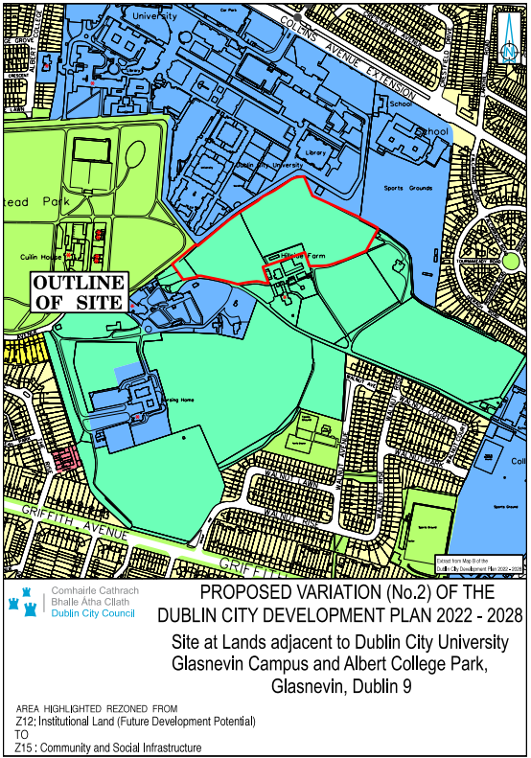
Figure 1: Location of Proposed Variation (No. 2) to the Dublin City Development Plan 2022-2028, lands adjacent to Dublin City University Glasnevin Campus and Albert College Park, Glasnevin, Dublin 9.
1.3 Purpose Of The Proposed Draft Variation
The subject site was acquired by DCU for future extension of the Dublin City University Campus and is required for educational purposes. A masterplan has been prepared by DCU that include these lands.

This proposed zoning change from Z12 to Z15 would help support and secure the extension and development of the DCU third level campus and its educational and related uses on the lands.

It would also align the zoning objective of the subject lands with the existing operational Dublin City University (DCU) campus lands located on adjoining Z15 lands thus providing a consistency to the zoning policy across the campus. This sequential approach to the extension of DCU on contiguous lands will ensure a compact and consolidated configuration of the landbank supporting a coherent, logical and optimal approach to the future layout of campus buildings within DCU.

1.4 Planning Context

Under the Dublin City Development Plan 2022-2028, the subject lands, located on Map B, Volume 3 to the CDP, are zoned Zone Z12 (‘Institutional Land [Future Development Potential]’) where the objective is ‘To ensure existing environmental amenities are protected in the predominantly residential future use of these lands.’ There are no specific objectives attaching to the variation site.

Adjoining lands to the north comprise the existing and operational DCU campus and are zoned Z15 (Community and Social Infrastructure) where the objective is ‘To protect and provide for community uses and social infrastructure.’
Lands to the west are zoned Z9 (Amenity/Open Space Lands/ Green Network) and comprise a large area known as Hampstead Park.

2.0 Flood Risk Guidance

The 2009 Guidelines recommend a staged approach to Flood Risk Assessment (pg 14):

Stage 1 – identify any flood risks issues
Stage 2 – where flood risk issues arise, identify the sources and access available mapping with flood risk extents
Stage 3 – detailed flood risk assessment
The CDP’s SFRA provides a flood extents map for the entire area of the city. This comprises the three flood zone classifications identified in the Guidelines, Flood Zones A, B and C. Flood Zones A and B are described as being of high probability of flooding and moderate probability of flooding respectively and low probability of flooding for Flood Zone C (pg 24).
These are coloured coded (dark blue and lighter blue for Flood Zones A and B respectively) and where no colour (white) is equivalent to Flood Zone C. Land-uses and types of development are accorded a vulnerability class, as set out in Table 3.1 of the Guidelines (pg 25). A matrix of what vulnerability class is appropriate for each flood zone has been provided in Table 3.2 of the Guidelines (pg 26), see extract below.
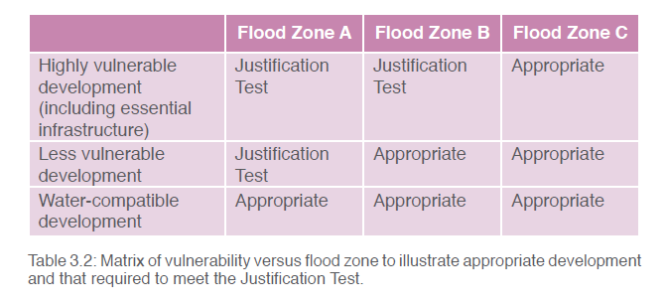
Extract: Table 3.2: Matrix of vulnerability versus flood zone to illustrate appropriate development and that required to meet the Justification Test (taken from the 2009 Planning Flood Risk Management Guidelines).

2.1 Screening

The lands will be subject to land use zoning:

Z15: Community and Social Infrastructure – ‘To protect and provide for community uses and social infrastructure.’
According to the Dublin City Development Plan SFRA, the lands are located in flood zone C.

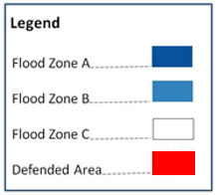
Figure 2: Composite Flood Map, Appendix E of the Dublin City Development Plan 2022 – 2028 Strategic Flood Risk Assessment, Dec 22. This shows the lands in flood zone c.

The proposed draft variation will allow for the development of a range of community and social infrastructure uses on the lands including educational uses. The vulnerability class that will pertain to these lands is therefore described as a ‘highly vulnerable development’.
For ‘highly vulnerable development’, a plan-making justification test is required for lands in Flood Zone A and Flood Zone B but not for Flood Zone C as these are considered ‘Appropriate’ and a justification test is not required.

The lands are located in Flood Zone C, and proposed land uses are considered appropriate in this flood zone. It is considered that the proposed draft variation in respect of these lands is considered ‘appropriate’ for highly vulnerable development,

3.0 Conclusion
The Flood Risk Assessment (Stage 1) for the Proposed Variation no. 2 on lands (4.08ha) adjacent to Dublin City University Glasnevin Campus and Albert College Park, Glasnevin, Dublin 9 has been undertaken in accordance with the requirements of Section 28 Guidelines for Planning Authorities: ‘The Planning System and Flood Risk Management’, 2009, as amended.

The proposed variation, in respect of lands with a Flood Zone C classification, does not require a justification test as the proposed land-zoning use, Z15 (Community and Social Infrastructure), while considered to apply to highly vulnerable uses, relates to land that has been classified as having a low probability of flooding.

Notwithstanding the above assessment, any future planning proposal for development on the variation site must comply with the requirements for surface water management and flood risk management. In respect of flood risk the 100 year flood must be contained on site.

This is to ensure that there is no increase in flood risk to properties upstream or downstream as a result of future development. This will be captured under the Development Management process.

Having reviewed the flood risk assessment in accordance with the above Guidelines the following has been determined:

The proposed variation, that seeks to change an area of land (4.08ha) from Z12 to Z15, and where the primary use of such a zoning objective is community and social infrastructure is located on land that is classified as Flood Zone C (a low probability of flooding), where such uses (categorised as a vulnerable use) are considered appropriate and not requiring a justification test under the Section 28 Guidelines for Planning Authorities: ‘The Planning System and Flood Risk Management’, 2009, as amended.

________________

Deirdre Scully
City Planner

Date: 8th September 2023

