To the Lord Mayor and Report of the Chief Executive
Members of Dublin City Council

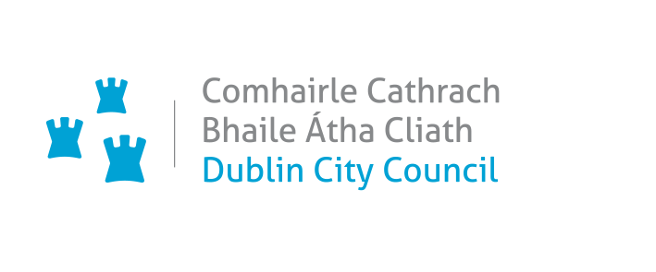_________________________________________________________________________
PROPOSED VARIATION (NO. 2) OF THE DUBLIN CITY DEVELOPMENT PLAN 2022 – 2028

RE: Lands adjacent to Dublin City University Glasnevin Campus and Albert College Park, Glasnevin, Dublin 9
_________________________________________________________________________

Executive Summary

The Variation
It is proposed to vary the Dublin City Development Plan 2022-2028, by changing the land use zoning of lands adjacent to Dublin City University (DCU) Glasnevin Campus and Albert College Park, Glasnevin, Dublin 9 from Zoning Objective Z12 Institutional Land (Future Development Potential) to Zoning Objective Z15 Community and Social Infrastructure.

The Purpose of the Variation
It is considered appropriate to change the Z12 land use zoning of the subject lands to Z15 (Community and Social Infrastructure) as a Z15 zoning, rather than a residential zoning as provided for under Z12, would help secure and support the extension and development of the DCU third level campus and its educational and related uses on the subject lands. The rezoning would also reflect the zoning objective of the main DCU campus thus providing a consistency to the zoning policy across the existing and extended campus.

Submissions
In total six submissions were received from Transport Infrastructure Ireland, Eastern and Midland Regional Assembly, the Environmental Protection Agency, Uisce Éireann, Dublin City University and the Office of the Planning Regulator.

Issues Raised
The majority of submissions support and accept the rationale for the proposed zoning amendment and state the rezoning of these lands is consistent with legislative and policy requirements and will allow for the orderly and planned expansion of the DCU Glasnevin Campus.

Response
The Chief Executive notes all these submissions and the support for the proposed change of land use zoning objective which will allow for the orderly and planned expansion of the DCU Glasnevin Campus.

Proposal

It is proposed to vary the Dublin City Development Plan 2022-2028, by changing the land use zoning of lands adjacent to Dublin City University (DCU) Glasnevin Campus and Albert College Park, Glasnevin, Dublin 9.

From: Zoning Objective Z12 – ‘Institutional Land (Future Development Potential)’ - ‘To ensure existing environmental amenities are protected in the predominantly residential future use of these lands.’

To: Zoning Objective Z15: Community and Social Infrastructure – ‘To protect and provide for community uses and social infrastructure.’

The relevant lands are 4.08 ha in area and are delineated on the map below, an extract from Map B, Volume 3 of the Dublin City Development Plan 2022 – 2028.
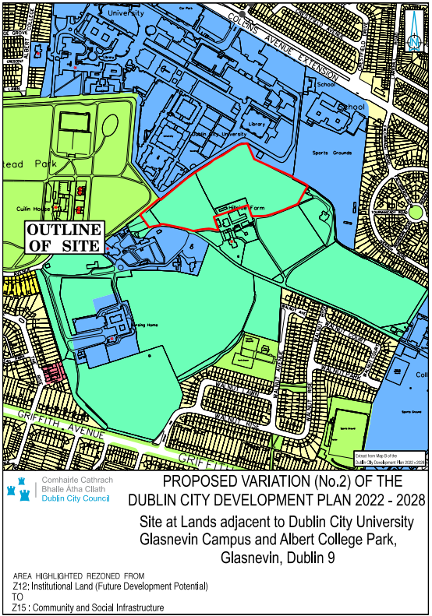

Procedure Followed
Public Notice and Public Display
Members of the public were invited to make submissions regarding the Proposed Variation. In accordance with the procedures set out in the Planning and Development Act 2000 as amended, the proposed variation was placed on public display from 5th October to 2nd November 2023 inclusive and a public notice was inserted into a national newspaper.

Copies of the Proposed Variation, together with the SEA and AA screening reports and Strategic Flood Risk Assessment, were made available for inspection at the Civic Offices, Wood Quay, Dublin 8 and at North Central Civic Centre, Bunratty Road, Coolock, Dublin 17 within the above listed dates. Details were also available on the City Council’s website at www.dublincity.ie.

Environmental Determinations
The Proposed Variation has been screened as part of the processes for Strategic Environmental Assessment (SEA) and Appropriate Assessment (AA).

A Strategic Environmental Assessment (SEA) Screening Report on the Proposed Variation has been prepared and a determination has been made that a full SEA is not required to be undertaken.

An Appropriate Assessment (AA) Screening Report on the Proposed Variation has been prepared. The Appropriate Assessment (AA) Conclusion is that Variation No. 2 does not require an Appropriate Assessment or the preparation of a Natura Impact Report (NIR).

A Stage 1 Strategic Flood Risk Assessment accompanies the Proposed Variation.

Purpose of the Proposed Variation
Under the 2022 – 2028 Dublin City Development Plan, the existing Dublin City University (DCU) Glasnevin campus is zoned Z15 (Community and Social Infrastructure) where the objective is ‘to protect and provide for community uses and social infrastructure.’ This Z15 zoning objective reflects the third level college campus and related uses on the lands.

The subject lands, which abut the DCU campus, have been acquired by DCU for the future sequential expansion of the college and its educational and related uses. DCU has prepared a masterplan for its lands in the Glasnevin area.

The subject lands are currently zoned Z12 (‘Institutional Land (Future Development Potential)’, and these lands are required / identified for predominantly residential use. These Z12 lands form part of a wider agricultural land bank which are zoned Z12 in the current Development Plan.

As set out at Section 5.5.8 of the Dublin City Development Plan 2022 – 2028, the Council recognises the importance of 3rd level colleges such as Dublin City University, to the city and supports their need for development, expansion and consolidation in line with national policy.

In this vein it is considered appropriate to change the Z12 land use zoning of the subject lands to Z15 (Community and Social Infrastructure). A Z15 zoning, rather than a residential zoning as provided for under Z12, would help secure and support the extension and development of the DCU third level campus and its educational and related uses on the subject lands. The rezoning would also reflect the zoning objective of the main DCU campus thus providing a consistency to the zoning policy across the existing and extended campus.

Report on Submissions and observations

List of Submissions Received
The following persons or bodies made submissions or observations in relation to the proposed variation of the Development Plan.
- Transport Infrastructure Ireland
- Eastern and Midland Regional Assembly
- Environmental Protection Agency
- Uisce Éireann
- Dublin City University
- Office of the Planning Regulator

Submission by the Office of the Planning Regulator (OPR)

Summary of Submission
The OPR accepts the rationale for the proposed zoning amendment and is of the view that it does not raise any concerns in relation to consistency with legislative and policy requirements. The Office accepts that the proposed Variation will not materially affect the housing and population targets set out in the core strategy of the Dublin City Development Plan 2022-2028 and will not have a material impact on Dublin achieving compact growth consistent with NPO 3 of the National Planning Framework. The Office acknowledges that the subject lands are required for the expansion of the DCU campus and agrees that changing the land use zoning to Z15 is consistent with the existing adjoining university land use zoning. The Office welcomes that the proposed Variation has been screened as part of the processes for Strategic Environmental Assessment (SEA) and Appropriate Assessment (AA) and concludes that the proposed Variation does not raise any issues in respect of compliance with section 28 guidelines.

Chief Executive’s Response
The OPR’s conclusion of the proposed Variation is noted.

Recommendation
Submission is noted; no change recommended.

Submission by the Eastern and Midland Regional Assembly

Summary of Submission
The Eastern and Midland Regional Assembly (EMRA) supports in principle the proposed change of land use zoning objective which will allow for the orderly and planned expansion of the DCU Glasnevin Campus and compliment RPO 9.22 in the RSES ‘To support the role of Higher Education Institutions and Educational Training Boards in addressing skills shortages and life-long learning needs in the Region, and to support the further development of multi-campus Technological Universities to drive research and innovation’. EMRA state that given the built-in headroom figures contained in the current Dublin City Development Plan it is not considered that the proposed variation will have a material impact on the core strategy of the Dublin City Development Plan 2022-2028 from a housing delivery perspective.

EMRA considers that the proposed Variation is consistent with the Regional Spatial and Economic Strategy (RSES) 2019-2031 and will align with Regional Strategic Outcomes 13 and 2 of the RSES, and will not impact on any of the Regional Policy Objectives contained in the RSES as it relates to Dublin City and the wider Metropolitan Area.

Chief Executive’s Response
EMRA’s support of the proposed Variation is noted.

Recommendation
Submission is noted; no change recommended.

Submission by the Environmental Protection Agency (EPA)

Summary of Submission
The Environmental Protection Agency (EPA) advocate consistency with higher level plans/ programmes, infrastructure-led development and alignment with national commitments on climate change mitigation and adaption. The agency highlights the environmental and climate change policy context of the proposed Variation and provides guidance on the procedures for carrying out an SEA Screening determination.

Chief Executive’s Response
The Chief Executive notes the submission by the EPA and the policy context and guidance that the agency has provided.

Recommendation
Submission is noted; no change recommended.

Submission by Uisce Éireann / Irish Water

Summary of Submission
Uisce Éireann state that they have no objection or comments to make in respect of the proposed Variation.

Chief Executive’s Response
The content of the submission is noted.

Recommendation
Submission is noted; no change recommended.

Submission by Transport Infrastructure Ireland

Summary of Submission
Transport Infrastructure Ireland (TII) state that they have no observations to make on the proposed Variation.

Chief Executive’s Response
The content of the submission is noted

Recommendation
Submission is noted; no change recommended.

Submission by Dublin City University

Summary of Submission
A submission by Dublin City University (DCU) states that DCU continues to expand in an effort to respond to the demographic pressures in the Dublin and north Leinster regions in particular and the acquisition of this 9.7 acre field, which abuts the Glasnevin campus eastern boundary, in 2019 is to provide additional land for capacity growth into the future. They state that the land in question is landlocked with the majority of its western boundary adjoining the DCU Glasnevin campus. DCU has prepared a masterplan for its academic campuses that includes the future development on this land. DCU state that they have planning permission for 1230 new on-campus beds on lands adjacent to these lands at its Glasnevin campus and have ambitions to build a further 500-600 student beds. DCU state that this is aligned with national policy in terms of the provision of additional affordable on-campus student accommodation that will help reduce the use of private rental accommodation by students.

DCU state that the University plays an important role in the economic, societal, cultural and sporting activities of Dublin City and the broader region and the rezoning of these lands will help the University provide additional capacity to respond to the regional demographic demands for access to third level education in the decade ahead.

Chief Executive’s Response
The content of the submission is noted.

Recommendation
Submission is noted; no change recommended.

Recommendation to City Council
Having regard to the submissions received and to the Chief Executive’s Response to the issues raised therein, it is recommended that the City Council adopt the Proposed Variation (No. 2) of the Dublin City Development Plan 2022-2028 to change the land use zoning of lands adjacent to Dublin City University (DCU) Glasnevin Campus and Albert College Park, Glasnevin, Dublin 9 from Zoning Objective Z12 Institutional Land (Future Development Potential) to Zoning Objective Z15 Community and Social Infrastructure.

Resolution on Adopting Variation No. 2
I recommend that the Elected Members adopt the following resolution:

‘The Members of the authority having considered the proposed variation and the Chief Executive’s Report, and the issues raised, the proper planning and sustainable development of the City, the statutory obligations of the local authority and the relevant policies or objectives of the Government or of any Minister of the Government; the City Council resolves that Variation No. 2 of the Dublin City Development Plan 2022-2028 is hereby made and that the necessary notices of the making of Variation No. 2 of the Dublin City Development Plan 2022-2028 be published’.

Dated this day the 28th November 2023.

Richard Shakespeare
Chief Executive

