Strategic Flood Risk Assessment

for

Proposed Variation
(No. 1)
of the

Dublin City Development Plan
2022-2028

- Introduction
Dublin City Council has prepared proposed variation no. 1 to reorganise the land use zoning of the lands at Basin View, Dublin 8 from Z1 (Sustainable Residential Neighbourhoods) and Z9 (Amenity/Open Space Lands/Green Network) to Z9 (Amenity/Open Space Lands/Green Network) and Z1 (Sustainable Residential Neighbourhoods).

The OPW is the lead agency for flood risk management in Ireland, part of the Department of Finance. The coordination and implementation of Government policy on the management of flood risk in Ireland is part of its responsibility. The European Communities (Assessment and Management of Flood Risks) Regulations 2010 (S.I. No. 122) identifies the Commissioners of Public Works as the ‘competent authority’ with overall responsibility for implementation of the Floods Directive 2007/60/EC.

The CFRAM (Catchment Flood Risk Assessment and Management) Programme has been completed and implementation of the outputs from this work is underway. The EU Floods Directive requires Member States to review the PFRA (Preliminary Flood Risk Assessment), the FRMPs (Flood Risk Management Plans) and the flood maps on a six-yearly cycle. As part of the OPW’s commitment to carry out these reviews, the NIFM (National Indicative Fluvial Maps) Programme was completed in 2019. The OPW continues to update predictive flood mapping to provide the best available flood risk information through the map review programme, where the criteria to trigger a review have been met.

As a variation to the Dublin City Development Plan 2022 – 2028, the preparation of the proposed variation no.1 documentation, apart from the principal variation report, includes a Strategic Environmental Assessment (SEA) Screening, an Appropriate Assessment (AA) Screening and this document, which represents the Strategic Flood Risk Assessment (SFRA) statement of the variation site.

The SFRA, prepared as part of the Dublin City Development Plan (CDP) 2022 – 2028 and which informed the preparation of the CDP, had regard to the DEHLG Guidelines for Planning Authorities (DEHLG & OPW, 2009) on ‘The Planning System and Flood Risk Management’ as amended by Circular Pl2/2014 together with Technical Appendices. These Guidelines (the 2009 Guidelines) were issued under Section 28 of the Planning and Development Act 2000 as amended, and require Planning Authorities to introduce flood risk assessment as an integral and leading element of Spatial Planning. This requirement is also sought for variations to any development plan, hence the preparation of this accompanying document to the proposed variation report.

The Strategic Flood Risk Assessment (SFRA) for the administrative area of Dublin City Council is captured under Volume 7 to the City Development Plan (CDP) 2022 - 2028, with Chapter 9 (Sustainable Environmental Infrastructure and Flood Risk) of Volume 1, the Written Statement, of the CDP citing policies and objectives relating to Flood Management. This relevant documentation can be viewed here at: https://www.dublincity.ie/residential/planning/strategic-planning/dublin-city-development-plan/development-plan-2022-2028

Any planning application arising from this proposed variation no. 1 will be required to comply with the flood risk management and surface water management provisions of the Dublin City Development Plan 2022 – 2028.

1.1 The Proposed Variation

It is proposed to vary the Dublin City Development Plan 2022-2028 to reorder the land use zoning of the subject lands at Basin View, Dublin 8;

From:

Zoning Objective Z1 - To protect, provide and improve residential amenities

and

Zoning Objective Z9 - To preserve, provide and improve recreational amenity, open space and ecosystem services

To:

Zoning Objective Z9 - To preserve, provide and improve recreational amenity, open space and ecosystem services

and

Zoning Objective Z1 - To protect, provide and improve residential amenities,

The proposed draft variation areas are delineated on the attached map.
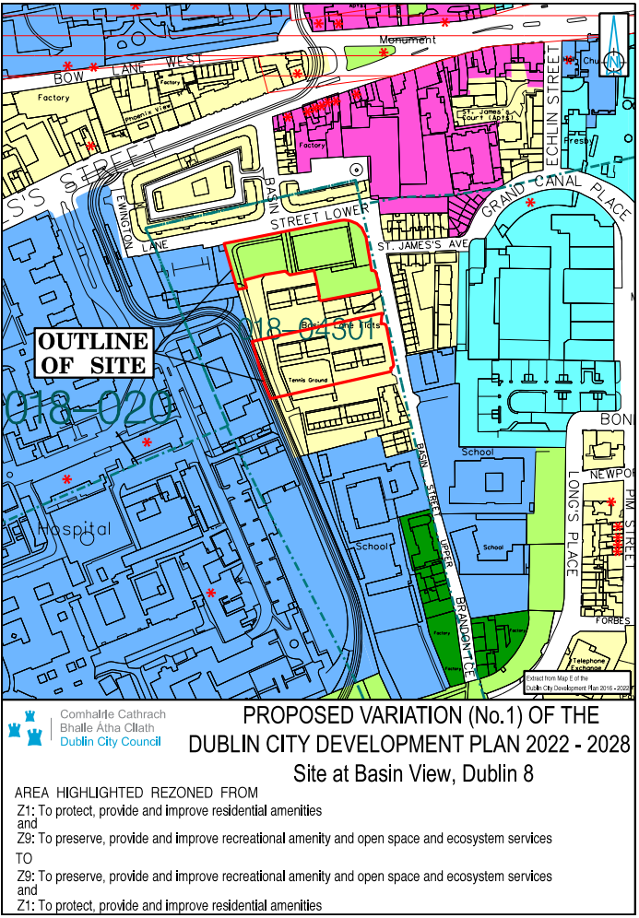

1.2 Purpose of The Proposed Draft Variation
The Planning Authority considers that it is appropriate to reorganise the land use zoning of the lands at Basin View, Dublin 8 from Z1 (Sustainable Residential Neighbourhoods) and Z9 (Amenity/Open Space Lands/Green Network) to Z9 (Amenity/Open Space Lands/Green Network) and Z1 (Sustainable Residential Neighbourhoods) on foot of a request from the Housing Department of the Council.
The Basin Street Flats site was selected for inclusion in the Social Housing Public Private Partnership (PPP) Programme, which is a partnership between the Department of Housing, Local Government and Heritage (DoHLGH), local authorities, the National Development Finance Agency and a specially formed Project Company to deliver new social housing units. The DoHLGH have approved in principle the site at Basin View, which is the first site to be regenerated under this programme and where 100-170 units are to be constructed.
The area encompassing the two variation sites will be the subject of a significant scale regeneration project, providing high quality new housing and a new public park. The purpose of the variation is to allow a new design and footprint for the housing, and a re-positioning of Oisín Kelly Park so that it serves better the residents of the regenerated housing and the wider public within the community. This re-positioning will also allow for a less disruptive approach to the regeneration of the site, by facilitating construction in a phased manner. The size of both plots are almost identical; and this proposed change will not result in the loss of any Z9 lands to this area. It will however, ensure that the open space provided in this street block is significantly upgraded and will provide a high quality amenity space for the community.
Allowing the reordering the zoning on this site will facilitate the successful delivery of the overall development, comprising of a new mixed tenure housing development; improved permeability east to west and north to south; a new Oisín Kelly Park in line with the Dublin City Council Parks Strategy 2019 and overall enrichments to the public realm.
The lands are located within the St. James Harbour Character Area of SDRA 15 Liberties and Newmarket Square, an area which has considerable regeneration potential with both private and public land holdings of considerable scale. Connectivity and green infrastructure initiatives are identified in the SDRA, including improved public open space at Oisín Kelly Park and new east-west permeability interventions between the St. James’ Hospital grounds and Basin View, which are required in order to improve the amenity for existing and future residents and to better integrate the area with its adjoining institutions and neighbourhoods.
It is therefore considered appropriate to seek to reorder the land use zoning of the subject lands at Basin View, Dublin 8 to Z1 (Sustainable Residential Neighbourhoods) and Z9 (Amenity/Open Space Lands/Green Network) for the following reasons:
- Oisín Kelly Public Park is currently underutilised by the general public with anti-social behaviour along the access streets Basin Street Lower and Basin View;
- Improved permeability along the public park to facilitate desirable connections with the surrounding area and provide clear, safe public streets;
- The area of park will open up a north-south connection alongside the Luas line and Basin Street Lower to cater for pedestrians;
- Improved permeability also opens up an east-west connection that allows St. James’s hospital usage of the public park and connection through the new Basin View development to Grand Canal Harbour and Bond Street;
- Clearly defines the flow and separation of the spaces between public; semi-public and private areas.
- Provides housing within enclosed urban blocks, making defensible amenity courtyard spaces thus enabling passive supervision of public open spaces and prevention of anti-social behaviour.
- Use of the redevelopment as an opportunity to improve public realm and surrounding streets to better integrate the scheme with its neighbourhood and support the Council’s wider regeneration strategies.
- The reordering of the zoning will provide a simpler phasing strategy, lower overall development costs and provides a feasible scheme that will regenerate this area of the city.
- Extension of amenity/recreational spaces in association with the linear park along St James Hospital.
- Existing area of Z9 land zoning (0.422 ha) is equal to the proposed Z9 land zoning (0.422 ha).

It is noted that there also have been significant improvements made and planned in the delivery of new public open space and upgraded open space in the wider area in the recent past, including Weaver Park, Bridgefoot Street, St Luke’s, St. Audeon’s Park, St Teresa’s Gardens and St. James's Linear Park.

1.3 Planning Context

The lands are located at Basin View, Dublin 8 and comprise Oisín Kelly Park adjoining Basin Street Lower to the north and the site of the two central blocks of Basin Street Flats.

Oisín Kelly Park is 0.422ha in area and accommodates a small hardstanding playing area and a grassed playground. The park is currently underutilised by the general public and the playground equipment and hardstanding playing area have been the subject of anti-social behaviour. It is proposed to change the land use zoning of Oisín Kelly Park which is currently zoned Z9 (Amenity/Open Space Lands/Green Network) to Z1 (Sustainable Residential Neighbourhoods).

The site of the two central blocks of Basin Street Flats is 0.422ha in area and is located between Basin View and the Luas Red line which runs to the west of the site. It is proposed to change the land use zoning of this part of the site which is currently zoned Z1 (Sustainable Residential Neighbourhoods) to Z9 (Amenity/Open Space Lands/Green Network).

There is no recent relevant planning history pertaining to the lands. A brief planning profile of the proposed variation site is as follows:
There are;
- no Natura 2000 sites on or beside the variation site
- no NHA (Natural Heritage Area) or a proposed NHA on or beside the variation site and,
- no significant flooding issues as identified in the accompanying SFRA statement to this variation documentation, which classifies the site as Flood Zone C (with a low probability of flooding) suitable for a vulnerable use such as housing without the need for a justification test, all as per the Section 28 Guidelines on Flooding 2009, as amended.
The site is located within a zone of archaeological interest associated with St. James’s Walk Watercourse (DU018-04301).

2.0 Flood Risk Guidance

The 2009 Guidelines recommend a staged approach to Flood Risk Assessment (pg 14):

Stage 1 – identify any flood risks issues
Stage 2 – where flood risk issues arise, identify the sources and access available mapping with flood risk extents
Stage 3 – detailed flood risk assessment

The CDP’s SFRA provides a flood extents map for the entire area of the city. This comprises the three flood zone classifications identified in the Guidelines, Flood Zones A, B and C. Flood Zones A and B are described as being of high probability of flooding and moderate probability of flooding respectively and low probability of flooding for Flood Zone C (pg 24). These are coloured coded (dark blue and lighter blue for Flood Zones A and B respectively) and where no colour is equivalent to Flood Zone C.

Land-uses and types of development are accorded a vulnerability class, as set out in Table 3.1 of the Guidelines (pg 25). The intended land use of the proposed variation is principally residential and open space/amenity in nature. The vulnerability class for residential development is described as a ‘highly vulnerable development’ and for open space/amenity is ‘water-compatible development.’ A matrix of what vulnerability class is appropriate for each flood zone has been provided in Table 3.2 of the Guidelines (pg 26), see extract below.
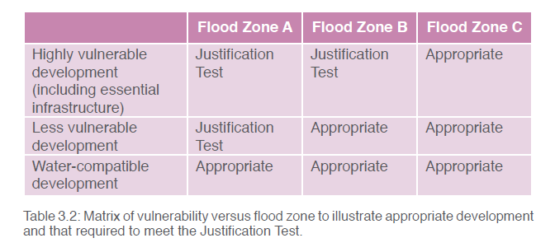
Extract: Table 3.2: Matrix of vulnerability versus flood zone to illustrate appropriate development and that required to meet the Justification Test (taken from the 2009 Planning Flood Risk Management Guidelines).

For ‘highly vulnerable development’, a plan-making justification test is required for lands in Flood Zone A and Flood Zone B but not for Flood Zone C as these are considered ‘Appropriate’.

The lands are located in Flood Zone C, which from the above is considered ‘appropriate’ for highly vulnerable development, such as residential development, and ‘appropriate’ for water-compatible development, such as open space/amenity.

An extract from the Dublin City Council Map E Flooding Map is set out below under Figure 2, demonstrating the above categorisation of the variation site. The approximate location of the variation site is marked with a red star.

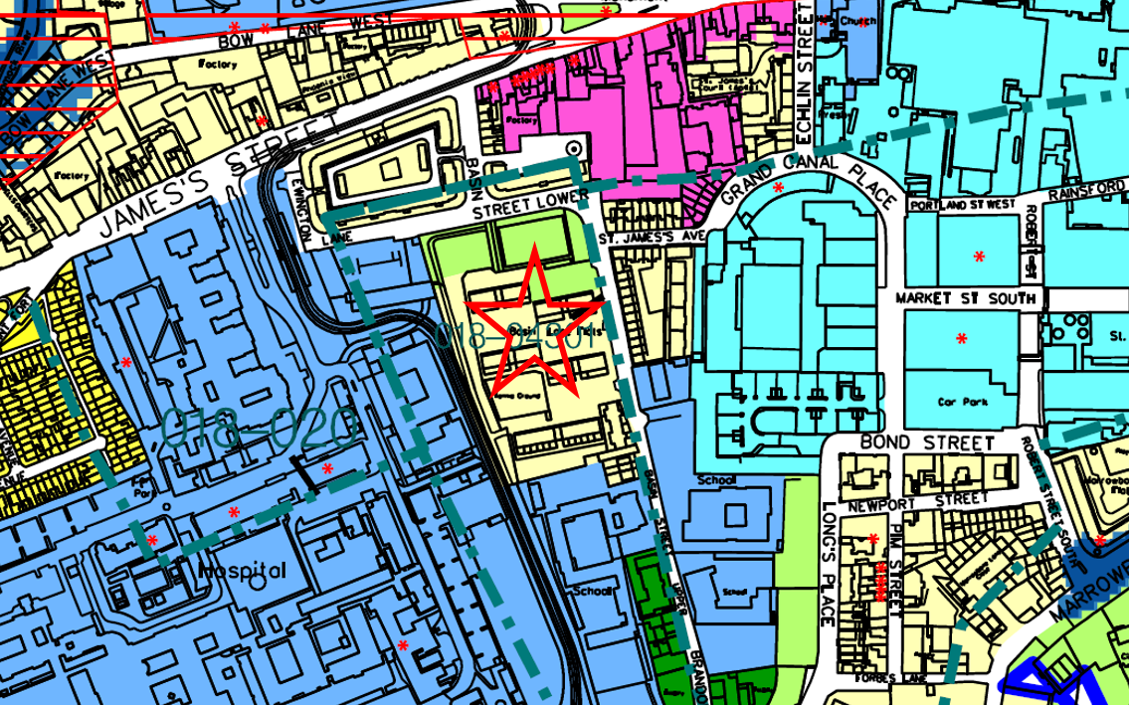
Figure 2: Subject site indicated with a red star, located at Basin View, Dublin 8
Source: Extract from DCC CDP, SFRA Volume 7, Zoning Map E with Flood mapping overlay.

3.0 Conclusion
The Flood Risk Assessment for the Proposed Variation no. 1 on lands at Basin View, Dublin 8 has been undertaken in accordance with the requirements of Section 28 Guidelines for Planning Authorities: ‘The Planning System and Flood Risk Management’, 2009, as amended.

The subject site, with a Flood Zone C classification, does not require a justification test at this time, as the proposed land-zoning uses, Z1 (Sustainable Residential Neighbourhoods) and Z9 (Amenity/Open Space Lands/Green Network) and likely development uses for these lands, residential considered a highly vulnerable use and open space/amenity considered a water-compatible use are located on lands that are classified as having a low probability of flooding.

Notwithstanding the above assessment, any future planning proposal for development on the variation site will be required to comply with the Development Plan for surface water management.

This is to ensure that there is no increase in flood risk to properties upstream or downstream as a result of future development. This will be captured under the Development Management process.

Having reviewed the flood risk assessment in accordance with the above Guidelines the following has been determined:
The proposed variation, that seeks to reorganise the land use zoning of the lands at Basin View, Dublin 8 from Z1 (Sustainable Residential Neighbourhoods) and Z9 (Amenity/Open Space Lands/Green Network) to Z9 (Amenity/Open Space Lands/Green Network) and Z1 (Sustainable Residential Neighbourhoods), and where the primary uses of such zoning objectives are largely likely to be residential and open space/amenity in nature are located on lands that are classified as Flood Zone C (a low probability of flooding), where residential use (categorised as a vulnerable use) and open space/amenity use (categorised as a water-compatible use) are considered appropriate and not requiring a justification test under the Section 28 Guidelines for Planning Authorities: ‘The Planning System and Flood Risk Management’, 2009, as amended. Therefore any future planning application that may arise from same that adequately addresses, through design, the flood risk/surface water requirement as part of the planning application process, through development management, is not likely to change flood risk in the area, upstream or downstream.

