DUBLIN CITY
2022-2028
DEVELOPMENT PLAN
Draft Plan
Proposed Material Alterations
Volumes 1, 2 & 4
July 2022

Contents

In this Document

- Volume 1 Written Statement page 7
- Volume 2 Appendices page 182
- Volume 4 RPS page 214

In Separate Documents

- Volume 3 Maps
- Volume 5 SEA Report
- Volume 6 AA Natura Impact Report
- Volume 7 SFRA
- Determinations SEA and AA

Introduction

The Draft Dublin City Development Plan 2022‐2028 was placed on public display from the 29th of November 2021 to the 14th of February 2022. A total of 4,323 submissions and observations were received during the prescribed period in response to this stage of public consultation.

In accordance with the requirements of Section 12(4)(b) of the Planning and Development Act 2000 (as amended), a Chief Executive’s Report was prepared, which summarised and detailed the submissions received on the Draft City Development Plan and provided the response and recommendations of the Chief Executive to the issues raised for the members to consider.

On foot of this report, motions were received from the elected members and a further CE Report providing a response and recommendations on these motions was issued on the 24th of June 2022 (Report No. 120/2022).

The Members of Dublin City Council, having considered the Draft City Development Plan 2022‐2028 and the Chief Executive’s Report on submissions received, under Section 12(b) of the Planning Act 2000 as amended, resolved at the special Council meeting held on the 5th, 6th and 7th of July 2022 to amend the Draft City Development Plan. A number of these amendments constitute material alterations to the Draft City Development Plan. Accordingly, the Council resolved to place the material alterations on public display for a period of not less than 4 weeks, in accordance with Section 12(7)(b) of the Planning and Development Act 2000 (as amended).

Proposed Material Alterations to the Draft Dublin City Development Plan 2022-2028

This document details the proposed material alterations in order to inform and assist the public and other interested parties in consideration of the proposed material alterations to the Draft City Development Plan.

Written observations or submissions, submitted during the consultation period, (27th July to 4.30 pm 1st September 2022) regarding the proposed material alterations and the likely significant effects on the environment of their implementation will be taken into consideration at this stage in the development plan process. After the consultation period ends, the Chief Executive will prepare a report on all submissions and observations received during the prescribed period and submit the report to the Elected Members by 29th September for their consideration. Having considered the proposed material alterations to the Draft Plan and the Chief Executive’s Report on submissions received, the Elected Members will make the Dublin City Development Plan 2022-2028 with or without amendment, at the end of October (date to be confirmed)

How to Make a Submission/Observation

Written observations or submissions regarding the proposed material alterations only must be received between

Wednesday 27th July 2022 and 4.30pm Thursday 1st September 2022.

- Online at www.dublincitydevelopmentplan.ie

- In writing to:

Development Plan Team, Planning & Property Development Department, Block 4 Floor 3, Civic Offices, Wood Quay, Dublin 8, D08 RF3F

Submissions/observations should be made by one medium only and should refer to

- Proposed Material Alteration Reference number (s) as shown in the document.

- Full Name & Address of person making submission/observation.

- Details of organisation/community group/company which you represent where relevant.

If you require any assistance you can contact a member of the Development Plan team on:

Tel: 01 222 3086.
Email: development.plan@dublincity.ie

How this Document is Organised

Written Statement, Appendices and RPS: The proposed material alterations to the Written Statement of the Draft Dublin City Development Plan 2022-2028 are set out in Volume 1 of this document, while proposed material alterations to the Appendices are set out in Volume 2 and to the RPS in Volume 4.

Material Alterations to the text of the Draft Plan are assigned a Material Alteration Reference Number. Their location in the Draft City Development Plan is indicated where applicable (any references to page numbers are to the Draft Dublin City Development Plan page number).

Proposals to add text to the Draft Plan are shown by way of bold green and underlined text.

Proposals to delete text are shown in bold red text with strikethrough.

A number of proposed alterations may contain a mix of deleted text and new text which would contain both red strikethrough and green text.

To assist those utilising a screen reader:

Alterations are enclosed with brackets with the following format: { }
Deletions are enclosed with brackets with the following format: ()

Please note, if you are using a screen reader, the level of punctuation may need to be amended throughout the text in order to identify these brackets correctly.

See example below:

Material Alteration Reference Number ES: 1.1

Executive Summary
Section: Chapter 2: Core Strategy
Page: 5, third paragraph on ‘population targets’

Amendment:

The plan considers Population Targets. It uses the national guidelines on how to calculate likely population increase. By 2028, the city must accommodate between (21,350 - 31,450) {20,120 – 31,520} additional people, up to an overall population target of between 625,750 and 640,000 people by 2028.

Additions to the text is shown in green, underlined with {}, while deletions to text is shown in red with strikethrough and () brackets

Mapping: The proposed material alterations to the maps of the Draft Dublin City Development Plan 2022-2028 are set out separately in Volume 3. These maps show the sites subject to rezoning. The Map Reference Number should be referenced when referring to maps when making a submission or observation. Map J, K and L are published in their entirety and a summary of key amendments to these maps is set out in Volume 3. Please note that the numbering of map amendments follows the numbering from the Draft Plan stage and is, therefore, not necessarily in sequential order.

Accompanying Documents: The details of the proposed material alterations to the Environmental Assessments and Reports (Volumes 5-7) of the Draft Dublin City Development Plan 2022-2022 are set out as separate documents. This includes the SEA Screening Determination and amended SEA Environmental Report (which includes information on the likely significant effects on the environment of implementing relevant alterations), amended SEA Non-Technical Summary, AA Screening Determination and amended AA Natura Impact Report and amended SFRA .
The material alterations are made on foot of the CE Report dated the 29th of April (Report No. 119/2022), the CE report dated the 24th of June (Report No. 120/2022) and the outcome of the Special Council meetings held between the 5th and 7th of July 2022.

Please note that data set out in Chapter 2 – the Core Strategy regarding the census and information from the Dublin Task Force returns will be updated prior to final publication to reflect the most up to date information available at that time.

Final amendments and updates to the zoning maps will be made in the final publication including any necessary updates to the legend and to include all relevant SDZ and LAP boundaries.

Non material alterations such as dates of Draft Documents, updated names of Departments or any publications will also be updated and included in the final version of the Plan.

Environmental Reports

The proposed material amendments to the Draft Plan have been assessed in terms of their potential for impact on the environment, European Sites and areas at risk of flooding. These assessments are detailed in the following environmental reports and determinations:

Volume 5 - Strategic Environmental Assessment (SEA) Environmental Report, Draft Dublin City Development Plan 2022-2028 – Material Amendments Stage, 27th July 2022

An amended SEA Environmental Report (and an amended SEA Non-Technical Summary) provides information on the likely significant effects on the environment of implementing the proposed material amendments. This been prepared in accordance with the Planning and Development (Strategic Environmental Assessment) Regulations 2004 (as amended).

An SEA Screening Determination made regarding the material amendments to the draft Dublin City Development Plan 2022 – 2028 accompanies this report.

Volume 6 – Natura Impact Report for the Dublin City Development Plan 2022 – 2028 – Material Amendments Stage, 27th July 2022

The amended NIR provides information in support of the appropriate assessment of the plan in accordance with Article 6 of the Habitats Directive (92/43/EEC), including the proposed material alterations.

An AA Determination, on whether or not the draft Dublin City Development Plan 2022-2028 would adversely affect the integrity of any European site, in accordance with Section 177 of the Planning and Development Act 2000, as amended, accompanies the NIR. An AA Determination regarding the requirement or not for appropriate assessment of the proposed material alterations of the draft Dublin City Development Plan 2022 – 2028, in accordance with Section 12 (7) (aa) of the Planning and Development Act 2000, as amended, accompanies the NIR.

Volume 7 – Updated SFRA for Dublin City Development Plan 2022 – 2028 – Material Amendments Stage, 27th July 2022

The proposed amendments are accompanied by an updated Strategic Flood Risk Assessment which also provides a Stage 1 flood risk identification assessment of the proposed zoning amendments.

Volume 1: Written Statement

Executive Summary

Material Alteration Reference Number ES: 1.1

Executive Summary
Section: Chapter 2: Core Strategy
Page: 5, third paragraph on ‘population targets’

Amendment:

The plan considers Population Targets. It uses the national guidelines on how to calculate likely population increase. By 2028, the city must accommodate between (21,350 - 31,450) {20,120 – 31,520} additional people, up to an overall population target of between 625,750 and 640,000 people by 2028.

Material Alteration Reference Number ES: 1.2

Executive Summary
Section: Chapter 3: Climate Action
Page: 6, final bullet point of the last paragraph

Amendment:

The plan must pay attention to the action areas identified in (the):

- {The} National Planning Framework (NPF) (and)
- {The} Regional Spatial Economic Strategy
- {The National Climate Action Plan}
- {The Climate Change Action Plan for Dublin City (2019‑2024)}
- {National Development Plan 2021 to 2030}
- (Dublin City Climate Change Action Plan)
- {The Whole of Government Economy Strategy 2022- 2023}

Chapter 1- Strategic Context and Vision

Material Alteration Reference Number 1.1

Chapter 1
Section: 1.4 Statutory Context
Page: 29, 2nd paragraph

Amendment:

The plan is required to be consistent with national and regional planning and development policy {including the National Planning Framework and the Regional Spatial and Economic Strategy for the Eastern and Midland Region.}(and development policy) {The Plan} must specifically address the following mandatory requirements:

Material Alteration Reference Number 1.2

Chapter 1
Section: 1.5.2 Appropriate Assessment (AA)
Page: 31, 1st paragraph

Amendment:

In accordance with the requirements under the EU Habitats Directive (92/43/EEC), the EU Birds Directive ((79/409/EEC) {2009/147/EC}) and Section 177 of the Planning and Development (Amendment) Act 2010, an Appropriate Assessment of the draft Dublin City Development Plan 2022- 2028 has been carried out to determine whether the draft plan could have significant effects on European sites, either individually or in combination with other plans or projects.

Material Alteration Reference Number 1.3

Chapter 1
Section: 1.9 Strategic Policy Context, Subsection 1.9.1, Figure 1-3: Key National, Regional and Local Planning Policy
Page: 37, first column, 2nd document listed

Amendment:

(Climate Action Plan 2019) {National Climate Action Plan (CAP) 2021} and sectoral adap{ta}tion plans.

Material Alteration Reference Number 1.4

Chapter 1
Section: 1.9.1 Introduction
Page: 37, Figure 1 - 3: Key National, Regional and Local Planning Policy

Amendment to Graphic Map:

- National Development Plan (2018 – 2027) {2021 – 2030}

- {Whole of Government Circular Economy Strategy 2022 – 2023}

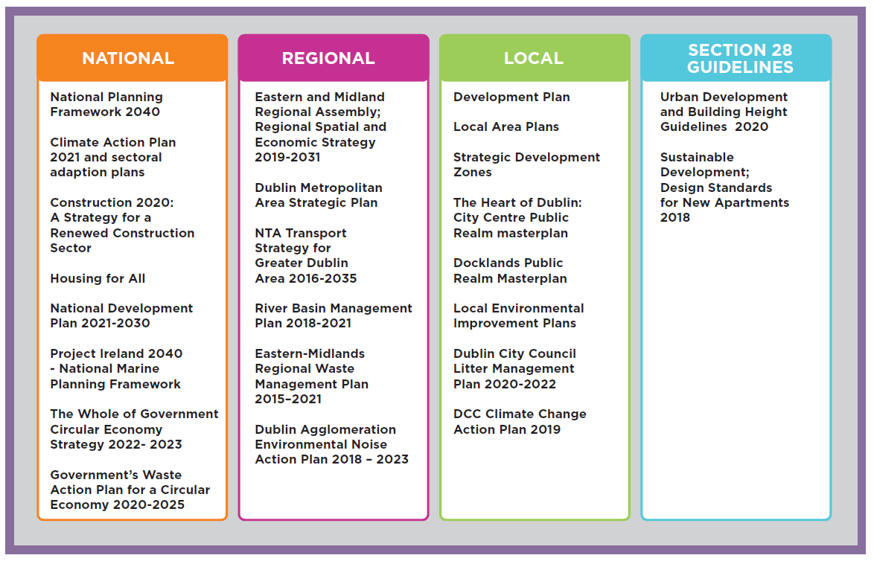

Material Alteration Reference Number 1.5

Chapter 1
Section: 1.9.2 UN Sustainable Development Goals
Page 38, new policy to be inserted after first paragraph

Amendment:

{Policy SCV1 United Nations Sustainability Goals (See also Chapter 3, Climate
Change):

It is the policy of Dublin City Council to contribute, via this Development Plan, towards achievement of the 17 Sustainable Development Goals of the United
Nations’ 2030 Agenda for Sustainable Development, as per link https://sdgs.un.org/goals}

Material Alteration Reference Number 1.6

Chapter 1
Section: 1.9.4 The National Climate Action Plan 2019-2024
Page: 40

Amendment:

1.9.4 The National Climate Action Plan (2019-2024) {2021}

The National Climate Action Plan (CAP) (2019-2024) {2021} (https://www.gov.ie), sets out a course of action to address the impacts of climate change on Ireland’s environment, society, economic and natural resources. The CAP identifies the scale of the challenge and examines impacts on a range of key sectors including electricity, transport, built environment, industry and agriculture and charts a course towards ambitious emission reduction targets.

The CAP recognises the role that Project Ireland 2040 and the NPF can play in climate action in providing for population growth in a compact, connected and sustainable way and the key role that land use planning can play in progressing climate change mitigation and adaption.

(It is recognised that the Government intends to publish a new National Climate Action Plan in the near future. Dublin City Council will consider a variation of the development plan within a reasonable period of time to ensure that the development plan will be consistent with the overall approach to climate action set out in any new National Climate Action Plan.)

{The CAP provides a detailed framework which identifies how Ireland will achieve a 51% reduction in Ireland's overall GHG emissions from 2021 to 2030, and to achieve net-zero emissions no later than 2050. These legally-binding objectives are set out in the Climate Action and Low Carbon Development (Amendment) Act 2021.}

Material Alteration Reference Number 1.7

Chapter 1
Section 1.9.6 Dublin Metropolitan Area Strategic Plan (MASP)
Page: 44

Amendment:

- Naas Road

{These Strategic Development Areas and Strategic Employment Lands are incorporated into the City Development Plan as SDRA’s – see Chapter 2, Core Strategy and Chapter 13, Strategic Development Regeneration Areas.}

Material Alteration Reference Number 1.8

Chapter 1
Section: 1.9.7 NTA Transport Strategy 2016-2035
Page: 46

Amendment:

This strategy for the Greater Dublin Area (GDA) provides a framework for a sustainable transport network for the long term. (Three k) {K}ey projects include:

- (The Bus Connects project with a targeted timeline of 2021 – 2023.
- The extended Luas Tram line to Finglas anticipated to be delivered by 2028.
- Metro train line from the city to Dublin Airport and Swords with a targeted delivery date of between 2021 and 2027.)
- {MetroLink from Charlemont to Swords via Dublin Airport, with construction date due to commence during the Development Plan period;
- The Bus Connects programme which includes the following:
  - Dublin Area Bus Network Redesign which provides for significantly enhanced bus services, with a completion by 2024 and
  - The Core Bus Corridor Projects which will provide bus priority on the radial routes, with a completion date by 2030;
- DART+ Programme, with construction to commence during the Development Plan period and
- Luas Finglas with a Railway Order due to be submitted by 2023.
- Greater Dublin Area Cycle Network Plan.}

Over the course of the development plan, it is expected that these key infrastructural projects will either be delivered or be at an advanced stage of design/planning. The alignment of future growth and key public transport infrastructure is a key consideration of the plan.

Chapter 2- Core Strategy

Material Alteration Reference Number 2.1

Chapter 2
Section: 2.1.2 Policy Context
Page 54: Figure 2.1

Amendment to Graphic Map:

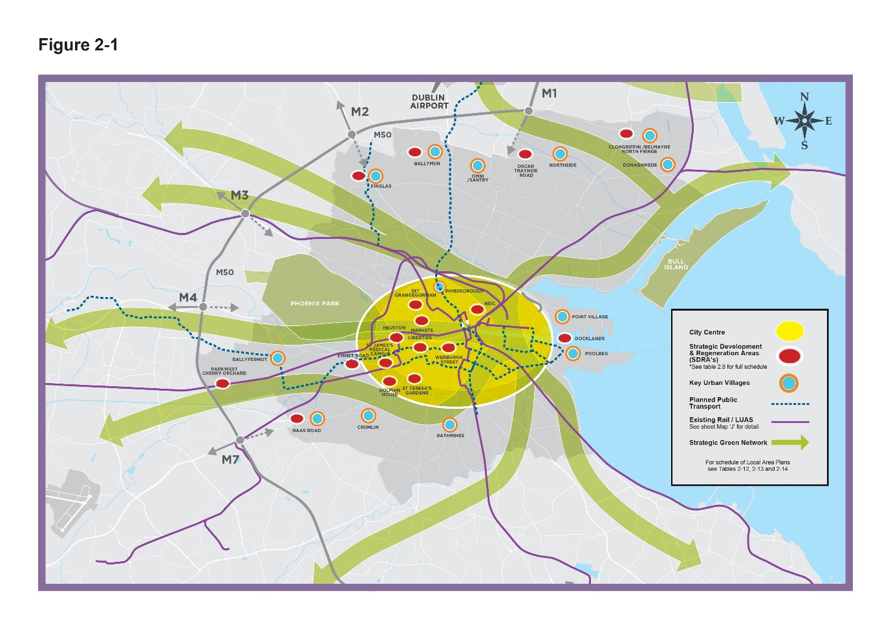
- Metro North indicated with a blue dashed line.

Material Alteration Reference Number 2.2

Chapter 2
Section: 2.2.1 Population and Housing Delivery, subheading Population Growth Patterns
Page: 55, Table 2-1: Population Change and page 56, 1st paragraph

Amendment:

Table 2-1: Population Change
Census year | Population | % increase
2006 | 506,211
2011 | 527,612 | +4.2% over 5 years
2016 | 554,554 | +5% over 5 years
202(0) {1} CSO population estimate | (595,434) {600,600} | (7.4) {8.3}% over (4){5} years
Source: CSO

The CSO’s 202(0){1}population estimate for the Dublin Region was (1,417,700) {1,430,000} persons. Dublin City Council’s share of the 2016 Census regional population figure for Dublin was approximately 42%. Assuming the same share for the CSO 202(0){1} estimated regional population figure for Dublin, this gives an estimated population figure of (595,434) {600,600} for Dublin City Council in April 202(0){1}. This indicates an estimated (7.4 %) {8.3%} rise in the population of Dublin City over a (four) {five} year period from 2016 through to 202(0){1}.

Material Alteration Reference Number 2.3

Chapter 2
Section: 2.2.1, subheading Summary
Page: 62, first paragraph

Amendment:

Based on the population targets and calculated housing need set out within national and regional planning policy, guidelines and prescribed methodology, the development plan must accommodate between (21,350 - 31,450) {20,120 – 31,520} additional persons up to an overall population target of between 625,750 and 640,000 by 2028. The housing demand calculated sets a requirement for the development plan to provide for approximately 40,000 housing units between 2022 and 2028.

Material Alteration Reference Number 2.4

Chapter 2
Section: 2.3.1 Land Capacity Assessment, subheading - Capacity of SDRA Lands
Page: 64

Amendment:

The SDRA lands are critical to the core Strategy. All SDRAs (both new and previously identified) have been examined to determine capacity for future housing growth, taking into account sustainable densities and relevant SDZs and LAPs where relevant. {This detailed assessment gave a potential yield from the 17 SDRAs of between 34,750 – 35,950 new dwellings on approximately 358 hectares. (Table 13-1 in Chapter 13 shows a breakdown of these figures by individual SDRA).}

Delete Table 2.8: Capacity of SDRA Designated lands for Residential Use or a Mixture of Residential and Other Uses, and

Replace with new subheading, text and table to this section, before subheading “Capacity of SDRA lands.”

{Integration of the Core Strategy and Settlement Hierarchy

The Core Strategy is shaped and driven by the overall vision outlined in the settlement strategy, with significant new housing delivery framed within the overall settlement hierarchy for the City targeted at (1) the inner city; (2) along key high quality transport corridors as set out by the RSES and MASP and within Key Urban Villages and (3) on key brownfield and infill opportunity sites with the Tier 1 RSES area (which encompasses the entire Council area) to support NPO3a, b and c and NPO11. The settlement strategy recognises there is a strong overlap between these categories within the hierarchy with many key SDRA sites fitting within two or three elements.

Table 2.8 - Core Strategy and Settlement Hierarchy

Settlement hierarchy | Relevant SDRAs/Strategic Lands | Character and general density applied* | Proposed Zoned Area | Proposed Residential Yield | Estimated population
Inner City
City Core | Docklands  (SDRA 6 and KUV) | Mixed use | 24 | 7,900 | 15,800
 | Dolphin House  (SDRA 12) | Residential | 6 | 350 | 700
 | Grangegorman/Broadstone  (SDRA 8) | Primarily education/health | 10 | 800** | 1,500
 | Heuston and Environs  (SDRA 7) | Mixed use | 14 | 1250 | 2,500
 | Liberties & Newmarket Square (SDRA 15) | Mixed use | 30 | 2500 | 5,000
 | Markets Area and Environs  (SDRA 13) | Mixed use | 8 | 400 | 800
 | North East Inner City  (SDRA 10) | Mixed use | 12 | 850 | 1,700
 | St. Teresa’s Gardens  (SDRA 11) | Residential and open space | 13 | 950 | 1,900
 | Other KUVs- Phibsborough
MASP Corridors
North East Corridor | Clongiffin/Belmayne  (SDRA 1 and KUV) | Mixed use | 52 | 6,950-7,350 | 14,700
 | Oscar Traynor Road  (SDRA 16) | Residential and open space | 17 | 850 | 1,700
 | Other KUVs- Santry (Omni), Northside, Donaghmede | Mixed use
North West Corridor | Ballymun  (SDRA 2 and KUV) | Primarily residential | 35 | 2,200-2,350 | 4,700
 | Finglas Village Environs and Jamestown (SDRA 3 and KUV) | Mixed use | 52 | 2,800 | 5,600
 | Glasnevin*** | Mixed use regen | - | -
South West Corridor | City Edge/Inchicore lands*** | Mixed use regen | - | -
 | Emmett Road  (SDRA 9) | Primarily residential | 15 | 1,050 | 2,100
 | Naas Road  (SDRA 5 and KUV) | Mixed use | 18 | 3,300 | 6,600
 | Park West and Cherry Orchard (SDRA 4) | Residential and open space | 49 | 2,500-3,100 | 6,200
 | Other KUVs- Ballyfermot, Crumlin | Mixed use
South East Corridor | Other KUVs- Rathmines | Mixed use
Urban Consolidation
City centre within M50 | Infill/smaller scale Brownfield and opportunity sites | Primarily residential | 189 | 13,000 | 23,400
TOTAL |  |  | 544 | 48,800 | 88,800

*Densities from extant LAPs/SDZs/existing permissions are included; over and above that, potential yields outside of these areas are estimated using standard densities of 200 units per hectare (uph) for inner city areas and 100 uph for areas in the suburbs, where sites are primarily residential. For mixed use zonings the figures are reduced to take account of the impact of other non-residential developments.

**Refers to primarily student and supported residential accommodation.
KUVs outside of SDRAs present opportunities for some densification and infill, however the housing yield this is not quantified due to the highly speculative and underdetermined nature of such estimation.

*** these lands are not yet zoned for residential purposes but it is anticipated that they will, through the variation process, come forward for first phase of development during the lifetime of the Plan.}

Material Alteration Reference Number 2.5

Chapter 2
Section: 2.3 Core Strategy
Page: 64

Amendment:

Replace within Table 2-8 and adjust table and relevant figures accordingly.

SDRA 11 St. Teresa’s Gardens; (estimated capacity) (950) {1,500}; (area Hectares) 13.4.

Material Alteration Reference Number 2.6

Chapter 2
Section: 2.3.3 Housing Strategy and HNDA – subheading Housing Strategy
Page: 68, add additional paragraph at end of subsection

{The conclusion of the HNDA and Housing Strategy is that there is a requirement for the full 20% complement of social housing to be provided under the provisions of Part V. The HNDA modelling indicates that over the six-year plan period of 2023-2028, there is an estimated need for 10,247 social homes in Dublin City as well as 7,887 affordable homes; 4,997 households are estimated to be able to access private ownership in Dublin City, while 4,088 households are estimated to be able to meet their needs in the private rental market.}
Material Alteration Reference Number 2.7

Chapter 2
Section: 2.3.5 Future Development Areas, 2nd paragraph
Page: 69

Amendment:

Two significant areas identified in the Z6 and Z7 zoned lands study remain mostly zoned Z6 within the development plan:

- Kylemore Road/Naas Road lands {(currently the focus of the City Edge Project, see www.cityedge.ie)} and
- Glasnevin (the Dublin Industrial Estate and surrounding lands).

Material Alteration Reference Number 2.8

Chapter 2
Section: 2.3.5 Future Development Areas
Page: 69, 3rd paragraph

Amendment:

Delete 3rd Paragraph -

(It is the intent of the Council that, following feasibility studies and/or the preparation of a local area plan (or if designated, a Strategic Development Zone) that these industrial lands will be brought forward as regeneration lands during the lifetime of the development plan.)

and replace with:

{It is the intention of Dublin City Council, following the completion of feasibility studies for these industrial lands, to seek Government approval for the appropriate statutory designation of these lands and to bring forward the early regeneration of these strategic lands.}

Material Alteration Reference Number 2.9

Chapter 2
Section: 2.4, Settlement Strategy
Page: 70

Amendment:

Insert additional text after first paragraph

{Dublin City Council has a unique position in relation to applying the RSES Settlement Hierarchy in that the entire area of the Council falls within Tier 1.}

Insert additional text to end of paragraph 2

{Table 2-8 in Section 2.4 below contains the Core Strategy for the city, incorporating the settlement hierarchy for the city as thus outlined.}

Move Section 2.4: Settlement Strategy to page 62 so it is now Section 2.3 Settlement Strategy. Subsequent heading numbering 2.5 to be amended accordingly.

Material Alteration Reference Number 2.10

Chapter 2
Section: 2.7.1 Plan Making, subheading Priority LAPs
Page: 75

Amendment:

Amend heading text for sub-section and for Table 2-13.

(Priority LAPs)

{Priority Statutory Local Plans^{[2]}}

Table 2-13: Schedule of (Local Area Plans) {Statutory Local Plans} to be Commenced over the Plan Period.

Material Alteration Reference Number 2.11

Chapter 2
Section: 2.7.1 Plan Making
Page: 76, Objective CSO2

Amendment:

Objective CSO2 Local Statutory Plan for lands at Kylemore Road/Naas Road and Ballymount {(City Edge)}

{In accordance with the objectives of the City Edge Project}, to prepare a local statutory plan in conjunction with South Dublin County Council for lands at Kylemore Road/Naas Road and Ballymount lands to enable a co-ordinated and phased development on these lands over the medium to long term.

Material Alteration Reference Number 2.12

Chapter 2
Section: 2.7.1, subheading Other Local Area Plans/ Village Improvement Plans (VIPS)
Page: 76

Amendment:

In addition to the above priority list of LAPs to be progressed over the development plan period, it is proposed to prepare a number of other Local Area Plans and/or Village Improvement Plans (VIPs) as set out in Table 2-14 below, subject to resources. {It should be noted that in the absence of an LAP, developments will be considered through the development management process in accordance with the policies and objectives of the Development Plan.}

Material Alteration Reference Number 2.13

Chapter 2
Section: 2.7.1 Plan Making, subheading Local Environmental Improvement Plans/Local Strategies
Page: 77

Amendment:

Other plans such as the (Dorset Street Together Plan) {Greater Dorset Street Plan}is an example of a local initiative that could be used to inform the future LEIP for this area.

Material Alteration Reference Number 2.14

Chapter 2
Section: 2.7.1 Plan Making
Page 78: Table 2-15 List of Proposed Local Environmental Improvement Plans (LEIPs)

Amendment:

New row to Table 2-15 with new text {Richmond Road} and re-order alphabetically and re-number accordingly.

Material Alteration Reference Number 2.15

Chapter 2
Section: 2.7.1 Plan Making
Page 78: Table 2-15 List of Proposed Local Environmental Improvement Plans (LEIPs)

Amendment:

New row to Table 2-15 with new text {South Georgian Core} and re-order alphabetically and re-number accordingly.

Material Alteration Reference Number 2.16

Chapter 2
Section: 2.7.5 Enhanced Co-ordination
Page: 83, Objective CSO14

Amendment:

Objective CSO14 Co-ordinated Approach to Future Development of Strategic Growth Areas

To facilitate a co-ordinated approach to the future development of strategic growth areas including the Naas Road area {(City Edge Project)}, lands at Dunsink and the Belmayne-Clongriffin area, with South Dublin County Council, Fingal County Council respectively and relevant stakeholders.

Chapter 3: Climate Action

Material Alteration Reference Number 3.1

Chapter 3
Section: 3.1 Introduction, subheading – International, National and Local Climate Policy
Page: 91

Amendment:

(Nationally, the government’s 2019 Climate Action Plan (CAP) provides a detailed framework which identified how Ireland will achieve its 2030 targets to reduce greenhouse gas emissions by 30% compared with 2005 limits. This target was increased to 51% under ‘Our Shared Future’, the 2020 programme for government.) {Nationally, a climate and biodiversity emergency was declared by Dáil Éireann and Dublin City Council in 2019. Subsequently, the government’s 2021 Climate Action Plan (CAP) provides a detailed framework which identified how Ireland will achieve a 51% reduction in Ireland's overall GHG emissions from 2021 to 2030, and to achieving net-zero emissions no later than 2050. These legally-binding objectives are set out in the Climate Action and Low Carbon Development (Amendment) Act 2021.} The CAP commits to delivering a just transition, recognising the significant level of change required and that the burden must be as fairly distributed as possible.

In addition, under the National Adaptation Framework, twelve Sectoral Adaptation Plans were published by various government departments in 2019, setting out key risks faced across the different sectors and the approach being taken to address these risks and build climate resilience for the future.

(More recently, the Climate Action and Low Carbon Development (Amendment) Bill 2021 has been adopted, putting Ireland on a legally binding path to net-Zero emissions no later than 2050, and to a 51% reduction in emissions (relative to a baseline of 2018) by the end of this decade.)

Material Alteration Reference Number 3.2

Chapter 3
Section: 3.1 Introduction, subheading–International, National and Local Climate Policy
Page: 91, include the following paragraph above the final paragraph

Amendment:

{The Climate Action Plan for Dublin City Council sets a target of 40% reduction in the Council’s greenhouse gas emissions by 2030. As a signatory to the Covenant of Mayors Dublin City has a more ambitious target of 55% by 2030 and carbon neutrality by 2050, in line with the EU Green Deal ambitions.} The CCAP is a key element of the Council’s strategic approach to climate action and has informed and guided the policies and objectives contained in this development plan.

Material Alteration Reference Number 3.3

Chapter 3
Section: 3.2 Achievements, subheading Energy Performance
Page: 95

Amendment:

Add the following to paragraph Energy Performance Contracting, to read:

{Based on the success of Energy Performance Contracting, Dublin City Council is planning to collaborate with the 4 Dublin Local Authorities to aggregate and scale EPCs for our significant energy users, to assist us achieve our 2030 targets.}

Material Alteration Reference Number 3.4

Chapter 3
Section: 3.5 Policies and Objectives
Page: 97, final paragraph

Amendment:

As climate action policy continues to develop with the publication of the Draft Development Plan Guidelines for Planning Authorities and (the anticipated introduction of new climate action legislation) {annual updates to the National Climate Action Plan}, Dublin City Council acknowledges that it may be necessary to adapt policies in future in order to ensure full compliance with any new legislative or policy requirements.

Material Alteration Reference Number 3.5

Chapter 3
Section: 3.5 Policies and Objectives
Page: 98, Policy CA1

Amendment:

Policy CA1 National Climate Action Policy

To support the implementation of national objectives on climate change including the (‘Climate Action Plan 2019 to Tackle Climate Breakdown’) {‘Climate Action Plan 2021: Securing Our Future’ (including any subsequent updates to or replacement thereof)}, the ‘National Adaptation Framework’ 2018 and the ‘National Energy and Climate Plan for Ireland 2021‑2030’ and other relevant policy and legislation.

Material Alteration Reference Number 3.6

Chapter 3
Section: 3.5 Policies and Objectives
Page 98, Policy CA2

Amendment:

Policy CA2 Mitigation and Adaptation

To prioritise {and implement} measures to address climate change by both effective mitigation and adaptation responses in accordance with available guidance and best practice.

Material Alteration Reference Number 3.7

Chapter 3
Section: 3.5.1 Sustainable Settlement Patterns
Page: 100, insert new Policy after CA3, subsequent numbering to be amended accordingly

Amendment:

{Policy - Improving Mobility Links in Existing Areas

To support retrofitting of existing built-up areas with measures which will contribute to their meeting the objective of a low-carbon city, such as reopening closed walking and cycling links or providing new links between existing areas.}

Material Alteration Reference Number 3.8

Chapter 3
Section: 3.5.1 Sustainable Settlement Patterns
Page: 100, Policy CA4

Amendment:

Policy CA4 Climate Mitigation and Adaptation in Strategic Growth Areas

To ensure {that all} new development (in strategic growth areas) including {in} Strategic Development and Regeneration Areas integrate(s) appropriate climate mitigation and adaptation measures. {See also Section 15.4.3. Sustainability and Climate Action and Section 15.7.3 Climate Action and Energy Statement.}

Material Alteration Reference Number 3.9

Chapter 3
Section: 3.5.2 The Built Environment
Page: 100, last paragraph

Amendment:

In line with this overall approach, proposals for major retrofitting of existing buildings should seek to reduce carbon dioxide emissions, improve the efficiency of resource use (such as water) and minimise the generation of pollution and waste from existing building stock. Such retrofitting projects should also seek to use innovative energy efficiency measures, such as decentralised and renewable energy in order to further reduce their carbon footprint. {In this regard, some 9,000 DCC homes have already had energy upgrades as part of an ongoing energy upgrade programme.}

Material Alteration Reference Number 3.10

Chapter 3
Section: 3.5.2 The Built Environment
Page: 102, Policy CA5

Amendment:

Policy CA5 Retrofitting and Reuse of Existing Buildings

To promote and support the retrofitting and reuse of existing buildings rather than their demolition and reconstruction, where possible (.) {See Section 15.7.1 Re-use of Existing Buildings in Chapter 15 Development Standards}.

Material Alteration Reference Number 3.11

Chapter 3
Section: 3.5.2 The Built Environment
Page 103, Policy CA7

Amendment:

To (promote) {require} low carbon development in the city which will seek to reduce carbon dioxide emissions and which will meet the highest feasible environmental standards during construction and occupation (.) {, see Section 15.7.1 when dealing with development proposals.} New development should generally demonstrate/ provide for:…..

Material Alteration Reference Number 3.12

Chapter 3
Section: 3.5.2 The Built Environment
Page 103, Policy CA8, 1st paragraph and part (f)

Amendment:

It is the Policy of Dublin City Council:

Development proposals (should) {must} demonstrate sustainable, {climate adaptation, circular} design principles for new buildings / services / site. The Council will promote and support development which is resilient to climate change…etc.

f. promoting {, developing} and protecting biodiversity, {novel urban ecosystems} and green infrastructure.

Material Alteration Reference Number 3.13

Chapter 3
Section: 3.5.3 Energy, sub-heading Renewable Energy
Page: 104, 2nd paragraph

Amendment:

(The National Climate Action Plan includes a commitment that 70% of our electricity needs will come from renewable sources by 2030. The plan states that achieving this target will involve phasing out coal and peat‑fired electricity generation plants, increasing our renewable electricity, reinforcing our grid (including greater interconnection to allow electricity to flow between Ireland and other countries), and putting systems in place to manage intermittent sources of power, especially from wind.)

{The National Climate Action Plan includes a target to increase the share of electricity demand generated from renewable sources to up to 80% where achievable and cost effective, without compromising security of electricity supply. The plan outlines a number of measures to deliver this target including the decarbonisation of our energy systems, reinforcing and upgrading our grid, a new approach to electricity demand management, large scale investment in renewable energy generation, micro-generation and community-based projects, as well as other supporting measures.}

Material Alteration Reference Number 3.14

Chapter 3
Section 3.5.3 Energy
Page: 106, Policy CA10

Amendment:

Policy CA10 Energy from Renewable Sources

To support {, encourage and facilitate} the production of energy from renewable sources, such as from solar energy, hydro energy, wave/tidal energy, geothermal, wind energy, combined heat and power (CHP), heat energy distribution such as district heating/cooling systems, and any other renewable energy sources, subject to normal planning and environmental considerations.

Material Alteration Reference Number 3.15

Chapter 3
Section 3.5.3 Energy
Page: 106, Policy CA11

Amendment:

Policy CA11 Micro-Renewable Energy Production

To support {, encourage and facilitate} and encourage the development of small scale wind renewable facilities / micro-renewable energy production.

Material Alteration Reference Number 3.16

Chapter 3
Section 3.5.3 Energy
Page: 106, Policy CA12

Amendment:

Policy CA12 Offshore Wind -Energy Production

To support {, encourage and facilitate} the implementation of the 2014 ‘Offshore Renewable Energy Development Plan’ (OREDP) {and any forthcoming review} and to facilitate infrastructure such as grid facilities on the land side of any renewable energy proposals of the offshore wind resource, where appropriate and having regard to the principles set out in the National Marine Planning Framework.

Material Alteration Reference Number 3.17

Chapter 3
Section 3.5.3 Energy
Page: 106, Policy CA13

Amendment:

Policy CA13 Geothermal Energy

To support {, encourage and facilitate} the exploration for, and development of, geothermal energy resources having regard to emerging government policy on geothermal energy.

Material Alteration Reference Number 3.18

Chapter 3
Section: 3.5.3 Energy, sun-heading District Heating and Waste Heat, 3rd & 4th paragraphs
Page: 107

Amendment:

(District heating is specifically referred to in the 2019 Climate Action Plan which states in order to realise the potential of district heating the government will take action to: “ensure the potential of district heating is considered in all new developments and in particular in Strategic Development Zones (SDZs)”.

Furthermore, Action 70 of the Climate Action Plan states that the government will “support the delivery of two district heating projects under the Climate Action Fund”, one of which is the Dublin District Heating System (DDHS) centred at Poolbeg and the Docklands.)

{The 2021 National Climate Action Plan is highly supportive of the development of district heating and includes a specific target to deliver up to 2.7 TWh of district heating, with the exact level to be informed by the outcome of a National Heat Study.

The Climate Action Plan includes specific actions relating to district heating including Action 183 "to ensure that national, regional and local planning frameworks encourage and facilitate the development of district heating where appropriate to facilitating compact urban development".

The Climate Action Plan refers to the ongoing work being carried out to inform the development of district heating policy, including the completion of the comprehensive assessment to support the rollout of district heating in Ireland. It also refers to two district heating projects in development, one of which is the Dublin District Heating System (DHS) centred at Poolbeg and the Docklands.}

Material Alteration Reference Number 3.19

Chapter 3
Section 3.5.3 Energy
Page: 108, Policy CA15

Amendment:

Policy CA15 The Dublin District Heating System (DDHS)

To support {, encourage and facilitate} the development and expansion of any necessary energy infrastructure which will deliver the low carbon Docklands and Poolbeg catchment of the Dublin District Heating System (DDHS) project including, its pipeline infrastructure and its energy centre with energy storage and back -up heat production.

Material Alteration Reference Number 3.20

Chapter 3
Section 3.5.3 Energy
Page: 109, Policy CA16

Amendment:

Policy CA16 Supporting the Potential of District Heating in Dublin City

To support {, encourage and facilitate} the potential of district heating in Dublin City, all Climate Action Energy Statements submitted to the Council (see Policy CA9) shall include an assessment of the technical, environmental and economic feasibility of district or block heating or cooling, particularly where it is based entirely, or partially on energy from renewable and waste heat sources.

Material Alteration Reference Number 3.21

Chapter 3
Section: 3.5.3 Energy, subheading Decarbonising Zones

Page: 110

Amendment:

Action (165) {80} of the (2019) Climate Action Plan (also) {2021} identified the need to engage at a local level and included a specific action which requires Local Authorities to identify and develop plans for at least one Decarbonising Zone (DZ) in their administrative area.

Material Alteration Reference Number 3.22

Chapter 3
Section 3.5.3 Energy
Page: 112, Policy CA18

Amendment:

Policy CA18 Decarbonising Zones

To support {, encourage and facilitate} the specific polices and projects identified in the Decarbonisation Zone of Ringsend/Irishtown in order to address local low carbon energy, greenhouse gas emissions and climate needs and commit to establishing Decarbonising Zones in each LEA {(Local Electoral Area)} within the lifetime of this plan, with a view to designating all of Dublin City as a decarbonised zone by the end of this Development Plan.

Material Alteration Reference Number 3.23

Chapter 3
Section 3.5.3 Energy
Page: 112, Policy CA19

Amendment:

Policy CA19 Strategic Energy Zones

To support {, encourage and facilitate} the designation of potential Strategic Energy Zones in the Dublin City Area in conjunction with the Eastern and Midland Regional Authority.

Material Alteration Reference Number 3.24

Chapter 3
Section 3.5.3 Energy
Page: 112, Policy CA20
Amendment:

Policy CA20 Sustainable Energy Communities

To support {, encourage and facilitate} the ongoing efforts and future development of Sustainable Energy Communities in Dublin City through the SEAI ‘Sustainable Energy Communities’ Initiative.

Material Alteration Reference Number 3.25

Chapter 3
Section 3.5.3 Energy
Page: 112, Policy CA21

Amendment:

CA21 Dublin Regional Energy Masterplan

To support {, encourage and facilitate} the preparation of the Dublin Regional Energy Masterplan by Codema and to support its implementation in conjunction with neighbouring Dublin Local Authorities, Dublin Metropolitan CARO and other relevant stakeholders.

Material Alteration Reference Number 3.26

Chapter 3
Section 3.5.4 Waste
Page 113, Policy CA22

Amendment:

Policy CA22 The Circular Economy

To support the shift towards the circular economy approach as set out in a Waste Action Plan for a Circular Economy 2020 to 2025, Ireland’s National Waste Policy, (or) as updated (.){together with The Whole of Government Circular Economy Strategy 2022- 2023. https://www.gov.ie/en/publication/b542d-whole-of-government circular-economy-strategy-2022-2023-living-more-using-less/}

Material Alteration Reference Number 3.27

Chapter 3
Section: 3.5.5 Sustainable Transport, subsection on ‘Decarbonising Transport and Electric Vehicles (EVs)’
Page: 114

Amendment:

The (2019) {2021} National Climate Action Plan calls for the combination of measures to influence the spatial pattern of development, urban structure and overall mobility, with low carbon technology measures, such as a significant increase in the EV fleet.

The Plan sets out a government target to accelerate the take up of EV cars and vans so that (Ireland reaches 100% of all new cars and vans being EVs by 2030. This that means approximately one third of all vehicles sold during the decade will be Battery Electric Vehicles (BEV) or Plug‑in Hybrid Electric Vehicles (PHEV).) {by 2030, there will be 945,000 EVs and low emitting vehicles (LERVs) on the road.}

Material Alteration Reference Number 3.28

Chapter 3
Section 3.5.7 Flood Resilience and Water
Page: 117, Policy CA25

Amendment:

Policy CA25 Flood and Water Resource Resilience

To support {, encourage and facilitate} the delivery of soft, green and grey adaptation measures to enhance flood and water resource resilience in the city and support the delivery of grey adaptation measures to enhance flood and water resource resilience where necessary.

Material Alteration Reference Number 3.29

Chapter 3
Section 3.5.7 Green Infrastructure and Nature Based Solutions
Page: 118, Policy CA29

Amendment:

Policy CA29 Coastal Zone Management

To support {, encourage and facilitate} coastal zone management measures for adapting to climate change which include restoration of degraded ecosystems, increased flood resilience, water quality improvement, habitat conservation and provision of amenities for the residents and visitors of Dublin City.

Chapter 4: Shape and Structure of the City

Material Alteration Reference Number 4.1

Chapter 4
Section: 4.5.1 Approach to the Inner City and Docklands
Page: 136, 3rd paragraph

Amendment:

The development of the new university, (in this area and the provision of other services and facilities connected with it, has anchored) {health, education facilities and public amenities for the existing and emerging communities of the Grangegorman neighbourhood is beginning to anchor} the ongoing regeneration of this part of the city.

Material Alteration Reference Number 4.2

Chapter 4
Section: 4.5.1 Approach to the Inner City and Docklands
Page: 138, Policy SC1

Amendment:

Policy SC1 Consolidation of the Inner City

It is the Policy of Dublin City Council:

To consolidate and enhance the inner city, promote compact growth and maximise opportunities provided by existing and proposed public transport by linking the critical mass of existing and emerging communities such as Docklands, Heuston Quarter, Grangegorman, Stoneybatter, Smithfield, the Liberties (and) the North East Inner City {and the south and north Georgian cores} with each other, and to other regeneration areas.

Material Alteration Reference Number 4.3

Chapter 4
Section: 4.5.1 Approach to the Inner City and Docklands
Page: 138, Policy SC2

Amendment:

Policy SC2 City’s Character: amend bullet point 4 to read:

• revitalising the north and south Georgian squares and their environs {and realising their residential potential};

Material Alteration Reference Number 4.4

Chapter 4
Section: 4.5.1 Approach to the Inner City and Docklands
Page 138, Policy SC3

Amendment:

Policy SC3 Mixed Use Development

To promote a mixed-use land use policy in the city centre, including the provision of
high quality, sustainable residential development(.) {, and facilitating the
conversion of both old office buildings and over shop spaces to residential.}

Material Alteration Reference Number 4.5

Chapter 4
Section: 4.5.1 Approach to the Inner City and Docklands
Page: 139, Policy SC6

Amendment:

Policy SC6 Docklands

To recognise the distinctive character of the Docklands regeneration area and to work with the relevant authorities to increase connectivity with the city centre {and its environs}.

Material Alteration Reference Number 4.6

Chapter 4
Section: 4.5.2 Approach to the Inner Suburbs and Outer City as Part of the Metropolitan Area
Page: 139, first paragraph

Amendment:

The inner suburbs comprise the established suburban communities{,largely,} located outside of the canal belt {e.g. such as Phibsborough} and the outer city refers to the newly developing areas on the fringe of the city administrative area including Clongriffin-Belmayne, Ashtown-Pelletstown, Park West and Cherry Orchard.
Material Alteration Reference Number 4.7

Chapter 4
Section: 4.5.2 Approach to the Inner Suburbs and Outer City as Part of the Metropolitan Area
Page: 140, Policy SC8

Amendment:

Policy SC8 Development of the Inner Suburbs

To support the development of the inner suburbs and outer city in accordance with the strategic development areas and corridors set out under the Dublin Metropolitan Area Strategic Plan and fully maximise opportunities for intensification of infill, brownfield and underutilised land where it aligns with existing and pipeline public transport (infrastructure) {services and enhanced walking and cycling infrastructure}.

Material Alteration Reference Number 4.8

Chapter 4:
Section: 4.5.4 Increased Height as Part of the Urban Form and Spatial Structure of Dublin
Page: 148, Policy SC16

Amendment:

Policy SC16 Building Height Locations

To recognise the predominantly low rise character of Dublin City whilst also recognising the potential and need for increased height in appropriate locations including the city centre, Strategic Development Zones, Strategic Development Regeneration Areas, Key Urban Villages and other locations as identified in Appendix 3, provided that proposals ensure a balance {with} (between) the reasonable protection of existing amenities and environmental sensitivities, protection of residential amenity and the established character of the area.

Material Alteration Reference Number 4.9

Chapter 4:
Section: 4.5.4 Increased Height as part of the Urban Form and Spatial Structure of Dublin, subheading Landmark/Tall Buildings
Page: 149, Policy SC17

Amendment:

Policy SC17 Building Height

To protect and enhance the skyline of the city, and to ensure that all proposals with enhanced scale and height:

- follow a design led approach;
- include a masterplan for any site over 0.5ha {(in accordance with the criteria for assessment set out in Appendix 3)};
- make a positive contribution to the urban character of the city and that responds positively to the existing or emerging context;
- deliver vibrant and equitable neighbourhoods that are walkable, compact, green, accessible, mixed and balanced; (and)
- {Do not affect the safety of aircraft operations at Dublin Airport (including cranage); and}
- have regard to the performance-based criteria set out in Appendix 3.

Chapter 5: Quality Housing and Sustainable Neighbourhoods

Material Alteration Reference Number 5.1

Chapter 5

Section: Section 5.2 Achievements
Page: 158, 2nd sentence of 1st paragraph

Amendment:

In the period since the adoption of the 2016 Plan, the city has seen a significant increase in the delivery of new housing with (7,078) {9,459} dwellings completed in the Dublin City Council area between (2016) {Q1 2017} and (mid-2020) {Q4 2021}.

Material Alteration Reference Number 5.2

Chapter 5

Section: 5.5.1 National and Regional Policy Context and the Housing Strategy
Page: 163, Policy QHSN2

Amendment:

Policy QHSN2 National Guidelines

To have regard to the DEHLG Guidelines on ‘Quality Housing for Sustainable Communities – Best Practice Guidelines for Delivering Homes Sustaining Communities’ (2007), ‘Sustainable Urban Housing: Design Standards for New Apartments’ (2020), ‘Sustainable Residential Development in Urban Areas’ and the accompanying ‘Urban Design Manual: A Best Practice Guide’ (2009), Housing Options for our Aging Population (2020) {2019, the Design Manual for Quality Housing (2022),} (and) the Design Manual for Urban Roads and Streets (DMURS) (2019) {the Urban Development and Building Height Guidelines for Planning Authorities (2018) and the Affordable Housing Act 2021 including Part 2 Section 6 with regard to community land trusts and/or other appropriate mechanisms in the provision of dwellings.}

Material Alteration Reference Number 5.3

Chapter 5

Section: 5.5.2 Regeneration, Compact Growth and Densification
Page: 164, insert new policy after Policy QHSN4, subsequent numbering to be amended accordingly

Amendment:

{Policy - Community Led Regeneration

It is the policy of Dublin City Council to ensure that regeneration of estates and communities will be planned with the needs of existing and future residents at the core.}

Material Alteration Reference Number 5.4

Chapter 5

Section: 5.5.2 Regeneration, Compact Growth and Densification
Page: 166, Policy QHSNO1

Amendment:

Objective QHSNO1 Land Development Agency
It is an Objective of Dublin City Council: That Dublin City Council will be the lead developer on City Council owned land, unless there are exceptional circumstances, and will work with other agencies including the Land Development Agency, to co-ordinate appropriate State owned land and the strategic assembly of public and private land to facilitate regeneration, housing and other developments. Priority will be given to social and affordable housing (tenure).

Material Alteration Reference Number 5.5

Chapter 5
Section: 5.5.2 Regeneration, Compact Growth and Densification
Page: 166, Objective QHSNO2 Lands at Alfie Byrne Road

Amendment:

Objective QHSNO2 Lands at Alfie Byrne Road

To undertake a land use and landscape masterplan for the underutilised lands located south east of Clontarf Road Railway station and railway line and fronting onto Alfie Byrne road to examine their potential for the following uses:

• suitable developments to provide overlooking of the route to Clontarf Road Railway station;
• upgraded coastal walkway linking to the Tolka River;
• {marine related leisure activities and} improved access and setting for the watersports centre;
• provision of new fire station;
• possible site for new second level school;
- {possible site for new skate park facility;}
• provision of new allotment and community gardens; and
• demarcation and preservation of a circus/funfair location for occasional use.

{The masterplan should recognise the role of some of these lands as a feeding ground for Brent Geese and also ensure that development is integrated with the Clontarf Promenade Development and Flood Protection scheme where appropriate.}

Material Alteration Reference Number 5.6

Chapter 5

Section: 5.5.2 Healthy Placemaking and the 15-Minute City

Page: 167, 2nd paragraph

Amendment:

In supporting the objectives of healthy placemaking, the Plan encourages the design of communities to support physical activity ({e.g.} (i.e.) via inclusion of cycle lanes and accessible {sport and} recreation areas{, and the protection of those already in situ}) in order to encourage residents to live healthier lives.

Material Alteration Reference Number 5.7

Chapter 5
Section: 5.5.3 Healthy Placemaking and the 15-Minute City
Page: 167-168

Amendment:

As outlined in the vision and introduction to the plan, a core objective of the plan is to promote the principle of the 15-minute city. The 15-minute city concept envisages that within 15 minutes on foot or bike from where they live, that people should have the ability to access most of their daily needs. {In order to realise the 15-minute city, it is envisaged that all new developments and existing neighbourhoods will require extensive investment in public transport, walking and cycling infrastructure and supporting measures, including retro-fitting and reconfiguration of established urban streets, and the Council supports measures in this regard.}

Material Alteration Reference Number 5.8

Chapter 5

Section: 5.5.3 Healthy Placemaking and the 15-Minute City
Page: 169, Policy QHSN10

Amendment:

Policy QHSN10 15-Minute City

It is the Policy of Dublin City Council to promote the (concept){realisation} of the 15-minute city which provides for liveable, sustainable urban neighbourhoods and villages throughout the city that deliver healthy placemaking, high quality housing and well designed, {intergenerational and accessible,} safe and inclusive public spaces served by local services, amenities(, sports facilities) and sustainable modes of {public and accessible} transport {where feasible}.

Material Alteration Reference Number 5.9

Chapter 5

Section: 5.5.3 Healthy Placemaking and the 15-Minute City

Page: 170, Policy QHSN11, 2nd bullet point

Amendment:

Policy QHSN11 Neighbourhood Development

• integrate active recreation and physical activity facilities {including community centres and halls as part of the 15-minute city};

Material Alteration Reference Number 5.10

Chapter 5

Section: 5.5.4 Social Inclusion
Page: 174, Policy QHSN15

Amendment:

Policy QHSN15 Accessible Built Environment

To promote built environments and outdoor shared spaces which are accessible to all. New developments must be in accordance with the seven principles of Universal Design as advocated by the National Disability Authority, Building For Everyone: A Universal Design Approach 2012 {and consistent with obligations under Article 4 of the United Nations Convention on the Rights of People with Disabilities}.

Material Alteration Reference Number 5.11

Chapter 5

Section: 5.5.4 Social Inclusion
Page: 174, Policy QHSN16

Amendment:

Policy QHSN16 Sustainable Neighbourhoods

It is the Policy of Dublin City Council to promote sustainable neighbourhoods which cater to the needs of persons in all stages of their lifecycle, {e.g.}(i.e.) children, people of working age, older people{, people living with dementia} and people with disabilities.

Material Alteration Reference Number 5.12

Chapter 5

Section: 5.5.4 Social Inclusion
Page: 175, New objective to be added after QHSNO8, subsequent objective numbering to be amended accordingly

It is the objective of Dublin City Council to:

{Objective - Autism Friendly or Neurodiversity Community Plans

Support and encourage the piloting of autism friendly or neurodiversity
community plans in partnership with all key stakeholders.}

Material Alteration Reference Number 5.13

Chapter 5

Section: 5.5.5 Housing for All
Page: 176

Amendment:

Policy QHSN21 Adaptable and Flexible Housing

It is the Policy of Dublin City Council: To ensure that all new housing is designed in a way that is adaptable and flexible to the changing needs of the homeowner as set out in the Lifetime Homes Guidance contained in Section 5.2 of the Department of the Environment, Heritage and Local Government’s ‘Quality Housing for Sustainable Communities – Best Practice Guidelines for Delivering Homes Sustaining Communities’ (2007) (.) {and the Universal Design Guidelines for Homes in Ireland 2015.}

Material Alteration Reference Number 5.14

Chapter 5
Section: 5.5.5 Housing for All, subheading Housing for People with Disabilities
Page: 177, 1st and 2nd paragraphs

Amendment:

Dublin City Council is committed to implementing the framework for the delivery of housing for persons with disabilities set out under the {‘National Housing Strategy for Disabled People 2022-2027'} (National Housing Strategy for People with Disability (2011-2016 - extended to 2020). In the strategy, the term ‘disability’ is used to refer to persons in one or more of the following categories (of disability): sensory disability, mental health {difficulties} (disability), physical disability and intellectual disability.

{The} (A new national strategy) National Housing Strategy for {Disabled People} (Persons with Disabilities) 2022-2027 {has been} (is being) developed with the objective of facilitating the provision of housing options and related services to people with disabilities, to allow individual choice and support independent living.

Material Alteration Reference Number 5.15

Chapter 5

Section: 5.5.5 Housing for All
Page: 178, Policy QHSN24

Amendment:

Policy QHSN24 Housing for People with Disabilities

It is the Policy of Dublin City Council: To support access, for people with disabilities, to the appropriate range of housing and related support services, delivered in an integrated and sustainable manner, which (promotes){facilitates} equality of (opportunity){outcome}, individual choice and independent living. To support the provision of specific purpose-built accommodation, including assisted/ supported living units, lifetime housing, and adaptation of existing properties.

Material Alteration Reference Number 5.16

Chapter 5

Section: 5.5.5 Housing for All
Page: 178

Amendment:

Objective QHSNO10 Universal Design

(It is an Objective of Dublin City Council: To require that a minimum of 10% of dwellings in all schemes over 100 units are designed to accommodate people with disabilities and older people in accordance with the Universal Design Guidelines for Homes in Ireland 2015.)
{It is an Objective of Dublin City Council: To ensure that 50% of apartments in any development that are required to be in excess of minimum sizes should be designed to be suitable for older people/mobility impaired people, people living with dementia and people with disabilities in accordance with the guidelines set out in the Universal Design Guidelines for Homes in Ireland 2015, the DHLG&H’s Design Manual for Quality Housing 2022 and the DHP&LG & DH’s Housing Options for Our Ageing Population Policy Statement 2019.}

Material Alteration Reference Number 5.17

Chapter 5

Section: 5.5.5 Housing for All
Page: 179

Amendment:

Policy QHSN26 Homeless{ness} Action Plan Framework for Dublin 2019-2021

It is the Policy of Dublin City Council: To support the implementation of the Homeless{ness} Action Plan Framework for Dublin 2019-2021 or any subsequent review {and the Housing First National Implementation Plan 2022-2026} and support related initiatives to address homelessness.

Material Alteration Reference Number 5.18

Chapter 5

Section: 5.5.5 Housing for All
Page: 179 - New Policy to be inserted after Policy QHSN27, subsequent policy numbering to be amended accordingly

Amendment:

{Policy - Temporary Accommodation Located in the City Centre:

It is the Policy of Dublin City Council: To ensure a review of the existing provision of temporary/homeless accommodation in the City Centre, with a specific regard to Dublin 1, 7 and 9. The aim of which should be to reduce the overconcentration of services in those locations. There will also be a general presumption against the development and expansion of any new temporary/homeless accommodation services within Dublin 1, 7 and 8, including adaptation of tourist hostels and hotels, in acknowledgement of the existing concentration of such uses.}

Material Alteration Reference Number 5.19

Chapter 5
Section: 5.5.5 Housing for All, subheading Traveller Accommodation
Page: 179

Amendment:

The Traveller Accommodation Programme 2019-2024, identifies the requirement to provide or assist in the provision of over 200 units across a full range of accommodation types over the period of the programme. The Council will continue to address the provision of accommodation appropriate to the particular needs of Travellers through the implementation of the programme. {Further details relating to the provision of Traveller accommodation can be found in the current Dublin City TAP at https://www.dublincity.ie/sites/default/files/2021-02/dublin-city-council-traveller-accommodation-programme-2019-2024.pdf and a Map of Dublin City Council Traveller Group Housing Schemes and Traveller Halting Sites is set out in Appendix 1. Please contact traveller.accommodation@dublincity.ie for further information.}

Material Alteration Reference Number 5.20

Chapter 5
Section: 5.5.5 Housing for All, subheading Traveller Accommodation
Page: 180, Policy QHSN29

Amendment:

Policy QHSN29 Traveller Culture

To recognise {and support} the separate identity, culture, tradition and history of the Travelling people and to reduce the levels of disadvantage that Travellers experience.

Material Alteration Reference Number 5.21

Chapter 5
Section: 5.5.5 Housing for All, subheading Traveller Accommodation
Page: 180 - New Objective to be inserted after Policy QHSN29, subsequent objective numbering to be amended accordingly

Amendment:

{Objective - Dublin City Council Traveller Accommodation Programme 2019-2024

To secure the implementation of the Dublin City Council Traveller Accommodation Programme 2019-2024 (TAP), to provide a range of accommodation options for Travellers who normally reside in the Dublin City area and who wish to have such accommodation and to review and update this programme during the course of the Development Plan.}

Material Alteration Reference Number 5.22

Chapter 5
Section: 5.5.5 Housing for All, subheading Traveller Accommodation
Page: 180 - New Objective to be inserted after Policy QHSN29, subsequent objective numbering to be amended accordingly

Amendment:

{Objective - Traveller Accommodation

To provide over 200 units of traveller accommodation that meets the needs of the community.}

Material Alteration Reference Number 5.23

Chapter 5
Section: 5.5.7 Specific Housing Typologies, subheading Build to Rent (BTR) and Shared Accommodation
Page: 184-185

Amendment:

It is recognised that Build to Rent (BTR) serves an important role in meeting housing demand and can fill a gap in tenure mix in established areas of owner-occupier housing. Recent emerging trends however, would indicate that the dominance of BTR in large schemes can be to the detriment of {standard designed apartment} (build to sell) units. Whilst such development has its place in the hierarchy of provision of homes across the city, the Planning Authority will seek to avoid over proliferation of such use in certain areas and encourage such development as part of a healthy mix of tenure in order to create sustainable communities and neighbourhoods.

BTR should be concentrated (in prime inner-city areas and also) in areas of high intensity employment use, (such as within 500 metres walking distance of a high employment area i.e. more than 500 employees per hectare,) within 500m of major public transport interchanges ((e.g. Connolly Station, Tara Street Station and Heuston Station)) and within identified Strategic Development Regeneration(s Zones) {Areas}. Furthermore, applications for BTR schemes should be required to demonstrate {how the development supports housing need, particularly with regard to tenure, unit size and accessibility with particular reference to the Dublin City Council Housing Need and Demand Assessment and} that there is not an over-concentration of Build to Rent Accommodation within an area, including a map showing all such facilities within {a 1km radius}((3km)) of a proposal. Such housing will be controlled in the interest of providing a mix of tenure and unit types. In assessing the matter of overconcentration, the Planning Authority will have regard to factors such as:

• the number and scale of other permitted BTR development in the vicinity {(within a 1km radius)}((3km)) of the site,

• the household tenure and housing type of existing housing stock in the approximate vicinity {(within a 1km radius)}((3km)) of the site,

• and the proximity of the proposal to high capacity urban public transport stops and interchange (such as DART, Luas and BusConnects).

There will be a general presumption against large scale residential developments (in excess of 100 units) which comprise of 100% BTR typology. To ensure a sustainable mix of tenure and long term sustainable communities, a minimum of (40%) {60%} of standard build to sell apartments will be required in such instances. BTR schemes of less than 100 units will generally not be supported. The concept of Built to Rent requires a critical mass of accommodation to provide a meaningful provision of communal facilities and services. Smaller BTR schemes with less than 100 units will only be considered where it can be demonstrated that there is a strong need for the development and a detailed justification is provided.)

Material Alteration Reference Number 5.24

Chapter 5
Section: 5.5.7 Specific Housing Typologies, subheading Build to Rent (BTR) and Shared Accommodation
Page: 186, Policy QHSN38

Amendment:

Policy QHSN38 Build to Rent Accommodation

To facilitate the provision of Build to Rent (BTR) Accommodation in the following specific locations:

- (Within the Inner City (i.e. within the canal ring)).
- Within 500 metre walking distance of a high employment area i.e. more than 500 employees per hectare.
- Within 500 metres of major public transport interchanges (e.g. Connolly Station, Tara Street Station and Heuston Station), and
- Within identified Strategic Development Regenerations Areas.

There will be a general presumption against large scale residential developments (in excess of 100 units) which comprise of 100% BTR typology. To ensure {there are opportunities for} a sustainable mix of tenure and long term sustainable communities, a minimum of (40%) {60%} of (standard build to sell apartments) {units within a development must be designed as standard apartments in accordance with the requirements set out in the Sustainable Urban Housing: Design Standards for New Apartments, December 2020} (will be required in such instances). There will be a presumption against the proliferation and over concentration of BTR development in any one area. In this regard, applications for BTR developments should be accompanied by an assessment of other permitted {and proposed} BTR developments {within a} (in the vicinity) {1km}((3km)){radius} of the site to demonstrate:

- that the development would not result in the overconcentration of one housing tenure in a particular area and take into {account} (regard) the (geographical area) {location} of the {proposed} BTR.
- {how the development supports housing need, particularly with regard to tenure, unit size and accessibility with particular reference to the Dublin City Council Housing Need and Demand Assessment.

Material Alteration Reference Number 5.25

Chapter 5
Section: 5.5.7 Specific Housing Typologies, subheading Provision of Student Accommodation
Page: 188, Policy QHSN43
Amendment:

Policy QHSN43 Third-Level Student Accommodation

It is the Policy of Dublin City Council: To support the provision of high-quality, professionally managed and purpose-built third-level student accommodation in line with the provisions of the National Student Accommodation Strategy (2017), on campuses or in appropriate locations close to the main campus (, in the inner city) or adjacent to high-quality public transport corridors and cycle routes, in a manner which respects the residential amenity and character of the surrounding area, in order to support the knowledge economy. Proposals for student accommodation shall comply with the ‘Guidelines for Student Accommodation’ contained in the development standards chapter. There will be a presumption against allowing any student accommodation development to be converted to any other use during term time.

Material Alteration Reference Number 5.26

Chapter 5
Section: 5.5.8 Social and Community Infrastructure
Page: 191, Policy QHSN45

Amendment:

Policy QHSN45 High Quality Neighbourhood and Community Facilities

It is the Policy of Dublin City Council to encourage and facilitate the timely and planned provision of a range of high-quality neighbourhood and community facilities which are multifunctional in terms of their use, adaptable in terms of their design and located to ensure that they are accessible and inclusive to all. {To also protect existing community uses and retain them where there is potential for the use to continue.}

Material Alteration Reference Number 5.27

Chapter 5
Section 5.5.8 Social and Community Infrastructure
Page: 192

Amendment:

The government’s (2018) Sláintecare Plan (encourages the development and resourcing of ‘community healthcare’ which it identifies as the future direction of health and social care services in Ireland.) {2021-2023 prioritises two reform programmes for implementation including improving safe, timely access to care, promoting health and well-being and addressing health inequalities.}

Material Alteration Reference Number 5.28

Chapter 5

Section: 5.5.8 Social and Community Infrastructure

Page: 193, Policy QHSN50

Amendment:

Policy QHSN50 Sláintecare Plan

It is the Policy of Dublin City Council: To support the Health Service Executive and other statutory, voluntary{,}(and ) private agencies {and community based services} in the provision of appropriate healthcare facilities - including the system of hospital care and the provision of community-based primary care facilities, mental health{, drug and alcohol services} and wellbeing facilities including Men’s Sheds - and to encourage the integration of healthcare facilities in accessible locations within new and existing communities in accordance with the government Sláintecare Plan.

Material Alteration Reference Number 5.29

Chapter 5

Section: 5.5.8 Social and Community Infrastructure, subsection Schools and Education
Page: 195, Policy QHSN51

Amendment:

Policy QHSN51 Education Provision

- To support the provision of new schools and the expansion of existing school facilities having regard to the requirements of the DES.
- {To protect and retain the entire curtilage of existing schools sites, including buildings, play areas, pitches and green areas, that may be required for the expansion of school facilities in the future, unless it has been determined in agreement with the Department of Education that the use of the site for school provision is no longer required}.
(iii) To support the ongoing development and provision of third level education, further education and lifelong learning in the city.

Material Alteration Reference Number 5.30

Chapter 5

Section: 5.5.8 Social and Community Infrastructure
Page: 197, 1st paragraph

Amendment:

The Council will continue to work with the Dublin City Childcare Committee and the newly established childcare planning function within the Department of Children (and Youth Affairs){, Equality, Disability, Integration and Youth} through the forward planning and development management processes in order to support the government’s objective to provide for sufficient high quality and affordable childcare services.

Material Alteration Reference Number 5.31

Chapter 5

Section: 5.5.8 Social and Community Infrastructure
Page: 199, Policy QHSN55

Amendment:

Policy QHSN55 Burial Grounds

To facilitate the development of new or extended burial grounds, including green cemeteries, eco-burial grounds {, crematoria, and} columbarium walls (and crematoria), having consideration for the burial preferences of multi-faith and non-religious communities, at suitable locations in the city, subject to appropriate safeguards with (regard to environmental considerations, noise and traffic impacts) {regard to minimising environmental impacts.}

Material Alteration Reference Number 5.32

Chapter 5

Section: 5.5.8 Social and Community Infrastructure
Page: 199 - New Objective to be inserted after Policy QHSN58, subsequent objective numbering to be amended accordingly

Amendment:

New Objective

{Objective - Corpus Christi Parochial Hall, Drumcondra

It is an Objective of Dublin City Council: To protect and retain the Corpus Christi Parochial Hall as an important and necessary community amenity in Drumcondra.}

Chapter 6: City Economy and Enterprise

Material Alteration Reference Number 6.1

Chapter 6
Section: 6.4 Strategic Approach
Page: 213, first bullet point

Amendment:

- safeguard and enhance Dublin’s role as Ireland’s internationally competitive capital {and global gateway to the region and state};

Material Alteration Reference Number 6.2

Chapter 6
Section: 6.5.2 Strategic and Targeted Employment Growth
Page: 218, last paragraph

Amendment:

The overall approach to employment growth set out in this Plan reflects the RSES/MASP strategy in that it provides for the appropriate economic development of specific areas of the city such as: the City Centre, the Docklands, {the Naas Road (City Edge Project)}, the Outer City and Key Urban Villages.

Material Alteration Reference Number 6.3

Chapter 6
Section: 6.5.6 Key Economic Sectors
Page: 225, 1st paragraph

Amendment:

Dublin has an open, international, competitive and diversified economy. It is a major hub for leading IT and financial services companies as well as for research and development activities. It is also a major tourism, leisure and culture destination and has a vibrant restaurant, food and craft sector. {Dublin is also known as a destination that supports the creation of new brewing and distilling opportunities given the important economic contribution both sectors make to the city.}

Material Alteration Reference Number 6.4

Chapter 6
Section: 6.5.6 Key Economic Sectors, subheading Data Centres
Page: 228, 1st and 2nd paragraphs under Data Centres

Amendment:

The accelerating digitisation of our society has created an increased international demand for additional data storage and processing infrastructure resulting in the development of large data centres in Ireland. {As is stated in the 2021 National Climate Action Plan, the forecast growth of data centres clearly represents a challenge to Ireland’s emissions targets.}

In 2017, the Government published a statement on the role of Data Centres in Ireland’s Enterprise Strategy. This document emphasised a plan led approach to promoting regional options for data centre investment. {According to the 2021 National Climate Action Plan, this document is to be reviewed to ensure alignment with: sectoral emissions ceilings and our renewable energy targets; ongoing security of supply concerns; and the demand flexibility measures that are now needed.}

Material Alteration Reference Number 6.5

Chapter 6
Section 6.5.6 Key Economic Sectors, Data Centres
Page: 229, Policy CEE25

Amendment:

Policy CEE25 Data Centres

To require applications for new data centre development {or expansions} to clearly demonstrate how the proposed development:

- {complies with any update of national policy and regulatory measures to manage demand from large energy users, such as data centres, in the context of climate targets and future network needs;}
- achieves high levels of energy efficiency;
- maximises the use on-site renewable energy;
- captures and reuses waste heat; (and)
- is signed-up to the Climate Neutral Data Centre Pact (.) {; and,}
- {impacts on the local, city and national economy in terms of, inter alia, local employment (direct and indirect), digital needs/benefits etc.}

Material Alteration Reference Number 6.6

Chapter 6
Section: 6.5.6 Key Economic Sectors, Tourism, Hotels and Events
Page: 231, Policy CEE27

Amendment:

Policy CEE27 Tourism Initiatives

To work with Fáilte Ireland and other stakeholders to deliver on significant tourism development initiatives for the city including:
(‘Smart Tourism’, the Dublin Coastal Trail and the Docklands Visitor
Experience Development (VEDP) Plan.)

- {Dublin Regional Tourism Strategy 2022-2026
- Destination & Experience Development Plans
- Outdoor Dining Enhancement Scheme
- Urban Animation Scheme
- The Dublin Coastal Trail
- Smart Tourism & Digital Capability }

Material Alteration Reference Number 6.7

Chapter 6
Section: 6.5.6 Key Economic Sectors, Tourism, Hotels and Events
Page: 231, Policy CEE28

Amendment:

Policy CEE28 (Tourism) {Visitor} Accommodation

To consider applications for additional hotel, tourist hostel and aparthotel development having regard to:

- the existing character of the area in which the development is proposed including local amenities and facilities;
- the existing and proposed mix of uses (including existing levels of (Tourism) {visitor} accommodation i.e. existing and permitted hotel, aparthotel {Bed and Breakfast, short-term letting} and student accommodation uses) in the vicinity of any proposed development;
- {the existing and proposed type of existing visitor accommodation i.e. Hotel Classification/Rating, Hostel Accommodation, Family Accommodation, Alternative Accommodation etc., in the vicinity of any proposed development;}
- the impact of additional (Tourism) {visitor} accommodation on the wider objective to provide a rich and vibrant range of uses in the city centre {including residential, social, cultural and economic functions;}
- the need to prevent an unacceptable intensification of activity, particularly in predominantly residential areas;
- the opportunity presented to provide high quality, designed for purpose spaces that can {generate activity at street level and} accommodate evening and night-time activities – see also Chapter 12, Objective CUO34.

Material Alteration Reference Number 6.8

Chapter 6
Section 6.5.6- Key Economic Sectors
Page: 232, Policy CEE29

Amendment:

Insert the following at the end of Policy CCEE29 Event Venues

{*See also Objective CUO34}

Material Alteration Reference Number 6.9

Chapter 6
Section: 6.5.6 Key Economic Sectors, Tourism, Hotels and Events
Page: 232, Objective CEEO1

Amendment:

Objective CEEO1 Study on the Supply and Demand for Hotels, Aparthotels and Hostels

To carry out an analysis of the supply and demand for tourism related accommodation including hotels, aparthotels, (and) hostels, {Bed and Breakfast Accommodation and other short-term letting} in the Dublin City area.

Chapter 7: The City Centre, Urban Villages and Retail

Material Alteration Reference Number 7.1

Chapter 7
Section: 7.3 Challenges, subheading Investment in Key Urban Villages
Page: 244

Amendment:

An opportunity presents itself to facilitate the incubation of indigenous craft, {arts and cultural goods and services}, food production, local farmers markets and the sale of local produce and other local services that can contribute to the vibrancy and occupancy of the key urban villages’ retail core.

Material Alteration Reference Number 7.2

Chapter 7
Section: 7.5.1 General Retail Policy
Page: 248, Figure 7.1: Retail Strategy

Amendment to Graphic Map:

- Stoneybatter included as an Urban Village

- Geographic extent of map extended to the north

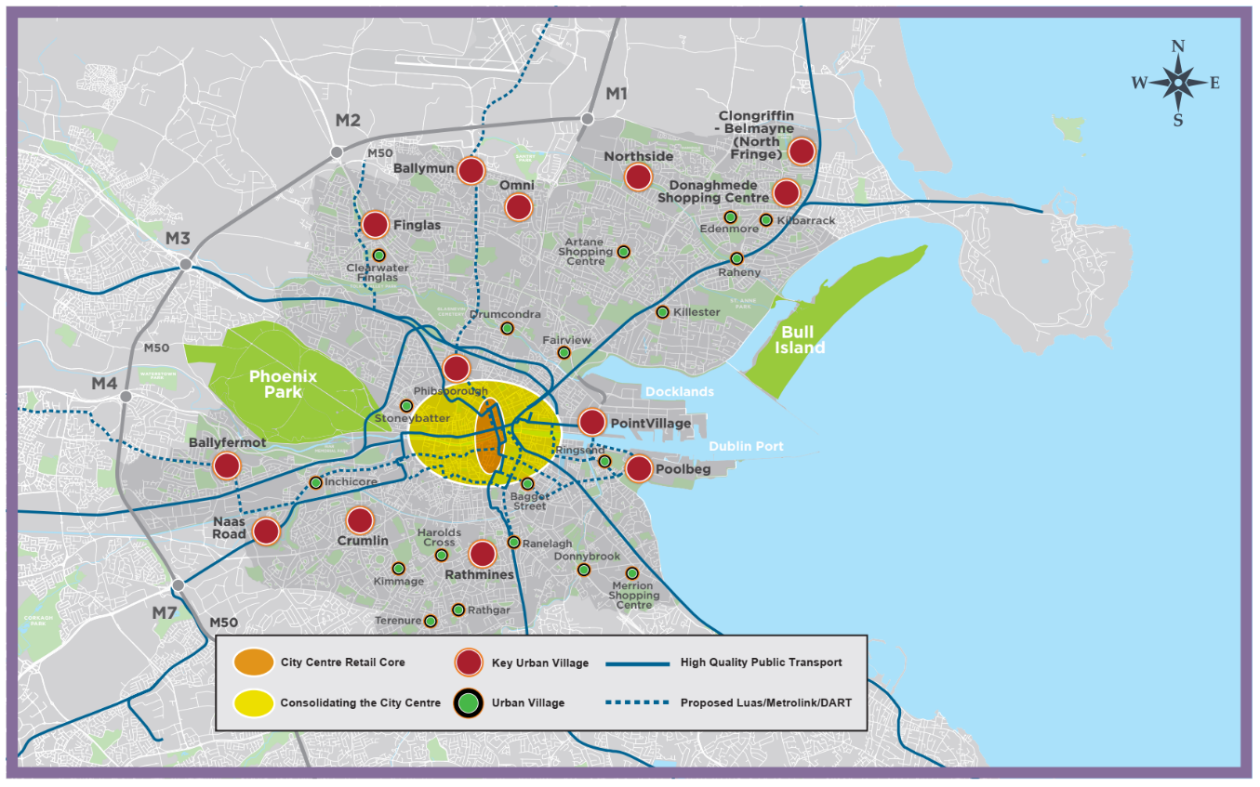
Material Alteration Reference Number 7.3

Chapter 7
Section: 7.5.1 General Retail Policy
Page: 250, Policy CCUV13

Amendment:

Policy CCUV13 Vacant Units

To promote the temporary use of vacant premises in order to reduce the level of vacancy on streets {in the city’s urban centres including Key Urban Villages} as this can compromise the vitality of urban centres. Temporary uses which can contribute to the economic, social and cultural vitality of the city centre {, Key Urban Villages and other centres} and which allow public access will be encouraged (pending permanent occupancy).

Material Alteration Reference Number 7.4

Chapter 7
Section: 7.5.1 General Retail Policy
Page: 250, Policy CCUV14

Amendment:

Policy CCUV14 Adult Shops, Betting Shops and Gaming Arcades

(To seek to prohibit) {That there will be a presumption against} adult shops, betting shops and gaming arcades in proximity to residential areas, places of public worship and schools and (to seek to prevent) {similarly, there will be a presumption against} an excessive concentration of such uses having regard to the existing presence of such retail outlets in an area.

Material Alteration Reference Number 7.5

Chapter 7
Section: 7.5.2 Primacy of the City Centre and Retail Core Area,
Page: 252, Figure 7.2: Dublin City Centre Retail Core, Principal Shopping Streets

Amendment to Graphic Map:

Figure 7.2 Dublin City Centre Retail Core, Principal Shopping Streets, amended to show route through Royal Hibernian Way (RHW) from Dawson Street towards Grafton Street, and Lemon Street as Category 2 Shopping Street

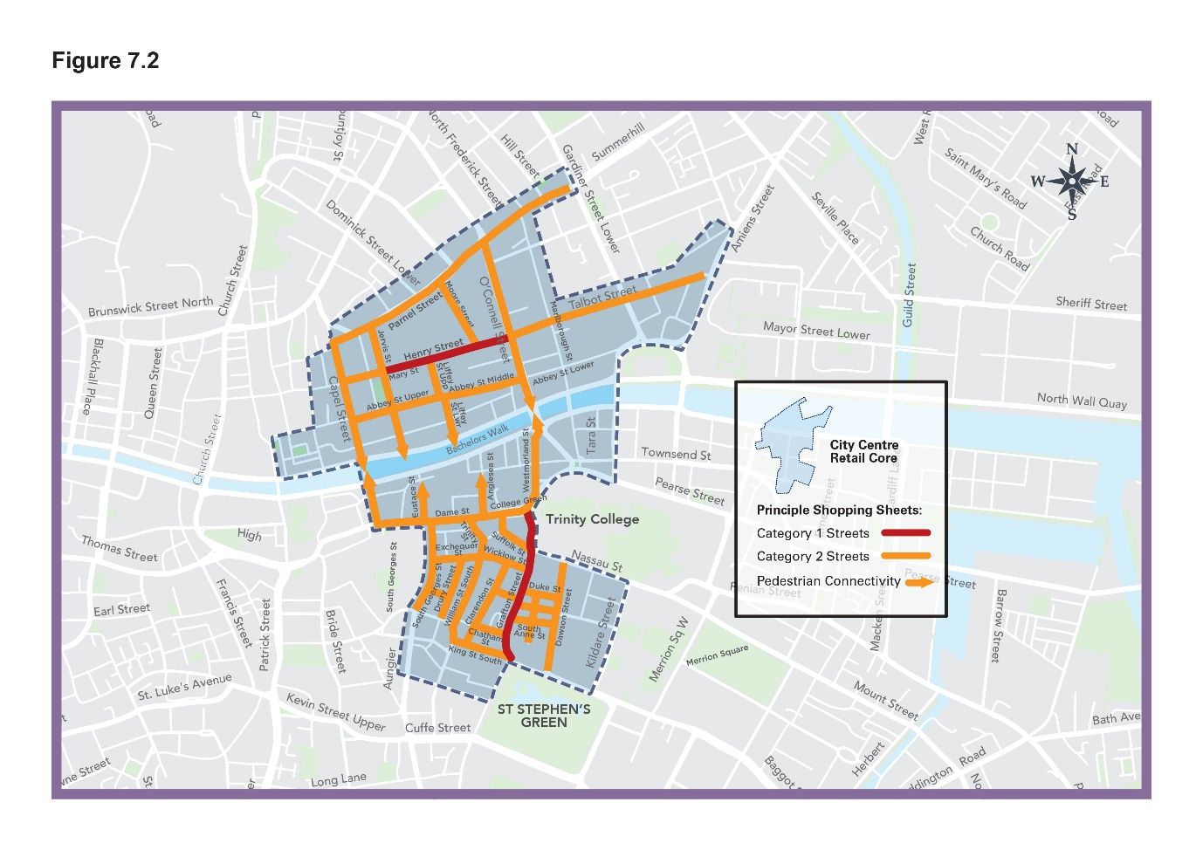

Material Alteration Reference Number 7.6

Chapter 7
Section: 7.5.2 Primacy of the City Centre and Retail Core Area
Page: 253, Policy CCUV18

Amendment:

Policy CCUV18 Residential Development

To encourage, support and promote more residential apartments as part of mixed-use developments or through the reuse / retrofit of the upper floors of existing buildings. The use of upper floors for residential use is supported in principle on Category {1 and} 2 Shopping Streets.

Material Alteration Reference Number 7.7

Chapter 7
Section: 7.5.2 Primacy of the City Centre and Retail Core Area
Page: 253, Policy CCUV19 Parking and the Retail Core

Amendment:

Policy CCUV19 Parking and the Retail Core

To support the re-use and replacement of {multi storey} car parks in the centre of the retail core and to safeguard short term car parking provision for shoppers and visitors at the periphery of the retail core. The redevelopment of central car parks will support public realm improvements and pedestrian priority in the retail core {and can support the retail core and night time economy by providing additional mobility hubs and other innovative transport solutions, see also Policy SMT26 (Chapter 8}.

Material Alteration Reference Number 7.8

Chapter 7
Section: 7.5.2 Primacy of the City Centre and Retail Core Area
Page: 254, Objective CCUVO6

Amendment:

Objective CCUVO6 Car Parks and Last Mile Delivery

To investigate the potential of the use of {multi-storey} car parks in the city centre for micro hubs and distribution centres for ‘last-mile’ delivery as part of the preparation of a Servicing / Logistics Strategy for the city (see also Objective SMT06).

Material Alteration Reference Number 7.9

Chapter 7
Section: 7.5.3, subsection on ‘Key Urban Villages’
Page: 257, 2nd paragraph

Amendment:

Chapter 2: Core Strategy, identifies a number of urban villages which are to be subject to {Local Area Plans (LAPs) /} Village Improvement Plan (VIPs) or Local Environmental Improvement Plans (LEIPs) to be prepared for these centres, as resources permit (see Chapter 2: Core Strategy).

Material Alteration Reference Number 7.10

Chapter 7
Section: 7.5.3 Key Urban Villages, Urban Villages and Neighbourhood Centres
Page: 257, Policy CCUV24

Amendment:

Policy CCUV24 Co - Working Hubs

To support the development of ‘Hub’ workspaces as part of new mixed new developments in (Key District Centres) {Key Urban Villages} and urban villages.

Material Alteration Reference Number 7.11

Chapter 7
Section: 7.5.3 Key Urban Villages, Urban Villages and Neighbourhood Centres
Page: 258, Objective CCUV010

Amendment:

Objective CCUVO10 Shopfront Improvement Scheme

To support the roll out of the Shop Front Improvement Scheme to the urban villages and radial streets in {the inner city} (centre) subject to a criteria based analysis, available resources and funding availability.

Material Alteration Reference Number 7.12

Chapter 7
Section: 7.5.6 Food and Beverage Sector / Markets
Page: 260, Policy CCUV34

Amendment:

Policy CCUV34 Moore Street Market

To recognise the unique importance of Moore Street Market to the history and culture of the city and to ensure its protection, renewal and enhancement in cooperation with the traders, {and taking account of the contents and relevant recommendations of the Moore Street Advisory Group Report, the OPW and other stakeholders including the response of the Minister for Heritage and Electoral Reform.}

Material Alteration Reference Number 7.13

Chapter 7
Section: 7.5.6 Food and Beverage Sector / Markets
Page: 261, Objective CCUVO12

Amendment:

Objective CCUVO12 Iveagh Market

To support a regenerated Iveagh Market as a major visitor attraction {/ for a compatible use that secures its preservation} and as a local amenity for the community and to ensure that regeneration proposals include an appropriate community/civic space.

Material Alteration Reference Number 7.14

Chapter 7
Section: 7.5.8 Public Realm,
Page: 264, insert a new Policy after CCUV41, subsequent numbering to be amended accordingly

Amendment:

{Policy - Public Realm – City Centre

To move to a low traffic environment generally and to increase the amount of traffic free spaces provided in the city centre over the lifetime of the Plan as well as create new high quality public realm areas where possible.}

Material Alteration Reference Number 7.15

Chapter 7
Section: 7.5.8 Public Realm, Objective CCUVO13
Page: 265

Amendment:

Objective CCUVO13 Civic Spine /{College Green Dame Street Project}(College Green)

To implement a programme of environmental and public realm improvements along the Grand Civic Spine from Parnell Square to Christchurch Place and along the city quays, and to prioritise (the redevelopment of College Green as a pedestrian friendly civic space including the pedestrianisation of Foster Place) {and deliver the redevelopment of the College Green and the Dame Street area up to the junction with South Great George’s Street and including Foster Place, as a premier civic space for the city with a traffic free world class public realm.}

Material Alteration Reference Number 7.16

Chapter 7
Section: 7.5.8 Public Realm
Page: 265 Insert a new Objective after CCUVO13, subsequent numbering to be amended accordingly

Amendment:

{Objective – Pedestrianisation South William Street}

{To support the full pedestrianisation of South William Street.}

Material Alteration Reference Number 7.17

Chapter 7
Section: 7.5.8 Public Realm
Page: 266, Objective CCUVO15

Amendment:

Objective CCUVO15 Public Realm Plans / Masterplans

To support the implementation of the following public realm plans / masterplans (listed below) and companion manuals:

• ‘The Heart of the City’ Public Realm Masterplan for the City Core 2016;
• Grafton Street Quarter Public Realm Improvement Plan, 2013;
• Public Realm Masterplan for the North Lotts & Grand Canal Dock SDZ Planning Scheme 2014;
• Temple Bar Public Realm Plan 2016; and
• (Markets Area Public Realm Plan 2021.)

Material Alteration Reference Number 7.18

Chapter 7
Section: 7.5.9 Outdoor Advertising Strategy
Page: 267, Objective CCUVO20

Amendment:

Objective CCUVO20 Audit of Redundant (Signage) {and Unnecessary Street Furniture}

To carry out an audit of (redundant) {existing street furniture including} signage and unused poles in the public realm {with the aim of identifying and removing redundant / unused and unnecessary street furniture (including redundant elements licenced under Section 254 of the Planning Act) in order to declutter and improve the pedestrian network and to optimise accessibility of all users. In this regard, Dublin City Council will aim to remove 100 such redundant elements in each administrative area each year for the life of the Development Plan. Dublin City Council will investigate measures to promote street furniture co-sharing and integration}. (in order to reduce street clutter and to investigate measures to promote co-sharing and integration with other street furniture elements.)

Chapter 8: Sustainable Movement and Transport

Material Alteration Reference Number 8.1

Chapter 8
Section: 8.5 Policies and Objectives, subheading 8.5.1 Addressing Climate Change through Sustainable Mobility
Page: 278, Table 8-1 Current and Target Mode Share

Amendment:

Table Content:
Current Mode Share {*}
Public Transport (bus, rail, LUAS) 57%*{*}

Table Note:

{*Current mode share figures are based on the NTA/DCC Canal Cordon Counts (November 2019) and present a picture of the modes of travel used by people travelling across the Canal Cordon into the City in a typical AM peak period.}

{*}*The modest increase in public transport mode share anticipates the construction of major public transport infrastructure that is proposed to occur over the lifetime of the plan. The impact of public transport infrastructure projects on mode share is more likely to come into fruition during the lifespan of the following plan.

Material Alteration Reference Number 8.2

Chapter 8
Section: 8.5.3 Public Realm, Place Making and Healthy Streets
Page: 284, Policy SMT9

Amendment:

Policy SMT9 Public Realm in New Developments

To encourage and facilitate the {co-ordinated} delivery of high quality public realm in tandem with new developments throughout the city in collaboration with private developers {and all service/utility providers,} through the Development Management process.

Material Alteration Reference Number 8.3

Chapter 8
Section: 8.5.3 Public Realm, Place Making and Healthy Streets
Page: 284, insert New Objective after Policy SMT9, subsequent numbering to be amended accordingly

Amendment:

{Objective - Public Realm Strategy

To review and update the Public Realm Strategy ‘Your City-Your Space’ within the lifetime of the Plan.}

Material Alteration Reference Number 8.4

Chapter 8
Section: 8.5.4 Accessibility for All
Page: 285, Policy SMT10 Pedestrian Network

Amendment:

Policy SMT10 Pedestrian Network

To protect, improve and expand on the pedestrian network (inclusive of facilities for people with mobility impairment and/or disabilities, including the elderly and people with children,) linking key public buildings, shopping streets, public transport points and tourist and recreational attractions {whilst ensuring accessibility for all, including people with mobility impairment and/or disabilities, older persons and people with children.}

Material Alteration Reference Number 8.5

Chapter 8
Section: 8.5.4 Accessibility for All
Page: 285, Objective SMTO2

Amendment:

Objective SMTO2 Improving the Pedestrian Network

To improve the pedestrian network{, and prioritise measures such as the removal of slip lanes, the} introduction of tactile paving, ramps{, raised tables} and kerb dishing at appropriate locations, including pedestrian crossings, {street junctions,} taxi ranks, bus stops and rail platforms in order to optimise {safe} accessibility for all users.
Material Alteration Reference Number 8.6

Chapter 8
Section: 8.5.4 Accessibility for All
Page 285, Objective SMTO4

Amendment:

Objective SMTO4 Taxi Ranks

To ensure the City is provided with adequate (and accessible) taxi ranks and facilities, {accessible and inclusive for a range of users} and to engage with the National Transport Authority and representatives of the taxi industry regarding provision of same.

Material Alteration Reference Number 8.7

Chapter 8
Section: 8.5.5 City Centre and Urban Villages - Access and Functional Needs, subsection Urban Villages
Page: 286

Amendment:

The importance of the urban villages as the heart and focus for communities is recognised and supported by this plan. Their role in contributing to the 15-minute city is crucial through their ability to provide a hub of services, facilities and amenities for the population within a 15 minute walking catchment. Dublin City Council is committed to improving connectivity to the urban villages, alongside improvements to the public realm and encouraging more active travel within these communities. {Dublin City Council will facilitate the delivery of public transport infrastructure and services, and cycle infrastructure, in order to ensure that the economic, social and cultural attractions of these locations can be supported, maintained and expanded by providing maximum accessibility by sustainable modes.}

Material Alteration Reference Number 8.8

Chapter 8
Section: 8.5.5 City Centre and Urban Villages - Access and Functional Needs
Page: 287, Policy SMT12

Amendment:

Policy SMT12 Urban Villages and the 15-Minute City

To support the role of the urban villages in contributing to the 15-minute city through improvement of connectivity, in particular for active travel {and facilitating the delivery of public transport infrastructure and services,} and public realm enhancement.

Material Alteration Reference Number 8.9

Chapter 8

Section: 8.5.5 City Centre and Urban Villages - Access and Functional Needs

Page: 287, Objective SMTO5

Amendment:

Objective SMTO5 Review of the City Centre Transport Study

To review the City Centre Transport Study 2016 {in collaboration with the NTA} in the lifetime of the plan, setting out a clear strategy to prioritise active travel modes and public transport use, whilst ensuring the integration of high quality public realm.

Material Alteration Reference Number 8.10

Chapter 8
Section: 8.5.6 Sustainable Modes, subheading Active Travel – Walking and Cycling
Page: 288 - 290

Amendment:

Page 288, first paragraph

A significant allocation of Government funding was announced in 2021 for
investment in walking and cycling and Dublin City Council, {through the Active Travel Programme Office,} is committed to supporting the roll out of the relevant infrastructure within the lifetime of this plan.

Page 290, fourth paragraph

The City Council, {through the Active Travel Programme Office,} will continue to work with the NTA’s ‘{Greater Dublin Area} Cycle Network Plan (for the Greater Dublin Area’) and its forthcoming review in order to develop a more comprehensive cycle network.

Material Alteration Reference Number 8.11

Chapter 8
Section: 8.5.6 Sustainable Modes, subheading Active Travel – Walking and Cycling
Page: 290, Policy SMT15

Amendment:

Policy SMT15 Walking, Cycling and Active Travel

To prioritise the development of {safe and connected} walking and cycling facilities and {prioritise} (encourage) a shift to active travel for people of all ages and abilities, in line with the city’s mode share targets.

Material Alteration Reference Number 8.12

Chapter 8
Section: 8.5.6 Sustainable Modes, subheading Active Travel – Walking and Cycling
Page: 290, Policy SMT16

Amendment:

Policy SMT16 Active Travel Initiatives

To promote and help develop community-based coordinated initiatives at local level that encourage active travel and modal switch to sustainable transport modes, and to target underrepresented cohorts/groups in such initiatives. (and specifically to target a significant increase in the number of children cycling to primary school).

Material Alteration Reference Number 8.13

Chapter 8
Section: 8.5.6 Sustainable Modes, subheading Active Travel – Walking and Cycling
Page: 290, Policy SMT17

Amendment:

Policy SMT17 The Pedestrian Environment

To continue to maintain and improve the pedestrian environment and (promote) {strengthen permeability by promoting} the development of a network of pedestrian routes {including laneway connections} which link residential areas with recreational, educational and employment destinations to create a pedestrian environment that is safe, accessible to all in accordance with best accessibility practice.

Material Alteration Reference Number 8.14

Chapter 8
Section: 8.5.6 Sustainable Modes, subheading Active Travel – Walking and Cycling
Page: 291, Objective SMTO7

Amendment:

Objective SMTO7 Review of Temporary Pedestrian and Cycling Improvement Interventions

To review the temporary pedestrian and cycling improvement interventions undertaken as part of Covid-19 mobility measures in 2020/2021, with a view to {upgrading and} implementing permanently the successful routes through the Roads Act, Part 8 or other appropriate mechanisms.

Material Alteration Reference Number 8.15

Chapter 8
Section: 8.5.6 Sustainable Modes, Subheading Active Travel – Walking and Cycling
Page 291, New Objective to be inserted after SMTO8 Cycling Infrastructure and Routes, subsequent numbering to be amended accordingly

Amendment:

{Objective - Greater Dublin Area Cycle Network Plan

To support the development of a connected cycling network in the City through the implementation of the NTA’s Greater Dublin Area Cycle Network Plan, subject to environmental assessment and route feasibility.}

Material Alteration Reference Number 8.16

Chapter 8
Section: 8.5.6 Sustainable Modes, subheading Active Travel – Walking and Cycling
Page: 291, insert New Objective, after New Objective ‘Greater Dublin Area Cycle Network Plan’, subsequent numbering to be amended accordingly

Amendment:

{Objective: Walking and Cycling Audits

Permission for major development (>100 units for example) will only be granted by the City Council, once a full audit of the walking and cycling facilities in the environs of a development is undertaken}

Material Alteration Reference Number 8.17

Chapter 8
Section: 8.5.6 Sustainable Modes, subheading Active Travel – Walking and Cycling
Page: 291, Objective SMTO11

Amendment:

Objective SMTO11 Design Standards for Cycle Parking in Developments

To prepare, (in the lifetime of the plan) {within two years of the adoption of the Plan,} a comprehensive guide setting out design standards and requirements for cycle parking in developments.

Material Alteration Reference Number 8.18

Chapter 8
Section: 8.5.6 Sustainable Modes, subheading Active Travel – Walking and Cycling
Page: 291, insert New Objective, after SMTO13 River Liffey Boardwalk, subsequent numbering to be amended accordingly

Amendment:

{Objective - Blaquiere Bridge

To seek to reopen the pathway underneath Blaquiere Bridge on the North Circular Road beside the Old State Cinema in Phibsborough to pedestrians and cyclists.}

Material Alteration Reference Number 8.19

Chapter 8
Section: 8.5.6 Sustainable Modes, subheading Active Travel and Schools
Page: 292, Policy SMT19

Amendment:

Change title of section:

(Active Travel and Schools) {Active Travel –Childcare Facilities, Schools and Third Level Institutions.}

Amend Policy SMT19 as follows:

Policy SMT19 Walking and Cycling for School Trips

- {To prioritise and target a significant increase in the number of children walking and cycling to and from schools.}
- To promote walking and cycling for school trips (through the){to all educational facilities};
- {To promote and support} (promotion of) initiatives such as “Safe Routes to School”, the ‘Green Schools’ and ‘Schools Streets’ projects, and to prioritise school routes for permeability projects and provision and enhancements of pedestrian and cycle ways.

Material Alteration Reference Number 8.20

Chapter 8
Section: 8.5.6 Sustainable Modes, subheading Active Travel and Schools
Page: 292, New Policy to be inserted after SMT19 Walking and Cycling for School Trips, subsequent numbering to be amended accordingly

Amendment:

{Policy - Accessibility and Design at Schools

To ensure that the development of new schools or expansion of existing schools demonstrate accessibility by sustainable transport options and that the layout and design shall be optimised to prioritise permeability and safe routes for pedestrians and cyclists.}

Material Alteration Reference Number 8.21

Chapter 8
Section: 8.5.6 Sustainable Modes, subheading Public Transport
Page: 293, additional text at the end of 2nd paragraph

Amendment:

The Council will continue to work with the NTA, the statutory authority responsible for long term strategic transport planning in the GDA, to focus on the delivery of additional and extended public transport routes to service newly developed and existing areas, to address gaps in existing areas, to improve access to public transport stops and services and to improve the integration between high density development and public transport nodes. {The Council will seek to safeguard existing public transport infrastructure to ensure future resilience is maintained.}

Material Alteration Reference Number 8.22

Chapter 8

Section: 8.5.6 Sustainable Modes, subsection Public Transport

Page: 295, Policy SMT20

Amendment:

SMT20 Key Sustainable Transport Projects

To support the expeditious delivery of key sustainable transport projects (including Metrolink, Bus Connects, DART+ and LUAS expansion programme) so as to provide an integrated public transport network with efficient interchange between transport modes, serving the existing and future needs of the city and region {and to support the integration of existing public transport infrastructure with other transport modes. In particular the following projects subject to environmental requirements and appropriate planning consents being obtained:

- DART +
- Metrolink from Charlemount to Swords
- Bus Connects Core Bus Corridor projects
- Delivery of Luas to Finglas
- Progress and delivery of Luas to Poolbeg and Lucan}

Material Alteration Reference Number 8.23

Chapter 8
Section: 8.5.6 Sustainable Modes, subheading Public Transport
Page: 295, Policy SMT21

Amendment:

Policy SMT21 The Rail Network and Freight Transport

- To work with Iarnród Éireann/Irish Rail, the NTA, TII and other operators to progress a coordinated approach to improving the rail network, integrated with other public transport modes to ensure maximum public benefit and promoting sustainable transport and improved connectivity.
- To facilitate {and support} the needs of freight transport in accordance with the NTA’s Transport Strategy for the Greater Dublin Area (2016 – 2035) {2022 – 2042} (and forthcoming review) and {enhance the capacity on existing rail lines and services to provide improved facilities promoting the principles of sustainable transport to cater for the movement of freight by rail}.
- {To support the outcomes of the Iarnród Éireann/Irish Rail Rail Freight 2040 Strategy}.

Material Alteration Reference Number 8.24

Chapter 8
Section: 8.5.6 Sustainable Modes, subheading Public Transport
Page: 295, Objective SMTO14

Amendment:

Objective SMTO14 Additional {Interchanges and} Rail Stations

- To promote and seek the development of a new (commuter rail) {interchange} station at Cross Guns {Glasnevin}(serving the existing rail line infrastructure and){, subject to environmental requirements being satisfied and appropriate planning consents being obtained, as part of the DART+ and Metro link projects}, (preferably as part of a larger mixed use development.)

{(ii) To promote the provision of a station at Croke Park Stadium.}

Material Alteration Reference Number 8.25

Chapter 8
Section: 8.5.6 Sustainable Modes; Subheading Public Transport
Page: 295, New Objective to be inserted after SMTO14 Additional Rail Stations, subsequent numbering to be amended accordingly

Amendment:

{Objective - Bus Infrastructure

DCC will work with the NTA to incorporate bus infrastructure within new large-scale developments where appropriate.}

Material Alteration Reference Number 8.26

Chapter 8

Section: 8.5.6 Sustainable Modes, subsection Public Transport

Page: 295, Objective SMTO15

Amendment:

Objective SMTO15 ‘Park and Ride’ Services

To promote ‘Park and Ride’ services at suitable locations in co-operation with neighbouring local authorities {and to support the implementation of the NTA’s Park and Ride Strategy for the Greater Dublin Area}.

Material Alteration Reference Number 8.27

Chapter 8
Section: 8.5.6 Sustainable Modes, subheading Micro-mobility and Shared Mobility
Page: 296-297, insert next text at the end of the 5th paragraph, Page 296

Amendment:

“Enhanced monitoring and data analysis will enable Dublin City Council to identify and cater for demand areas, to better design and manage road space and to develop an adaptive infrastructure. {Dublin City Council will continue to support Smart Dublin, an initiative of the Dublin local authorities, which aims to promote the Dublin region as a world leader in the development of smart city technologies.}”

Material Alteration Reference Number 8.28

Chapter 8
Section: 8.5.6 Sustainable Modes, subheading Micro-mobility and Shared Mobility
Page: 296-297, Policy SMT22

Amendment:

Policy SMT22 Shared Mobility and Adaptive Infrastructure

To promote the use and expansion of shared mobility to all areas of the city and facilitate adaptive infrastructure for the changing modal transport environment, including other micro-mobility and shared mobility, as part of an integrated transport network in the city {, and to support and promote smart growth initiatives that develop new solutions to existing and future mobility services and support Smart Dublin in the development of a Mobility as a Service (MaaS) platform.}

Material Alteration Reference Number 8.29

Chapter 8

Section: 8.5.9 Street/Road, Bridge and Tunnel Infrastructure
Page: 300, Policy SMT28

Amendment:
SMT28 National Road Projects

To protect national road projects as per the NTA {Transport} Strategy for the Greater Dublin Area (2016 – 2035) {2022 – 2042} and its review, {and in consultation with TII and the NTA, to support} (including) the (provision) {delivery}of (a){the} Southern Port Access Route to Poolbeg, {as a public road. The indicative alignment of this road link is shown on Map J.}

Material Alteration Reference Number 8.30

Chapter 8
Section 8.5.9 Street/Road, Bridge and Tunnel Infrastructure,
Page: 300, insert new policy after Policy SMT29 Transport Tunnels, subsequent numbering to be amended accordingly

Amendment:

{Policy - Dublin – Belfast Economic Corridor

To support the improvement, and protection, of the EU TEN-T network and the strategic function of the Dublin to Belfast road network.}

Material Alteration Reference Number 8.31

Chapter 8

Section: 8.5.9 Street/Road, Bridge and Tunnel Infrastructure
Page: 301, Objective SMTO23

Amendment:

Objective SMTO23 Road, Street and Bridge Schemes

To initiate and/or implement the following street/road schemes and bridges within the six year period of the development plan, subject to the availability of funding and environmental requirements and compliance with the ‘Principles of Road Development’ set out in the NTA {Greater Dublin Area} Transport Strategy.

Roads and Streets

River Road {Map A}
Belmayne Main Street {Map C}
Sean Moore Road {Map F}
Cherry Orchard Link Roads {Map D}
Richmond Road {Map E}
Collins Avenue Extension {Map B}
Blackhorse Avenue {Map D}
Clonshaugh Road Industrial Estate {Map B}
Cappagh Road {Map A}
St. Margaret’s Link Road {Map B}
Northern Cross/Belcamp Lane {Map B}
Santry Avenue Link Road {Map B}
Newtown Avenue {Map B}

Bridges

- Dodder Public Transport Bridge, linked with BusConnects 16 proposals {Map E}.
- Bridge from North Wall Quay at Point Depot (Point Bridge) and the widening of Tom Clarke Bridge, improve pedestrian and cycling facilities at the crossing point as well as accommodating additional public transport routes in conjunction with the Dodder Bridge {Map E}.
- Pedestrian/cycle bridge crossing the Liffey between the Samuel Beckett Bridge and the Tom Clarke Bridge {Map E}.
- Liffey Valley Park pedestrian/cycle bridge {Map E}.
- Pedestrian/Cycle Bridge across River Liffey from Irish National War Memorial Gardens/Islandbridge to the Chapelizod Road, Islandbridge {Map D}.
- Cycle/pedestrian bridges that emerge as part of the evolving Strategic Cycle Network and Strategic Green Infrastructure Network.
- Broadstone to Grand Canal pedestrian/cycle bridge {Map E}.

Material Alteration Reference Number 8.32

Chapter 8

Section: 8.5.9 Street/Road, Bridge and Tunnel Infrastructure
Page: 302, Objective SMTO25

Amendment:

Objective SMTO25 Road, Tolka Park Pedestrian/Cycle Connection

To provide a pedestrian/cycle connection {adjacent to} (from) Tolka Park to the lands to the south.

Material Alteration Reference Number 8.33

Chapter 8

Section: 8.5.10 Traffic Management and Road Safety Impacts

Page: 305, Objective SMTO32, insert new bullet point after first bullet point

Amendment:

Objective SMTO32 Environmental and Road Safety Impacts of traffic in the City

{To undertake a study, assessing and identifying areas adjacent to proposed sustainable transport projects for traffic calming and filter permeability.}
Chapter 9: Sustainable Environmental Infrastructure and Flood Risk

Material Alteration Reference Number 9.1

Chapter 9

Section: 9.5.1 Water Supply and Wastewater
Page: 315, 3rd paragraph

Amendment:

The water supply and wastewater needs of Dublin are to be met by a series of planned Strategic Water Services Projects designed to enhance the city’s water supply and increase wastewater treatment capacity in compliance with the Urban Waste Water Treatment and Drinking Water Directives. The phased upgrade of the Ringsend WWTP Project and Greater Dublin Drainage Project remain critical waste water infrastructure investment priorities in the short-to-medium term, whilst the Water Supply Project for the Eastern and Midlands Region (EMR) is identified as a critical longer term project to ensure resilience and security of supply. This project is due to be implemented under the IW National Water Resources Plan – Framework Plan (2021) which outlines how Irish Water intends to maintain the balance between the supply from water sources around the country and demand for drinking water over the short, medium and long-term. (The next phase will be the preparation of Regional Water Resources Plans (RWRP), which will in turn inform future capital investment and operational plans.){This Framework Plan is supported by the Draft Regional Water Resources Plan: Eastern and Midlands (RWRP-EM) which will inform future capital investment and operational plans in Dublin city.}

Material Alteration Reference Number 9.2

Chapter 9

Section: 9.5.2 Urban Watercourses and Water Quality
Page: 318, 3rd paragraph

Amendment:

The Council has a role to play in co-ordinating and tracking the implementation of {current, Draft and future 3rd cycle} RBMP measures at regional and local level, and in making sure they are fully considered throughout the physical planning process to ensure alignment between the Development Plan, WFD and RBMP. It is anticipated that forthcoming Section 28 Guidance on WFD Assessment and Sustainable Urban Drainage will assist planning authorities in addressing these water quality considerations as part of the planning and development decision-making process. {In the interim, regard will be had to the Government’s best practice guidance document, Nature-based Solutions to the Management of Rainwater and Surface Water Runoff in Urban Areas (December 2021)}.
Material Alteration Reference Number 9.3

Chapter: 9
Section: 9.5.2 Urban Watercourses and Water Quality
Page: 322, Objective SIO9

Amendment:

Objective SIO9: Planning for (Nature-based Water Management){Surface Water Management}

To undertake (Rainwater) {Surface Water} Management Plans for each river catchment and as part of this, include a study of relevant zoned lands within the city in order to ensure that sufficient land is provided for nature-based {surface} water management {, SuDS and green infrastructure}.

Material Alteration Reference Number 9.4

Chapter: 9
Section: 9.5.3 Flood Management
Page: 323, last paragraph on page

Amendment:

In 2013, the OPW published the Irish Coastal Protection Strategy Study (ICPSS) which provided strategic coastal flood and erosion hazard maps for the national coastline. {This was updated by the Irish Coastal Wave and Water Level Modelling Study (ICWWS) 2018, and the National Coastal Flood Hazard Mapping, 2021.} (This) {These} stud(y){ies} (has) {have} informed local authority assessment of potential hazards associated with future development, (has) {have} guided decision making on local coastal planning and development, and (has) {have} facilitated the development of appropriate plans and strategies for the sustainable management of coastlines. {Regard will also be had to the forthcoming recommendations of the Government’s Inter-Departmental Group on Coastal Change Management.}

Material Alteration Reference Number 9.5

Chapter: 9
Section: 9.5.3 Flood Management
Page: 324, Policy SI13

Amendment:

Policy SI13 Minimising Flood Risk

To minimise the flood risk in Dublin City from all other sources of flooding as far as is practicable, including fluvial, {coastal,} reservoirs and dams, (and) the piped water system {and potential climate change impacts}.

Material Alteration Reference Number 9.6

Chapter: 9
Section: 9.5.3 Flood Management
Page: 324, Policy SI14

Amendment:

Policy SI14 Strategic Flood Risk Assessment

To implement and comply fully with the recommendations of the Strategic Flood Risk Assessment prepared as part of the Dublin City Development Plan 2022-2028, {including all measures to mitigate identified climate change and flood risks, including those recommended under Part 3 (Specific Flood Risk Assessment) of the Justification Tests,} and to have regard to the Flood Risk Management Guidelines (2009), as revised by Circular PL 2/2014, when assessing planning applications and in the preparation of statutory and non-statutory plans.

Material Alteration Reference Number 9.7

Chapter: 9
Section: 9.5.3 Flood Management
Page: 324, Policy SI15

Amendment:

Policy SI15 Site-Specific Flood Risk Assessment

All development proposals shall carry out, to an appropriate level of detail, a Site-Specific Flood Risk Assessment (SSFRA) that shall demonstrate compliance with:

- The Planning System and Flood Risk Management, Guidelines for Planning Authorities, Department of the Environment, Community and Local Government (2009), as revised by Circular PL 2/2014 {and any future amendments}, and the Strategic Flood Risk Assessment (SFRA) as prepared by this Development Plan.
- The application of the sequential approach, with avoidance of {highly and less vulnerable} development in areas at risk of flooding as a priority {and/ or the provision of water compatible development only}. Where the Justification Test for Plan Making and Development Management have been passed, the SSFRA will address all potential sources of flood risk and will consider residual risks including climate change {and those associated with existing flood defences}. The SSFRA will include site-specific mitigation measures, flood-resilient design and construction, and any necessary management measures (the SFRA and Appendix B(4) of the above mentioned national guidelines refer). Attention shall be given in the site-specific flood risk assessment to building design and creating a successful interface with the public realm through good design that addresses flood concerns but also maintains appealing functional streetscapes. {Allowances for climate change shall be included in the SSFRA.}
- {On lands where the Justification Test for Plan Making has been passed and where a small proportion of the land is at risk of flooding, the sequential approach to development will be applied, and development will be limited to Minor Development (Section 5.28 of the Planning System and Flood Risk Management). There will be a presumption against the granting of permission for highly or less vulnerable development which encroaches onto or results in the loss of the flood plain. Water compatible development only will be considered in such areas at risk of flooding.}

Material Alteration Reference Number 9.8

Chapter: 9
Section: 9.5.3 Flood Management
Page: 325, Policy SI16

Amendment:

Policy SI16 Site-Specific Flood Risk Assessment

Proposals which may be classed as ‘minor development’, for example, small-scale infill, extensions to houses and small-scale extensions to existing commercial and industrial enterprises in Flood Zone A or B, should be assessed in accordance with the Guidelines for Planning Authorities on the Planning System and Flood Risk Management and Technical Appendices (2009), as revised by Circular PL 2/2014, with specific reference to Section 5.28 and in relation to the specific requirements of the Strategic Flood Risk Assessment. {This will include an assessment of the impact of climate change and appropriate mitigation.} The policy shall be not to increase the risk of flooding to the development or to third party lands, and to ensure risk to the development is managed.

Material Alteration Reference Number 9.9

Chapter: 9
Section: 9.5.3 Flood Management
Page: 325, Policy SI18

Amendment:

Policy SI18 Protection of Flood Alleviation Infrastructure

To put in place adequate measures to protect the integrity of flood alleviation infrastructure in Dublin City and to ensure new developments or temporary removal of any flood alleviation asset does not increase flood risk, while ensuring that new flood alleviation infrastructure has due regard to nature conservation, natural assets, open space and amenity values(.){, as well as potential climate change impacts}.

Material Alteration Reference Number 9.10

Chapter: 9
Section: 9.5.3 Flood Management
Page: 326, Policy SI19

Amendment:

Policy SI19 Provision and Upgrading of Flood Alleviation Assets

To facilitate the provision of new or the upgrading of existing flood alleviation assets where necessary and in particular, the implementation of proposed flood alleviation schemes, on the Santry, Camac, Dodder, Wad, Naniken, Mayne, Tolka and Poddle rivers as well as Clontarf Promenade, Sandymount {/ Promenade (northwards towards Irishtown Nature Park subject to the outcome of a flood / environmental study),} Liffey estuary and any other significant flood risk areas being progressed through the planning process {to completion} during the lifetime of the 2022-2028 Dublin City Development Plan, with due regard to the protection of natural heritage, built heritage and visual amenities (.){, as well as potential climate change impacts.}

Material Alteration Reference Number 9.11

Chapter 9
Section: 9.5.3 Flood Management
Page: 326, Policy SI21

Amendment:

Policy SI21 Managing Surface Water Flood Risk

To minimise flood risk arising from pluvial (surface water) flooding in the city by promoting the use of natural or nature-based flood risk management measures as a priority and by requiring the use of sustainable drainage systems (SuDS) to minimise and limit the extent of hard surfacing and paving, and requiring the use of sustainable drainage techniques, where appropriate, for new development or for extensions to existing developments, in order to reduce the potential impact of existing and predicted flooding risk and to deliver wider environmental and biodiversity benefits {and climate adaption}.

Material Alteration Reference Number 9.12

Chapter 9

Section: 9.5.3 Flood Management
Page: 326, Objective SIO10

Amendment:

Objective SIO10 OPW Flood Relief Maintenance

To support and facilitate the OPW in its duty to maintain flood relief schemes completed under the Arterial Drainage Acts, 1945-1995, including the schemes ( in Carysfort Maretimo Stream,) {at} River Dodder (Tidal), River Tolka, River Wad (Clanmoyle) South Campshires and Spencer Dock.

Material Alteration Reference Number 9.13

Chapter: 9
Section: 9.5.3 Flood Management
Page: 326, Objective SIO12

Amendment:

Objective SIO12 OPW Catchment-Based Flood Risk

To work with the OPW in the development and implementation of catchment-based strategies for the management of flood risk – including those relating to storage, and conveyance(.){and climate adaption}.

Material Alteration Reference Number 9.14

Chapter 9
Section: 9.5.4 Surface Water Management and Sustainable Drainage Systems (SuDS)
Page: 328, Policy SI22

Amendment:

Policy SI22 Sustainable Drainage Systems

To require the use of Sustainable Drainage Systems (SuDS) in all new developments, where appropriate, as set out in the Greater Dublin Strategic Drainage Study (Vol 2: New Development)/ Greater Dublin Regional Code of Practice for Drainage Works {and having regard to the guidance set out in Nature Based Solutions to the Management of Rainwater and Surface Water Runoff in Urban Areas, Water Sensitive Urban Design Best Practice Interim Guidance Document (DHLGH, 2021)}. Sustainable Drainage Systems (SuDS) should incorporate nature-based solutions and be designed in accordance with the Dublin City Council Sustainable Drainage Design and Evaluation Guide (2021) which is summarised in Appendix 12. SuDS should protect and enhance water quality through treatment at source while enhancing biodiversity and amenity.

Material Alteration Reference Number 9.15

Chapter 9

Section: 9.5.5 Waste Management and Circular Economy Practice
Page: 329, 2nd paragraph

Amendment:

The Government’s Waste Action Plan for a Circular Economy 2020-2025 provides Ireland with a roadmap for waste planning and management and is supported by the {Whole of Government Circular Economy Strategy 2022-2023 which provides a policy framework for Ireland’s transition to a circular economy through new policies and practices. The Draft Circular Economy Bill was published in 2021.} (Government Strategy to comply with EU Waste Directive obligations).

Material Alteration Reference Number 9.16

Chapter 9
Section: 9.5.5 Waste Management and Circular Economy Practice
Page: 330, 1st paragraph

Amendment:

The {current} Eastern Midlands Regional Waste Management Plan 2015–2021 (EMRWMP) provides a strategic vision and framework for the prevention, reduction and management of waste in a safe and sustainable manner and the development plan is required to take account of the requirements of the plan. Waste streams are viewed as a valuable material resource and landfilling discouraged in favour of higher value waste recovery options, such as the generation of energy from municipal waste. The plan sets strong targets on waste prevention, re-use, recycling and segregation, all to be achieved through active enforcement of waste policy/ legislation and the promotion of reuse, repair and resource efficiency activities. (The EMRWMP is under review with a new plan due to be published in 2022.) {A National Waste Management Plan for a Circular Economy is due to be published in late 2022 and will replace the existing Regional Waste Management Plans.}

Material Alteration Reference Number 9.17

Chapter: 9
Section: 9.5.5 Waste Management and Circular Economy Practice
Page: 331, Policy SI27

Amendment:

Policy SI27 Sustainable Waste Management

To support the principles of the circular economy, good waste management and the implementation of best practice in relation to waste management in order for Dublin City and the Region to become self-sufficient in terms of resource and waste management and to provide a waste management infrastructure that supports this objective. {To support opportunities in the circular resource efficient economy in accordance with the National Policy Statement on Bioeconomy (2018).}

Material Alteration Reference Number 9.18

Chapter 9

Section: 9.5.5 Waste Management and Circular Economy Practice
Page: 331, Policy SI28

Amendment:

Policy SI28 Sustainable Waste Management

To prevent and minimise waste generation and disposal, and to prioritise prevention, recycling, preparation for reuse and recovery in order to {develop Dublin as a circular city and} safeguard against environmental pollution.

Material Alteration Reference Number 9.19

Chapter: 9
Section: 9.5.8 Noise Pollution
Page: 336, SI40

Amendment:

Policy SI40 Dublin Airport Noise Zones and other Noise Plans

To take account of the Dublin Airport Local Area Plan (2020) and Noise Action Plan for Dublin Airport 2019-2023 as part of the development management process in order to (protect noise sensitive development) {ensure the protection/ prevention of noise sensitive uses within this zone} whilst facilitating the continued operation of Dublin Airport; and to develop similar appropriate plans for areas adjacent to Dublin Port.

Material Alteration Reference Number 9.20

Chapter 9

Section: 9.5.12 Energy Utilities
Page: 341, 2nd and 3rd paragraphs

Amendment:

Gas and electricity are the energy utilities which have traditionally heated and powered Dublin City, which is identified as a major energy demand centre. The development of low carbon, resilient, reliable and indigenous energy sources and networks is recognised as very important to supporting the social and economic development of (the city) {Dublin}, especially if {the city} (Dublin) is to fulfil its role as a digital connectivity hub which attracts high technology industries. Support for decentralised and indigenous energy sources such as the Dublin district heating project will have an important role to play in achieving this objective alongside small scale/ community investment in solar and other domestic scale renewables. {In the short to medium term, it is prudent that existing electricity generation capacity needs to be retained in order to ensure security of electricity supply. Any potential impact of large energy users will be assessed against this need.}

The Council will support energy utility providers in their efforts to {to deliver,} reinforce and strengthen existing (utility infrastructure and) {electricity and natural gas} transmission/ distribution {grid infrastructure,} (networks) {electricity interconnection and electricity storage in order to ensure security of electricity supply and support the growth of renewable electricity generation. The Council} will {also} support new infrastructure projects and technologies with particular emphasis on renewable, alternative and decentralised energy sources, and those which are less carbon intensive in line with the Electricity and Gas Networks Sector Climate Change Adaptation Plan (2019) {and Shaping our Electricity Future - A Roadmap to achieve our Renewable Ambition (2021)}.

Chapter 10: Green Infrastructure and Recreation

Material Alteration Reference Number 10.1

Chapter 10
Section: 10.2 Achievements
Page: 349, 2nd paragraph

Amendment:

The challenges associated with green infrastructure deficits, particularly within the city centre, are being tackled in recent years through the implementation of area-based greening strategies. The first greening strategy commenced in 2015 in The Liberties and, since then, (three) {two} more have followed: North-East Inner City (NEIC) and Stoneybatter. (and the Markets Area.)

Material Alteration Reference Number 10.2

Chapter 10
Section: 10.5.1 Green Infrastructure
Page: 358, Policy GI5

Amendment:

Policy GI5 Greening of Public Realm / Streets

To integrate urban greening features including nature based solutions into the existing public realm where feasible and into the design of public realm projects for civic spaces and streets. The installation of living green walls will be encouraged to the fullest possible extent throughout the city of Dublin {and tree pits with mixed planting will be preferred for the greening of streets in recognition of the co-benefits they offer for SuDs, biodiversity, amenity value and traffic calming.}

Material Alteration Reference Number 10.3

Chapter 10
Section: 10.5.1 Green Infrastructure
Page: 359, Objective GIO1

Amendment:

Objective GIO1 Green Roof Guidance Document (2021)

The use of green / blue roofs in developments will be in accordance with the requirements of the Dublin City Council Green {and Blue} Roof {Guide}(ance) Document (2021), see Appendix 11.

Material Alteration Reference Number 10.4

Chapter 10
Section: 10.5.1 Green Infrastructure
Page: 359, Objective GIO6

Amendment:

Objective GIO6 Metropolitan and Local Greenways

To support the development of the following metropolitan greenways and local cycleways / walkways:

      - Royal Canal and the Grand Canal (including the inner Grand/Royal canal loop linking the two canals via the Phoenix Park).
      - Rivers Liffey (Dublin Galway Euro route) Dodder ({Ringsend} to Dublin Mountains).
      - Coastal corridor.
      - Local routes and extension of existing routes including along the Rivers Tolka, Santry, Poddle, Camac and Mayne.

Material Alteration Reference Number 10.5

Chapter 10
Section: 10.5.2 Biodiversity
Page: 363, Policy GI16

Amendment:

Policy GI16 Habitat Creation and New Development

That new development {s (as appropriate) will be required to support local biodiversity and} (should provide opportunities to) incorporate biodiversity improvements through urban greening and the use of nature-based infrastructural solutions that are of particular relevance and benefit in an urban context. Opportunities should be taken as part of new development to provide a net gain in biodiversity {and provide links to the wider Green Infrastructure network. All suitable new buildings will be required to incorporate swift nesting blocks into the building fabric.}

Material Alteration Reference Number 10.6

Chapter 10
Section: 10.5.2 Biodiversity
Page: 365, Figure 10-2: SPA/SAC/pNHA Map

Amendment to Graphic Map:

- Inclusion of Royal and Grand Canals.
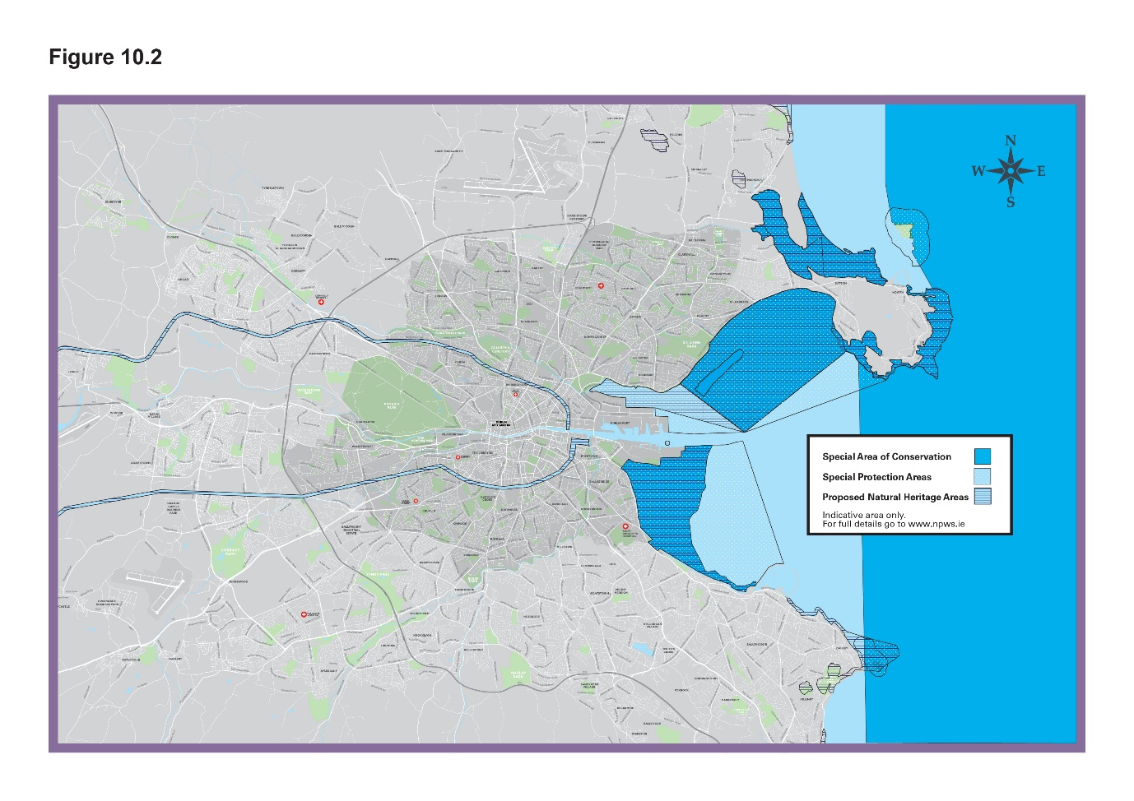
Material Alteration Reference Number 10.7

Chapter 10
Section: 10.5.4 Parks and Open Spaces
Page: 371, Objective GIO28

Amendment:

GIO28 Urban Farming and Food Production

- To support the provision of urban farming and food production initiatives, where feasible, and in particular, on the roofs of buildings, as temporary uses on vacant, under-utilised or derelict sites in the city and in peripheral urban areas / near M50, and in residential developments;
- (To seek to) {To commit to} increase the provision of allotments in the city (in the order of 100%) {by at least 100% if feasibly possible};
- To carry out a survey of underutilised open spaces for community gardens
with a view to identifying areas in the city appropriate and suitable for
community gardens.

Material Alteration Reference Number 10.8

Chapter 10
Section: 10.5.4 Parks and Open Spaces
Page: 371, Objective GIO29

Amendment:

Objective GIO29 Scully’s Field

To promote and actively pursue the development of a {primarily wooded} park in the area known as Scully’s Field between Clonskeagh and Miltown, while ensuring the conservation of {its} existing {character and} biodiversity. {Dublin City Council will seek to prepare a masterplan for Scully’s Field and environs, to enable the creation of an enhanced public space/park/ nature space at Scully’s Field and environs and consideration of the feasibility of limited development subject to environmental and flooding considerations, in conjunction with all relevant land owners}.

Material Alteration Reference Number 10.9

Section: 10.5.4 Parks and Open Spaces
Page: 371 Insert a New Objective after GIO30, subsequent numbering to be amended accordingly

Amendment:
{Objective - Mount Bernard Park

To seek to expand Mount Bernard Park northwards to the Royal Canal, with a bridge connecting with the Green Way}

Material Alteration Reference Number 10.10

Chapter 10
Section: 10.5.5 Rivers and Canals
Page: 374, Policy GI33

Amendment:

Policy GI33 River Liffey

To recognise the unique character, importance and potential of the River Liffey to the city and to protect and enhance its civic, ecological, amenity, historical and cultural connections. To promote the sustainable development of this key resource for amenity and recreational uses in and along the river and its development as a green corridor in the city. {In this regard, Dublin City Council will work with river based organisations and relevant stakeholders who use the river.}

Material Alteration Reference Number 10.11

Chapter 10
Section 10.5.5 Rivers and Canals
Page 374, Objective GIO34

Amendment:

Objective GIO34 Water Animation Strategy Docklands

To support the implementation of the North Lotts and Grand Canal Dock SDZ Docklands Water Animation Strategy 2018 to promote the Dublin Docklands as a significant water focussed amenity and the sustainable use of the waterways as an integral part of the vitality and experience of Dublin Docklands, that enhances the area as a world class destination for living, doing business, tourism, leisure and cultural activities; {and to explore the possibility of a new cultural space as part of the development of Georges Dock Basin. The Council commits to liaise and work with the Docklands Oversight and Advisory Committee and other relevant bodies in relation to proposals in George’s Dock.}

Material Alteration Reference Number 10.12

Chapter 10
Section: 10.5.6 The Coast and Dublin Bay UNESCO Biosphere
Page: 376, Objective GIO36

Amendment:

Objective GIO36 Bathing Beaches and Blue Flag Status

To maintain beaches for bathing at Dollymount {and} Sandymount {Strand}(, Merrion and Poolbeg/Shelly Banks) to a high standard and to protect and improve water quality and bathing facilities in order to bring them to ‘Blue Flag’ standard.

Material Alteration Reference Number 10.13

Chapter 10
Section: 10.5.6 The Coast and Dublin Bay UNESCO Biosphere
Page: 377, Objective GIO37

Amendment:

Objective GIO37 Dublin Bay Discovery Centre

To develop an accessible Discovery Centre for Dublin Bay (at North Bull Island) for education, interpretation, visitor management and research to support the nature conservation objectives of the North Bull Island Nature Reserve, the vision of the Dublin Bay UNESCO Biosphere and the criteria for biosphere reserves of the UNESCO Man and the Biosphere (MAB) Programme.

Material Alteration Reference Number 10.14

Chapter 10
Section: 10.5.7 Urban Forest
Page: 379, Objective GIO42

Amendment:

Objective GIO42 Urban Tree Canopy Plan

To support the preparation of an Urban Tree Canopy Plan for the City Centre Area and Inner City in the lifetime of this plan}. To increase the tree canopy cover to a minimum of 10% in all areas with an emphasis in increasing the tree canopy cover in areas where there is a deficit, and a minimum of 5% each year in the city centre {(a minimum of 5% over 6 years = a minimum of 30% over the life time of the plan)}.
Material Alteration Reference Number 10.15

Section: 10.5.8 Sport Recreation and Play
Page: 382, add to 1st paragraph

Amendment:

Figure 10-5 identifies and maps the strategic Public Rights of Way (PROW) in the city. Many of these PROW incorporate / will incorporate Metropolitan Greenways {or other public domain areas} thereby, promoting and enabling wider regional recreation and tourism objectives and also sustainable travel modes.

Material Alteration Reference Number 10.16

Chapter 10
Section: 10.5.8 Sport Recreation and Play
Page: 383, Policy GI52

Amendment:

Policy GI52 Children’s Playing facilities in New Residential {and Mixed} Developments

To seek the provision of children’s playing facilities in new residential developments {and mixed developments with a residential element}. To provide playgrounds to an appropriate standard of amenity, safety, and accessibility and to create safe and accessible places for socialising and informal play.

Material Alteration Reference Number 10.17

Section: 10.5.8 Sport, Recreation and Play
Objective GIO51 Dalymount Park
Page: 384

Amendment:

GIO51 Dalymount Park {,Tolka Park and St. Patrick’s Athletic FC Richmond Park}

To redevelop Dalymount Park, {Tolka Park and St. Patrick’s Athletic FC Richmond Park soccer stadia} providing enhanced sporting, recreational and community amenities and as part of this development {plan} to celebrate the rich sporting history of {these sites}.

Material Alteration Reference Number 10.18

Chapter 10
Section: 10.5.8 Sport, Recreation and Play
Page: 384, Objective GIO53

Amendment:

Objective GIO53 Water Sports and Leisure Activities

To support the development of a public lido {at George’s Dock, and to strive to achieve this within the first three years of the Development Plan being adopted,} and to provide other water sports and leisure activities in the city centre and {at the liffey, canals and other key water bodies}.

Material Alteration Reference Number 10.19

Chapter 10
Figure 10.5 Public Rights of Way
Page: 385, amendments to Graphic map

Amendment to Graphic Map:

- Corrections to Legend

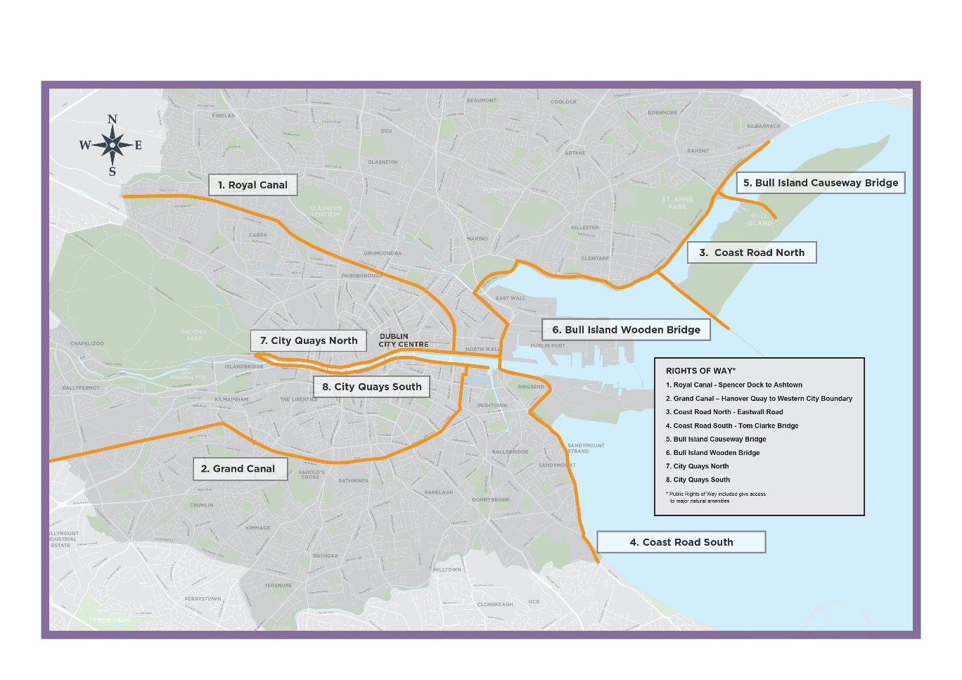

Chapter 11: Built Heritage and Archaeology

Material Alteration Reference Number 11.1

Chapter 11
Section: 11.5.5 Archaeological Heritage
Page: 394, 422, 424, Executive Summary

Amendment:

Delete the phrase (Sites and Zones of Archaeological Interest) and replace with {Record of Monuments and Places (RMP) as Established under Section 12 of the National Monuments (Amendment) Act 1994.} within the Draft Plan.

- Page 17, the Executive Summary
- Page 394, in the list of bullet points
- Page 422, 3rd and 4th paragraph
- Page 424, BHA26, paragraph 1, 3 & 4)

and make any necessary consequential minor amendments on foot of these changes.

Material Alteration Reference Number 11.2

Chapter 11
Section: 11.5.1 The Record of Protected Structures
Page: 398, Policy BHA2

Amendment:

Policy BHA2 Development of Protected Structures

(c): Ensure that works are carried out (under the supervision of) {in line with best conservation practice as advised by} a suitably qualified person with expertise in architectural conservation.

Material Alteration Reference Number 11.3

Chapter 11
Section: 11.5.2 Architectural Conservation Areas, subheading Priority Architectural Conservation Areas
Page: 401 - insert bullet after Henrietta Street

Amendment:

- {Iveagh Gardens, Crumlin}

Material Alteration Reference Number 11.4

Chapter 11
Section: 11.5.3 Built Heritage Assets of the City
Page: 409, BHA9 Conservation Areas

Amendment:

Policy BHA9 Conservation Areas

6. Retention of buildings and features that contribute to the overall character and integrity of the Conservation Area.
{7. The return of buildings to residential use.}

Material Alteration Reference Number 11.5

Chapter 11
Section: 11.5.3 Built Heritage Assets of the City, Subsection Buildings of Heritage Interest Including Mews and Vernacular Buildings
Page: 411, Policy BHA12

Amendment:

Policy BHA12 Industrial, Military and Maritime, Canal-side and Rural Heritage

To promote the awareness of Dublin’s industrial, military and maritime, canal-side (including lock-keepers’ dwellings, {locks and graving docks}, rail and rural (vernacular) heritage.

Material Alteration Reference Number 11.6

Chapter 11
Section: 11.5.3 Built Heritage Assets of the City, Subsection Industrial Heritage
Page: 413, Policy BHA17

Amendment:

Policy BHA17 Industrial Heritage of Waterways, Canals and Rivers

To support and promote a strategy for the protection and restoration of the industrial heritage of the city’s waterways, canals and rivers, including retaining features such as walls, weirs, (and) millraces(,) {and the graving dock structures at Ringsend.}

Material Alteration Reference Number 11.7

Chapter 11
Section: 11.5.5 Archaeological Heritage
Pg. 418, first paragraph

Amendment:

Dublin City has a rich archaeological heritage. It has a recorded history of human settlement of over 9,000 years, centred along the line of the River Liffey. (While there are few upstanding monuments in the city centre, beneath the surface is a rich and complex record of human activity. The upstanding monuments that survive include the city walls, several castles, churches and graveyards and the quay walls.) {There are significant upstanding monuments of archaeological interest across Dublin’s city centre including the ancient city walls, castles, churches and graveyards and the River Liffey’s quay walls. As with other European capital cities Dublin also has important subsurface archaeological remains that represent the history of the development of the city from its origins through the medieval period right up to modern times.} Mesolithic fish traps were excavated at Spencer Dock, while an exceptionally well-preserved Viking town was uncovered at Wood Quay. There are over 600 shipwrecks recorded in Dublin Bay {and the River Liffey. Many additional wrecks whose precise location is unknown are also likely to be present.} (while t){T}he industrial heritage of the city c.1750-1950 survives in areas such as St. James’s Gate.

Material Alteration Reference Number 11.8

Chapter 11
Section: 11.5.5 Archaeological Heritage, Record of Monuments and Places
Pg. 419, amendment to bullet point 5 and insertion of new bullet point 6

Amendment:

Amendment to bullet point 5:

- All previously unknown archaeology that becomes known (e.g. through ground disturbance, fieldwork or the discovery of {wrecks} or sites underwater).

New bullet point 6:

{Wrecks over 100 years old and archaeological objects underwater, irrespective of their age or location, are protected under the National Monuments Acts. Wrecks, though less than 100 years old, as well as sites or areas around sites or archaeological objects, due to their historic, archaeological or artistic value, can also be protected by means of designation through placement of an Underwater Heritage Order (UHO). See https://www.archaeology.ie/underwater-archaeology/planning-and-development for further detail in relation to planning and development and
:http://www.archaeology.ie/underwater-archaeology /wreck-viewer for the relevant mapping information}.

Material Alteration Reference Number 11.9

Chapter 11
Section: 11.5.5 Archaeological Heritage
Pg. 419, end of 1st paragraph

Amendment:

{The 2019 publication ‘Built and Archaeological Heritage Climate Change Sectoral Adaption Plan’, prepared under the National Adaptation Framework by the Department of Culture, Heritage and the Gaeltacht sets out an approach to responding to the challenges climate change poses to the built and archaeological heritage. The plan is framed by five goals –

1.To improve understanding of each heritage resource and its vulnerability to climate change
2. To develop and mainstream sustainable policies and plans for climate-change adaptation of built and archaeological heritage
3. To conserve Ireland’s heritage for future generations
4. To communicate and transfer knowledge
5. To exploit the opportunities for built and archaeological heritage to demonstrate value and secure resources
Dublin City Council fully supports the goals and aims of the adaptation plan and will work with key stakeholders to this end.}

Dublin City Council recognises the key role the Department of Housing, Local Government and Heritage have and will continue to work with the Department to promote the protection of the City’s archaeological heritage, including seeking funding through the Community Monuments Fund (CMF) to implement the policies and objectives of the Plan by supporting owners and custodians (including Dublin City Council) of archaeological monuments to safeguard them into the future for the benefit of communities and the public.}

Material Alteration Reference Number 11.10

Chapter 11
Section: 11.5.5 Archaeological Heritage, Record of Monuments and Places
Page: 422, 1st paragraph

Amendment:

The Record of Monuments and Places (RMP) was established under Section 12 of the National Monuments (Amendment) Act, 1994. Structures, features, objects or sites listed in this Record are known as Recorded Monuments. (The RMP is accompanied by a set of maps on which monuments are designated by a relevant reference number and denoted by a circle defining a Zone of Archaeological Potential. The Record of Monuments and Places for Dublin City is listed in Appendix 6 and detailed on Map L). {The Record of Monuments and Places (RMP) consists of a published county-by-county set of Ordnance Survey maps, on which monuments and places are marked by a circle or polygon, and an accompanying book for each county listing the monuments and places. It should be borne in mind that the circle or polygon does not necessarily define the extent of the monument or place. Much of the area of the core of modern Dublin City is designated in the RMP as ‘Historic City’ including the remains of the city walls and individual monuments that have been identified within the medieval walled town and around its environs. The RMP does not include all known archaeological sites and monuments, given that further such sites and monuments are found on an ongoing basis. For that reason, it is important (in the context of considering proposed development) to take account of all information available on the Historic Environment Viewer (HEV) available at www.archaeology.ie. The HEV will provide information not only on those archaeological monuments included in the statutory RMP, but also in regard to many more which have been identified since the RMP was issued. Such newly identified monuments will appear on the next revision of the RMP. RMP sites outside of the historic city are shown on Maps A-H. RMP within the historic city area (DU018-020) are shown on Map L. Appendix 6, Section 4.4 of this Plan lists the National Monuments in State care. }

Material Alteration Reference Number 11.11

Chapter 11
Section: 11.5.5 Archaeological Heritage
Page: 423, final paragraph

Amendment:

The policies and objectives below are intended to {identify, preserve,} conserve, raise awareness of {and provide access} to Dublin City’s rich archaeological heritage.

Material Alteration Reference Number 11.12

Chapter 11
Section: 11.5.5 Archaeological Heritage
Page: 424, Policy BHA26

Amendment:

Policy BHA26 Archaeological Heritage

Paragraph 1
To protect and preserve Sites and Zones of Archaeological interest which have been identified in the Record of Monuments and Places and the Historic Environment Viewer (www.archaeology.ie) {and all wrecks over 100 years old including those in the Shipwreck Inventory of Ireland.}

Paragraph 3
To seek the preservation in situ (or where this is not possible or appropriate, as a minimum, preservation by record) of all archaeological monuments included in the Record of Monuments and Places, (and of previously unknown sites, features and objects of archaeological interest that become revealed through development activity) {all wrecks and associated objects over 100 years old and of previously unknown sites, features and objects of archaeological interest that become revealed through development activity.} In respect of decision making on development proposals affecting sites listed in the Record of Monuments and Places, the Council will have regard to the advice and/or recommendations of the Department of Housing, Heritage and Local Government.

Paragraph 4
Development proposals within Sites and Zones of Archaeological {Notification} (Interest), of sites over 0.5 hectares size, {with potential underwater impacts} and of sites listed in the Dublin City Industrial Heritage Record, will be subject to consultation with the City Archaeologist and archaeological assessment prior to a planning application being lodged.

Paragraph 7
Development proposals in marine, lacustrine and riverine environments and areas of reclaimed land shall have regard to the Shipwreck Inventory maintained by the {Department of Housing, Local Government and Heritage} {Department of Culture, Heritage and the Gaeltacht} and be subject to an appropriate level of archaeological assessment.

Material Alteration Reference Number 11.13

Chapter 11
Section: 11.5.5 Archaeological Heritage,
Page: 425, Objective BHAO15

Amendment:

BHAO15 Civic Museum

To develop a strategy for improving public access to the former Civic Museum collection and for curation of other collections of civic interest and importance {including collaboration with other cultural bodies}.

Material Alteration Reference Number 11.14

Chapter 11
Section: 11.5.5
Page: 425, Objective BHAO17

Amendment:

Objective BHAO17 Tourism

Promote tourism in the medieval {and historic core of} the city drawing on its archaeological {and industrial} heritage to create a strong an authentic sense of place and to support educational and historical tours of sites in the city.

Material Alteration Reference Number 11.15

Chapter 11
Section: 11.5.5 Archaeological Heritage
Page: 426, Objective BHAO19

Amendment:

Objective BHAO19 Built Heritage and Archaeology

To provide for the protection, preservation and promotion of the built heritage, including architectural heritage and archaeological heritage {and underwater heritage} and support the in situ presentation and interpretation of archaeological finds within new developments.

Material Alteration Reference Number 11.16

Chapter 11
Section: 11.5.6 City Heritage Plan
Page: 427, Policy BHA28

Amendment:

BHA28 Historic Place and Street Names

To preserve historic place and street {and development} names and ensure that new street {and development} names reflect appropriate local archaeological, historical or cultural associations.

Material Alteration Reference Number 11.17

Chapter 11
Section: 11.5.6 City Heritage Plan
Page: 427, Policy BHA30

Amendment:

BHA30 Moore Street National Monument

To co-operate with and facilitate the state in its {preservation} of the National Monument at 14-17 Moore Street on a joint venture basis and to support the retention and refurbishment of the cultural quarter associated with 1916 on Moore Street {and taking account of the contents and relevant recommendations of the Moore Street Advisory Group Report to the Minister for Heritage and Electoral Reform and the ministers response.}

Material Alteration Reference Number 11.18

Chapter 11
Section: 11.5.6
Page: 427 insert New Policy after BHA33, subsequent numbering to be amended accordingly

Amendment:

{Policy - OPW Historic Sites

To co-operate with and facilitate the Office of Public Works to improve visitor experience/interpretation and upgrade key historic sites, including the Dublin Castle complex, St. Sepulchre’s Palace complex, Werburgh Street/Ship Street, the Debtors Prison, Royal Hospital at Kilmainham, the Irish National War Memorial Gardens and Commemorative Bridge, Phoenix Park (including the Visitors Centre and Magazine Fort), Collins Barracks, National Library of Ireland, the Casino at Marino and The Custom House and the 1916 Moore Street National Monument.}

Chapter 12: Culture

Material Alteration Reference Number 12.1

Chapter 12
Section: 12.2 Achievements
Page: 434, 4th paragraph

Amendment:

Dublin City Council Culture Company, on behalf of Dublin City Council, run a range of cultural initiatives and buildings across the city including programmes such as Culture Connects, Creative (residences) {Residencies}, Culture Club and the National Neighbourhood. They also manage and provide a range of services for two key Council heritage assets – {14} Henrietta Street and Richmond Barracks, as well as {conducting and} maintaining a {cultural audit}, database and map (Culture Near You) of all cultural assets in the city (www.dublincityculturecompany.ie).

Material Alteration Reference Number 12.2

Chapter 12
Section: 12.5.1 Protecting and Enhancing Dublin City’s Cultural Assets
Page: 439, Objective CUO2

Amendment:

Objective CUO2 Dublin Fire Brigade Museum

That Dublin City Council {as soon as practicable} undertake a study to identify a viable, appropriately scaled, permanent location for the Dublin Fire Brigade Museum currently housed in the O’Brien Institute.

Material Alteration Reference Number 12.3

Chapter 12
Section 12.5.1 Protecting and Enhancing Dublin City’s Cultural Assets
Page: 439, Objective CUO3

Amendment:

Objective CUO3: Dublin Music Resource Centre and Museum

In recognising the significant musical tradition in Dublin, the City Council will undertake a study (to explore the opportunity of creating) {to inform the creation of} a new Dublin Music Resource Centre and Museum that can provide facilities and opportunities for engagement with music for all, with a particular focus on engaging and encouraging under represented and socially excluded people within the city.

Material Alteration Reference Number 12.4

Chapter 12
Section 12.5.1 Protecting and Enhancing Dublin City’s Cultural Assets
Page: 439, Objective CUO5

Amendment:

Objective CUO5 Cultural Forum

{To work to establish} (explore the possibility of establishing) a Cultural Forum for Dublin, led by Dublin City Council and working with other cultural partners.

Material Alteration Reference Number 12.5

Chapter 12
Section 12.5.2 Cultural Hubs and Quarters
Page: 440, last sentence of first paragraph item (ii)

Amendment:

(ii) North Georgian City incorporating O’Connell St. {, Parnell Square,} and Moore Street;

Material Alteration Reference Number 12.6

Chapter 12
Section 12.5.2 Cultural Hubs and Quarters, subheading South Georgian Quarter
Page: 440

Amendment:

Significant investment has seen transformative improvements to the quality of space including the National Gallery, upgrades to the National Library, (and) the National Museum {and the proposed development of a new National Children’s Science Centre at Earlsfort Terrace}.

Material Alteration Reference Number 12.7

Chapter 12
Section: 12.5.2- Cultural Hubs and Quarters
Page: 442, Objective CUO9
Amendment:

Objective CUO9 14-17 Moore Street

To support the preservation and restoration of the historic terrace 10-25 Moore Street and adjacent yards and lanes, and the remaining historic built heritage of the street including numbers 1-8 Moore Street, and the establishment of a commemorative visitor centre, as a fitting tribute to the men and women of Easter 1916 and as an education and cultural resource centre {and taking account of the contents and relevant recommendations of the Moore Street Advisory Group Report, OPW and other stakeholders including the response of the Minister for Heritage and Electoral Reform.}

Material Alteration Reference Number 12.8

Chapter 12
Section 12.5.2 Cultural Hubs and Quarters
Page: 442, Objective CUO10

Amendment:

Objective CUO10 Convent and Magdalene Laundry Building on Sean Mc Dermott St.

CU{O}10 Convent and Magdalene Laundry Building on Sean McDermott St.

To (explore) {support} opportunities for suitable {and appropriate} development of this site that incorporates (housing and community uses and a memorial in the former Convent and Magdalene Laundry building on Sean McDermott St. and that are sensitive to the legacy and history of this location) {the Government proposal for a National Centre for Research and Remembrance, alongside provision of a mix of uses including residential, community/cultural and educational uses.}

Material Alteration Reference Number 12.9

Chapter 12
Section: 12.5.2- Cultural Hubs and Quarters, subheading Dublin 8, Kilmainham and Inchicore, insert after 1st paragraph
Page: 442

Amendment:

{The area also contains a number of high profile cultural and tourism destinations including Christchurch and St. Patrick’s cathedrals, and a range of brewing/distilling attractions; reflecting the craft and industrial heritage of this historic area. Weaving is also a strong tradition within the Liberties and a resurgence in interest in reviving the tradition presents opportunities to create new attractions, such as a craft hub}.

Material Alteration Reference Number 12.10

Chapter 12
Section 12.5.2- Cultural Hubs and Quarters
Page: 443, insert New Objective before CUO11, subsequent numbering to be amended accordingly

Amendment:

{Objective - Markets & Capel Street

To retain existing and seek the development of new community, arts and entrepreneur led arts and cultural initiatives within the Markets Area of the City and to support this area developing an identity as a vibrant cultural hub within the city core.}

Material Alteration Reference Number 12.11

Chapter 12
Section: 12.5.2 Cultural Hubs and Quarters, subheading Temple Bar
Page: 443, insert text after 2nd paragraph

Amendment:

{It is also recognised that the Temple Bar Quarter and environs have a strong connection with the LGBT+ community, and the importance of preserving and enhancing cultural spaces for this community in the city is supported.}

Material Alteration Reference Number 12.12

Chapter 12
Section 12.5.2- Cultural Hubs and Quarters
Page: 444, Objective CUO17

Amendment:

Objective CUO17 – Temple Bar as a Mixed Use Cultural Quarter

To seek to maintain the role of Temple Bar as a mixed use cultural quarter and avoid the concentration of particular uses and retail facilities which would re-inforce particular activities in the area to the detriment of the cultural, residential and social functions of the area. (Any application for) {There will be a presumption against} further expansion of floor space for licenced premises, (restaurant) or the sale of food or alcohol for consumption off the premises, {and any application} will have to demonstrate how such expansion will not have a detrimental impact on the character of the area. {Any further expansion of restaurant floor space will be assessed on a case by case basis and will also be required to demonstrate how such an expansion will not have a detrimental impact on the character of the area.}

Material Alteration Reference Number 12.13

Chapter 12
Section 12.5.2- Cultural Hubs and Quarters
Page: 444, Objective CUO18

Amendment:

CUO18 (National Photographic Archive) {Gallery of Photography} and the {Irish Film Institute (IFI)}

{To support the expansion of the IFI and associated Irish Film Archive to create additional cultural offering for the City and to support the exploration of the possibility of a Museum and Archive of Irish Film;} and to (recognise the need for the expansion of the photographic archive and to) support the identification of a new space {for the Gallery of Photography} to meet the needs of this cultural facility.

Material Alteration Reference Number 12.14

Chapter 12
Section 12.5.2- Cultural Hubs and Quarters
Page: 444, insert New Objective after CUO18, subsequent numbering to be amended accordingly

{Objective - Artistic Spaces

To protect key artistic spaces within Temple Bar that provide the basis of Temple Bar’s cultural infrastructure and to ensure that any changes of use to such buildings continue to deliver artistic spaces or similar cultural uses.}

Material Alteration Reference Number 12.15

Chapter 12
Section 12.5.2 Cultural Hubs and Quarters, sub heading Temple Bar
Page: 444, insert New Objective after New Objective – Artistic Spaces, subsequent numbering to be amended accordingly

Amendment:

{Objective - LGBT+ Community

To build upon the strong connection between the Temple Bar Quarter and environs and the LGBT+ community and (i) seek to preserve and enhance key cultural spaces within the area that serve the community and (ii) undertake a feasibility study in relation to a new dedicated Museum and Cultural Centre dedicated to Irish Queer history and LGBT+ rights}.

Material Alteration Reference Number 12.16

Chapter 12
Section: 12.5.2 Cultural Hubs and Quarters, sub heading Dublin Docklands
Page: 445, Policy CU11

Amendment:

Policy CU11 Cultural Facilities within Docklands

Support and encourage the growth of cultural facilities within Docklands {to include the Poolbeg Peninsula}, at community and city-wide scale, to enrich the areas, generate activity and economic benefits and celebrate the maritime heritage of the Docklands area.

Material Alteration Reference Number 12.17

Chapter 12
Section 12.5.3 Supporting Cultural Vibrancy in the City
Page: 447, Policy CU12

Amendment:

CU12 Cultural Spaces and Facilities

To grow the range of cultural spaces and facilities in tandem with all new developments and across existing developments {such as in basement or roof-top spaces where suitable} to meet the needs of an increasing population in the city.

Material Alteration Reference Number 12.18

Chapter 12
Section: 12.5.3 Supporting Cultural Vibrancy in the City
Page: 447, Policy CU14

Amendment:

Policy CU14 Cultural Uses in Developments on Former Industrial Lands

To ensure new developments on former industrial lands incorporate cultural uses {(including night-time entertainment space designed to minimise impact on residential areas)} as part of new mixed-use communities.

Material Alteration Reference Number 12.19

Chapter 12
Section 12.5.3 Supporting Cultural Vibrancy in the City
Page: 448, Objective CUO22, add footnote

Amendment:

{*Such developments shall incorporate both cultural/arts and community uses individually or in combination unless there is an evidence base to justify the 5% going to one sector.}

Material Alteration Reference Number 12.20

Chapter 12
Section 12.5.3 Supporting Cultural Vibrancy in the City
Page: 448, insert New Objective after CUO25, subsequent numbering to be amended accordingly

Amendment:

{Objective - Performing Arts Venue

To undertake a feasibility study to assess the need for; and the possible form and scale of a new performing arts space (and ancillary spaces) within the inner city and the options for achieving successful implementation.}

Material Alteration Reference Number 12.21

Chapter 12
Section 12.5.4 Supporting Key Cultural Activities
Page 449, insert additional text after 1st paragraph

Amendment:

{*All references to artist/artistic means practitioners in all artistic disciplines.}

Material Alteration Reference Number 12.22

Chapter 12
Section 12.5.4 Supporting Key Cultural Activities
Page: 450, Objective CUO27

Amendment:

Objective CUO27- Artist (Studios) {Workspaces}

To further develop and provide for artist (studio) {work} spaces {and spaces for creative production} within the city and avail of opportunities for utilising underused buildings within communities for artistic and cultural purposes.

Material Alteration Reference Number 12.23

Chapter 12
Section 12.5.5 Culture in the Community
Page: 451, Objective CUO31

Amendment:

Objective CUO31- Music Venues

To encourage the development of new music {and dance} venues {at accessible locations} that will provide opportunities for music artists to perform {and spaces for people to experience music} at a range of venue sizes.

Material Alteration Reference Number 12.24

Chapter 12
Section 12.5.4 Supporting Key Cultural Activities
Page: 452, Objective CUO32

Amendment:

Objective CUO32 Audio-Visual Sector

To support the growth of the audio-visual sector within the city, and the continued growth of the existing clusters in Dublin 8 and Dublin 2 {and the emerging cluster in Dublin 7}, including encouraging start-up space provision.

Material Alteration Reference Number 12.25

Chapter 12
Section 12.5.4 Supporting Key Cultural Activities
Page: 452, insert new paragraph at end

Amendment:

{Also critical to the functioning of many larger cultural spaces is the maintenance of HGV delivery access of large sets/gig equipment; which needs to be taken into consideration for both applications for expansion by the venue and for proposed public realm projects immediately adjacent to such spaces.}

Material Alteration Reference Number 12.26

Chapter 12
Section 12.5.3 Supporting Cultural Vibrancy in the City
Page: 453, Policy CU22

Amendment:

Policy CU22 Range of Cultural and Amenity Options

To seek and encourage a range of cultural and amenity options for residents and visitors within the city that are independent of licenced premises to allow options for younger people, {families} and others to engage and enjoy a range of activities in the city during evening hours.

Material Alteration Reference Number 12.27

Chapter 12
Section 12.5.3 Supporting Cultural Vibrancy in the City
Page: 453, Objective CUO34

Amendment:

Objective CUO34 Noise Impacts

{*See also Policy CCUV36}

Material Alteration Reference Number 12.28

Chapter 12
Section 12.5.4 Supporting Key Cultural Activities
Page: 453, Objective CUO35

Amendment:

Objective CUO35 Purpose Spaces for Evening and Night Time Activities

To encourage the opportunity presented by new larger developments, {including a requirement for all large hotels*}; to provide high quality designed for purpose spaces that can accommodate evening and night time activities, such as basement/roof level “black box” spaces that can be used for smaller scale performance/theatre{/music}/dance venues, and{/or} for flexibility in the design of larger spaces, such as conference spaces, to be adaptable for evening uses.
{*Over 100 bedrooms}

Material Alteration Reference Number 12.29

Chapter 12
Section 12.5.5 Culture in the Community
Page: 457, Objective CUO40

Amendment:

Objective CUO40 – Cultural and Artistic Space Audit

To aim to undertake during the life of the development plan, an audit and implementation plan for each Electoral Area of the Council to assess the current and future needs with regard to cultural and artistic spaces, {(including music)} and to set a series of actions, policy tools, and initiatives to address identified shortfalls.

Material Alteration Reference Number 12.30

Chapter 12
Section 12.5.5 Culture in the Community
Page: 457, Objective CUO43

Amendment:

Objective CUO43- Accessibility

To encourage (disabled) people {of all abilities and ages} to take part fully in the city’s culture as creators, artists, workers and consumers by supporting a high standard of accessibility in new and existing cultural assets.

Material Alteration Reference Number 12.31

Chapter 12
Section 12.5.6 Supporting the Irish Language and Culture in the City
Page: 459, Policy CU26

Amendment:

Policy CU26- Irish Language

To continue supporting Gaeilge as part of our identity and as a living language within the city and to (explore options for promoting) {promote} Irish language and culture through policy and actions.

Material Alteration Reference Number 12.32

Chapter 12
Section 12.5.6 Supporting the Irish Language and Culture in the City
Page: 459, Objective CUO45

Amendment:

Objective CUO45 Dublin Gaeltacht

To support the promotion of the Irish language and support initiatives to establish Irish language network areas/”Dublin Gaeltacht” in Dublin; {and the implementation of Dublin City Council’s initiative Baile Átha Cliath le Gaeilge to increase the opportunities and space for people to use and learn}.

Material Alteration Reference Number 12.33

Chapter 12
Section 12.5.6 Supporting the Irish Language and Culture in the City; Sub Heading Irish Language Quarter
Page: 459, Objective CUO49

Amendment:

Objective CUO49 Irish Language on Shopfronts

To support {and identify funding for} the use of the Irish language on shopfronts, having regard to the principles set out in Dublin City Council’s ‘Shop-f{r}ont Design Guidelines’ and Chapter 15.

Material Alteration Reference Number 12.34

Chapter 12
Section 12.5.6 Supporting the Irish Language and Culture in the City
Page: 460, Objective CUO51

Amendment:

Objective CUO51- Dublin City Language and Cultural Hub

To promote and support the development of a flagship Dublin City Language and Cultural Hub {on Harcourt Street} as outlined in {the National Development Plan 2021-30 and}(the) Project Ireland 2040 (document, Infheistinár dTeanga & inár nOidhreacht- Investing in our Culture, Language & Heritage 2018-2027.)

Material Alteration Reference Number 12.35

Chapter 12
Section 12.5.7 Culture in the Public Domain.
Page: 462, Policy CU29

Amendment:

Policy CU29- Public Realm for Cultural Events

To encourage greater use of the public realm for cultural events to make the {inner} city (centre), {and urban villages} more attractive to those with young families {for both day and night time events}, and to seek provision of new public spaces for outdoor performance that are designed and fitted to host a range of events.

Material Alteration Reference Number 12.36

Chapter 12
Section 12.5.7 Culture in the Public Domain
Page: 462, insert New Objective after CUO55 - Broadstone Plaza, subsequent numbering to be amended accordingly

Amendment:

{Objective - Broadstone Plaza

To undertake a study to examine the potential of utilizing the Broadstone Plaza for hosting public events and markets and to explore opportunities to work with TU Dublin and Grangegorman Development Agency in developing new opportunities for public events in this area.}

Chapter 13: Strategic Development Regeneration Areas

Material Alteration Reference Number 13.1

All SDRA maps are amended as follows:

(“Permeability Interventions” and “Greening, Cycle and Pedestrian Corridors”)

{“Access and Permeability Corridor”}

Relevant Maps/Figures are shown are shown sequentially below. The symbols on the key are amended accordingly.

Material Alteration Reference Number 13.2

Chapter 13
Section: Section 13.1 Introduction
Page: 466, 2nd paragraph

Amendment:

The active land management measures and approach referred to under the core strategy will be pursued in the development and delivery of the SDRAs. {Table 13.1 sets out the 17 SDRA’s, their estimated capacity and key supporting infrastructure.}

Delete Table 13.1 and replace with following table:

{Table 13.1: Capacity of SDRA Designated Lands for Residential Use or a Mixture of Residential and Other Uses and Supporting Infrastructure}
SDRA Ref. | City Area Name | Estimated Capacity | Area (Ha) | Supporting Infrastructure
SDRA 1 | Clongriffin/Belmayne and Environs | 6,950 – 7,350 | 52 | DART+,  Bus Connects, completion of Main Street, social infrastructure
SDRA 2 | Ballymun | 2,200 – 2,350 | 35 | Metrolink, Bus Connects
SDRA 3 | Finglas Village Environs and Jamestown Lands | 2,800 | 52 | Luas Finglas, Bus Connects, social infrastructure
SDRA 4 | Park West/Cherry Orchard | 2,500 – 3,100 | 49 | DART+,  Bus Connects, social infrastructure.
SDRA 5 | Naas Road | 3,300 | 18 | Bus Connects, Luas stop,  Water service upgrade
SDRA 6 | Docklands | 7,900 | 24 | DART+,  Dodder Bridge, Bus Connects, Luas Poolbeg, District Heating, social infrastructure
SDRA 7 | Heuston and Environs | 1,250 | 14 | DART+,  Bus Connects
SDRA 8 | Grangegorman/Broadstone | 900 | 11 | Bus Connects
SDRA 9 | Emmet Road | 1.050 | 15 | Bus Connects, social infrastructure
SDRA 10 | North East Inner City | 850 | 12 | DART+,  Bus Connects, social infrastructure
SDRA 11 | St. Teresa’s Gardens | 950 | 13 | Bus Connects
SDRA 12 | Dolphin House | 350 | 6 | Bus Connects
SDRA 13 | Markets Area and Environs | 400 | 8 | Public realm
SDRA 14 | St. James’ Medical Campus and Environs | - | - | Bus Connects
SDRA 15 | Liberties and Newmarket Square | 2,500 | 30 | Bus Connects, social infrastructure, public realm
SDRA 16 | Oscar Traynor Road | 850 | 17 | Bus Connects
SDRA 17 | Werburgh Street | 100 | 2 | Public realm
 | Total | 34,750 – 35,950 | 358}

Material Alteration Reference Number 13.3

Chapter 13
Section: 13.1 Introduction
Page: 467, 2nd paragraph

Amendment:

The guiding principles plans are not intended to be prescriptive, but seek to set out an overall strategy for each site in terms of the appropriate form and scale of development, key routes and permeability, open space etc. (Minor deviations from the guiding principles map may be acceptable) {Some flexibility in the interpretation of the guiding principles maps will be applied} where the applicant can demonstrate that the overall intent of the guiding principles has been incorporated and considered and that an appropriate development response for the site has been developed.

Material Alteration Reference Number 13.4

Chapter 13
Section: After section 13.1
Page: 467

Amendment:

The following text will be added to Chapter 13 after section 13.1 as a new section, subsequent section titles to be renumbered accordingly
{13.2 Alignment of Strategic Development and Regeneration Areas with the NPF and RSES

As set out in Chapter 1, the Development Plan is informed by a hierarchy of international, national and regional policies. Of particular note, is the National Planning Framework (2018) and the Regional Spatial and Economic Strategy (2019-2031). Chapter 2, the Core Strategy, details how the policies and objectives of these documents will influence the future growth and development of the city. Table 2.8 in Chapter 2 –clearly shows the alignment of the SDRAs with the core strategy and sets out information regarding the area, population and yield of each area.

In terms of the NPF, the SDRA’s will play a key role in meeting the National Strategic Objectives, and particularly those of compact growth (NSO 1), sustainable mobility (NSO 4), and the transition to a low carbon and climate resilient society (NSO 8). In accordance with National Policy Objective 3b, the SDRA’s are critical to the delivery of the core strategy and compliance with the objective that 50% of new homes are within the existing built up footprint of the city.

The designated SDRA’s align with the overarching objectives of the NPF and RSES. They will be drivers of economic growth and investment in the city in line with NPO 5. Their development is also important in the context of NPO 6, and the vision of the plan is that the SDRA’s will be developed over the plan period for significant residential and employment uses developed in tandem with high quality social and community infrastructure and amenities, served by excellent public transport.

More specifically the ongoing development of the National Children’s Hospital (SDRA 14) and Grangegorman campus (SDRA 8) align with NSO10. The development of Clongriffin (SDRA 1); the development of ambitious largescale regeneration areas; and facilitating the growth and expansion of Dublin Port (SDRA 6) will play a key role in supporting the strategic growth enablers for Dublin City as identified in the NPF.

In terms of the RSES, a number of Residential Strategic Development Areas (SDA’s) are identified. Many of the SDRA’s identified align with these SDA’s and will provide for high quality, higher density residential development in line with RPO 5.4. The RSES also identifies a number of Employment Strategic Development Areas which also align with the SDRA’s. The development of these areas will accord with objective RPO 5.6 of the RSES (see also section 1.9.6, Chapter 1). It is envisaged that the relevant SDRA’s will be developed for appropriate employment densities in tandem with the provision of high quality public transport corridors.}

Material Alteration Reference Number 13.5

Chapter 13
Section: 13.2 Overarching Principles
Page: 467 – 469, insert New Objective SDRAO1 in section 13.2 after 1st paragraph

Amendment:

After 1st paragraph delete existing text in section 13.2 and replace with the following text:

{13.2.1 Overarching Principles and Vision

Objective SDRAO1 Overarching Principles and Vision

It is the objective of Dublin City Council:

To support the ongoing redevelopment and regeneration of the SDRA’s in accordance with the guiding principles and associated map; the qualitative and quantitative development management standards set out in Chapter 15; and in line with the following overarching principles:

Architectural Design and Urban Design: All development within the SDRAs must be of the highest architectural quality and adhere to the key architectural and urban design principles set out in Chapter 15 in order to create long term, viable and sustainable communities aligned with the principles of the 15-minute city.

Phasing: Large scale development proposals should be developed in accordance with agreed phasing plans to ensure that adequate social and physical infrastructure is delivered in tandem with development.

Access and Permeability: Development proposals should ensure adequate permeability and connectivity to surrounding neighbourhoods and public transport infrastructure through the provision of high quality, accessible public realm and high-quality walking and cycling infrastructure. Access and layout should accord with the principles of DMURS.

Height: Guiding principles regarding height are set out for each SDRA. Where development adjoins lower scaled residential communities, development must be appropriately designed so that no significant adverse impacts on the residential amenities of adjacent residential properties arises. The performance criteria set out in Appendix 3 should be adhered to for developments of significant scale and/or density.

Urban Greening and Biodiversity: Development proposals within the SDRA must ensure the integration of greening and biodiversity measures including high quality public open space as well as micro greening measures including green walls, green roofs, parklets etc. In general, unless otherwise specified under a separate LAP/SDZ Planning Scheme/other statutory plan policy/objective or site-specific guiding principle, a minimum of 10% public open space should be provided as part of all development proposals in SDRAs. A financial contribution in lieu of same will only be considered in exceptional circumstances.

Surface Water Management: All development proposals should provide for sustainable surface water management and the installation of sustainable drainage systems (SuDS) in order to reduce surface water runoff and potential flooding. This should be considered in conjunction with open space design and greening/biodiversity initiatives. See Appendix 11, 12 and 13 for further detail.

Flood Risk: All development proposals within the SDRA’s will have regard to restrictions / measures to mitigate identified flood risk outlined in Strategic Flood Risk Assessment and in particular, Appendices A and B.

River Restoration: Opportunities for enhanced river corridors are applicable to the following Strategic Development and Regeneration Areas (SDRAs) in order to harness significant opportunities for river restoration where feasible: SDRA 1 Clongriffin/Belmayne and Environs; SDRA 3 Finglas Village Environs and Jamestown Lands; SDRA 4 Park West/Cherry Orchard; SDRA 5 Naas Road; SDRA 6 Docklands; SDRA 7 Heuston and Environs; SDRA 9 Emmet Road; SDRA 10 North East Inner City and SDRA 16 Oscar Traynor Road. See Chapter 9, Policy SI12 for further detail.

Sustainable Energy: Climate Action Energy Statements for significant new residential and commercial developments, in Strategic Development and Regeneration Areas (SDRAs), will be required to investigate local heat sources and networks, and, where feasible, to demonstrate that the proposed development will be ‘District Heating Enabled’ in order to facilitate a connection to an available or developing district heating network. Further specific guidance regarding ‘District Heating Enabled’ Development is set out in Chapter 15 and should be complied with. Specific guidance is set out regarding SDRA 6 (Docklands) and SDRA 10 (NEIC) where applicants must demonstrate how a proposed development is District Heating Enabled and will connect to the ‘Docklands and Poolbeg’ DDHS catchment. Guidance is also set out regarding SDRA 7 (Heuston and Environs), SDRA 8 (Grangegorman/Broadstone), SDRA 11 (St. Teresa’s Garden and Environs), SDRA 14 (St. James Medical Campus & Environs), SDRA 15 (Liberties and Newmarket Square) where possible connections or interconnections to existing heat networks in the area, to create a district heating ‘node’ must be investigated.

Climate Change: Proposed developments within the SDRA shall be required to apply innovative approaches to energy efficiency, energy conservation and the use of renewable energy in order to contribute to achieving zero carbon developments.

Cultural Infrastructure: All new regeneration areas (SDRAs) and large-scale developments above 10,000 sq. m. in total area must provide at a minimum 5% community, arts and culture internal floorspace as part of their development. See policy CUO21, Chapter 12 for further detail.}

Material Alteration Reference Number 13.6

Chapter 13
Figure 13-1: SDRA 1 Clongriffin/Belmayne and Environs
Page: 476, amendments to graphic map

Amendment to Graphic Map:

- “Permeability Intervention” leading from top left corner of the large green open space omitted and replaced with an “Access and Permeability” guiding principle.

- Two of the “Permeability Intervention” guiding principles connecting through the LAP Phase 6 lands omitted and replaced with “Access and Permeability” guiding principles.

- Removal of “Permeability Intervention” guiding principle connecting through the eastern most Clongriffin lands and replacement with an “Access and Permeability” guiding principle.

- Removal of “Permeability Intervention” guiding principle running along west side of Clongriffin lands designated for “Community/ Culture/ School Use” and replacement with an “Access and Permeability” guiding principle.

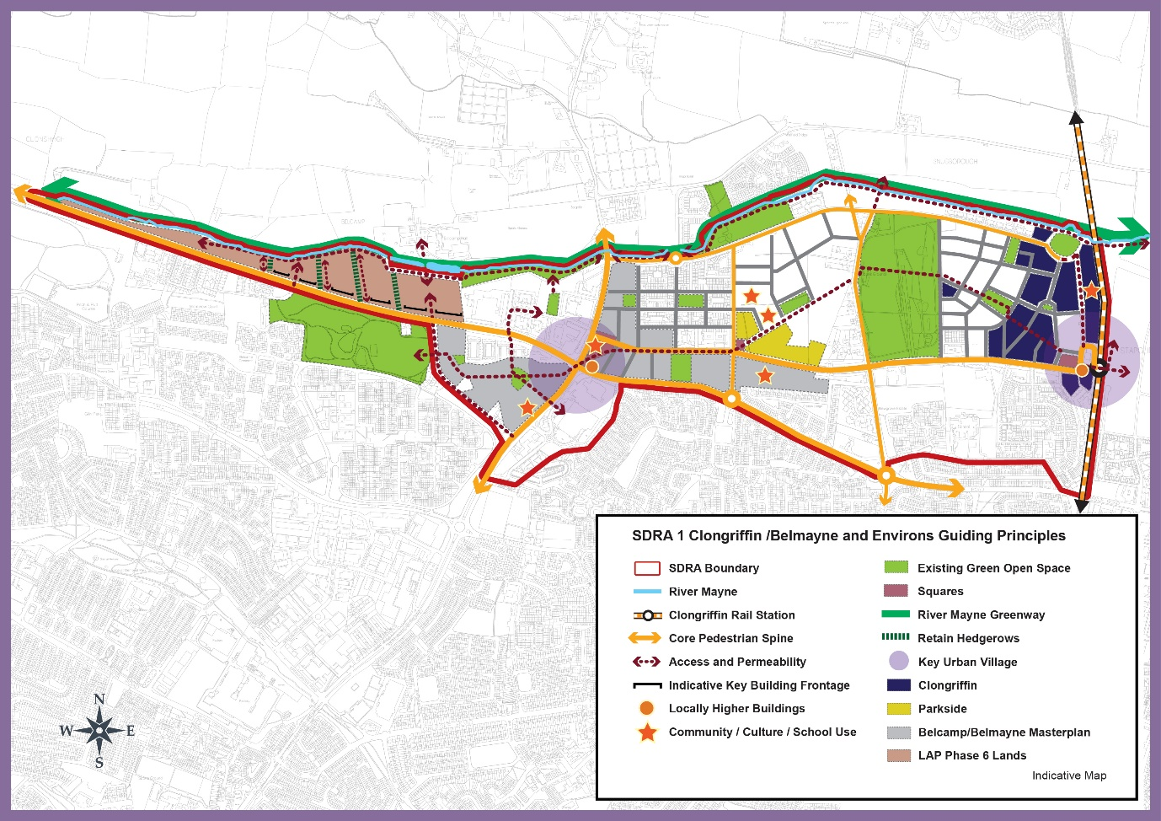

Material Alteration Reference Number 13.7

Chapter 13
Section: 13.4 – SDRA 2 – Ballymun, Introduction,
Page: 477, 4th Paragraph, 2nd sentence

Amendment:

The remaining sites have the capacity to deliver (c.1,700) {between 2,200 – 2,350} new housing units, new commercial and employment opportunities having regard to compact growth principles, development of infill sites and intensification of development along the proposed new Metrolink route.

Material Alteration Reference Number 13.8

Chapter 13
Section: 13.5 SDRA 3 - Finglas Village Environs and Jamestown Lands, subsection Jamestown Road Character Area
Page: 489

Amendment:

Note: deviations in use mix and in relation to density ranges (of up to 10%) within individual sites and quarters to meet design requirements {will be open for consideration during the Masterplan preparation process}, and accepted if the change supports overall compliance with the guiding principles, and where a joint agreement is proposed between landowners to accommodate certain uses within a particular area, such will be considered where the overall principles are retained and the use and typology is delivered.

Material Alteration Reference Number 13.9

Chapter 13
Figure 13-3: SDRA 3 Finglas Village Environs and Jamestown Lands
Page: 492, amendments to graphic map

Amendment to Graphic Map:

- Include the full extent of the sites at Iceland and Raven House.

- “Permeability Intervention” guiding principle on Cardifsbridge Road omitted and replaced by an “Access and Permeability” guiding principle.

- “Permeability Intervention” guiding principle replaced by an “Access and Permeability” guiding principle between Opportunity Sites 2 and 3 on east side of Cardiffsbridge Road.

- “Permeability Intervention” guiding principle on Proposed Housing Site to north of Wellmount Court omitted and replaced by an “Access and Permeability” guiding principle.

- “Permeability Intervention” guiding principle connected with Opportunity Site 1 omitted and replaced with an “Access and Permeability” guiding principle.

- Indicative key building frontage along Jamestown Road extended further northwards.

- Indicative key building frontage along Jamestown Road extended further northwards along Seamus Ennis Road.

- “Permeability Intervention” guiding principle within the internal road network within the Jamestown industrial lands subject to masterplan omitted and replaced with an “Access and Permeability” guiding principle.

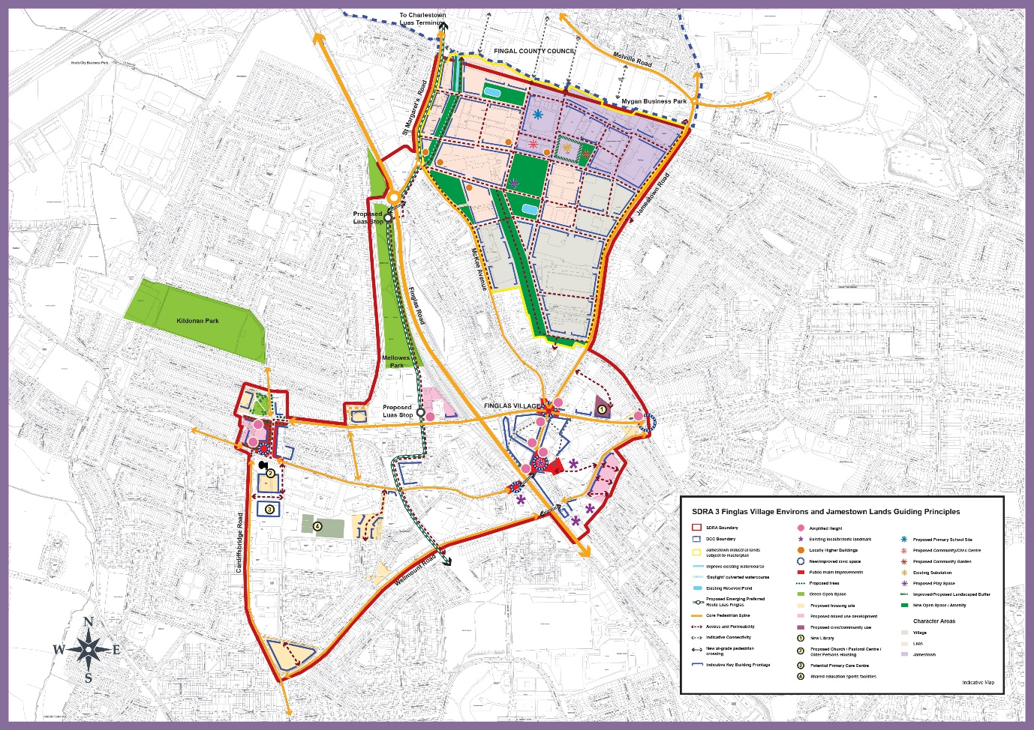

Material Alteration Reference Number 13.10

Chapter 13
Section: 13.6 SDRA 4 – Park West/Cherry Orchard, subheading Introduction
Page: 494, 3rd paragraph

Amendment:

Eight key development sites are identified with the capacity to deliver in the order of 2,500 – 3,100 new residential units alongside new employment and retail opportunities, with higher densities focused on the railway station which is planned to be upgraded to an electrified DART line. The plan also supports the delivery of two key amenity sites at Cherry Orchard Park and Gallanstown Waterworks, linked via a strategic green infrastructure network.

{It should be noted that the SDRA adjoins lands part of the City Edge Project to the south. Dublin City Council together with South Dublin County Council are currently in the process of preparing “The City Edge Project” funded under the Urban Regeneration and Development Fund (URDF) programme which is a new Strategic Framework Plan for the Naas Rad, Ballymount and Park West area comprising of c. 700 hectares, and it is important that the two designated areas mutually benefit each other.}

Material Alteration Reference Number 13.11

Chapter 13
Figure 13-4: SDRA 4 Park West/Cherry Orchard
Page: 498, amendments to graphic map

Amendments to Graphic Map:

- “Permeability Intervention” guiding principle within the internal road network within LAP Key Development Site 1 omitted and replaced with an “Access and Permeability” guiding principle.

- Minor change to landmark building configurations in LAP Key Development Site 5 (to north-west and south-east of Parkwest Cherry Orchard Train Station).

- “Permeability Intervention” guiding principle between Lavery Avenue and SDRA area omitted and replaced with an “Access and Permeability” guiding principle.

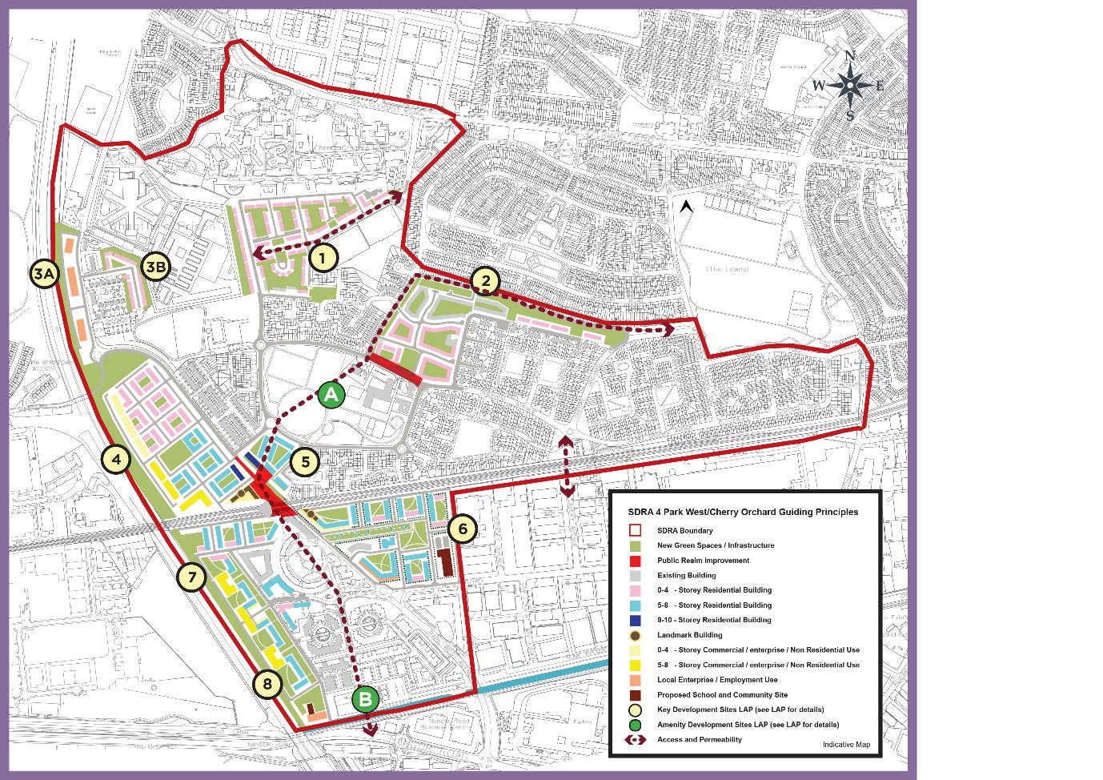

Material Alteration Reference Number 13.12

Chapter 13
Section: 13.7 SDRA 5 – Naas Road, Introduction
Page: 499-500

Amendment:

A Local Area Plan (LAP) for the Naas Road lands was adopted by the City Council on 14 January 2013. The plan was extended for a further 5 years in 2018 and will expire in January 2023. The plan area covers approximately 100 hectares and contains a number of major brownfield sites. It occupies a strategic location on a gateway point into the city with good public transportation links to the wider metropolitan area. {Dublin City Council together with South Dublin County Council are currently in the process of preparing “The City Edge Project” funded under the Urban Regeneration and Development Fund (URDF) programme which is a new Strategic Framework Plan for the Naas Rad, Ballymount and Park West area comprising of c. 700 hectares. The vision for the area is to create a mixed use and climate resilient high density urban quarter of the city, where citizens will be able to access affordable homes, live close to where they work, in an area home to outstanding public amenities and public transport services. The City Edge project will inform a new Statutory Plan to be prepared for this area over the life of the Development Plan.

The Naas Road SDRA sets out guiding principles for lands within the current Naas Road LAP and part of the future City Edge project. The guiding principles are in place to support development in the area pending the finalisation of the City Edge Project and Statutory Plan for the area. }.

(The overall vision for this area set out in the 2013 LAP is as follows:

‘To create a great place to work and live, and create a new urban identity for the Naas Road lands area plan by regenerating existing developed lands as a sustainable mixed-use area, capitalising on the area’s locational advantages and improving the relationship of the lands to their immediate surroundings through improved linkages, green infrastructure and permeability. As part of this transformation, there will be an increase in the range of land-uses, and improvements in the visual environment, resulting in an increase in street level activity and the general revitalisation of the area.’)

The {SDRA} (plan) contains (three) {6} remaining key re-development sites, namely:

- Royal Liver Retail Park
- Motor Distributors Ltd site (Volkswagen factory)
- Nissan plant site
- {Bluebell Avenue
- Former Irish Water and Bluebell Road Regeneration Area
- Nass Road Industrial Estate and surrounding lands}
Linking the re-development of these sites into the wider surrounding environment, and creating sustainable successful communities is central to the successful regeneration of this SDRA.

(It should be noted that since the adoption of the LAP, there have been changes in the national planning context via the introduction of Ministerial Guidelines relating to height and apartment standards.) {Some of} the key sites identified in the area have been the subject of planning activity in recent years, with permission for c.3,000 units in the vicinity of the Naas Road/Kylemore Road junction. {The SDRA seeks to continue to support the redevelopment of the keys sites for mixed use development in the short term pending the adoption of a new LAP for the area.}

(It is also noted that the wider Naas Road lands area, incorporating parts of Park West and lands in South Dublin County Council, are the subject of a masterplanning process funded under the Urban Regeneration and Development Fund (URDF) programme. It is anticipated that this will result in a wider statutory plan coming forward that will supersede the LAP in the coming years, and may, if appropriate, inform a variation to the development plan.)

Material Alteration Reference Number 13.13

Chapter 13
Section: 13.7 SDRA 5 – Naas Road, Guiding Principles for Key Opportunity Sites
Pages: 500 - 501, 2. Motor Distributors Site

Amendment:

- Facilitate the sustainable redevelopment of this key site with a fine urban grain and a mix of uses as part of the mixed-use core of the Key Urban Village all at sustainable densities within a vibrant and interesting environment and integrating with the wider plan area and the administrative area of South Dublin County Council directly adjoining {and aligning with the City Edge Project when adopted.}

- Require a general height of between 6 and 8 storeys fronting onto Walkinstown Avenue, Longmile Road, Robinhood Road. There is potential for one to two mid -rise buildings (up to 50m) within the site. (but any development in the immediate vicinity of the protected structure should protect the special character of the protected structure and its setting.)

- The height of new development along Naas Road, directly adjacent to the protected structure, should protect the special character {and its setting} (of the protected structure. and should be no more than 4 storeys in height immediately proximate to the building.)

Material Alteration Reference Number 13.14

Chapter 13
Section: 13.7 SDRA 5 – Naas Road, Guiding Principles for Key Opportunity Sites
Page: 504, last paragraph

Amendment:

(Two areas have been added to the SDRA boundary that are outside the LAP boundary and are indicated on the accompanying figure.)

Material Alteration Reference Number 13.15

Chapter 13
Section: 13.7 SDRA 5 – Naas Road, Guiding Principles for Key Opportunity Sites
Page: 505, insert additional text after Sub Section 5 Former Irish Water and Bluebell Road Regeneration Area

Amendment:

{6 – Naas Road Industrial Estate and Surrounding Lands.

These lands currently comprise of existing industrial / warehouse units bound by the Old Naas Road to the north and the Naas Road to the south. The lands also include a protected structure (RPS Ref. 5793) located on the eastern portion of the site at the junction of the Old Naas Road and Naas Road.
The regeneration of these lands shall be subject to the preparation of a Masterplan to ensure an appropriate mix of uses and development strategy is set out to guide future development. The Masterplan shall have regard to the vision for the City Edge Project and any future statutory plan. Any future development should also ensure the character and setting of the protected structure is safeguarded. The provision of open space and green infrastructure along the route of the Camac shall also be safeguarded and provided for in the Masterplan.}

Material Alteration Reference Number 13.16

Chapter 13
Figure 13-5 SDRA 5 Naas Road
Page: 506, amendments to graphic map

Amendment to Graphic Map:

- Remove KUV boundary from SDRA Map and include new Key Development Site for Naas Road Industrial Estate and surrounding lands and related protected structure symbol.

- Position of north arrow moved from bottom left to top left of graphic map.

- Key Urban Village boundary removed from around Key Opportunity Sites 1, 2 and 3.

- Opportunity site 6 included.

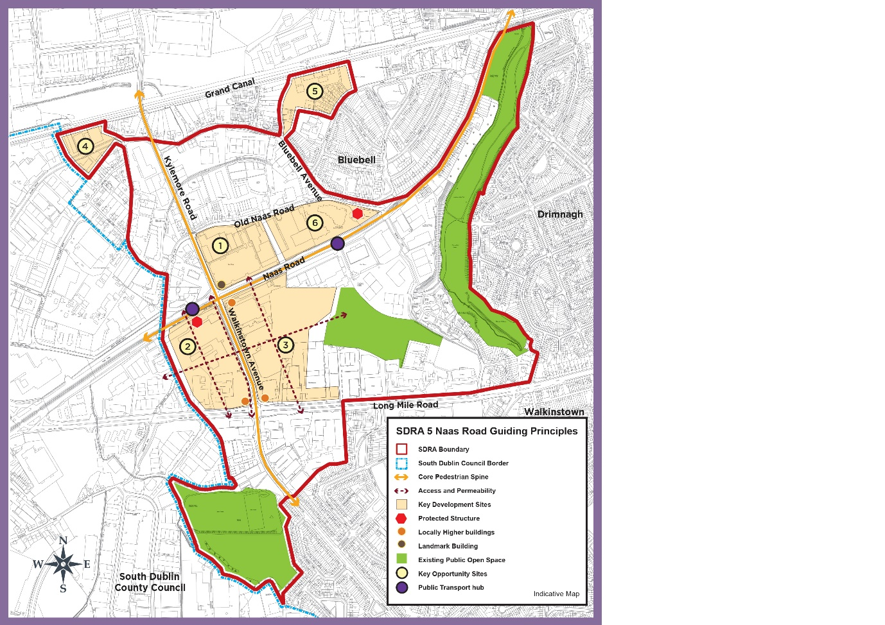

Material Alteration Reference Number 13.17

Chapter 13
Section: 13.8 SDRA 6 – Docklands, subheading Green Infrastructure
Page: 512, insert additional bullet point

Amendment:

- {To support and promote that expansion of water-based activities including slipways, pontoons and marinas}

Material Alteration Reference Number 13.18

Chapter 13
Section:13.8 SDRA 6 – Docklands, Guiding Principles for Key Opportunity Sites
Page: 516, Site 1. Connolly Station, insert bullet point to the Masterplan requirements

Amendment:

- {Strategy to protect and enhance the character of the existing historic station building}

Material Alteration Reference Number 13.19

Chapter 13
Section:13.8 SDRA 6 – Docklands, Guiding Principles for Key Opportunity Sites
Page: 517, Site 5 - Cody’s Yard, Ossory Road

Amendment:

Redevelopment of this site should provide a setback from Ossory Road, enabling a widening of the road to facilitate an improved pedestrian and cycle environment. Own-door access to ground floor dwellings fronting Ossory Road, should also be provided {where feasible, to encourage ground floor activation}. Requirements of Irish Rail shall be adhered to in relation to built footprint and necessary clearances.

Material Alteration Reference Number 13.20

Chapter 13
Section:13.8 SDRA 6 – Docklands, 6 – Guiding Principles for Key Opportunity Sites
Page: 518, Site 6 - North Strand Fire Station/Former Readymix Site

Amendment:

All dwellings at ground floor level should have own-door access. Given the scale of this site, (it is appropriate that) a masterplan {shall} be prepared for the entire area to address the above matters in addition to planned phasing.

Material Alteration Reference Number 13.21

Chapter 13
Section: 13.8 SDRA 6 – Docklands, Guiding Principles for Key Opportunity Sites
Page: 518, Site 7 – Docklands Innovation Park

Amendment:

Adequate space should be reserved along the south-western boundary of the site for a pedestrian throughway in order to enhance connectivity through this large block, {including to the local school.}

Material Alteration Reference Number 13.22

Chapter 13
Section: 13.8 SDRA 6 – Docklands, Guiding Principles for Key Opportunity Sites
Page: 519, Site 8 – Chadwick’s Yard, first paragraph on page

Amendment:

Given the scale of this site, (it is appropriate that) a masterplan {shall} be prepared for the entire area, to address the above matters in addition to planned phasing.

Material Alteration Reference Number 13.23

Chapter 13
Section: 13.8 SDRA 6 – Docklands, Guiding Principles for Key Opportunity Sites
Page: 519, Site - 9 - East Road, 2nd paragraph
Amendment:

Given the scale of this site, (it is appropriate that) a masterplan {shall} be prepared for the entire area, to address the above matters in addition to planned phasing.

Material Alteration Reference Number 13.24

Chapter 13
Section: 13.8 SDRA 6 – Docklands, Guiding Principles for Key Opportunity Sites
Page: 520, Site - 10 – Castleforbes Business Park, last sentence

Amendment:

Given the scale of this site, (it is appropriate that) a masterplan {shall} be prepared for the entire area, to address the above matters in addition to planned phasing.

Material Alteration Reference Number 13.25

Chapter 13
Section: 13.8 SDRA 6 – Docklands, Guiding Principles for Key Opportunity Sites
Page: 520, 1st, 2^{nd,} 3rd 4th paragraphs, Site 11 - Trinity College Innovation District

Amendment:

This site located north of the rail line between Macken Street and Grand Canal Quay, has potential to provide a new hub for innovation, {teaching, research, collaboration, enterprise and support facilities} bridging between the commercial activities in Docklands and research at Trinity College {and enabling the development of a globally competitive innovation district for Ireland}.

(Setbacks on) {The Interface with} Pearse Street shall accommodate a transformed and (widened) public realm, and {on street} parking provision shall be minimal. The existing historic Tower Building (original sugar mill) should be retained and potentially extended vertically by a maximum of 2-3 storeys, and {public realm surrounding the building shall provide physical and visual linkages between the proposed central square and} (generous new public space surrounding the building shall enhance its setting, providing an open aspect to) Grand Canal Quay. The approach to building height and design shall take account of established residential uses to the west and north, and also proximity to the Alto Vetro building. General site heights to range from 7 to 9 storeys with potential for {some} locally higher buildings. (at the three selected positions illustrated in the Guiding Principles Map.)

There is potential for a landmark building/s within this site having regard to the surrounding context and emerging developments in the area.

{The City Council will work closely with TCD and all relevant stakeholders to prepare a Masterplan for the phased development of the site that establishes high quality development objectives and parameters to ensure that an appropriate mix of uses are provided to support a working and resident community including cultural, recreational, retail and related uses.}

(Development of this innovation district shall be in accordance with a masterplan to be agreed with Dublin City Council and addressing phasing in addition to the above matters.)

Material Alteration Reference Number 13.26

Chapter 13
Section: 13.8 SDRA 6 – Docklands, Guiding Principles for Key Opportunity Sites
Page: 521, Site 12 – ESB Complex, South Lotts Road, last sentence

Amendment:

Given the scale of this site, (it is appropriate that) a masterplan {shall} be prepared for the entire area, to address the above matters in addition to planned phasing.

Material Alteration Reference Number 13.27

Chapter 13
Section: 13.8 SDRA 6 – Docklands, Guiding Principles for Key Opportunity Sites
Page: 522, insert additional text after Site 14 Former Power Station and Pigeon House Hotel, Poolbeg

Amendment:

{15. Shelbourne Stadium, South Lotts Road

The subject site, located in a highly accessible area of the city and comprises of c. 3ha of urban lands suitable for strategic development and regeneration. The lands are capable of delivering a high quality mixed use development to complement and enhance both the existing land uses and future strategic plans for the area.

Any future development of the site should be subject to a Masterplan as part of the planning application process and should provide for a mixed use development comprising of residential, commercial and public open space. The building design and layout should respect the existing buildings to the north along Ringsend Road and the proposed future development of opportunity site 12.

Given the scale of the site, opportunities exist for the provision of some locally higher buildings and landmark buildings addressing the River Dodder.

Permeability interventions should be provided through the site from South Lotts Road to the River Dodder and from Ringsend Road through to opportunity site 12. A feasibility study, including the necessary environmental studies, should be prepared to assess the potential of a pedestrian footbridge across the Dodder connecting Ringsend Village and the Wider Docklands area. A public walkway along the bank of the River Dodder should also be delivered to enhance amenity value of the river at this location.}

Material Alteration Reference Number 13.28

Chapter 13
Figure 13-6 SDRA 6 – Docklands
Page: 523, amendments to graphic map

Amendment to Graphic Map:

- Shelbourne Stadium included as an opportunity site.

- Landmark buildings included at Opportunity site 1, Connolly, Tara Street Station, Opportunity Site 11 – Trinity College Innovation District and Opportunity Site 15 Shelbourne Stadium.

- Locally higher buildings included at Hawkins House, City Quay.

- Colour of “Proposed Eastern By-Pass" symbol in map legend of guiding principles amended from red to grey in guiding principles.

- “Landmark building” symbol included in map legend of guiding principles.

- Opportunity Site 15 newly added to graphic together with built form/public open space/access and permeability/ potential new bridge symbols.

- “Permeability Intervention” guiding principle removed and replaced with “Access and Permeability” guiding principles within Opportunity Sites 1, 6, 7, 11, 12 and 15.

- “Permeability Intervention” guiding principle removed and replaced with “Access and Permeability” guiding principle along east bank of River Dodder within Docklands SDZ.

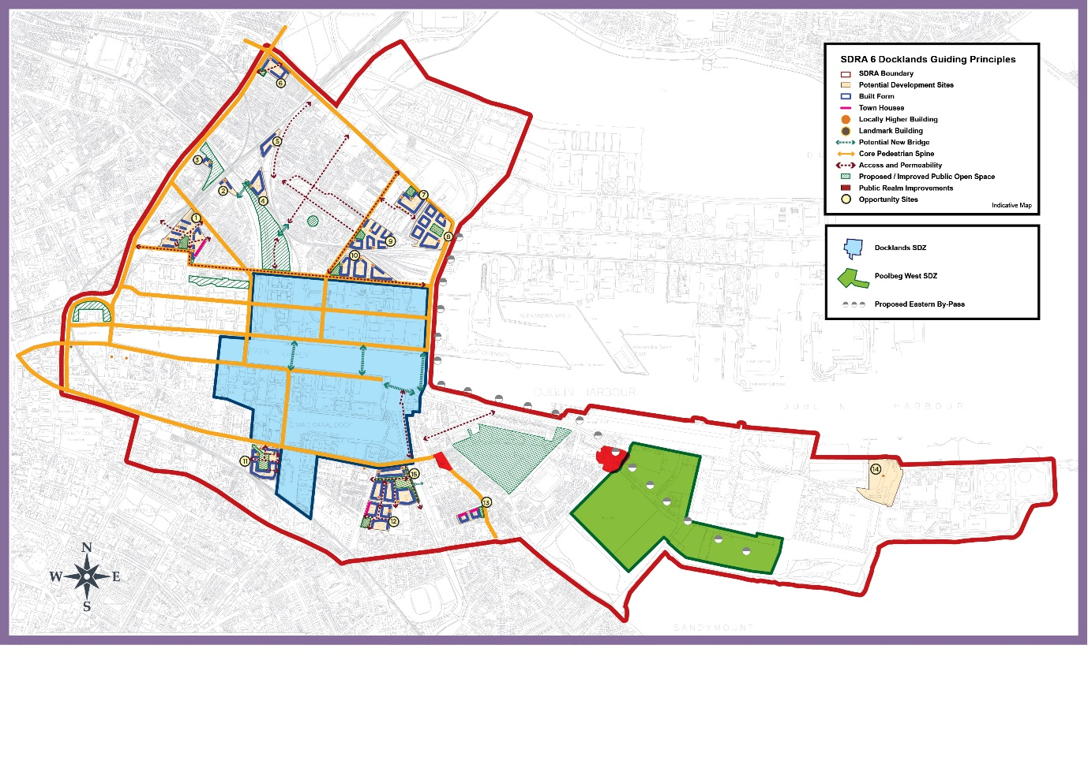

Material Alteration Reference Number 13.29

Chapter 13
Section: 13.9 SDRA 7 – Heuston and Environs, subheading - Height
Page: 526, 2nd bullet point

Amendment:

- Opportunities exist for landmark buildings at the Heuston Gateway and, at Sean Heuston Bridge on the former Hickeys site, {and to the west of Steevens Hospital} in line with the considerations outlined in Appendix 3 of the development plan. The potential locations for landmark buildings are shown on the accompanying Guiding Principles Map.

Material Alteration Reference Number 13.30

Chapter 13
Section: 13.9 SDRA 7 – Heuston and Environs, Guiding Principles for Key Opportunity Sites
Page: 528, Site 3 – Heuston, 1st paragraph

Amendment:

Given the scale of the site and its redevelopment potential, it is appropriate that in advance of any development proposal, a masterplan {shall} be prepared (and agreed), taking into consideration the wider area, {the SDRA principles and addressing} planned phasing. {This masterplan shall be submitted with the first and subsequent applications for significant redevelopment in the area}.

Material Alteration Reference Number 13.31

Chapter 13
Section: 13.9 SDRA 7 – Heuston and Environs, Guiding Principles for Key Opportunity Sites
Page: 529, Site 3 – Heuston, 3rd paragraph

Amendment:

A greening and open space masterplan {shall} (should) also be provided identifying a network of public open spaces including civic squares and parks, throughout the Heuston lands, that are attractive, multifunctional, safe, welcoming and accessible to the wider public.

Material Alteration Reference Number 13.32

Chapter 13
Section: 13.9 SDRA 7 – Heuston and Environs, Guiding Principles for Key Opportunity Sites
Page: 529, Site 4 – Heuston South Quarter, 2nd paragraph

Amendment:

Building heights should respond to the ‘Cone of Vision’ identified in the Guiding Principles Map. {During the lifetime of the development plan, a re-assessment of the Cone of Vision shall take place having regard to the national planning context requiring the need to accommodate increased densities on urban brownfield sites, and the landscape character for protection within the cone, such as landmarks, buildings, views, corridors, etc., identified and weighted.}

Material Alteration Reference Number 13.33

Chapter 13
Figure 13-7: SDRA 7 Heuston and Environs
Page 530, amendments to graphic map

Amendment to Graphic Map:

- “Permeability Intervention” guiding principles within Opportunity Sites 2, 3, Phoenix Park Train Tunnel and through Waterloo Avenue at Clancy Barracks removed and replaced with “Access and Permeability” guiding principles.

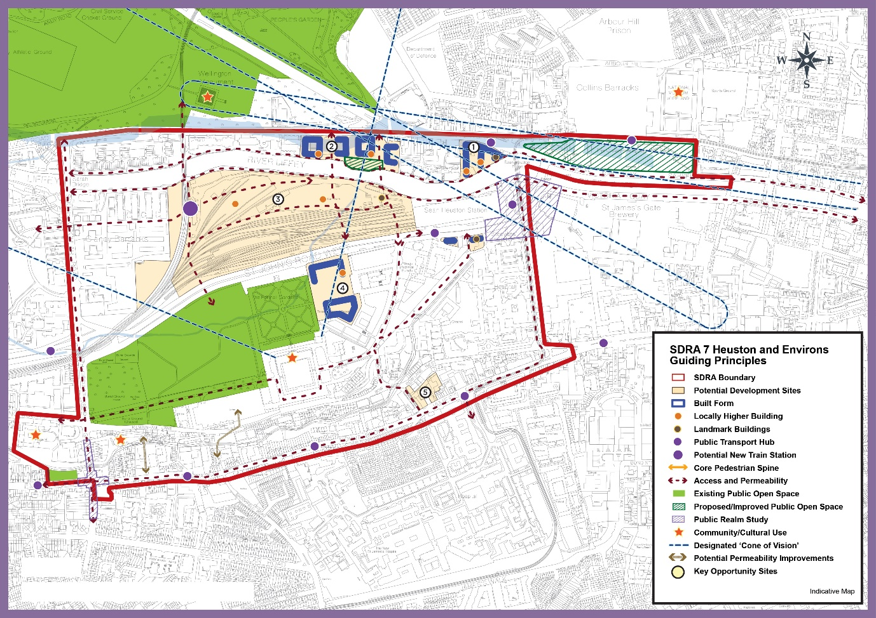

Material Alteration Reference Number 13.34

Chapter 13
Section: 13.10 SDRA 8 – Grangegorman/Broadstone, subheading Introduction
Page: 532, 4th paragraph

Amendment:

The construction of a c. 4,414 m² Greenway Hub building, a c.16,000m² East Quad and a c.33,000m2 Central Quad is now complete, accommodating academic activities and facilities required for the Environmental Health Sciences Institute and business incubation space, the College of Arts & Tourism, College of Sciences & Health and College of Engineering and Built Environment. It is anticipated that the TU Dublin developments will provide capacity for a student population of c.15,000 by 2024. {The repurposing of TU Dublin’s Park House continues. It now occupied by c. 10,000 sq. m. of temporary university library and office space.}

Material Alteration Reference Number 13.35

Chapter 13
Section:13.10 SDRA 8 – Grangegorman/Broadstone
Page: 533, 2nd paragraph

Amendment:

(By 2023, c.100 bed Residential Care Neighbourhood for the elderly and those with a mental health support needs will be delivered). {It is currently anticipated that by 2025, a c. 100 bed Residential Care Neighbourhood for the elderly, and for those with a mental health support need will be delivered}. Within this timeframe, it is also anticipated that a new 24 Classroom Educate Together National School will be in service, replacing a current temporary facility.

Material Alteration Reference Number 13.36

Chapter 13
Section:13.10 SDRA 8 – Grangegorman/Broadstone
Page: 534, insert text after last paragraph

Amendment:

{Prussia Street is located on the western side of the SDRA linking Stoneybatter Village to the North Circular Road. This key thoroughfare provides for significant strategic development opportunities through the regeneration of a number of vacant and underutilised sites for mixed use development. Future development in the area shall provide for a coherent and considered streetscape that respects the existing historic character whilst at the same time ensuring an appropriate scale and density is achieved in line with the 15 minute city objective.

A Masterplan shall be prepared for the area that sets out a clear development strategy including the provision of new permeability routes linking to the wider Grangegorman Campus, a vibrant and active streetscape and the provision of local services and amenities. All developments will be assessed on a case by case in the context of Appendix 3 and the relevant development standards.}

Material Alteration Reference Number 13.37

Chapter 13
Figure 13-8:SDRA 8 Grangegorman/Broadstone
Page: 535, amendments to graphic map

Amendment to Graphic Map:

- SDRA boundary amended to include all Prussia Street, Fingal Place and lands along North Circular Road.

- “Permeability Intervention” guiding principle on North Circular Road connecting to SDRA removed and replaced with “Access and Permeability” guiding principle.

- “Permeability Intervention” guiding principle on Grangegorman Road Lower connecting to SDRA removed and replaced with “Access and Permeability” guiding principle.

- “Permeability Intervention” guiding principle connecting to SDRA from Constitution Hill removed and replaced with “Access and Permeability” guiding principle.

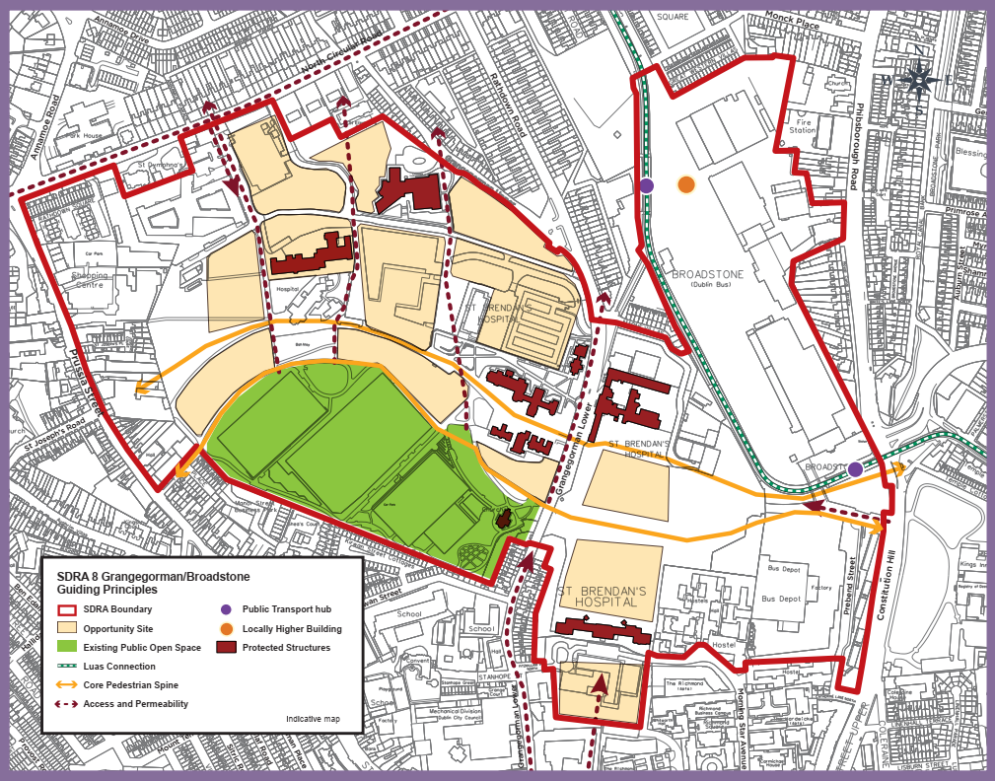
Material Alteration Reference Number 13.38

Chapter 13
Figure 13-9: SDRA 9 Emmet Road
Page 541, amendments to graphic map 13-9

Amendment to Graphic Map:

- SDRA boundary amended to include St. John Bosco Youth and Community Centre on Davitt Road.

- “Permeability Intervention” guiding principles in Opportunity Site 1 removed and replaced with “Access and Permeability” guiding principles.

- “Permeability Intervention” guiding principles in Opportunity Site 2 removed and replaced with “Access and Permeability” guiding principles.

- “Permeability Intervention” guiding principles in Opportunity Site 4 removed and replaced with “Access and Permeability” guiding principles.

- North arrow relocated from top left to bottom left corner of graphic map.

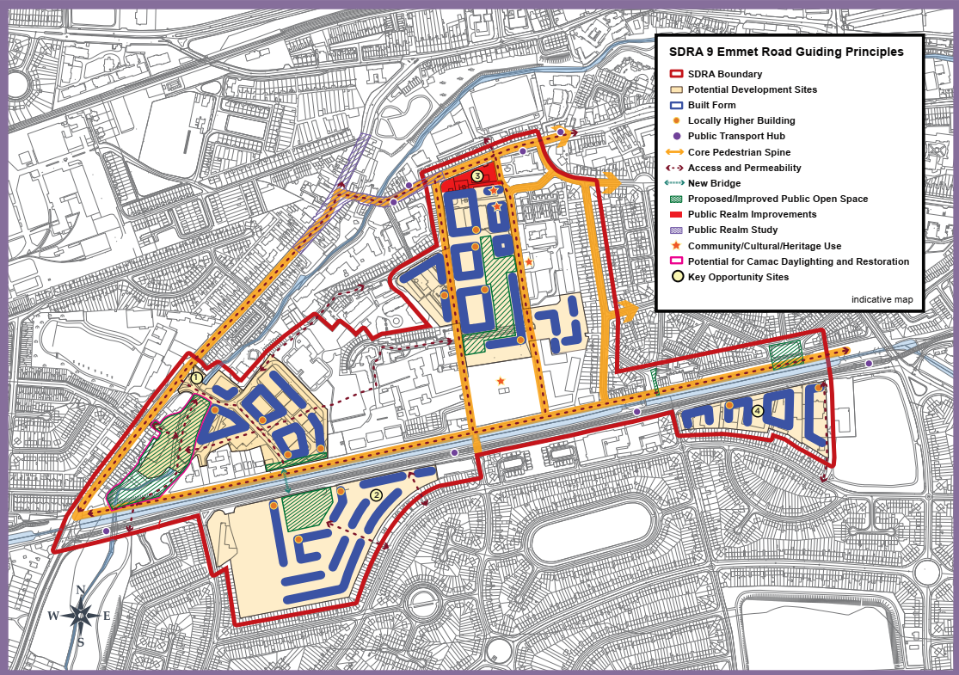

Material Alteration Reference Number 13.39

Chapter 13
Section: 13.12 SDRA 10 – North East Inner City
Page: 543, insert additional text after d)

Amendment:

- To provide a spatial framework for land uses including much-needed housing.
- To restore a coherent urban structure where it is poor or fragmented and improving the public realm.
- To support community development through targeted objectives on selected sites.
- To plan for improved connectivity and public amenity while utilising existing assets in the area.
- {To support the protection and enhancement of the unique historic character of the area through refurbishment and regeneration of the North Georgian Core}

Material Alteration Reference Number 13.40

Chapter 13
Section: 13.12 SDRA 10 – North East Inner City, subheading Land Use and Activity
Page: 545, City Gateway Civic Hub

Amendment:

Immediately adjoining the SDRA for the Docklands and serves as an entry point to the inner city and also an access to the employment lands of the Docklands SDRA. It’s positioning on the River Tolka at Annesley Bridge, overlooking Fairview Park, gives the hub capacity for large scale developments. Its regeneration will work in tandem with an identified regeneration site 6 within the Docklands SDRA, where a planned (landmark) {locally higher} building will provide a clear visual marker.

Material Alteration Reference Number 13.41

Chapter 13
Section: 13.12 SDRA 10 – North East Inner City, Subheading Movement and Transport
Page 549, insert additional bullet point

Amendment:

- {To promote the provision of a station at Croke Park.}

Material Alteration Reference Number 13.42

Chapter 13
Section: 13.12 SDRA 10 – North East Inner City, Guiding Principles for Key Opportunities Sites
Page: 550, Site 1 – O’Connell Street to Moore Lane incorporating Carlton Site, 2nd paragraph

Amendment:

Scheme design {shall} (should) be based on a comprehensive masterplan that incorporates a convenient access route to the planned Metrolink stop, quality connections across the site, and a cultural interpretative element.

Material Alteration Reference Number 13.43

Chapter 13
Section: 13.12 SDRA 10 – North East Inner City,
Guiding Principles for Key Opportunity Sites
Page: 552, Site 2 – Lands to the west of existing Hotel off Jones Road, insert additional text to the end of the 2nd paragraph

Amendment:

{That the provision of community facilities such as a children’s’ playground and/or community garden be incorporated/included in any future development.}

Material Alteration Reference Number 13.44

Chapter 13
Section: 13.12 SDRA 10 – North East Inner City, Guiding Principles for Key Opportunity Sites
Page: 552, Site 3 – Russell St/North Circular Road

Amendment:

A masterplan {shall} (will) be {prepared} (required) in relation to proposals on this site, addressing stated requirements and setting out planned phasing.

Material Alteration Reference Number 13.45

Chapter 13
Section: 13.12 SDRA 10 – North East Inner City, Guiding Principles for Key Opportunity Sites
Page: 553, Site 4 – Croke Park Lands to the South of Croke Park Stadium, insert additional bullet points to 2nd paragraph

Amendment:

- {To create and implement a quality public realm scheme for Jones’ Road to animate the street, and help provide passive surveillance of the canal.}

- {To examine the feasibility of a station serving Croke Park at this location in conjunction with Iarnród Éireann/Irish Rail}

Material Alteration Reference Number 13.46

Chapter 13
Section: 13.12 SDRA 10 – North East Inner City, Guiding Principles for Key Opportunity Sites
Page: 555, Site 10 – Convent Lands, Sean McDermott St.

Amendment:

As a former Magdalene Laundry, it is a site of great historic importance. Its
regeneration and refurbishment should marry the conservation and cultural heritage qualities of the lands with the opportunity to provide activation and renewal of the Railway Street interface, thereby, enhancing public realm. {The area will be the location for a National Centre for Research and Remembrance}. As an integral part of this work, the provision of an appropriate memorial will be investigated with key agencies and stakeholders. An internal garden/courtyard befitting a site of its cultural significance should be designed to be accessible and inviting to the public. Also, two north-south connections through the site should be provided at the locations indicated on the Guiding Principles Map, to tie into the more strategic connections through the area. These should provide throughways that are visible and legible on approach, the routes designed with sufficient width to avoid creation of narrow alleyways. See also CUO9, Chapter 12.

Material Alteration Reference Number 13.47

Chapter 13
Section: 13.12 SDRA 10 – North East Inner City, Guiding Principles for Key Opportunity Sites
Page: 557, Site 15 - Lands off Richmond Street North, south of the Royal Canal, insert additional text at end of last paragraph
Amendment:

{The feasibility of a station serving Croke Park at this location in conjunction with Iarnród Éireann/Irish Rail should be examined}.

Material Alteration Reference Number 13.48

Chapter 13
Figure 13-10: SDRA North East Inner City
Page 559, amendments to graphic map

Amendment to Graphic Map:

- Reference to permeability intervention at Summer Street North omitted and guiding principles map amended accordingly.

- Reference to potential development site to the rear of Summer Street North and North Great Charles Street omitted by deleting yellow shading. Retain star symbol (community/cultural use).

- All “Permeability Intervention” guiding principles in SDRA 10 removed and replaced with “Access and Permeability” guiding principles.

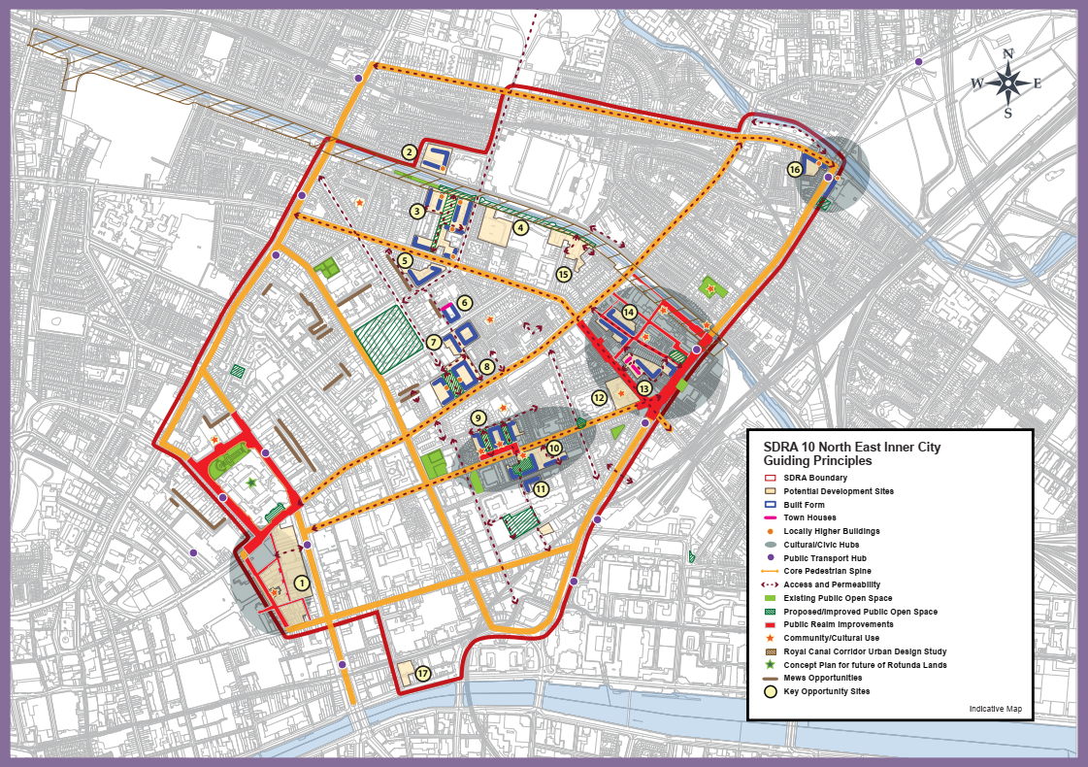

Material Alteration Reference Number 13.49

Chapter 13
Section: 13.13 SDRA 11 – St. Teresa’s Gardens and Environs, subheading: Height, subheading Urban Structure
Page: 561, first paragraph

Amendment:

The potential for further integration with the Coombe Hospital is indicated on the Guiding Principles Map but is indicative only. (Regard will need to be had to any flooding constraints in the redevelopment of the Coombe Hospital lands in terms of land use and block layout.)

Material Alteration Reference Number 13.50

Chapter 13
Section: 13.13 SDRA 11 – St. Teresa’s Gardens and Environs, subheading: Height
Page: 562, first and third bullet points

Amendment:

- In general, the height strategy for the SDRA is that building heights in the range of {3} (6)-8 storeys will be considered the baseline height for new developments, subject to adequately interacting with the existing building heights adjacent to the subject site.
- The SDRA Guiding Principles Map identifies opportunities for landmark buildings in the order of 15(-22) storeys to frame the proposed centrally located open space and.....

Material Alteration Reference Number 13.51

Chapter 13
13.13 SDRA 11 – St. Teresa’s Gardens and Environs, subheading Design
Page 562, insert additional bullet point to read:

Amendment:

- {Design shall protect the special character of the listed Player Wills factory and its setting.}

Material Alteration Reference Number 13.52

Chapter 13
Figure 13-11: SDRA 11 St. Teresa’s Gardens and Environs
Page: 564, amendments to graphic map

Amendment to Graphic Map:

- All “Permeability Intervention” guiding principles in SDRA 11 removed and replaced with “Access and Permeability” guiding principles.

- Landmark building(s) replaced with locally higher building(s).

- North arrow relocated from bottom left to top right corner of graphic map.

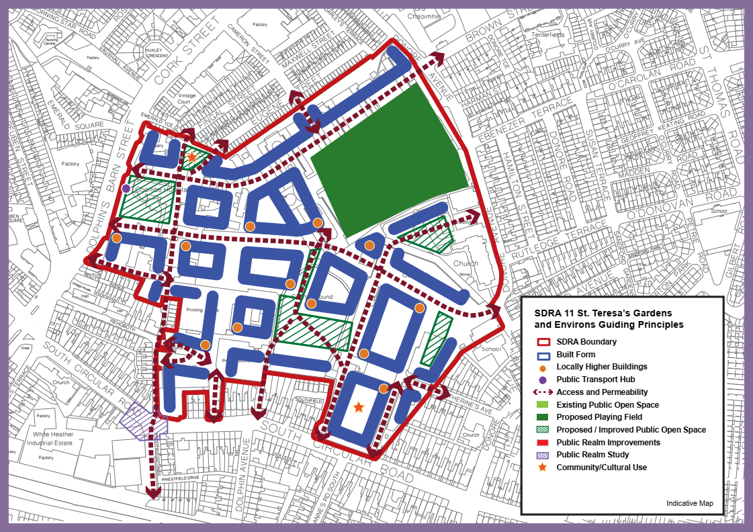

Material Alteration Reference Number 13.53

Chapter 13
Section: 13.14 SDRA 12 – Dolphin House, subheading Green Infrastructure
Page: 567, insert additional bullet point

Amendment:

{To support the provision of water based amenities and recreation along the Canal in accordance with GI32.}

Material Alteration Reference Number 13.54

Chapter 13
Figure 13-12: SDRA 12 Dolphin House
Page 568, amendments to graphic map

Amendment to Graphic Map:

- All “Permeability Intervention” guiding principles in SDRA 12 removed and replaced with “Access and Permeability” guiding principles.

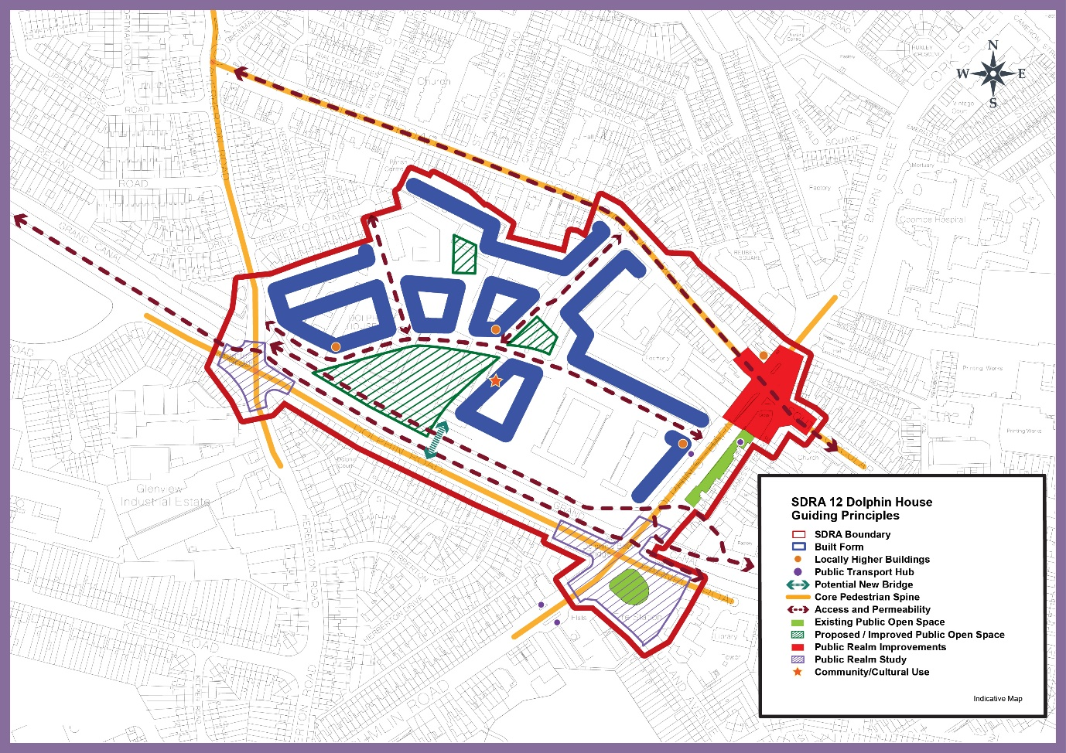

Material Alteration Reference Number 13.55

Chapter 13
Section: 13.15 SDRA 13 – Markets Area and Environs, subheading, Urban Structure
Page: 571, insert additional bullet point

Amendment:

- {To recognise the strong character and historic built fabric of the area and support the retention and reuse of existing historic buildings of merit.}

Material Alteration Reference Number 13.56

Chapter 13
Section:13.15 SDRA 13 – Markets Area and Environs, Sub Section: Land Use and Activity
Page: 571, 3rd paragraph

Amendment:

Having regard to the above, a framework for redevelopment of underutilised sites needs to demonstrate sensitive integration whilst also generating new vitality. Opportunities for the creation of quality new green/open spaces as part of larger redevelopment projects can supplement existing spaces at Chancery Park, St. Michan’s Park and Ormond Square. There is also considerable scope for public realm upgrades which can both enhance the setting of these spaces and provide quality connections between key destinations. {Opportunities also exist to support casual market trading in appropriate public realm areas subject to appropriate licencing.}

Material Alteration Reference Number 13.57

Chapter 13
Section: SDRA 13 Markets Area and Environs, Guiding Principles for Key Opportunity Sites
Page: 575, Site 5 - Ryders Row, 2nd paragraph

Amendment:

With respect to built form and height, it should respond to the prevailing built form, character and grain of the established buildings to its west along Parnell St. However, at the corner it could accommodate a slender building of up to {6-8} (8-10) storeys. Whilst outside the immediate SDRA boundary, the development of this site has potential to signal the route from Parnell Street through to the markets area.
Material Alteration Reference Number 13.58

Chapter 13
Figure 13-13: SDRA 13 Markets Area and Environs
Page 576, amendments to graphic map

Amendment to Graphic Map:

- All “Permeability Intervention” guiding principles in SDRA 13 removed and replaced with “Access and Permeability” guiding principles.

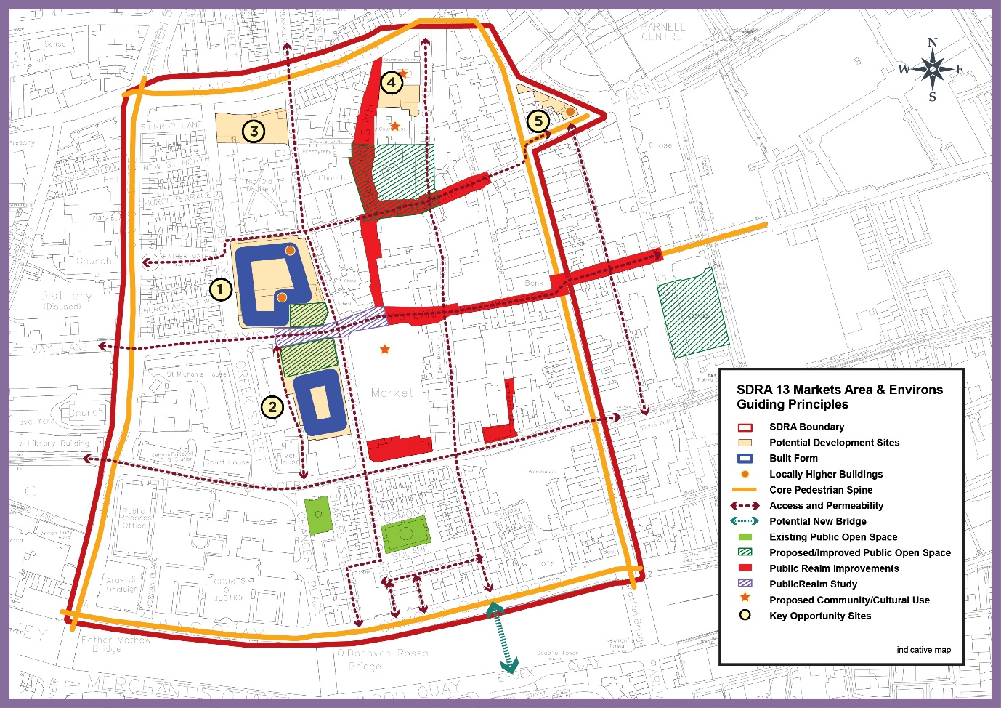

Material Alteration Reference Number 13.59

Chapter 13
Section: 13.16 SDRA 14 St. James Medical Campus and Environs
Page: 577

Amendment:

Replace St. James Medical Campus and Environs with St. James Healthcare Campus and Environs in all occurrences in the plan.

Material Alteration Reference Number 13.60

Chapter 13
Figure 13-14: SDRA 14 St. James Healthcare Campus and Environs
Page 581, amendments to graphic map

Amendment to Graphic Map:

- All “Permeability Intervention” guiding principles in SDRA 14 removed and replaced with “Access and Permeability” guiding principles.

- Title of Graphic changed to ‘SDRA 14 St. James Healthcare Campus and Environs Guiding Principles’’.

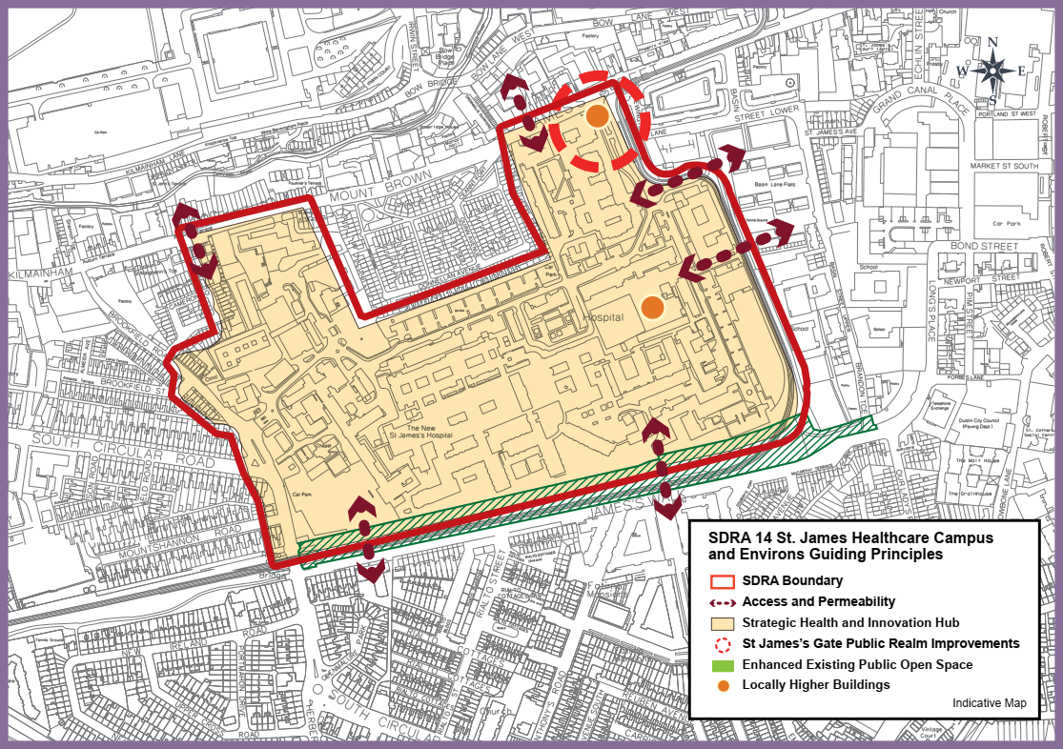

Material Alteration Reference Number 13.61

Chapter 13
Section:13.17 SDRA 15 Liberties and Newmarket Square, subheading Land Use and Activity
Page: 582

Amendment:

- To support the provisions of the Smart D8 project in relation to the provision of a Healthcare Innovation Corridor.
- To {support the provision of community/ cultural uses and} undertake an audit of community infrastructure in the Liberties area in order to identify {additional} community needs.

Material Alteration Reference Number 13.62

Chapter 13
Section:13.17 SDRA 15 Liberties and Newmarket Square, subheading Green Infrastructure
Page: 584

Amendment:

- To support the creation of a public park as part of the regeneration of the Pimlico flat complex. (involving the consolidation of the Poole St. playing facilities and the existing pocket park at the corner of Earl St. and Thomas Court Bawn.)

Material Alteration Reference Number 13.63

Chapter 13
Section: 13.17 SDRA 15 Liberties and Newmarket Square, Guiding Principles for Key Opportunity Sites
Page: 586, Site 2 – Vicar Street, last paragraph

Amendment:

A public realm study should be conducted for the public space identified in the
Guiding Principles Map, with the aim of building upon the planned public realm
improvements for Francis St. and Meath Street {and also addressing potential for sporting and community opportunities in the area.}

Material Alteration Reference Number 13.64

Chapter 13
Section: 13.17 SDRA 15 Liberties and Newmarket Square, Guiding Principles for Key Opportunity Sites
Page: 587, Site 5 – Digital Hub, 3rd paragraph

Amendment:

Given the scale of this landholding, (it is appropriate that) a masterplan {shall be} prepared for the entire area, to address the above matters in addition to planned phasing. Any masterplan should also provide for the delivery of enterprise and employment uses in this area.

Material Alteration Reference Number 13.65

Chapter 13
Section: 13.17 SDRA 15 Liberties and Newmarket Square, Guiding Principles for Key Opportunity Sites
Page: 588, Site 6 – Marrowbone Lane

Amendment:

It is considered that the SDRA should deliver the objectives for the site including:

- (The council owned depot at Marrowbone Lane to be developed as a Green Infrastructure and Recreational Area.)
- {Consolidation and reduction in area of the existing City Council depot and the regeneration of the wider depot area.}
- Extension of amenity/recreational spaces in association with St. Catherine’s sports centre {and a new public space onto Marrowbone Lane.}

Material Alteration Reference Number 13.66

Chapter 13
Section:13.17 SDRA 15 Liberties and Newmarket Square, Guiding Principles for Key Opportunity Sites
Page: 589, Site 9 – Guinness Lands, 1st paragraph

Amendment:

While the operational requirements of the Guinness Lands to the north of Thomas St. are likely to remain beyond the term of the Development Plan, opportunities for smaller parcels of land to be redeveloped may arise in the medium term. {The guiding principles identified for Diageo’s lands north of James’s Street are for consideration as part of any major future redevelopment of the lands and should be designed to be compatible with the operational requirements of the brewery during the lifetime of the development plan.}

Material Alteration Reference Number 13.67

Chapter 13
Section: 13.17 SDRA 15 Liberties and Newmarket Square, Guiding Principles for Key Opportunity Sites
Page: 590, Section: 9 – Guinness Lands, 2nd paragraph

Amendment:

Given the scale of these two sites, it is appropriate that in advance of any development proposal, a masterplan {shall be prepared} (and be prepared and agreed for the respective site), taking into consideration the wider area, to address the above matters in addition to planned phasing.

Material Alteration Reference Number 13.68

Chapter 13
Figure 13-15: SDRA 15 Liberties and Newmarket Square
Page: 591, amendments to graphic map

Amendment to Graphic Map:

- Guiding principles map amended to omit reference to green infrastructure and recreational area at Marrowbone Lane and included as part of Opportunity site 6.

- “Green Infrastructure and Recreational Area” removed from guiding principles in map legend.

- All “Permeability Intervention” guiding principles in SDRA 15 removed and replaced with “Access and Permeability” guiding principles.

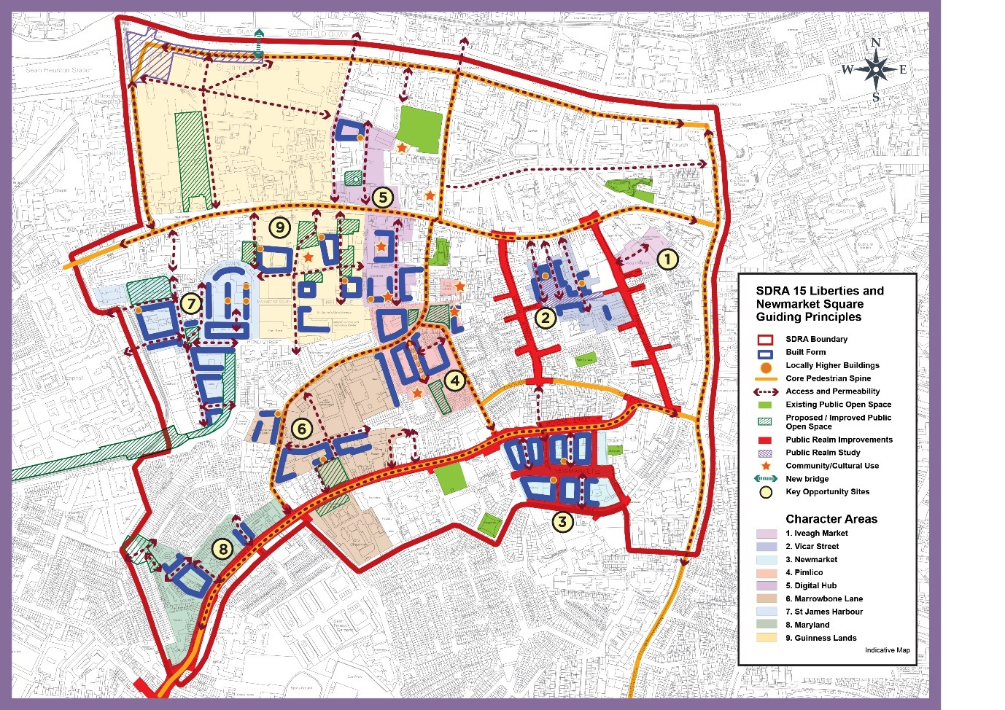

Material Alteration Reference Number 13.69

Chapter 13
Figure 13-16: SDRA 16 Oscar Traynor Road
Page: 595, amendments to graphic map

- All “Permeability Intervention” guiding principles in SDRA 16 removed and replaced with “Access and Permeability” guiding principles.

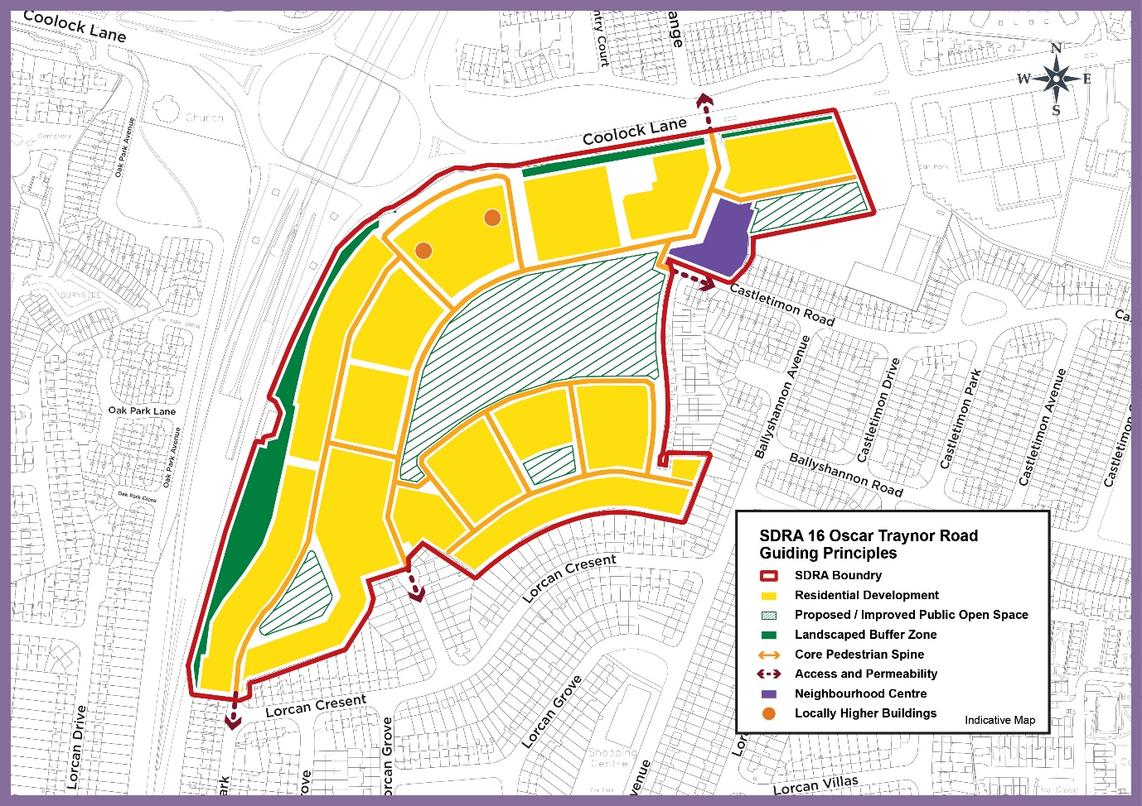

Material Alteration Reference Number 13.70

Chapter 13
Section 13.19 SDRA 17 – Werburgh Street, subheading Land Use & Connectivity and Open Space and Amenity
Page: 597

Amendment:

Under Land Use and Connectivity delete:

- (To recreate the lie of Hoey’s Cuort (the birthplace of Jonathan Swift).)
- To provide a new wall walk (at Hoey’s Court), looking over Ship Street.

Under Open Space and Amenity, insert additional bullet point:

- {To represent in some form the birth place of Jonathan Swift, (No. 9 Hoey’s Court), one of Ireland’s greatest satirists and authors.}

Chapter 14: Land Use Zoning

Material Alteration Reference Number 14.1

Chapter 14
Section: 14.7 Primary Land use Categories
Page: 609 Table 14.1

Amendment:

(Z16 Affordable Housing and Employment)

Material Alteration Reference Number 14.2

Chapter 14
Section: 14.7.2 Residential Neighbourhoods (Conservation Areas) - Zone Z2
Page: 611, first paragraph, first sentence

Amendment:

Residential conservation areas have extensive groupings of buildings and associated open spaces with an attractive quality of architectural design and scale. {A Zone Z2 area may also be located within or surrounded by an Architectural Conservation Area and/or a group of protected structures.}

Material Alteration Reference Number 14.3

Chapter 14
Section: 14.7.4 Key Urban Villages and Urban Villages – Zone Z4
Page: 615, final paragraph

Amendment:

Z4 – Open for Consideration Uses
Advertisement and advertising structures, betting office, Build to Rent residential, civic and amenity/recycling centre, conference centre, embassy residential, funeral home, garage (motor repair/service), household fuel depot, internet café/call centre, laundromat, nightclub, (office), outdoor poster advertising, postal hotel/motel, shop (factory shop), shop (major comparison), student accommodation, warehousing (retail/non-food)/retail park.

Material Alteration Reference Number 14.4

Chapter 14
Section: 14.7.4 Key Urban Villages and Urban Villages – Zone Z4 Open for Consideration Uses’
Page: 616, 1st paragraph

Amendment:

In the case of Z14 lands that are identified as (KDCs) {KUVs}, all uses identified as permissible uses and open for consideration uses on Z4 lands will be considered.

Material Alteration Reference Number 14.5

Chapter 14
Section: 14.7.6 Employment/Enterprise – Zone Z6
Page: 619, Z6 - Open for Consideration Uses

Amendment:

Z6 – Open for Consideration Uses
Advertisement and advertising structures, amusement and leisure complex, beauty/ grooming services, betting office, boarding kennel, buildings for the health, safety and welfare of the public, car trading, community facility, craft centre/ craft shop, crematorium, {embassy residential}, financial institution, funeral

Material Alteration Reference Number 14.6

Chapter 14
Section: 14.7.8 Georgian Conservation Areas – Zone 8
Page: 620, 2nd Paragraph

A range of uses is permitted in such zones, as the aim is to maintain and enhance these areas as active residential streets and squares during the day and at night-time. Offices or the expansion of existing office use may be permitted where they do not impact negatively on the architectural character and setting of the area and do not result in an over-concentration of offices within a Z8 zoned area. {Where residential levels are low, it is the aim to encourage more residential use in the area, to include support for sub‐division and universal access that do not impact negatively on the architectural character and setting of the area (for example in line with the South Georgian Townhouse Re-Use Guidance Document commissioned by Dublin City Council in March 2019).}

Material Alteration Reference Number 14.7

Chapter 14: Land Use Zoning
Section: 14.7.9 Amenity/Open Space Lands/Green Network – Zone Z9
Page: 622, 5th paragraph of Section 14.7.9

Amendment:

In certain specific and exceptional circumstances, where it has been demonstrated to the satisfaction of the planning authority, some limited degree of residential or commercial development may be permitted on Z9 land subject to compliance with the criteria below:

- Where it is demonstrated that such a development would be essential in order to ensure the long term retention, enhancement and consolidation of a sporting facility on the site.

- Any such {residential/commercial} development must be {subordinate} (ancillary) in scale and demonstrate that the primary sporting land use on the site is not materially eroded, reduced or fragmented.

- In all cases, the applicant shall submit a statement, (as part of a legal agreement under the Planning Acts,) demonstrating how the sports facility will be retained {and enhanced} (long term) on site.

- (Only a once-off development in respect of the site/lands in the ownership of and/or use by the sporting facility will be considered.)

- {In proposals for any residential/commercial development, the applicant must demonstrate that the future anticipated needs of the existing use, including extensions or additional facilities would not be compromised.}

- In all cases {(with the exception of land disposed of prior to the adoption of the plan),} the applicant shall be the sports club owner (/occupier.) {or have a letter of consent from the owner.}

Material Alteration Reference Number 14.8

Chapter 14
Section: 14.7.9 Amenity/Open Space Lands/Green Network – Zone Z9
Page: 622, Z9 – Permissible Uses

Amendment:

Z9 – Permissible Uses
Allotments, cemetery, {club house associated with the primary Z9 objective,} municipal golf course, open space, public service installation.

Material Alteration Reference Number 14.9

Chapter 14
Section: 14.7.9 Amenity/Open Space Lands/Green Network – Zone Z9
Page: 622, Z9 – Open for Consideration Uses

Amendment:

Z9 – Open for Consideration Uses
Boarding kennel, café/ tearoom, caravan park/camp site (holiday),car park for recreational purposes, childcare facility, civic and amenity/recycling centre, community facility, (club house and associated sports facilities,) craft centre/craft shop, crematorium, cultural/recreational

Material Alteration Reference Number 14.10

Chapter 14
Section: 14.7.10 Inner Suburban and Inner City Sustainable Mixed-Uses – Zone Z10
Page: 623, 2nd and 4th paragraphs

Amendment:

In order to ensure that a mixed use philosophy is adhered to on Z10 zoned lands, the focus will be on delivering a mix of residential and commercial uses. (and t) {T}here will be a requirement that {a range of 30% to} (maximum of) 70% {of the area} of (a) Z10 zoned {lands} (site (30% or greater)) can be given to one particular use, with the remaining portion of the {lands} to be given over to another use or uses (e.g. residential or office/employment). {For very small sites, typically less than 0.5ha, flexibility on mix requirement may be considered on a case by case basis, where it can be demonstrated that the proposal would not result in an undue concentration of one particular land use on the Z10 landholding as a whole.}

(Z10 – Open for Consideration Uses) {Z10 - Open for Consideration Uses}
{Advertisement and a}(A)dvertising structure{s}, betting office, boarding kennel, Build to Rent residential, car park, car trading, funeral home, garage (motor repair/ service), garden centre/ plant nursey, household fuel depot, industry (light), laundromat, nightclub, office-based industry, outdoor poster advertising, petrol station, pigeon loft, postal hotel/motel, science and technology-based industry, student accommodation, take-away, transport depot, warehousing (retail/non-food)/retail park, wholesale outlet.

Material Alteration Reference Number 14.11

Chapter 14
Section: 14.7.13 Strategic Development and Regeneration Areas– Zone Z14
Page: 628, Permissible and Open for Consideration Uses

Amendment:

Z14 – Permissible Uses
Assisted living/retirement home, beauty/ grooming services, bed and breakfast, buildings for the health, {Build To Rent residential,} safety and welfare of the public, café/ tearoom, childcare facility, community facility, conference centre, craft

Z14 – Open for Consideration Uses
Advertisement and advertising structures, betting office, (Build To Rent residential), car park ancillary to main use, car trading, civic and amenity/recycling centre, cultural, creative and artistic enterprises and uses

Material Alteration Reference Number 14.12

Chapter 14: Land Use Zoning
Section: 14.7.14 Community and Social Infrastructure
Page: 628

Amendment:

Land-Use Zoning Objective Z15: To protect and provide for community uses and social infrastructure

Z15 lands (typically) comprise {a variety of} (large) sites, often consisting of long established complexes of institutional/community buildings and associated open grounds. (, but also comprise smaller sites usually in more central areas.) The existing uses on these lands generally include community, {social or institutional} (related) development such as schools, colleges, sports grounds, residential institutions and healthcare institutions, such as hospitals.

Such facilities are considered essential in order to provide adequate community and social infrastructure commensurate with the delivery of compact growth {and the principle of the 15 minute city}. It is the policy of the council to promote the retention, protection and enhancement of the city’s Z15 lands as they contribute to the creation of vibrant neighbourhoods, {healthy placemaking} and a sustainable well connected city.

The city’s Z15 landbank also accommodates many nationally important institutions such as the RDS and St. James’ Hospital, and the Council are committed to safeguarding their continued operation, consolidation and enhancement.

In recent years, Z15 lands have come under increased pressure for residential development. However, protecting and facilitating the ongoing use of these lands for community and social infrastructure, {as well as their use in some instances for charitable purposes,} is a key objective of the Council. The Council are committed to strengthening the role of Z15 lands and will actively discourage the piecemeal erosion and fragmentation of such lands.

{The following paragraphs sets out the criteria for:

- Development on Z15 lands
- Development following cessation of Z15 use}

{A: Development on Z15 Lands}

Limited residential/(office){commercial} development on Z15 lands will only be allowed in highly exceptional circumstances where it can be demonstrated by the (institutional) landowner/{applicant} that the proposed development is required in order to maintain or enhance the function / operational viability of the primary institution{al}/social/community use on the lands {and/or other institutional social/community use within the Dublin City Council area in the control of the landowner/applicant} ((see paragraph 14.3.1 above)). The following criteria must also be adhered to:

- {In proposals for any residential/commercial development, the applicant must demonstrate that the future anticipated needs of the existing use, including extensions or additional facilities would not be compromised.}

- Any such residential/(office) {commercial} development must demonstrate that it is {subordinate} (ancillary) in scale to the primary {institutional}/social/community use.

- {Where appropriate, proposals should be subject to consultation with the relevant stakeholder e.g. Department of Education/Health Service Executive.}

- The development must not compromise the open character of the site and should have due regard to features of note including mature trees, boundary walls and any other feature/s as considered necessary by the council.

- (Only a once-off development in respect of the site / lands in the ownership of and /or use by the institution will be considered).

- In all cases, the applicant shall submit a statement, {typically in the form of a business plan,} (as part of a legal agreement under the Planning Acts,) demonstrating how the existing institutional{/social/community} facility will be retained {and enhanced} (long term) on {the} site{/lands}.

- In all cases {(with the exception of land disposed of prior to the adoption of the plan),} the applicant shall be the (institutional) {land}owner(/occupier) {or have a letter of consent from the landowner}.
- (In cases of rationalisation of an existing use in order to facilitate such a residential/office development, the applicant must demonstrate that the future anticipated needs of the existing use, including extensions or additional facilities would not be compromised.)

For clarity, the above criteria do not apply to residential institution use {, including ancillary staff accommodation or assisted living/retirement home.} ((e.g. supported living units).) {Student accommodation will only be considered in instances} where it is related to the primary use on the Z15 lands.

{Any proposed development for ‘open for consideration’ uses on part of the Z15 landholding, shall be required to demonstrate to the planning authority how the proposal is in accordance with and assists in securing the aims of the zoning objective;} (how it provides for significant new community and social infrastructure that will be of benefit to the wider community; ) {and, how such a development would preserve, maintain or enhance the existing social and community function(s) of the lands subject to the development proposal.}

{B: Development Following Cessation of Z15 Use}

(In instances where all or part of a Z15 landholding, is sold or otherwise disposed of for development (e.g. where there has been a cessation of the existing use or the lands or part thereof are sold effectively severing them from the existing primary institutional landholding), the use of the lands will continue on the basis that the existing community and social infrastructure function of the lands remains.) The cessation of an existing {Z15 institutional}/social/community use on a site or change in land ownership does not extinguish / negate the (function of such lands for) {purpose of these lands for} community and social infrastructure {use. It is the objective of the Council that such lands should be retained for a use in accordance with the zoning objective unless exceptional circumstances prevail.}

In {such} (these) circumstances, (i.e. cessation of use on a Z15 site or disposal of all or part of a Z15 site), a variation or {material contravention} to the Development Plan will be required to develop such lands for (other uses including) residential/(office){commercial} purposes. Any such variation/{material contravention} would need to be supported by a detailed {community and social infrastructure audit} (masterplan) which should clearly demonstrate why the land is not viable / suitable for social and community use {(defined as the physical infrastructure necessary for successful communities, i.e. community infrastructure such as schools, libraries, community centres, cultural spaces, health centres, facilities for the elderly and persons with disabilities, childcare facilities, parks, and other facilities and spaces for play and recreational activity) in accordance with the zoning objective.}

{Masterplan Requirement

In either scenario A or B, it is a requirement that for sites larger than 1ha that a masterplan is provided.} (The Masterplan should also set out a clear vision for the {Z15} lands and provide for) {The masterplan must set out the vision for the lands and demonstrate that} a minimum of 25% of the overall development {site/}lands is retained for open space and/or community and social facilities. This requirement need not apply if the footprint of existing buildings to be retained on the site exceeds 50% of the total site area.

(The masterplan must incorporate landscape features that contribute to the open character of the lands and ensure that public use including the provision of sporting and recreational facilities which would be available predominantly for the community are facilitated.) The 25% public open space shall not be split up, unless site characteristics dictate otherwise, and shall comprise mainly of soft landscaping suitable for recreational and amenity purposes and should contribute to, and create linkages with, the strategic green network. {Development proposals must incorporate landscape features that contribute to the open character of the lands and ensure that public use, including the provision of sporting and recreational facilities which would be available predominantly for the community, are facilitated.}

Where there is an existing sports pitch or sports facility on the Z15 lands subject to redevelopment, commensurate sporting/recreational infrastructure will be required to be provided and retained for community use where appropriate as part of any new development (see also Chapter 10: Green Infrastructure and Recreation, Policy GI49).

(Any proposed development for ‘open for consideration’ uses on part of the Z15 landholding, shall be required to demonstrate to the planning authority how the proposal is in accordance with and assists in securing the aims of the zoning objective; (how it provides for significant new community and social infrastructure that will be of benefit to the wider community); and, how such a development would preserve, maintain or enhance the existing social and community function(s) of the lands subject to the development proposal.)

Z15 – Permissible Uses
{Assisted living/retirement home,} Buildings for the health, safety and welfare of the public, café/ tearoom {(associated with the primary use)}, cemetery, childcare facility, club house and associated sports facilities, community facility, cultural/recreational building and uses, education, medical and related consultants, open space, place of public worship, {primary health care centre}, public service installation, residential institution (and ancillary residential accommodation for staff), sports facility {and recreational uses}.

Z15 – Open for Consideration Uses
Allotments, (assisted living/retirement home), (bed and breakfast), car park ancillary to main use, civic and amenity/recycling centre, conference centre {(associated with the primary use)}, crematorium, craft centre/ craft shop {(associated with the primary use)}, (delicatessen, funeral home, guesthouse, hostel (tourist)), municipal golf course, (primary health care centre), (restaurant, shop (local)), student accommodation (associated with the primary institutional use), training centre {(associated with the primary use)}, veterinary surgery. ((see (paragraph 14.3.1 and) above paragraphs in relation to residential/office proposals).)
Material Alteration Reference Number 14.13

Chapter 14
Section: 14.7.15 Affordable Housing and Employment – Zone Z16
Page: 632

Amendment:

Delete Section 14.7.15 Affordable Housing and Employment - Zone Z16

(Land-Use Zoning Objective Z16: To seek the social, economic, and physical development and/or rejuvenation of an area with mixed-use, the primary objective of which would be the delivery of affordable housing and employment. The new Z16 zoning would require a master plan for all sites rezoned to Z16. The master plan would be developed in full consultation with DCC, the National Transport Authority, Transport Infrastructure Ireland, the Department of Education and Skills, representative Enterprise and Employment bodies, Irish Water, and the local community. The land uses of the new Z16 zoning would be defined as follows: 30% Employment 10% High Quality Recreational Open Space 10% Community and/or Cultural Amenities 10% Private Residential 40% Social and Affordable residential – to be comprised of a mix of social housing, affordable purchase, affordable rental and senior citizen’s housing with affordability to be defined by the Dublin City Council Housing SPC with the approval of the full council.)

Material Alteration Reference Number 14.14

To amend ‘sports facility’ to ‘sports facility and recreational uses’ in all relevant zoning categories under permissible and open for consideration and to update land use definition accordingly.

Chapter 15: Development Standards

Material Alteration Reference Number 15.1

Chapter 15

Section: 15.3.2 Appropriate Assessment
Page: 649, 2nd paragraph

Amendment:

With introduction of the EU Birds Directive ((79/409/EEC) {2009/147/EC}) and the EU Habitats Directive ((43/92/EEC) {92/43/EEC}) came the obligation to establish the Natura 2000 network of sites of highest biodiversity importance for rare and threatened habitats and species across the EU. In Ireland, the Natura 2000 network of European sites comprises Special Areas of Conservation (including candidate SACs), and Special Protection Areas (including proposed SPAs).

Material Alteration Reference Number 15.2

Chapter 15

Section: 15.7.1, Reuse of Existing Buildings
Page: 675, 1st paragraph

Amendment:

Where demolition is proposed, the applicant must submit a demolition justification report to set out the rational for the demolition having regard to the ‘embodied carbon’ of existing structures and {demonstrate that all options other than demolition, such as refurbishment, extension or retrofitting are not possible}; as well as the additional use of resources and energy arising from new construction relative to the reuse of existing structures.

Material Alteration Reference Number 15.3

Chapter 15
Section: 15.7.3 Climate Action and Energy Statement
Page: 676, insert new bullet point, after ‘heat pumps’, to read

- {include an assessment of embodied energy impacts}

Material Alteration Reference Number 15.4

Chapter 15
Section: 15.8.1 Quality/Making Sustainable Neighbourhoods
Page: 680, 2nd paragraph
Proposals should have regard to the following guidelines in the making of sustainable neighbourhoods, as well as the principles and key characteristics of a good neighbourhood including {‘Quality Housing for Sustainable Communities: Design Guidelines’ (2007),} ‘Sustainable Residential Developments in Urban Areas: Guidelines for Planning Authorities’ (2009) and accompanying ‘Urban Design Manual (2010)’, (the) Local Area Plans - Guidelines for Planning Authorities (2013), (the) NTA Permeability Best Practice Guide (2015), (the) Sustainable Urban Housing; {Design standards for New Apartments} (Guidelines) ((2018) {2020}) (and the) Design Manual for Urban Roads and Streets (2019) and {Design Manual for Quality Housing (2022)}.

Material Alteration Reference Number 15.5

Chapter 15
Section: 15.8.8 Play Infrastructure
Page: 688, amend last bullet point and insert additional bullet point

Amendment:

Amend last bullet point to read:

"invest in {and prioritise} universal design to support accessible and inclusive opportunities to play {with regard to input from relevant representative organisations}"

Insert additional bullet point to list

- {Increase and enhance passive surveillance.}

Material Alteration Reference Number 15.6

Chapter 15
Section: 15.9.1 Unit Mix
Page: 692, last paragraph

Amendment:

SPPR 2 provides some flexibility in terms of unit mix for building refurbishment schemes on sites of any size, urban infill schemes on sites up to 0.25 ha, schemes up to 9 units and for schemes between 10 and 49 units. The Planning Authority will assess each application having regard to SPPR 2 on a case by case basis. For further details, please refer to The Sustainable Urban Housing: Design Standards for New Apartments (December 2020) guidelines. {For clarity, in accordance with SPPR 8, the unit mix requirement for the North Inner City and Liberties Sub-City Areas does not apply to units that are designed to a BTR standard.}

Material Alteration Reference Number 15.7

Chapter 15
Section: 15.9.2 Unit Size / Layout

Page: 693, 4th paragraph

Amendment:

The majority of all apartments in any proposed scheme of 10 or more apartments (excluding Build to Rent accommodation) shall exceed the minimum floor area types, by a minimum of 10% (any studio apartments must be included in the total, but are not included as units that exceed the minimum by at least 10%). (The layout of the larger units of each type should be designed in accordance with the guidance set out in Universal Design Guidelines for Homes in Ireland 2015. ) {In accordance with the Housing Options for an Ageing Population Policy Statement 2019, 50% of the apartments that are in excess of the minimum sizes should be designed in accordance with the guidance set out in Universal Design Guidelines for Homes in Ireland 2015 to ensure that they are suitable for older people, mobility impaired people and people with disabilities.}

Material Alteration Reference Number 15.8

Chapter 15
Section: 15.10 Build to Rent Residential Developments (BTR)
Page: 706

Amendment:

“Build to Rent” (BTR) refers to purpose built residential accommodation and associated amenities built specifically for long term rental that is managed and serviced in an institutional manner by an institutional landlord. Recent emerging trends would indicate that the dominance of BTR in large schemes can be to the detriment of {standard designed apartment}(the build to sell) units. Dublin City Council will consider “Built to Rent” developments in specific locations as follows:

(• Within the Inner City (i.e. within the canal ring)).
• Within 500m walking distance of a high employment area i.e. more than 500 employees per hectare.
• Within 500m of major public transport interchanges (e.g. Connolly Station, Tara Street Station and Heuston Station), and within identified Strategic Development Regenerations {Areas}(Zones).

There will be a general presumption against large scale residential developments (in excess of 100 units) which comprise of 100% BTR typology. To ensure a sustainable mix of tenure and long term sustainable communities, minimum of (40 %) {60%} of standard build to sell apartments will be required in such instances.

{Please refer to section 5.5.7 of this City Development Plan – Policy QHSN38.}

BTR schemes of less than 100 units will generally not be supported. The concept of Built to Rent requires a critical mass of accommodation to provide a meaningful provision of communal facilities and services. Smaller BTR schemes with less than 100 units will only be considered where it can be demonstrated that there is a strong need for the development and a detailed justification is provided.

Furthermore, whilst BTR is considered to be an integral part in achieving an appropriate mix of housing in the right locations, there will be a presumption against the proliferation and over concentration of Build to Rent development in any one area (refer to Section 5.5.7 of Chapter 5 Quality Housing and Sustainable Neighbourhoods). Applications for “Build to Rent” developments should be accompanied by as assessment of other permitted {and proposed} BTR developments {within a} (in the vicinity) {1km} ((3km)) {radius} of the site to demonstrate:

  - that the development would not result in the over concentration of one housing tenure in a particular area.
  - {how the development supports housing need, particularly with regard to tenure, unit size and accessibility with particular reference to the Dublin City Council Housing Need and Demand Assessment.}

Material Alteration Reference Number 15.9

Chapter 15
Section: 15.13.1.2 Daylight and Sunlight

Page: 711, 1st paragraph

Amendment:

Student accommodation should be designed to give optimum orientation in terms of daylight to habitable rooms. Given the nature of student occupancy, the residential standards in relation to dual aspect may be relaxed. Proposed developments shall be guided by the principles {and standards set out in Appendix 16}. (of Site Layout Planning for Daylight and Sunlight, A Guide to Good Practice (Building Research Establishment Report, 2011). See also Appendix 16)

Material Alteration Reference Number 15.10

Chapter 15
Section: 15.14.1 Hotels and Aparthotels
Page: 724

Amendment:

To {ensure a} (counter) balance {is achieved between the requirement to provide for adequate levels of visitor accommodation and other uses in the city such as residential, social, cultural and economic uses}, there will be a general presumption {against} (to avoid) an overconcentration of hotels and aparthotels{.}

Pending the outcome of (a hotel study) {an analysis of the supply and demand for tourism related accommodation in the Dublin City area (to be carried out by Dublin City Council),} hotels and aparthotels will be considered on a case by case basis having regard to the location of the site and existing hotel provision in the area.

In (certain) {all} instances, where the planning authority deems there to be an overconcentration of such facilities in an area, the applicant will be requested to submit a report indicating all existing and proposed hotel and aparthotel developments within a 1km catchment providing a justification that the development will not undermine the principles of achieving a balanced pattern of development in the area, and demonstrating that the proposed development fully complies with the criteria set out in Policy CEE28 and in Section 15.14.1.1 and 15.14.1.2 below.

Material Alteration Reference Number 15.11

Chapter 15
Section: 15.14.4 Office
Page: 727, 3rd paragraph

Amendment:

Large scale office schemes, in excess of 5,000 sq. m., will be required to provide for an element of high quality, public open space or contribute to the public realm of the area through landscaped features such as roof terraces, courtyard gardens and enhanced amenity at street level. {For schemes less than 5,000 sq. metres, a high quality environment should be provided where feasible through measures such as landscaping and public realm enhancements.} Such proposals should be accompanied by a landscape design report in this regard which demonstrates how the proposals contribute to the natural and built environment. {As part of the Architectural Design Statement for larger office schemes, an assessment should be provided as to how the development would impact on other buildings in close proximity.}

Material Alteration Reference Number 15.12

Chapter 15

Section: 15.14.14 Data Centres
Page: 735-736, 3rd paragraph, insert additional bullet point

Amendment:

The following points shall be considered in accessing applications for data centres:

- {Compliance with any update of national policy and regulatory measures to manage demand from large energy users, such as data centres, in the context of climate targets and future network needs.}

Material Alteration Reference Number 15.13

Chapter 15

Section: 15.17.2 Public Lighting
Page: 754, 2nd paragraph

Amendment:

The provision of public lighting, including on public roads, shall be provided in accordance with the requirements of with the latest Public Lighting Standards IS EN13201 and further updates and should be designed to minimise the impact on protected species, such as light sensitive bat species in accordance with best practice, the National Parks and Wildlife Service (NPWS) Bat Mitigation Guidelines for Ireland (2006) and {the Technical Guidance Note on Biodiversity for Development Management in Dublin City (DCC 2021}. (Institution of Lighting Professionals (ILP) Guidance Note 08/18 on Bats and artificial lighting in the UK (2018)).

Material Alteration Reference Number 15.14

Chapter 15
15.18.8 Solar Energy
Page 764, 2nd paragraph

Amendment:

Large scale proposals for solar panels or any development in the vicinity of the airport will be required to submit a Glint and Glare Assessment. Domestic applications will be assessed on a case by case basis. All large scale proposals involving solar panels shall be sent to Irish Aviation Authority {and Dublin Airport Authority} as part of the statutory consultee process.

Material Alteration Reference Number 15.15

Chapter 15
Section: Insert new section – Section 15.19
Page: 767

Amendment:

{15.19 Dublin Port

In assessing proposals for the Dublin Port area, Dublin City Council will have regard to the following:

- Recognition of the important role of Dublin Port in the economic life of the city and the region and the consequent need in economic and employment terms to facilitate port development.
- The periphery of the port area facing residential areas shall be designed to minimise the impact of its industrial character.
- The impact on nature conservation, recreation and amenity use, and other environmental considerations, including having regard to the designation of Dublin Bay as a UNESCO biosphere and other environmental designations such as Special Area of Conservation (SAC) and Special Protection Area (SPA).
- The protection of the amenities of residential and commercial uses in adjoining areas.
- Design criteria including appropriate landscaping, finishes, signage, boundary treatments and site layout where development adjoins residential and commercial uses.}

Chapter 16: Monitoring and Implementation

No material amendments proposed.

Chapter 17: Glossary and Acronyms

Material Alteration Reference Number 17.1

Chapter 17
Section: Glossary and Acronyms
Page: 803, 5th paragraph

Amendment:

Shared Accommodation/Co-living Developments:
Professionally managed rental accommodation, where individual rooms are rented within a(n overall) {commercial} development that includes access to shared or communal facilities and amenities. (See also Section 5. (13){19} of the (DHPLG){DHLG&H’s} Section 28 Guidelines, “Sustainable Urban Housing: Design Standards for new Apartment’s” (20(18){20}).

Material Alteration Reference Number 17.2

Glossary
Page: 804

Amendment:

Deletion of following text:

(Social Infrastructure: Social infrastructure includes all community infrastructure. The physical infrastructure necessary for successful communities, i.e. community infrastructure such as schools, libraries, community centres, cultural spaces, health centres, facilities for the elderly and persons with disabilities, childcare facilities, parks, and other facilities and spaces for play and recreational activity.)

Material Alteration Reference Number 17.3

Chapter 17
Section: Glossary and Acronyms
Page: 811 – Add additional text as follows into existing list

LEO: Local Enterprise Office
{LEV: Low Emitting Vehicle}
LIHAF: Local Infrastructure Housing Activation Fund

Volume 2: Appendices

Appendix 1:
Housing Strategy

Material Alteration Reference Number Appendix 1.1

Volume 2: Appendix 1
Section: 3.1, Legislative Context
Page: 6, 2nd paragraph

Amendment:

Section 94 (3) of the Act (as amended by the Affordable Housing Act 2021 {and the Large-scale Residential Act 2021}) specifies that in preparing such a housing strategy, a planning authority shall take into account:

- The existing need and likely future need for housing for the purposes of the provision of social housing support, affordable dwellings and cost rental housing;
- The need to ensure that housing is available for persons who have different levels of income;
- The need to ensure that a mixture of house types and sizes is developed to reasonably match the requirements of the different categories of households, as may be determined by the planning authority, and including the special requirements of older people and persons with disabilities;
- The need to counteract undue segregation in housing between persons of different social backgrounds: and,
- {The existing need and the likely future need for housing, in particular houses and duplexes, for purchase by intending owner-occupiers}.

Material Alteration Reference Number Appendix 1.2

Volume 2: Appendix 1
Section: 3.1, Legislative Context
Page 8: Insert new paragraph after second bullet point

Amendment:

{The Planning and Development (Amendment) (Large-scale Residential Development) Act 2021 was signed into law in December 2021. In addition to the provisions regarding large scale residential development, Section 7 amends Part V of the Planning and Development Act so that the housing strategy prepared by a local authority shall take into account the need to ensure that the existing need and the likely future need for housing, in particular houses and duplexes, for purchase by intending owner occupiers, is provided for and estimated in its Housing Strategy.}

Material Alteration Reference Number Appendix 1.3

Volume 2: Appendix 1
Section: 3.3, National Housing Policy, subheading Housing First National Implementation Plan 2018–2021
Page: 17

Amendment:

(Housing First National Implementation Plan 2018–2021

This implementation plan was launched by the Minister of Housing and the Minister of Health in September 2018. The key principles of the Housing First approach are stated whereby housing will be provided to rough sleepers and the long-term homeless alongside a range of supports. The plan sets targets for each Local Authority area to deliver.)

{Housing First National Implementation Plan 2022-2026

Housing First is a housing-led approach that enables people with a history of rough sleeping or long-term use of emergency accommodation, and with complex needs, to obtain permanent secure accommodation, with the provision of intensive supports to help them to maintain their tenancies.}

Material Alteration Reference Number Appendix 1.4

Volume 2: Appendix 1
Section: 6.3.3 HNDA Forecasts
Page: 39, insert new text as 2nd paragraph

Amendment:

{The HNDA estimates a housing need for nearly 5,000 households during the Plan period in the owner-occupier sector. It is anticipated that apartment development will be the predominant housing type in this sector over the Plan period having regard to observed intercensal trends and to the policy framework set out at a national and regional level to promote compact growth and sustainable settlement patterns throughout the city.}

Material Alteration Reference Number Appendix 1.5

Volume 2: Appendix 1
Section: Housing Strategy, subheading Sub-City Residential Mix Requirements
Page: 58, Table 37: Mix of Residential Units, Minimum and Maximum Requirements - ‘Exemptions’ Cell, 3rd bullet point (page 59)

Amendment:

In accordance with Specific Planning Policy Requirement 2, all building refurbishment schemes on sites of any size, or urban infill schemes on sites of up to 0.25ha, where up to 9 residential units are proposed, notwithstanding SPPR 1, there shall be no restriction on dwelling mix, provided no more than 50 percent of the development (i.e. up to 4 units) comprises studio-type units. {For clarity, in accordance with SPPR 8, the unit mix requirement does not apply to units that are designed to a BTR standard.}

Material Alteration Reference Number Appendix 1.6

Volume 2: Appendix 1
Section: 7.2.3 Specialist Provision Support from Dublin City Council, subheading Meeting the Housing and Accommodation Needs of the Travelling Community
Page: 67, paragraph 2

Amendment:

(Group Housing is provided at Cara Park and Northern Close, Coolock;
Avila Park and St Mary’s Park, Finglas; Labre Park and Kylemore Grove,
Ballyfermot; and Bridgeview, Clondalkin. Halting Sites are provided
at Tara Lawns, Coolock; St Margaret’s Park, Ballymun; St Joseph’s Park,
Finglas and St Oliver’s Park, Clondalkin.)

{Dublin City Council Traveller Group Housing Schemes and Traveller Halting Sites}
North Central Area

Cara Park/ Close | Group Housing | Belcamp Lane, Coolock, D17
Tara Lawns | Halting Site | Belcamp Lane, Coolock, D17
Northern Close | Group Housing | Belcamp Lane, Coolock, D17
Grove Lane | Group Housing | Malahide Road, D17
North West Area

Avila Park/Close/ Gardens | Group Housing | Cappagh Road, Finglas, D11
St. Margaret’s Park | Halting Site | St Margaret’s Road, Ballymun, D11
St. Mary’s Park | Group Housing | Dunsink Lane, Finglas, D11
St. Joseph's Park | Halting Site | Dunsink Lane, Finglas, D11
South Central Area

Labre Park/ Kylemore Grove | Group Housing | Kylemore Road, Ballyfermot, D10
St. Oliver’s Park | Halting Site | Cloverhill Road, Clondalkin, D22
Bridgeview | Group Housing | Cloverhill Road, Clondalkin, D22

Material Alteration Reference Number Appendix 1.7

Volume 2: Appendix 1
Section 7.2.3 Specialist Provision Support from Dublin City Council
Meeting the Housing and Accommodation Needs of the Travelling Community
Page: 68

Amendment:

Insert map - Map of Dublin City Council Traveller Group Housing Schemes and Traveller Halting Sites

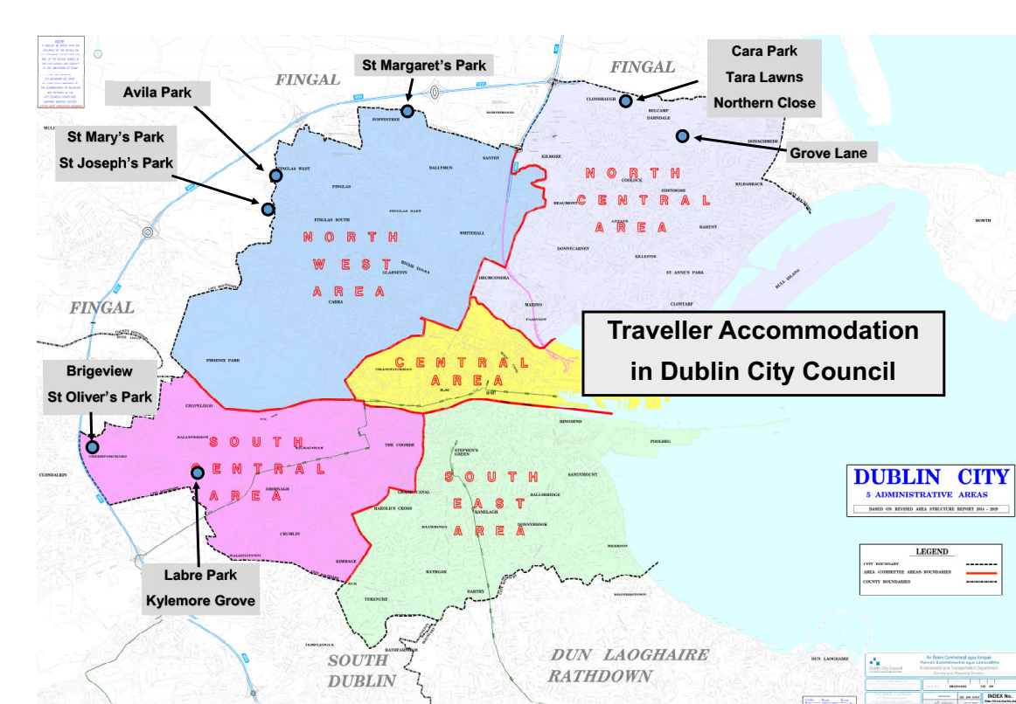

Material Alteration Reference Number Appendix 1.8

Volume 2: Appendix 1
Section: 7.2.3 Specialist Provision Support from Dublin City Council, subheading Households Experiencing Homelessness and Rough Sleeping
Page: 69, final paragraph

Amendment:

Dublin City Council will support the implementation of the Homeless{ness} Action Plan Framework for Dublin 2019-2021 or any subsequent review {and the Housing First National Implementation Plan 2022-2026} and support related initiatives to address homelessness.

Material Alteration Reference Number Appendix 1.9

Volume 2: Appendix1
Section: 7.2.3 Specialist Provision Support from Dublin City Council, subheading Meeting the Housing Needs of Older Persons and Persons with Disabilities
Page: 70

Amendment:

Page 70: Paragraph 1

This housing strategy will facilitate the implementation of Dublin City Council’s Strategic Plan for Housing People with a Disability 2016, and its successor currently being drafted. Dublin City Council is also committed to implementing the framework for the delivery of housing for persons with disabilities set out under the (‘National Housing Strategy for People with Disability 2011–2016’ and its successor) {National Housing Strategy for Disabled People 2022 – 2027} . The strategy is about facilitating the provision of housing options and related services to persons with disabilities to allow individual choice and support independent living.

(A new national strategy, National Housing Strategy for Persons with Disabilities 2022-2027 is being developed with the objective of facilitating the provision of housing options and related services to people with disabilities to allow individual choice and support independent living. The provisions of the new national strategy will be incorporated into any forthcoming review of the development plan.)

Page 70: Paragraph 2

Dublin City Council is committed to implementing Universal Design models to all new developments and encouraging private developers to incorporate them into all residential dwelling design proposals having regard to the Universal Design Guidelines for Homes in Ireland, published by the National Disability Authority in 2015. All new housing should be designed in a way that is adaptable and flexible to the changing needs of the homeowner as set out in the Lifetime Homes Guidance contained in Section 5.2 of the Department of Environment, Heritage and Local Government ‘Quality Housing for Sustainable Communities – Best Practice Guidelines for Delivering Homes Sustaining Communities’ (2007) {and to the Department’s Design Manual for Quality Housing 2022.} In line with Part M of the Building Regulations (as amended), all public and private buildings must also have provision for suitable access and use for all persons.

Material Alteration Reference Number Appendix 1.10

Volume 2: Appendix1
Section: 7.2.3 Specialist Provision Support from Dublin City Council, subheading: Meeting the Housing Needs of Older Persons and Persons with Disabilities
Page: 72, 3rd paragraph

Amendment:

(This housing strategy will support a commitment whereby a minimum of 10 percent of dwellings in all schemes over 100 units are designed to accommodate people with disabilities and older people in accordance with the Universal Design Guidelines for Homes in Ireland, 2015.)
{This housing strategy will support an objective to ensure that 50% of apartments in any development that are required to be in excess of minimum sizes should be designed to be suitable for older people/mobility impaired people and people with disabilities in accordance with the guidelines set out in the Universal Design Guidelines for Homes in Ireland 2015, the DHLG&H’s Design Manual for Quality Housing 2022 and the DHP&LG & DH’s Housing Options for Our Ageing Population Policy Statement 2019.}

Appendix 2:
Retail Strategy

No material amendments proposed.

Appendix 3:
Achieving Sustainable Compact Growth

Material Alteration Reference Number Appendix 3.1

Volume 2: Appendix 3
Section: 3.0 Understanding Height and Density – the Strategic Approach, Subsection 3.2. - Density
Page: 220, Table 2: Indicative Plot Ratio and Site Coverage

Amendment:

Indicative Site Coverage.

Central Area (80-90%) {60-90%.}

Material Alteration Reference Number Appendix 3.2

Volume 2: Appendix 3
Section: 4.0 The Compact City – How to Achieve Sustainable Height and Density, subsection 4.1 Introduction – Identification of Areas for Increased Height and Density
Page: 222, last paragraph

Amendment:

In considering locations for greater height and density, all schemes must have regard to the local prevailing context within which they are situated. This is particularly important in the lower scaled (suburban) areas of the city where broader consideration must be given to potential impacts such as overshadowing and overlooking, as well as the visual, functional, environmental and cumulative impacts of increased building height.

Material Alteration Reference Number Appendix 3.3

Volume 2: Appendix 3
Section: 4.0 The Compact City – How to Achieve Sustainable Height and Density, subsection 4.1 Introduction – Identification of Areas for Increased Height and Density
Page: 223, sub section Key Criteria

Amendment:

Insert Text after Key Criteria

Key Criteria {- (See Table 3).}
Material Alteration Reference Number Appendix 3.4

Volume 2: Appendix 3
Section: 4.0 The Compact City – How to Achieve Sustainable Height and Density, subsection 4.1 Introduction: Key Locations - City Centre and within the Canal Ring (inner suburbs)
Page: 224, first paragraph

Amendment:

In general, and in accordance with the Guidelines, a default position of 6 storeys will be promoted in the city centre and within the canal ring subject to site specific characteristics and heritage/environmental considerations (.){and social considerations in respect of sustaining existing inner city residential communities}.

Material Alteration Reference Number Appendix 3.5

Volume 2: Appendix 3
Section: Table 3: Performance Criteria in Assessing Proposals for Enhanced Height, Density and Scale; Objective 4
Page: 231, last bullet point

Amendment:

Provide for people friendly streets and spaces {and prioritise street accessibility for persons with a disability.}

Material Alteration Reference Number Appendix 3.6

Volume 2: Appendix 3
Section: Table 3: Performance Criteria in Assessing Proposals for Enhanced Height, Density and Scale; Objective 7
Page: 233

Amendment:

(have appropriate and reasonable regard to quantitative approaches to assessing daylighting and sun lighting proposals. Where appropriate, satisfactory, alternative compensatory design solutions should be provided for a failure to meet reasonable daylighting provisions, in the context of a constrained site or securing wider objectives such as comprehensive urban regeneration or an effective urban design and streetscape solution – see Appendix 16.)

{apply appropriate quantitative approaches to assessing daylighting and sun lighting proposals. In exceptional circumstances compensatory design solutions may be allowed for where the meeting of sun lighting and daylighting requirements is not possible in the context of a particular site (See Appendix 16).}

Material Alteration Reference Number Appendix 3.7

Volume 2: Appendix 3
Section: Table 3: Performance Criteria in Assessing Proposals for Enhanced Height, Density and Scale; Objective 7
Page: 233, insert bullet point after last bullet point

Amendment:

Insert bullet point on Page 233 after last bullet point on SFRA.

- {include an assessment of embodied energy impacts – see Section 15.7.1}

Material Alteration Reference Number Appendix 3.8

Volume 2: Appendix 3
Section: Table 4: Performance Criteria in Assessing Proposals for Landmark Tall Building/s, Objective 2
Page: 238 after ‘adapted overtime’ bullet

Amendment:

- {include an assessment of embodied energy impacts – see Section 15.7.1}

Material Alteration Reference Number Appendix 3.9

Volume 2: Appendix 3
Section: Table 4: Performance Criteria in Assessing Proposals for Landmark Tall Building/s, Objective 5
Page: 239, last bullet point

Amendment:

All tall building proposals must be accompanied by a full transport capacity assessment. The intensity of use associated with tall buildings will only be appropriate if it is supported by an appropriate level of transport capacity to ensure good pedestrian {, disability} and public transport access.

Appendix 4:
Development Plan Mandatory Requirements

No material amendments proposed.

Appendix 5:
Transport and Mobility: Technical Requirements

Material Alteration Reference Number Appendix 5.1

Volume 2:
Appendix 5: Transport and Mobility: Technical Requirements
Section: 4.0 Car Parking Standards; Table 2: Maximum Car Parking Standards for Various Land Uses
Page: 263

Amendment:

Category | Land-Use | Zone 1 | Zone 2 | Zone 3
Accommodation | Hotel¹ | None | 1 per 3 rooms | 1 per room
 | Nursing Home  Retirement Home | 1 per 3 residents | 1 per 2 residents | 1 per 2 residents
 | Elderly Persons Housing  Sheltered Housing | 1 per 4 dwellings | 1 per 2 dwellings | 1 per 2 dwellings
 | Student Accommodation | None² | 1 per 20 bed spaces | 1 per 10 bed spaces
 | Houses  Apartments/ Duplexes | (1) {0.5}per dwelling | 1 per dwelling | 1 per dwelling

Appendix 6:
Conservation

Material Alteration Reference Number Appendix 6.1

Volume 2:
Appendix 6: Conservation
Section: 4.3 Department of Housing, Local Government and Heritage (DHLGH) Guidelines
Page: 300

Amendment:

Archaeology (and) {in} the Planning Process {(Planning Leaflet 13; 2021)}

- {Built and Archaeological Heritage Climate Change Sectoral Adaptation Plan, (2019).}

Appendix 7 - Guidelines for Waste Storage Facilities,

Appendix 8 - COMAH (Seveso) Establishments

and

Appendix 9 - Basement Development Guidance

No material amendments proposed.

Appendix 10:
Infrastructure Capacity Assessment

Material Alteration Reference Number Appendix 10.1

Volume 2:
Appendix: 10 Infrastructure Capacity Assessment
Section: 4.1.1 Table 1: Strategic Water Supply Infrastructure (Source: Irish Water)
Page: 333-334

Amendment:

Table 1: Strategic Water Supply Infrastructure (Source: Irish Water)
Project Name | Project Delivery | Zoning Tier
(Eastern Midlands Water Supply Scheme){Water Supply Project – Eastern and Midlands Region}  The long-term development of the Eastern and Midland Region (EMR) will be dependent on this project. The NPF provides that a new long-term water supply source for the EMR, which includes the Dublin Water Supply Area, is needed by the mid 2020’s, to provide for projected growth up to 2050 and contribute to resilience and security of supply.  The project involves a 170km pipeline with supporting infrastructure (water treatment plant, pumping stations and terminal point reservoir) to ensure that the long-term water supply needs of the Region are met in a sustainable manner. IW has concluded a four-phase public consultation process and identified the preferred scheme:  - Abstraction of water from the Lower {River} Shannon at Parteen Basin.  - Water treatment at Birdhill.  - Treated water piped to a termination point reservoir at Peamount in south County Dublin, with supplies of treated water available to Midland communities along the route. | Identified in the {National Development Plan (NDP)} ‘Strategic Investment Priorities – {Water Quality} (2018-2027’).  Estimated cost of €1(.2 to €1.3) billion{+} (source: NDP).  IW are in the process of preparing a SID planning application to An Bord Pleanála for the scheme. | Tier 1 - All sites subject to connection agreement with Irish Water (in line with existing standard practice).

Material Alteration Reference Number Appendix 10.2

Volume 2:
Appendix: 10 Infrastructure Capacity Assessment
Section: 4.1.2 Wastewater Infrastructure, Table 2
Page: 335

Amendment:

Table 1: Strategic Wastewater Infrastructure (Source: Irish Water)

Project Name | Project Delivery | Zoning Tier
Ringsend Wastewater Treatment Plant Upgrade Project  The Ringsend Waste Water Treatment Plant which, whilst currently overcapacity, is undergoing significant upgrades in response to capacity issues which will allow the plant to treat increasing volumes of wastewater by 2025.  This upgrade project will increase the capacity of the Ringsend plant from c. 1.64m population equivalent (PE) to c. 2.4m PE. This will provide for both existing population and future growth, and bring benefits in terms of health, environmental protection and improved water quality. The project includes:  - Additional secondary treatment capacity.  - Works to facilitate the use of aerobic granular sludge technology in the existing secondary treatment tanks.  - Expansion of the plant’s sludge treatment facilities. | Identified in the NDP.  Currently under construction and due for completion in 2025.  Phased increase in capacity (2.1m PE in 202{3}(2) and 2.4m PE in 2025).  Estimated cost of c. €400m (source: Irish Water). | Tier 1 - All sites subject to connection agreement with Irish Water (in line with existing standard practice).
Greater Dublin Drainage Project (GDDP)  The GDDP aims to provide long-term sustainable wastewater drainage and treatment to facilitate the continued social and economic development of the Region.  The project involves the provision of new wastewater treatment works, a marine outfall and a new drainage network in the northern part of the GDA.  Together, with the upgrade of the Ringsend Wastewater Treatment Plant, these projects are intended to provide adequate wastewater treatment to serve the GDA to 2050. It is anticipated that the GDDP will provide the additional treatment capacity required from the mid-2020s. | Identified in the NDP within the category ‘Strategic Investment Priorities – {Water Quality} (2018-2027’).  Planning application is under determination. Construction scheduled for 2022-2026.  Estimated cost of c. €500m {- €1bn} (source: NDP). | Tier 1 - All sites subject to connection agreement with Irish Water (in line with existing standard practice).
Source: Irish Water

Material Alteration Reference Number Appendix 10.3

Volume 2:
Appendix: 10 Infrastructure Capacity Assessment
Section: 4.2.1 Key Public Transport Projects
Page: 337-338, 1st paragraph & Table 3

Amendment:

Table 2: Key Public Transport Projects (Source: NDP and NTA/TII)

The (Transport Strategy for the Greater Dublin Area (GDA) prepared by the National Transportation Authority (NTA), {National Transport Authority (draft) Strategy for the GDA 2022-2042,} provides for a number of key transport projects of strategic importance which will improve public transport provision across the city, and support ongoing sustainable growth focussed on the integration of land use and transportation. The following projects are of particular importance in the content of the strategic growth areas identified in the Core Strategy{:}

Table 3: Key Public Transport Projects (Source: NDP and NTA/TII)
Project Name | Project Delivery | Zoning Tier
Luas Green Line {Upgrade / Capacity} (Enhancement Project)  This project (is) {seeks to} incrementally increase{e}(ing) capacity on the network {through the provision of additional fleet and necessary infrastructure to meet forecast passenger demand.} (a combination of higher frequencies, additional trams and larger rolling stock.  - Phase 1 - involves extending existing trams to increase passenger capacity by c. 30%.  - Phase 2 - involves increasing tram frequency to every two minutes which would greatly increase carrying capacity.) | Identified in the NDP and the NTA’s (Draft) (Transport) Strategy for the GDA {2022-2042} (2016-2035).  {Delivery over the period 2022-2030.} (of tram extensions commenced in Q2 2019 and due to be complete by Q2 2021.  Delivery of new trams to commence in Q2 2020 and due to be complete by Q2 2021.  Estimated cost c. 100m)  {Cost estimate not currently available.} | Tier 1 - Subject to assessment on site-by-site basis.
Luas to Finglas ((2028){2031-2042)}  The preferred route for the extended Luas Tram line to Finglas has recently been released by TII and NTA with a decision to be made on final alignment.  Luas Finglas will create a new public transport connection between the communities of Charlestown, Finglas Village, Finglas west, St. Helena’s, Tolka Valley and the city centre and will include the delivery of new cycle and pedestrian infrastructure. | Identified in the NDP and the NTA’s (Draft) (Transport) Strategy for the GDA {2022-2042} (2016-2035).  NDP commits to undertake appraisal, planning and design of LUAS network expansion to Finglas. {A public consultation on its Emerging Preferred Route has been completed and it is expected that a Railway Order application will be submitted in 2023/2024.}  Luas likely to become operational {after} (by) 2028.  Cost estimate not currently available | Tier 1 - Subject to assessment on site-by-site basis.
Bus Connects (2021 – 202(3){4})  Bus Connects Dublin aims to overhaul the current bus system in Dublin through a 10-year programme of integrated actions to deliver a more efficient, reliable and better bus system. Bus Connects includes:  - Redesign of the bus network with high frequency spines, orbital routes and increased bus services.  - New cycle network.  - New ticketing and cashless payment system.  - New bus stops and shelters with better signage and information.  - Bus-based park and rides in strategic locations.  - New bus livery and transitioning to a new bus fleet with low emission vehicle technologies. | The NDP {identifies} (commits to the delivery of the full) BusConnects {as a Strategic Investment Priority over the period 2021-2030.}  (programme during the period to 2027.)  Project is at public consultation stage.  Estimated cost of €2billion (source: NDP). | Tier 1 - Subject to assessment on site-by-site basis.
Metrolink: (Metro to Ballymun) ((and onto) Dublin Airport/Swords) (2021 - 2027)  MetroLink is the proposed high-capacity, high-frequency, automated rail line running from Swords to Charlemont, linking Dublin Airport, Irish Rail, DART, Dublin Bus and Luas services, creating fully integrated public transport in the Greater Dublin Area. As well as linking major transport hubs, MetroLink will connect key destinations including Ballymun to the city centre. | TII due to apply for Railway Order {and planning consent for Metrolink} in 202(1){2}.  12-18 month planning process will commence once Railway Order granted and following this, work can commence on site. (It is anticipated that it will take between 6-8 years to complete) {No estimated completion date is currently available for the project.}  Estimated cost is €(3) {1} billion{+} (source: NDP) | Tier 1 - Subject to assessment on site-by-site basis.

Material Alteration Reference Number Appendix 10.4

Volume 2:
Appendix: 10 Infrastructure Capacity Assessment
Section: 4.2 Transport Infrastructure
Page: 339, Figure 3

Amendment:

Figure 1: {Dublin Proposed} (Greater Dublin Area) Public Transport Network (2027) (Source: National Development Plan (2018-2027) {2021-2030})

Material Alteration Reference Number Appendix 10.5

Volume 2:
Appendix: 10 Infrastructure Capacity Assessment
Section: 5.2 Active Travel – Walking and Cycling
Page: page 340, 1st paragraph

Amendment:

{Certain critical factors are required to} (To) make active travel an attractive alternative choice to car-based transport on the existing public road network, and to facilitate the 15-minute city concept of creating active, healthy communities with ease of access to amenities and services (,certain critical factors are required).

Material Alteration Reference Number Appendix 10.6

Volume 2:
Appendix: 10 Infrastructure Capacity Assessment
Section: 6.2 Other Lands
Page: page 346, 3rd paragraph

Amendment:

The implementation of a proactive land and development management strategy, enhanced partnership-working and coordination, and the effective utilisation of URDF funding, will be crucial to achieving the delivery of c. 13,(600){000} housing units on these non-SDRA lands.
Material Alteration Reference Number Appendix 10.7

Volume 2:
Appendix: 10 Infrastructure Capacity Assessment
Section: 7.0 Assessment Conclusion
Page: page 347, Table 6

Amendment:

Table 6: Settlement Capacity Audit – Summary Table
Tier | Settlement | Existing Population | Potential Housing Estimate
Tier 1 - Serviced lands | Dublin City other lands (excluding SDRAs) | 595,434  (2020, CSO Estimate) | 13,(600){000}
 | Dublin City SDRA lands |  | 34,350 - 35,550
Tier 2 - Serviceable lands | Potential lands at Glasnevin & Naas Road, Phase 1 |  | 6,000

Appendix 11:
Technical Summary of Dublin City Council Green Roof Guidance

Material Alteration Reference Number Appendix 11.1

Volume 2:
Appendix: 11 Technical Summary of Dublin City Council Green Roof Guidance
Section: 1.2 Benefits of Green and Blue Roofs, Subsection on ‘National Policy’
Page: 351

Amendment:

{European/} National Policy

- {Nature-based Solutions to the Management of Rainwater and Surface Water Runoff in Urban Areas Water: Sensitive Urban Design Best Practice Interim Guidance Document (2021)}
- National Biodiversity Action Plan 2017– 2021 {or any successor plan.}

Appendix 12:
Technical Summary of Dublin City Council Design Guidance Document for Implementing SuDS Solutions

Material Alteration Reference Number Appendix 12.1

Volume 2:
Appendix: 12 Technical Summary of Dublin City Council Design Guidance Document for Implementing SuDS Solutions
Section: 1.0 Introduction
Page: 355, 3rd paragraph insert text

Amendment:

Since the GDSDS was first published, it has been commonplace for drainage schemes to include underground tanks or ‘end of pipe’ structures to hold surface water and restrict the rate of flow leaving the development. However, this simplistic approach does not accord with the original vision for SuDS as outlined by the GDSDS. Underground tanks offer no benefits in terms of improved water quality, nor do they make provision for amenity or biodiversity.

{The National Planning Framework (2018) seeks to enhance water quality and resource management by ensuring that flood risk management and RBMP objectives are fully considered through the physical planning process and through the integration of sustainable water management solutions into place-making. The forthcoming 3rd cycle RBMP for the period 2022 to 2027 will address the impact of urban run-off on our water environment by strengthening the delivery of water sensitive urban design in how local authorities and others plan for, build and maintain our urban areas. Nature-based solutions to the management of rainwater and surface water run-off surface water management (i.e. SuDS) will be central to delivering on this objective in line with government policy published in the SuDS Interim Guide (2021).}

Material Alteration Reference Number Appendix 12.2

Volume 2:
Appendix: 12 Technical Summary of Dublin City Council Design Guidance Document for Implementing SuDS Solutions
Section: 1.0 Introduction, bullet points under ‘National Policy’
Page: 356, insert text

Amendment:

{European/} National Policy

- {Water Framework Directive
- National Planning Framework 2018
- River Basin Management Plan (2nd and 3rd cycles)
- Nature-based Solutions to the Management of Rainwater and Surface Water Runoff in Urban Areas Water: Sensitive Urban Design Best Practice Interim Guidance Document (2021)}
- National Biodiversity Action Plan 2017– 2021 {or any successor plan.}

Material Alteration Reference Number Appendix 12.3

Volume 2:
Appendix: 12 Technical Summary of Dublin City Council Design Guidance Document for Implementing SuDS Solutions
Section: 1.1 What are SuDS?
Page: 357, 4th paragraph bullet point list

Amendment:

There are four critical objectives that SuDS seek to meet:

- Quantity: {preserve natural hydrological systems / surface water resources by} managing flows and volumes to match the rainfall characteristics before development, in order to prevent {flooding on-site and within the receiving catchment.} (flooding from outside the development, within the site and downstream of the development)
- Quality: preventing and treating pollution to ensure that clean water is available as soon as possible to provide amenity{,} (and) biodiversity {and climate resilience} benefits within the development, as well as protecting watercourses, groundwater and the sea.
- Biodiversity: {protecting natural habitats, providing ecological connectivity and creating/ supporting sustainable ecosystems} (maximising the potential for wildlife) through {the} design and management of SuDS.
- Amenity: enhancing people’s quality of life through (an) integrated {place-making and} design that provides {for climate resilient,} useful and attractive multi-functional spaces.

Appendix 13 - Surface Water Management Guidance

and

Appendix 14 - Statement Demonstrating Compliance with Section 28 Guidelines

No material amendments proposed.

Appendix 15:
Land Use Definitions

Material Alteration Reference Number Appendix 15.1

Volume 2, Appendix 15
Land Use Definitions
Page: 395

Amendment:

Add following text:

{Social and Community Infrastructure: is the physical infrastructure necessary for successful communities, i.e. community infrastructure such as schools, libraries, community centres, cultural spaces, health centres, facilities for the elderly and persons with disabilities, childcare facilities, parks, and other facilities and spaces for play and recreational activity.}

Material Alteration Reference Number Appendix 15.2

Volume 2, Appendix 15
Land Use Definitions
Page: 395

Sports Facility {and Recreational Uses}

A building, or part thereof, or land used for organised competitive activity {and/or recreational use} that aims to promote physical activity and well being e.g.

Appendix 16:
Sunlight and Daylight

Material Alteration Reference Number Appendix 16.1

Appendix 16
Section: 3.5 National Policy
Page: 401

Amendment:

3.5 National Policy

Beyond guidance given in the Dublin City Development Plan 2022 – 2028, direction and information on daylight and sunlight is given within the Urban Development and Building Height Guidelines for Planning Authorities (2018) and the Sustainable Urban Housing: Design Standards for New Apartments (December 2020). Both documents refer to BR209 and BS 8206-2. Neither document refers to BS EN 17037 or {IS} EN 17037.

{For clarity, appropriate and reasonable regard should be taken of government policies, including the Urban Development and Building Height Guidelines for Planning Authorities (2018) and the Sustainable Urban Housing: Design Standards for New Apartments (December 2020), in the completion of sunlight and daylight assessments.}

Material Alteration Reference Number Appendix 16.2

Appendix 16
Section: 4.0 Relevant Metrics
Page: 4.4: Insert new subsection after subsection 4.6, on page 404

Amendment:

{4.7 Vertical Sky Component (VSC – skylight metric)

The Vertical Sky Component is defined in BR 209 as the “Ratio of that part of illuminance, at a point on a given vertical plane, that is received directly from a Commission Internationale de l'Eclairage (CIE) standard overcast sky, to illuminance on a horizontal plane due to an unobstructed hemisphere of this sky”.}

Material Alteration Reference Number Appendix 16.3

Appendix 16
5.0 Assessment Methodologies
Pages 404, 405, 406
Sections 5.1, 5.2 and 5.3.

Amendment:

5.1 Performance of the Proposed Development

- Annual Probable Sunlight Hours on all {relevant} windows
- Winter Sunlight Hours on all {relevant} windows
- Sunlight on Ground in all amenity spaces
- Average Daylight Factor in all habitable rooms
- No Sky Line in all habitable rooms
- Target Illuminance in all habitable rooms

5.2 Impact on the Surrounding Properties

- Vertical Sky Component on all {relevant} surrounding windows
- Annual Probable Sunlight Hours on all {relevant} surrounding windows
- Winter Sunlight Hours on all {surrounding} windows
- Sunlight on Ground in all surrounding amenity spaces

5.3 Other Criteria and Considerations

In addition to the above metrics, the planning authority (notes the points below for clarity) {will require consideration of the points below, save in agreed exceptional circumstances:}

When assessing the impact of a proposed development, it is expected that all surrounding properties are assessed. It is not acceptable to assess only the surrounding residential properties. Residential properties should be clearly marked out and results for these presented separately.

When assessing the impact of a proposed development on the existing surrounding properties, it is expected that the rule within clause 2.2.4 of BR 209 is applied. This rule outlines that “Loss of light to existing windows need not be analysed if the distance of each part of the new development from the existing window is three or more times its height above the centre of the existing window”. Thus, all surrounding buildings that sit within three times the height of the proposed development shall be included within the assessment. {The assessment can then use methods typically applied in BR 209 to determine the correct approach to investigating loss of light.}

When analysing the results found to investigate the impact of a proposed development on the surrounding existing buildings, it is expected that the nomenclature and associated descriptions from within Appendix I of BR 209 are used. The wordings of negligible, minor adverse, moderate adverse and major adverse have defined meanings. These meanings have associated descriptors, and these shall be applied during the analytics section of reports. Appendix I in BR 209 provides these descriptions in full.

The use of average daylight factor in assessing the impact of a new development on surrounding existing developments is not permitted.

Where alternate target values are being set, this shall be completed in line with Appendix F of BR 209.

When analysing the performance of a proposed development, it is expected that all rooms with an expectation for daylight are assessed. Assessing only a sample of rooms is not permitted.

When determining input factors for simulations, (the criteria below shall be applied. Deviations from these values shall not be accepted.) {applicants shall clearly state their assumptions.}

(Table 1: Input Parameters
Input Parameter | Value
Internal floor reflectance | 20 %
Internal wall reflectance | 50 %
Internal ceiling reflectance | 70 %
External material reflectance | 20 %
Glazing Transmission | 70 %
Glazing Maintenance Factor | 88 %
Framing Factor | 95 %
Grid Height above ground (Residential) | 0.85 m
Grid Height above ground (Commercial)) | 0.70 m

Appendix 17 - Advertising and Signage Strategy

No material amendments proposed.

Appendix 18:
Ancillary Residential Accommodation

Material Alteration Reference Number Appendix 18.1

Appendix 18
Section: 7.0 Ancillary Family Accommodation
Page: 435, 1st paragraph

Amendment:

Ancillary family accommodation refers to a subdivision or extension of a single family dwelling unit to accommodate an immediate family member for a temporary period (e.g. elderly parent) or where an immediate relative with a disability, illness or {specific temporary housing need} may need to live in close proximity to their family.

Volume 4: Record of Protected Structures

Material Alteration Reference Number Appendix RPS 1.1

Proposed Description in Draft Development Plan
RPS Ref No | Address | Description
838 | 57 Bolton Street, Dublin 1 | (Commercial premises)  {Three-storey commercial building to Bolton Street and Yarnhall Street; exterior only.}

Material Alteration Reference Number Appendix RPS 1.2

Proposed Description in Draft Development Plan
RPS Ref No. | Address | Description
5268 | 34 Molesworth Street, Dublin 2 | (Front façade only including entrance steps, plinth wall and railings)  {Historic granite plinth wall to basement and brick vaults beneath pavement}

Material Alteration Reference Number Appendix RPS 1.3

Proposed Description in Draft Development Plan
RPS Ref No | Address | Description
8831 | Echlin Street, Dublin 8 | The Echlin Buildings – Block A {(exterior and communal stairwell with granite cantilevered staircase.)}
8832 | Echlin Street, Dublin 8 | The Echlin Buildings – Block B {(exterior and communal stairwell with granite cantilevered staircase.)}
8833 | Echlin Street, Dublin 8 | The Echlin Buildings – Block C {(exterior and communal stairwell with granite cantilevered staircase)}
8834 | Echlin Street, Dublin 8 | The Echlin Buildings – Block D {(exterior and communal stairwell with granite cantilevered staircase)}

Material Alteration Reference Number Appendix RPS 1.4

Proposed Description in the Draft Development Plan:
Recommendation
RPS No. | Address | Description (to appear on RPS)
8849 | 4a Henrietta Lane, Dublin 1 | (18th century stone and brick boundary walls to include surviving opening to laneway)  {Historic stone and brick east boundary walls (i.e. boundary wall with No. 3 Henrietta Lane only).}

Material Alteration Reference Number Appendix RPS 1.5

Proposed Description in the Draft Development Plan
Recommendation
RPS no. | Address | Description (to appear on RPS)
8850 | 4b Henrietta Lane, Dublin 1 | (18th century stone and brick boundary walls to include masonry vaults and surviving opening to laneway)  {Historic stone and brick boundary walls within No. 4b (only) including masonry vaults.}

Material Alteration Reference Number Appendix RPS 1.6

Proposed Description in Draft Development Plan
RPS Ref No | Address | Description
8888 | Stillorgan Road, Donnybrook, Dublin 4 | RTE Campus: 5 buildings comprising:  (1) Television Building, 1962 and 1979 extension;  (2) Scene Dock Building c. 1965-69 {(exterior and lightweight trussed roof structure);}  (3) Restaurant Building c. 1965 (excluding later extension);  (4) Administration Building, 1967 (excluding later extension); and  (5) Radio Building, 1973.

